

Neuro-Trap: An Adaptive Behavior-Driven Honeypot System with Machine Learning and Automated Threat Intelligence
By
Goh Yuan Kee
TP070126
APU3F2511CS(CYB)

A report submitted in partial fulfillment of the requirements for the degree of B.Sc. (Hons) Computer Science (Cyber Security)
at Asia Pacific University of Technology and Innovation.

Supervised by Mr. SHAHAB ALIZADEH
2nd Marker by DR. MOHAMED SHABBIR HAMZA ABDULNABI

DECLARATION OF THESIS CONFIDENTIALITY

Author’s full name: Goh Yuan Kee
IC No./Passport No.: ___040816101602__________
Thesis/Project title: Neuro-Trap: An Adaptive Behavior-Driven Honeypot System with Machine Learning and Automated Threat Intelligence

I declare that this thesis is classified as:
☐ CONFIDENTIAL
☐ RESTRICTED
☑ OPEN ACCESS

I acknowledged that Asia Pacific University of Technology & Innovation (APU) reserves the right as follows:
- The thesis is the property of Asia Pacific University of Technology & Innovation (APU).
- The Library of Asia Pacific University of Technology & Innovation (APU) has the right to make copies for the purpose of research only.
- The Library has the right to make copies of the thesis for academic exchange.
Author’s Signature:
Date: | 21/08/2026
Supervisor’s Name: | Mr. Shahab Alizadeh
Date:
Signature:

Please fill in all the following details for library cataloguing purposes.
First Name: Goh
Middle Name (only if applicable): –
Last Name: Yuan Kee
Title of the Final Year Project / Dissertation / Thesis: Neuro-Trap: An Adaptive Behavior-Driven Honeypot System with Machine Learning and Automated Threat Intelligence
Abstract: Neuro-Trap is a combination of deception and internet threat information system, which aims to captured, analysis and implement under controlled environment for attacker interaction. It implements configurable service bait, records session logs, and applies automated classification through the Isolation Forest anomaly detection model with feature extraction. Sessions are prioritised for analyst verification, candidate indicators of compromise are automatically extracted and formatted into YARA/Suricata structures, and a web-based human-in-the-loop dashboard supports review, comment and approval before export into MISP-compatible JSON.
A few keywords associated with the work: Honeypot, Machine Learning, Isolation Forest, Threat Intelligence, Anomaly Detection, Cybersecurity
General Subject: (e.g. Management information system, Software Engineering, etc.) Cyber Security
Date of Submission: 22 July 2026

Acknowledgment
The accomplished of Neueo-Trap final year project is thanks to support and guidance of various stakeholders. Special thanks to the profesional guidance that given by FYP supervisor during investigation phases. The nice and continuous guilds on methodology suggestion, fyp title designed helps the researcher completed the final year project phase one well.
Besides that, appreciation is expressed to all responses that joined my survey, the responses give the key opinions and evidence to support this project. The data collection shows various people insight, which help to improve the design and features of system. Furthermore, deep appreciation is recorded for open-sources dataset and result of investigation by enterprise, which help for implementation of basic features and theoretical background.
Thanks to that organization that provided tools that can be utilize during the implementation of system. These contributions were crucial to the project's success and the preparation of the relevant documentation.

Abstract
Neuro-Trap is a combination of deception and internet threat information system, which aims to captured, analysis and implement under controlled environment for attacker interaction. This platform implements configurable service bait, simulate common network service and protocols. Thus, record the sessions log. Data that captured are conducted by automated classification process. This process generates risk assessments through the anomaly detection model Isolation Forest and feature extraction techniques. Therefore, conduct a priority sequence to sessions to verify by analytic. The candidate indicators of compromise will be automated extract and formatting to the detection tools like structure of YARA/Suricata. Web-based human machine collaboration panel support the highly efficient of checking, comment and approved to information that auto generated. Thus, exported into MISP compatible JSON format after approved by analytic. Furthermore, evaluation metrics includes sessions captured rate, distribution of anomaly scores, rate of metric generation, analyst approval rate interaction and dwell time with adaptive decoys. This investigation records the introduction, methodology, analysis and future suggestion.

Table of Contents
Acknowledgment 4
Abstract 5
List of Figures 15
List of Tables 18
CHAPTER 1: INTRODUCTION 19
1.1 Introduction 19
1.2 Problem Background 22
1.2.1 Static honeypot configurations and limited engagement depth 22
1.2.2 Fragmented intelligence pipelines and manual IoC workflows 23
1.2.3 Lack of automated session triage and analyst validation controls 24
1.3 Project Aim 25
1.4 Objective 26
1.5 Project Scope 27
1.5.1 Tasks to be Executed 28
1.5.2 Constraints of Development 30
1.5.3 What to Do 31
1.5.4 What Not to Do 31
1.6 Overview of the IR 32
1.7 Project Plan 33
CHAPTER 2: LITERATURE REVIEW 36
2.1 Domain Research 36
2.1.1 Computer Networking 36
2.1.2 Network Security 38
2.1.3 Network Intrusion Detection Systems (NIDS) 40
2.1.4 Honeypot Technology 42
2.1.5 Cyber Threat Intelligence (CTI) 46
2.1.6 Machine Learning in Cybersecurity 48
2.1.7 SDG Alignment 51
2.2 Machine Learning Paradigms in Intrusion Detection 53
2.2.1 Overview of Machine Learning Paradigms in Intrusion Detection 53
2.2.2 Supervised Learning 54
2.2.3 Reinforcement Learning 54
2.2.4 Unsupervised Learning 55
2.2.5 Isolation Forest 56
2.2.6 Algorithm Structure and Theoretical Foundations 56
2.2.7 Performance in Network Intrusion Detection Contexts 56
2.2.8 Limitations of Isolation Forest 57
2.2.9 One-Class Support Vector Machine (One-Class SVM) 58
2.2.10 Algorithm Structure and Theoretical Foundations 58
2.2.11 Limitations and Practical Constraints 58
2.2.12 Local Outlier Factor (LOF) 59
2.2.13 Algorithm Structure and Theoretical Foundations 59
2.2.15 Structural Limitations in IDS Deployment 59
2.6 Comparative Analysis: Isolation Forest, One-Class SVM, and LOF 60
2.7 Justification for the Selection of Isolation Forest in Neuro-Trap 63
2.3 Honeypot: Static Honeypot vs Dynamic Honeypot 64
2.3.1 Static Honeypot 65
2.3.1.1 Features of Static Honeypot 65
2.3.1.2 Advantages of Static Honeypot 66
2.3.1.3 Disadvantages of Static Honeypot 66
2.3.2 Dynamic Honeypot 67
2.3.2.1 Features of Dynamic Honeypot 67
2.3.2.2 Advantages of Dynamic Honeypot 68
2.3.2.3 Disadvantages of Dynamic Honeypot 69
2.3.3 Comparison of Static Honeypot and Dynamic Honeypot 69
2.3.4 Chosen Honeypot Design for Neuro-Trap 71
2.4 Threat Intelligence Pipelines: Human-in-the-Loop vs Fully Automated (MISP) 72
2.4.1 Human-in-the-Loop Threat Intelligence 73
2.4.1.1 Features of Human-in-the-Loop Threat Intelligence 73
2.4.1.2 Advantages of Human-in-the-Loop Threat Intelligence 74
2.4.1.3 Disadvantages of Human-in-the-Loop Threat Intelligence 75
2.4.2 Fully Automated Threat Intelligence 76
2.4.2.1 Features of Fully Automated Threat Intelligence 76
2.4.2.2 Advantages of Fully Automated Threat Intelligence 77
2.4.2.3 Disadvantages of Fully Automated Threat Intelligence 78
2.4.3 Comparison of Human-in-the-Loop and Fully Automated Threat Intelligence 79
2.4.4 Chosen Approach for Neuro-Trap: Human-in-the-Loop with MISP Export 81
2.5 Similar System 82
2.5.1 Similar Systems / Works 82
2.5.2 Conpot 82
2.5.2.1 Features of Conpot 83
2.5.2.2 Advantages of Conpot 88
2.5.2.2 Disadvantages of Conpot 91
2.5.3 Cowrie Honeypot 94
2.5.3.1 Features of Cowrie 96
2.5.3.2 Advantages of Cowrie 101
2.5.3.3 Disadvantages of Cowrie 103
2.5.4 Glastopf 106
2.5.4.1 Features of Glastopf 107
2.5.4.2 Advantages of Glastopf 111
2.5.4.3 Disadvantages of Glastopf 114
2.5.4 Comparison of Similar Systems 117
2.6 Technical Research 125
2.6.1 Programming Language 125
Python (Version 3.11) 125
Interpreted and Cross-Platform Nature 126
Dynamic Typing and Rich Ecosystem 127
Direct Relevance to This Project 127
Compatibility and Environment Considerations 128
Comparison with Alternative Languages 129
2.6.2 Integrated Development Enviromnemt (IDE) 131
PyCharm 131
Smart Code Completion and Context-Aware Assistance 131
Integrated Debugger with Breakpoints and Variable Inspection 132
Real-Time Error Detection and Code Quality Analysis 133
Refactoring Tools and Version Control Integration 133
Virtual Environment and Package Management 134
Comparison of PyCharm with Alternative Development Environments 134
2.6.3 Library / Tools chosen 137
2.6.3.1 Python socket (Standard Library, Python 3.11) 137
Role in the Proposed System 138
Representative Usage Example 139
Key Socket Methods and Their Application in This Project 140
Limitations and Platform Considerations 142
Alternative Libraries Considered 143
2.6.3.2 scikit-learn Isolation Forest (Version 1.3) 143
The Isolation Forest Algorithm 144
Application in the Proposed Honeypot System 145
Key Parameters and Configuration 146
Representative Usage Example 148
Limitations 148
2.6.3.3 SQLite (Version 3.45) 149
Role in the Proposed System 150
Representative Usage Example 151
Advantages of SQLite for This Project 152
Limitations 153
2.6.3.4 Flask (Version 3.0) 153
Role in the Proposed System 154
Key Flask Concepts Used in This Project 155
Comparison with Alternative Web Frameworks 156
Limitations 158
2.6.3.5 YARA (Version 4.5) 159
YARA Rule Structure and Syntax 159
Application in the Proposed System 161
Integration with IDS Rule Generation (Suricata Context) 162
Limitations 162
2.6.4 Operating System 163
2.6.4.1 Windows 11 (Version 22H2) 163
Security Features Relevant to This Project 163
Windows 11 vs Linux for Development 164
Hardware Specifications 165
2.6.5 Library and Tools Summary 166
CHAPTER 3: METHODOLOGY 167
3.1 System Development Methodology 167
3.1.1 Introduction 167
3.1.2 Scrum 168
3.1.2.1 Scrum Events 169
3.1.2.2 Scrum Lifecycle 171
3.1.2.3 Advantages of Scrum 172
3.1.2.4 Disadvantages of Scrum 173
3.1.3 DevOps 174
3.1.3.1 DevOps Key Practices and Pipeline 175
3.1.3.2 DevOps Lifecycle 176
3.1.3.3 Advantages of DevOps 177
3.1.3.4 Disadvantages of DevOps 178
3.1.4 Rapid Application Development (RAD) 180
3.1.4.1 RAD Lifecycle 181
3.1.4.2 Advantages of RAD 183
3.1.4.3 Disadvantages of RAD 184
3.1.5 Methodology Comparison 185
3.1.6 Chosen Methodology 187
3.2 Data Gathering Design 189
3.2.1 Surveys 189
Section B Multi-Layered Deception Infrastructure 195
Section C Machine Learning-Based Threat Analysis 199
Section D Automated Threat Intelligence Generation 203
Section E Human-in-the-Loop Dashboard and MISP Pipeline 207
CHAPTER 4: DESIGN AND IMPLEMENTATION 211
4.1 Introduction 211
4.2 Design 212
4.2.1 System Architecture 212
4.2.2 Use Case 214
4.2.2.1 Use Case Specification 215
4.2.3 Flowchart 221
4.2.3.1 Choose Network Interface and Enter Email 221
4.2.3.2 Monitor and Detect Threat in Network Traffic 222
4.2.3.3 View CSV Logs of Detected Threat 223
4.2.3.4 View PCAP Files 224
4.2.3.5 Alerting System 225
4.2.4 Sequence Diagram 226
4.2.4.1 Choose Network Interface and Enter Email 226
4.2.4.2 Monitor and Detect Threat in Network Traffic 227
4.2.4.3 View CSV Logs of Detected Threat 227
4.2.4.4 View PCAP Files 228
4.2.4.5 Alerting System 229
4.2.5 Activity Diagram 230
4.3 Implementation 231
4.3.1 Module 1 Honeypot Engine (simple_honeypot.py) 231
4.3.1.1 Configuration and Database Initialisation 231
4.3.1.2 Session Logging and Fake Banner 232
4.3.1.3 Connection Handler and Main Listener 233
4.3.2 Module 2 ML Analysis Engine (behaviour_ml.py) 236
4.3.2.1 Feature Extraction 236
4.3.2.2 Rule-Based Classifier 237
4.3.2.3 Isolation Forest Model 239
4.3.3 Module 3 IoC Extraction Subsystem (ioc_extractor.py) 239
4.3.3.1 Regex Pattern Library 240
4.3.3.2 YARA and Suricata Rule Generation 241
4.3.3.3 Extraction Pipeline 243
4.3.4 Module 4 Decoy Orchestration Controller (decoy_orchestrator.py) 244
4.3.4.1 Decoy Service Listeners 245
4.3.4.2 Orchestration Loop and Event Logging 246
4.3.5 Module 5 Flask Analyst Dashboard (app.py) 247
4.3.5.1 Application Setup and API Routes 247
4.3.5.2 Dashboard Interface 249
4.3.6 Module 6 MISP Export Pipeline (misp_mock.py) 253
4.3.6.1 MISP Type Mapping 253
4.3.6.2 Event Construction and Export 254
4.3.7 Integrated System Operation 256
4.3.8 User Testing 260
4.4 Chapter Summary 261
CHAPTER 5: TESTING AND EVALUATION 262
5.1 Introduction 262
5.2 Testing Methodology 263
5.3 Unit Testing 265
5.3.2 Module 2 ML Analysis Engine (behaviour_ml.py) 267
5.3.3 Module 3 IoC Extraction Subsystem (ioc_extractor.py) 270
5.3.4 Module 4 Decoy Orchestration Controller (decoy_orchestrator.py) 272
5.3.5 Module 5 Flask Analyst Dashboard (app.py) 274
5.3.6 Module 6 MISP Export Pipeline (misp_mock.py) 277
5.4 Integration Testing 280
5.4.1 Honeypot-to-SQLite Pipeline Integration 280
5.4.2 ML Classification Pipeline Integration 282
5.4.3 IoC Extraction Pipeline Integration 284
5.4.4 Decoy Orchestration Integration 285
5.4.5 End-to-End Dashboard Integration 286
5.4.5 End-to-End Dashboard Integration 286
5.5 System Testing 287
5.5.1 End-to-End Analyst Workflow Test 288
5.5.2 MISP JSON Output Validation 290
5.5.3 Concurrent Session Handling Test 290
5.5.4 Edge Case and Error Handling Test 291
5.6 Classification Performance Analysis 291
5.6.1 Full Session Classification Results 292
5.6.2 Two-Stage Pipeline Efficiency Analysis 295
5.6.3 Anomaly Score Distribution and Threshold Analysis 296
5.7 Security Evaluation 297
5.8 Evaluation Against Objectives 298
5.8.1 Objective 1 Multi-Layer Deception Infrastructure 299
5.8.2 Objective 2 ML-Based Behavioural Classification 299
5.8.3 Objective 3 YARA/Suricata Rule Generation and IoC Extraction 300
5.8.4 Objective 4 Human-Centred Dashboard and MISP Pipeline 300
5.9 Chapter Summary 301
CHAPTER 6: CONCLUSION 302
6.1 Introduction 302
6.2 Research Summary 303
6.3 Achievement of Objectives 304
6.4 Limitations 306
6.4.1 Single-Host Prototype Deployment 306
6.4.2 SQLite Concurrency Constraints 306
6.4.3 Simulated MISP Export 307
6.4.4 ML Model Training Data Scale 307
6.4.5 TCP-Only Protocol Coverage 308
6.5 Future Work 308
6.5.1 Live MISP REST API Integration 309
6.5.2 Reinforcement Learning Adaptive Decoy Controller 309
6.5.3 Containerised Multi-Host Deployment 310
6.5.4 NLP-Enhanced IoC Extraction 310
6.5.5 Analyst Feedback Loop for Model Improvement 311
6.6 Reflection on Research Contribution 312
6.7 Final Conclusion 313
Chapter 7 – CONCLUSION (Brief) 315
7.1 Conclusion and Reflection 315
7.2 Limitation 317
8.0 References 318
9.0 Appendix 338
9.1 Meeting Scheduling & Meeting Logs 338
9.2 Ethical Form (Fast Track) 340
9.3 Respondent’s Demographic Profile 345
9.4 Gantt Chart 346
9.5 PPF 348
9.6 Poster FYP 351

List of Figures
Figure 1: Survey Introduction and Participant Agreement 190
Figure 2: Section A Demographics Questions (A1–A5) 191
Figure 3: Section A Response Results (A1–A5) 192
Figure 4: Section B Multi-Layered Deception Infrastructure Questions (B1–B5) 194
Figure 5: Section B Response Results (B1–B5) 195
Figure 6: Section C Machine Learning-Based Threat Analysis Questions (C1–C5) 198
Figure 7: Section C Response Results (C1–C5) 199
Figure 8: Section D Automated Threat Intelligence Generation Questions (D1–D5) 202
Figure 9: Section D Response Results (D1–D5) 203
Figure 10: Section E Human-in-the-Loop Dashboard and MISP Pipeline Questions (E1–E5) 206
Figure 11: Section E Response Results (E1–E5) 207
Figure 4.1: Neuro-Trap System Architecture six-module pipeline from capture to MISP export 212
Figure 4.2: Neuro-Trap Use Case Diagram two actors across six system use cases 213
Figure 4.3: Flowchart Choose Network Interface and Enter Email 220
Figure 4.4: Flowchart Monitor and Detect Threat in Network Traffic 221
Figure 4.5: Flowchart View CSV Logs of Detected Threat 222
Figure 4.6: Flowchart View PCAP Files 223
Figure 4.7: Flowchart Alerting System 224
Figure 4.8: Sequence Diagram Choose Network Interface and Enter Email 225
Figure 4.9: Sequence Diagram Monitor and Detect Threat in Network Traffic 226
Figure 4.10: Sequence Diagram View CSV Logs of Detected Threat 226
Figure 4.11: Sequence Diagram View PCAP Files 227
Figure 4.12: Sequence Diagram Alerting System 228
Figure 4.13: Neuro-Trap System-Level Activity Diagram three swim lanes across all six modules 229
Figure 4.14 — simple_honeypot.py configuration block and database initialisation 231
Figure 4.15: simple_honeypot.py log_session() function and pre-configured fake banner and response dictionary 232
Figure 4.16: simple_honeypot.py handle_connection() thread and start_honeypot() main TCP listener loop 234
Figure 4.17: simple_honeypot.py running console output confirming database initialisation and listener active on port 2222 235
Figure 4.18: behaviour_ml.py extract_features() producing 8-element numerical vectors with keyword flags 236
Figure 4.19: behaviour_ml.py rule-based classifier with HIGHLY_KEYWORDS and SUSPICIOUS_KEYWORDS lists 237
Figure 4.20: behaviour_ml.py Isolation Forest model fitting and anomaly scoring with threshold-based labelling 238
Figure 4.21: behaviour_ml.py console output sessions scored with anomaly values and risk labels 238
Figure 4.22: ioc_extractor.py compiled regex patterns for IP, domain, URL, hash, CVE, and malicious command extraction 239
Figure 4.23: ioc_extractor.py YARA and Suricata rule generation functions 241
Figure 4.24: ioc_extractor.py console output extracted IoC types and values per session 243
Figure 4.25: decoy_orchestrator.py DECOY_BANNERS dictionary and run_decoy_listener() function 245
Figure 4.26: decoy_orchestrator.py orchestration polling loop and spawn_decoys() with decoy_events logging 246
Figure 4.27: decoy_orchestrator.py running console output confirming HIGHLY_SUSPICIOUS detection and decoy spawn events 246
Figure 4.28: app.py Flask application setup, database helper, and key API route definitions 248
Figure 4.29: Neuro-Trap analyst dashboard Overview page with risk distribution charts and statistical summary cards 249
Figure 4.30 — Session registry with colour-coded risk label badges 249
Figure 4.31 — IoC Registry showing extracted indicators and analyst approval controls 250
Figure 4.32 — Detection Rules dashboard showing auto-generated YARA and Suricata rules 250
Figure 4.33 — Decoy Service Events log 251
Figure 4.34 — MISP Export dashboard with selectable IoCs 251
Figure 4.35 — Individual session detail view 251
Figure 4.36: misp_mock.py MISP_TYPE_MAP and MISP_CATEGORY_MAP dictionaries 252
Figure 4.37: misp_mock.py build_misp_attribute() 253
Figure 4.38: misp_mock.py build_misp_event() construction functions 254
Figure 4.39: Generated MISP-compatible JSON export file structure viewed in Visual Studio Code 254
Figure 4.40: All Neuro-Trap modules running simultaneously honeypot, orchestrator, and dashboard terminals 255
Figure 4.41: test_attack.py sending 20 test sessions output confirming HIGHLY_SUSPICIOUS, SUSPICIOUS, and NORMAL categories 256
Figure 4.42: SQLite neuro_trap.db viewed in DB Browser attacks table with ML scores and risk labels 258
Figure 9.4.1 Gantt Chart part 1 343
Figure 9.4.2 Gantt Chart part 2 343
Figure 9.6 Poster FYP 347

List of Tables
Table 4.1: Summary of Neuro-Trap module responsibilities and database interactions 257
Table 4.2 Summary of user testing activities and outcomes 259
Table 5.1: Neuro-Trap test environment specifications 263
Table 5.2: simple_honeypot.py unit test results 7/7 test cases passed 265
Table 5.3: behaviour_ml.py unit test results 8/8 test cases passed 267
Table 5.4: ioc_extractor.py unit test results 10/10 test cases passed 270
Table 5.5: decoy_orchestrator.py unit test results 8/8 test cases passed 272
Table 5.6: app.py (Flask dashboard) unit test results 9/9 endpoint tests passed 275
Table 5.7: misp_mock.py unit test results 9/9 test cases passed 278
Table 5.8: Honeypot capture integration results all 20 sessions logged correctly, all risk_label fields UNSCORED 280
Table 5.9: ML pipeline integration results two-stage classification across all 20 sessions 282
Table 5.10: IoC extraction integration results 66 IoCs across 4 types from 13 suspicious sessions 284
Table 5.11: Dashboard integration verification all 10 display elements match database ground truth 286
Table 5.12: End-to-end system test complete 9-step analyst workflow verified 288
Table 5.13: Full classification results for all 20 sessions (* Session #17: submitted 3 commands vs 1–2 for other NORMAL sessions; Isolation Forest correctly detected the deviation from the benign baseline) 293
Table 6.1: Summary of objective achievement with supporting test evidence 304

CHAPTER 1: INTRODUCTION

1.1 Introduction
Presently, the quantity and complexity of malicious activities targeting digital infrastructure have reached an unprecedented level. Organizations worldwide faced a variety of network threats continuously, from malicious software attacks that break out randomly to Advanced Persistent Threats that are highly precise and have prolonged concealment. Its objectives encompass the main fields such as key basic infrastructure, financial system, medical network, and others. The ENISA report recently points out that financial loss caused by cybercriminals has increased day by day over the years. Attackers have developed ever-evolving techniques. For example, polymorphic malicious code, a hidden system that utilizes legitimate system resources to execute, and a multi-stage attack chain that is designed just to avoid traditional defence mechanisms. This kind of new attack method has greatly reduced the effectiveness of methods that rely on known signatures and traditional detection methods that are updated regularly. Hence, it is important to conduct a deep investigation and deployment of a proactive defence system that focuses on behavior analysis to face the challenges of the network nowadays.

Deception technology, especially for honeypot and honeynet had provided a supplementary active defense strategy. It lures the attacker to a controllable environment for observation by face deliberately configured decoy resources that intentional disclosure. Due to Honeypot itself does not hosting any legitimate service, any interaction with it is essentially suspicious. Consequently, it manages to generate high-fidelity telemetry data to minimize the false positive rate of the monitoring system and reveal attacker's strategic clearly. Nevertheless, in the real applications, honeypot encounters two big challenges. One is the generated raw interaction log data are large-scale and complex structure, second is the deployment of operational and post-analysis procedures is complicated. These logs are usually messy and verbose, which need huge human intervention to extract the IoC that shareable or valid detection rules. The conversion from original data to usable information exists a gap, which leads to latency in intelligence production.

Automation technologies have been extremely effective in the honeypot data problem. Isolation Forest, which is an unsupervised learning method, shows its advantages due to the reason that manual filtering thousands of logs is a waste of time and prone to making mistakes. It doesn't require identifying which is wrong or right. Instead, it grades and make sequence for each record through analyzing the abnormal level of the season itself. By doing such things, the real malicious activities will show up, and the analytics don't need to search for a needle in a haystack within overwhelming noise. Furthermore, if let IOC automatically generate, YARA, and Suricate rules become template-based generation, and the platform automatically pushes links together, the whole intelligence production chain can execute faster. The defense response becomes timelier from capture to sharing.

However, the approach of automation had a limitation itself. Most of the legal operations might deviate from the norm, which might be judged as malicious activities. Meanwhile, certain highly hidden attacks will simulate normal flow on purpose, show low activity level and structure, to avoid bypassing detection systems. Therefore, the warning that is generated automatically by the system still needs a professional's cautious verification. The ideal method is to use an algorithm to perform priority sequence and initial screening on large-scale log data, then pass it to a professional for further analysis and assessment. This kind of collaborative division of work style is able to increase the processing efficiency, while also ensuring the accuracy and operability of threat information. Fundamentally, the value of a honeypot is not reflected in the quantity of captured, but in the availability of continuous generation of high-reliability threat indicators. To achieve these aims, deep integration between human and technical tools is necessary.

Neuro-Trap is a behavior analysis-based adaptive honeypot system that combines machine learning and automation threat information techniques. The system with Python as the core, adopt modular design and builds a full-function prototype, including socket-based session capture, SQLite data storage, the characteristic of session extraction, unsupervised anomaly analysis, automation IOC capture, rules generation of YARA/Suricata, an analytics dashboard that is based on Flask, and an MISP-ready JSON export option.

Different from traditional honeypots, Neuro-Trap can adjust the strategy of bait based on the attacker's behavior dynamics. When a session reached a preset risk threshold. For example, multiple times of authentication failure, or had been tagged by a machine learning model as HIGHLY_SUSPICIOUS, the system will automatically enable extra simulation service on a new port or open a new interactive interface. This kind of dynamic response is to extend the dwell time of the attacker, enhance them to carry out more operations. Thus, explore more completed attack methods and collect more effective IOC. Security is the main point of system design. All the external response all belongs to preset simulate content, any code and command that provided by attacker will not be execute. This system is not completed rely on automation. All the information that exports from MISP need to review and confirm by analytic through dashboard. This mechanism ensures the accuracy and reliability of the information.

1.2 Problem Background
Once the honeypot large-scale deployment, the quantity of attack sessions will sharply spike and eventually lead to alert fatigue. Although unsupervised anomaly detection can help filter suspicious sessions, but just relying on the judgment of the algorithm might lead to errors. Consequently, information becomes trusted when automation classification needs to be paired with a mandatory manual review.

1.2.1 Static honeypot configurations and limited engagement depth
Most of the traditional honeypot deployment is a constant service and response style. This kind of static characteristic is easy to spot immediately by automation reconnaissance tools such as Nmap or a public internet scanning service. Once the attacker confirms the target is a bait, the attacker will usually skip straight away, cause system loses the opportunity to capture the high-level attack chain or real payload.

Recent research increasingly emphasizes that to make a honeypot truly effective, a static deployment method is far from sufficient. The honeypot adapts dynamically during interaction with the attacker is the core idea of the system. When the attacker shows a certain intention, the timely exposure of the new port could retain the attacker and observe more real behavior and collect more valuable IOC.

1.2.2 Fragmented intelligence pipelines and manual IoC workflows
To transform original honeypot telemetry data into usable threat information often requires reliance on large-scale human operation and process fragmentation. The analyst should parse logs, then manually extract suspicious characteristics, and thereafter write a detection signature, ultimately still required to convert the result into shared format by utilizing custom script. For instance, MISP event. This kind of multi-phase chain is not only time-consuming but also prone to making mistakes. The basic infrastructure of the attacker might renew when the final information is released, leading to invalidation of the IOC.

In the recent investigation and practical system was clearly defined, that establishing an end-to-end automation flow manage to bring huge operational value. The optimal solution is to ensure seamless integration of data captured, feature extraction, and rules generated, thereby compressing the generation phases of information significantly and reducing the pressure of analysis.

1.2.3 Lack of automated session triage and analyst validation controls

Large-scale honeypot deployment will generate a massive amount of session data. If all session uniform handling, not only will it be easy to trigger alert fatigue, but it may also let a real high-value attack event be ignored. Therefore, the priority of the sequence is critical.

Unsupervised anomaly detection methods like Isolation Forest already been proven to conduct preliminary classification for sessions under the condition of unlabelled data. However, the actual performance relies on the quality of feature engineering and the size of the training dataset. The issues, such as a high false positive rate and difficulty in unifying risk thresholds, still exist in the real situation. If the output of such models is used for intelligence dissemination without human verification, it may harm the reliability of the intelligence.

1.3 Project Aim

The project aims to design and implement Neuro-Trap, which is a Python-based, lightweight adaptive honeypot system. This system conducts priority sequence to attacker's sessions through analysis of unsupervised behavior, automation extract IOC, thus generates YARA/Suricata candidate rules, and the final output is usable threat information on MISP, and it is manually verified. Therefore, this system supports dynamic deception function to extend the depth of interaction with the attacker securely and increase the quality of telemetry data and the IOC collection efficiency.

1.4 Objective

- To develop a multi‑layer basic deception infrastructure, listen to TCP connections that are on configurable honeypot ports. Store all the interactions of the attacker into the SQLite database and enable a deeper decoy service automatically when discover high risk session to extent attacker's activity time, thus collecting more telemetry data.

- To implement machine learning-based automation for threat analysis, which automatically classifies sessions into normal, suspicious, and highly suspicious, and to implement intelligent risk prioritization through extracting the behavioral characteristics from the captured session, thus training the isolation forest.

- To generate the candidate YARA/Suricata detection rules template through analysis of the command that was captured, extraction of IOC for analytics to review, and verification, which could implement the automation of threat information generated.

- To build a human-centred dashboard and MISP pipeline, which provides a Flash-based interface that uses for monitoring sessions, reviewing ML scores and IOC, enabling analysts to approve labelled sessions, thereby exporting approved information to JSON files for direct use in MISP so that threat information can be shared.

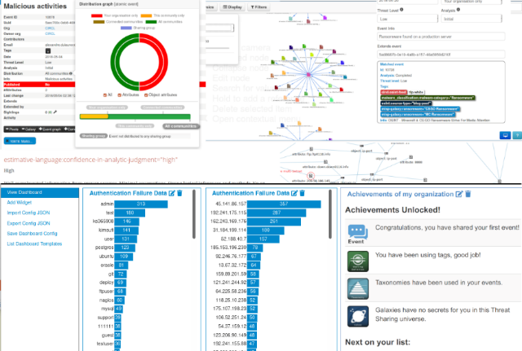

1.5 Project Scope

This project covers the design, implementation, and analysis of Neuro-Trap. Neuro-Trap, which is a Python-based, lightweight adaptive honeypot system that uses the configurable TCP honeypot port pipeline to catch the session of an attacker. Thus, store complete session and commands into structure SQLite database. This system adopts unsupervised machine learning, which is Isolation Forest, to conduct behavior analysis for each session and automatically extract candidate IOC. Thus, generate the YARA/Suricata rules framework. At the same time, provide a Flask-based human-machine interaction dashboard that allow analyst verify the information before exporting it, thereby outputting the result in JSON format, which is supported by MISP.

In addition, the system implements the behavior-driven decoy orchestration mechanism. When a high-risk session is detected, simulate socket decoy can be enabled dynamically to extend the attacker's activity time, thus collecting more telemetry data. The scope of this project is strictly limited to function deployment as aforementioned, local testing, and preliminary assessment, which does not include enterprise-level deployment, deep protocol analysis, or integration with the production environment MISP instance.

1.5.1 Tasks to be Executed

To methodically turn the theoretical idea into a validated prototype, this project employs an organized iteration deployment procedure that is broken down into seven main steps. In the meantime, ensure the entire procedure complies with ethical and academic standards.

The initial phases focus on explicit definition and systematic planning. At this stage, the project has been named Neuro-Trap, thereby ensuring the aims that are measurable align with deception defence and the threat intelligence direction. Simultaneously, clearly define the area of system functions to avoid unnecessary expansion. Next, conduct the formal ethics and analysis of security risk concurrently, identify the potential issues, and deliver to the institution for review. This project only implements in an environment that is isolated and controllable and ensure not have any interaction between the production network and any external entity.

On the basic of complete the project definitions and ethical risk assessment above, formulate the completed project plan and define the deliverables and quality assurance node for each phase. Given that this project belongs to research-oriented development and to ensure the flexibility required by this approach, the plan is not designed with mandatory milestones. Instead, it conducts reasonable adjustments to the technical roadmap based on the responses from the experiment.

Subsequently, a wide-ranging analysis for the research overview and differences was conducted to build the theoretical and empirical foundation of this project. These phases are mainly concerned with investigating the modern structure of honeypot, the approach of anomaly detection for unsupervised machine learning, IOC extraction techniques, and the MISP threat sharing framework. Meanwhile, analyse the current system to identify the weakness on automaton section. On this foundation, the architecture design phase defines six modular components. Thus, clearly divide the responsibility of each component, which uses the socket-based honeypot engine, SQLite persistence layer, machine learning operational service, IOC extraction, Flask dashboard and components that are exported from MISP.

The development of core modules employs an iterative method. First of all, implement the honeypot engine like simple_honeypot.py, this engine is bound to a configurable TCP port and persists the session data. Thereafter, build the machine learning analysis module, which is behavior_ml.py that is used for feature extraction and analysis of isolation forest, then build the IoC extraction subsystem that is used to generate the framework of YARA/Suricata rules. The decoy orchestration controller monitors the threshold set by machine learning and launches auxiliary services through subprocess calls. Flask control panel, which provides the interface for session review and approval for analytics. MISP pipeline, which is misp_mock.py transforms the verified information sequence into a JSON structure that meets the requirements of threat sharing mode.

Furthermore, data collection employs a simulated attack client to generate various threat behaviors and ensures the dataset for model training and analysis is representative. Testing includes unit testing, user acceptance testing, and the probability of capture session, the accuracy of machine learning classification, the bait, and the output generated by IoC lead to a longer staying time and quantitative measurement of such indicators. The documentation summarizes the investigation report, which includes the embedded evidence and the future automation suggestion.

1.5.2 Constraints of Development

Neuro-trap, which acts as a prototype system, is deliberately designed for a single-host research system. Hence, there exist some real limitations. All the components are operation on the same laptop, which limits the CPU, memory, and network resources and restricts the quantity of concurrent decoys and the number of sessions processed simultaneously. The prototype system is not designed for high-throughput enterprise environments. For easy porting, the system uses SQLite. Although SQLite is easy to deploy on a single host, but its write concurrency is limited. It might become a bottleneck under the situation of large-scale writes. Therefore, it required migration to client-server database management system to extend. This system uses CPython to implement. Therefore, unless it adopts multi-process or native extension, otherwise the Global Interpreter Lock will limit multi-threaded CPU-bound parallelism. Isolation Forest classifiers are designed to be lightweight, but the effect relies on data scale and feature diversity. These models require retraining regularly and incorporate labelled feedback to ensure accuracy. Thusly, for the sake of safety, decoys only operate under simulated mode, which does not execute any payload of the attacker. Furthermore, completed high-interaction decoy or real-time MISP integration is not in the research scope without the approval of the institution. These limitations are helpful for reproducibility and overall security for the result.

1.5.3 What to Do

Neuro-Trap listen to the incoming attacker traffic on the TCP port that can be configured for the honeypot and record all of the session activity log into structured SQLite data storage to conduct follow-up analysis. This system focus on deception threat intelligence generation, captures the attacker input, extract the candidate IoC, generated the framework of YARA/Suricata rules and transform the verified information into MISP-compliant JSON format to conduct controlled sharing. The original system implements lightweight and hierarchical explainable framework for machine learning, which used to ensure the priority of sessions. Thus, uses Flask control panel to shows sessions record, machine learning analysis and candidate IoC for analytic to verify. To ensure the security, the bait is simulate using simulation mode, the system provides metrics and log to conduct reproducible analysis.

1.5.4 What Not to Do

Neuro-Trap is not proactive defence or predict system. It does not block, isolated or using other method to resolve the attacker traffic. The original system does not follow the real-time traffic to retrain the machine learning model. The model update required explicit retrain training flow. It is not designed for generate scale, high-throughput deployment, unauthorized and unhardened, should not explore on untrusted public network. This system do not execute any of payload or real shell that given by attacker, which in the standard process, the researcher utilizes simulated MISP export files rather than directly connecting to active groups for threat intelligence exchange.

1.6 Overview of the IR
This IR shows the implementation, analysis, conclusion, investigation of Neuro-Trap final year project.
Chapter 1 — Introduction
This chapter elaborated on the project background and problem statement. 1.1 and 1.2 section was introduced about technological and operational motivations for adaptive deception and automated threat intelligence pipelines, thus point out the limitations. 1.3 to 1.5 was talking about the project aims, measurable aims, details project scope and limitation of implementation. 1.6 to 1.7 section was conducting about the structure of IR and introduce the project plan.

Chapter 2 — Literature Review
This chapter is about literature review and domain research. It conducts the domain research within computer networking, network security, network intrusion detection system, honeypot technology, cyber threat intelligence and machine learning in cybersecurity. Besides that, this section also conducts the tools and similar system that chosen with the detailed explanation and comparation.

Chapter 3 — Methodology
This chapter is talking about methodology and analysis. It describes the methodology that chosen and the data collection that collected via survey. Comparation table had been provided and detail explanation with the graphic is insert inside this section.

Chapter 4 — Conclusion and limitation
This chapter is about conclusion of this IR and the limitation of it. This section gives a summary about the overview of IR and analysis for the results. This chapter will also examine key challenges encountered during the project, such as limitations in system scope, testing environments, and dataset scale. We will validate these constraints, identify areas with potential for further research and development, and provide corresponding recommendations.

1.7 Project Plan
Start date: 02-Feb-2026
Current date: 09-Mar-2026
Chapter 1
Phase / Task | Start | End | Duration | Status (target) | Deliverable / Note
Project proposal and approval | 02-Feb-2026 | 03-Feb-2026 | 2 | Completed | Approved proposal / PP
Problem background | 04-Feb-2026 | 05-Feb-2026 | 2 | Completed | Background and problem statement
Project Aim | 05-Feb-2026 | 05-Feb-2026 | 2 | Completed | Clear projects aim statemen
Objective & Scope | 06-Feb-2026 | 06-Feb-2026 | 2 | Completed | Objectives, scope and constraints
Overview of IR | 06-Feb-2026 | 06-Feb-2026 | 2 | Completed | IR structure summary

Chapter 2
Phase / Task | Start | End | Duration | Status (target) | Deliverable / Note
Domain Research | 07-Feb-2026 | 16-Feb-2026 | 10 | Completed | Networking, NIDS, honeypot, CTI literature
Similar System | 12-Feb-2026 | 20-Feb-2026 | 9 | Completed | Conpot, Cowrie, Glastopf comparative analysis
Technical research | 17-Feb-2026 | 24-Feb-2026 | 8 | Completed | Tools, libraries, OS, versions, rationale

Chapter 3
Phase / Task | Start | End | Duration | Status (target) | Deliverable / Note
Methodology comparation | 25-Feb-2026 | 27-Feb-2026 | 3 | Completed | Scrum, DevOps, RAD comparison table
Methodology chosen | 28-Feb-2026 | 01-Mar-2026 | 2 | Completed | Chosen approach + justification
Data Gathering Design | 01-Mar-2026 | 07-Mar-2026 | 7 | Completed | Survey instrument, sampling, ethics & collection plan

Chapter 4
Phase / Task | Start | End | Duration | Status (target) | Deliverable / Note
Conclusion | 08-Mar-2026 | 09-Mar-2026 | 2 | Completed | Synthesis of findings
Limitation | 09-Mar-2026 | 09-Mar-2026 | 1 | Completed | Key limitations and recommendations

CHAPTER 2: LITERATURE REVIEW

2.1 Domain Research
This section provides an overview of domain research that the project was rely on, which use to build the concept and the background basic of Neuro-Trap system. First, it initiates from computer networking, network security, which define the threat environment. Moreover, it investigates the technique of network intrusion detection systems (NIDS), which explore the approach of deception-based detection. Lastly, it examines network threat and machine learning inside network security and explain how to transform the Raw honeypot telemetry data into actionable information. Each of the nodes are introduced from the concept. Thus, point out the limitation of Neuro-Trap design.

2.1.1 Computer Networking
The computer networking is a system that connected to each other by computing devices. This system conduct communication via exchanging data through shared protocols and implement layered structured. According to the Computer Network that published by Gudhka (2024), the author define network as a basic infrastructure, it allowed device sharing information and resources in the structure of Local Area Network (LAN) and Wide Area Network (WAN). Notably, Transmission Control Protocol (TCP) and Internet Protocol (IP) is the basic of the modern internet standard. For Network-Based Threat Detection (NBTD), the transport layer and application layer of this protocol stack is important. The transport layer governs the utilization of the TCP and UDP protocols to data flow for conduct segmentation and reassembly, while application layer is transmission of service-specific content, including HTTP, SSH, FTP and DNS. These protocols build the GUI that targeted mainly by attacker. The research that published by U, H. D. (2024) point out that understanding the structures of network traffic is the prerequisite for any attempt to simulate between the normal communication mode and abnormal communication mode.

Network traffic shows comprehensive measurable characteristic in transport layer and application layer. Theses characteristic is the main input of intrusion detection and abnormal analysis system. The key characteristic includes TCP control flags such as SYN, ACK, FIN and RST, packet length distribution (PLD), inter-arrival time (IAT), connection duration, source port number, destination port number and bytes transferred per flow. According to the research that published by Manocchio, L. D., Layeghy, S., Lo, W. W., Kulatilleke, G. K., Sarhan, M., & Portmann, M. (2024) on Expert Systems with Applications, which related to transformer-based flow Analysis proof that flow-level features manage to provide enough information to conduct high accuracy traffic classification. Meanwhile, ensure the feasibility on devices to implement real-time processing. Neuro-Trap are using this flow-based representation format to capture and storing the session log of honeypot to conduct the anomaly score.

All designed that network-based detection system (NIDS) are direct constrained by the size and the characteristic of the network traffic monitoring. The characteristic that chosen, the strategic of implementation and available computational resources are required to conduct calibration based on the network environment. According to the research that published by Chen, Q., Li, D., & Wang, L. (2024) on Journal of Industrial Engineering and Applied Science, which related to enhance the network security investigation point out that high-throughput environment required lightweight detection mechanism that line-rate operation, while low-throughput environment provides flexibility that deep analysis to each captured sessions. Due to the reason that Neuro-Trap is operate on specific honeypot subnet, which the design intent of this subnet is to receive the traffic that attacker launch. Hence, all captured session manage to conduct a completed characteristic extraction and machine learning-based scoring and avoid compromising between performance and precision.

2.1.2 Network Security
Network security refers to the policies, procedures, and tools employed to protect the confidentiality, integrity, and availability (CIA) of network infrastructure and the data it contains. Traditional defences boundary centres on few mature control category constructions. The firewall checks the traffic of ingress and egress through rules, these rules define the combination of source, destination and port that allowed. Furthermore, network address translation (NAT) obscures internal host addresses. VPN are secure when transport untrusted traffic. Signature-based intrusion detection and prevention system (IDPS)conduct a corporatization with known attack pattern repository via observation. Manda, J. K. (2025) published research on SSRN Electronic Journal, which related to investigation of next-generation firewall (NGFW) technology in telecommunications, and describe these layered perimeter model as core defence method for enterprise networks.

Although traditional security controls play a critical role, but its structures limit their effectiveness against attacker nowadays. Signature-based detection required understanding and cataloguing attack mode to conduct an identify, which is a blind sport for novel or zero-day vulnerabilities. Moreover, firewall ruleset needs manual maintenance, which will bring the risk of management latency and configuration error. Furthermore, the widely adopted transport layer encryption significantly reduces the visibility for content of application layer to conduct deep packet inspection (DPI), because it cannot check the TLS-encrypted traffic without ending the sessions. Besides that, Chen, Q., Li, D., & Wang, L. (2024) point out that network that increasingly sophisticated such as cloud infrastructure, containerized workloads and software define internet, which increase the quantity that attack vectors that needs to face by static rule-based control measures and maximum the onus of analytic. The most important is according to the research that published by ENISA. (2023, October 19), point out that the threat evolutionary speed nowadays is much faster than the speed of signature database update, including the ransomware software, distributed denial of service (DDoS) and supply chain attack. Thereby, attacker implement more artificial intelligence technique to avoid detection. This limitation jointly drives people to implement abnormal-based detection and deception mechanisms as augment methods to identify the threat of perimeter control oversights.

The transition from safety methodology of perimeter-centric defense to defense-in-depth, reflect that people nowadays notice that there is none of the defence layer which is totally effective. Attacker that technical sophistication will end up breach the traditional defence architecture. According to the research that published by Atefinia, R., & Ahmadi, M. (2020) on The Journal of Supercomputing, which is the investigation of intrusion detection system (IDS) for deep neural network-based point out that the signature-based control measures is not enough to face a new type of variant attacks. This enhances people involved large amount of investigation funding to uses as abnormal detection and machine learning. This technique uses statistical modelling to simulate predict the network behavior and label the deviation rather than matching the pre-existing mode. Thus, the technique of honeypot taking a fresh approach. Honeypots are not trying to detect the attack that aims for production system. Thereby, it is inversion these issues by creating an environment. Within this environment, any observation activities are inevitably driven by adversarial intent, which increase the high reliability of attack data. Meanwhile, avoid the false positive problem that occur when conduct abnormal detection in real-time traffic.

2.1.3 Network Intrusion Detection Systems (NIDS)
Network Intrusion Detection System (NIDS) monitoring network traffic and conduct an alert when detect any activistic that match standard predefined threat. Two core detection styles are signature-based detection and anomaly-based detection. The signature-based system maintains the known attack known signature repository and compare between traffic observe and these signature to identify known threat. The research that published by Otoum, Y., & Nayak, A. (2021) on Journal of Network and Systems Management point out that signature-based detection is very reliable to known threat but cannot identify the zero-day attack and novel attacks without signature. Anomaly-based detection is achieved by establishing statistical baselines of typical behavior. Thus, seen deviation tagging as potential malicious behavior to bridge the gap.

This two-paradigm trade-off already been fully demonstrated, and its id direct related to Neuro-Trap design. The false positive rate of signature-based system to known attack is lower but needs to continuously maintain the signature-based dataset and cannot detect the new variants. Anomaly-based system manages to detect any deviation from the baseline in principle, but the effectiveness depends on representative of normal models. Thus, false positive rate easy to increase during the traffic mode occur fluctuation or contaminated training data. According to the research that published by Sowmya, T., & Mary Anita, E. A. (2023) which related to artificial intelligent intrusion detection point out that class imbalance, even though normal traffic is far more than attack traffic and it is the man changes for trending anomaly detection model. Furthermore, it lacks reliable label training dataset to speed up these issues because the cost to generate real attack labels is high and these labels will obsolete soon.

The standard analysis metrics of Network Intrusion Detection System (NIDS) including the accuracy, false negative, F1-score, false positive rate and the latency of operate. Manocchio, L. D., Layeghy, S., Lo, W. W., Kulatilleke, G. K., Sarhan, M., & Portmann, M. (2024). point out that within the most secure development, high false-negative rate is the core of the operational objectives. Vulnerability attack is usually posing a greater threat than false positive investigation, but false positive rate that significant high will bring prohibitive burden to analytic, and lead to alert fatigue and low-quality responses. These two limitations of paradigm facilitate Neuro-Trap implement component approach. Honeypots provide a controllable bait environment, which can generate high confidence and non-label attack telemetry data. While supervised machine learning can conduct the abnormal severity level rating to captured without the needs of label training dataset.

2.1.4 Honeypot Technology
Honeypot is a meticulously configured bait system, which implement within network environment. The sole objective is to attract, observation and record unauthorized behaviour. Besides that, honeypot is fundamentally an observation tools which different from traditional secure control architecture that tried to block the attack. It does not equip with any legal operational features, which means any interaction that targeted on it is suspicious and having adversarial intent. According to the research that published by Moric, Z., Dakic, V., & Regvart, D. (2025), which related network security investigation by utilization of honeypot and deception strategy and describe honeypot as a vulnerability system that designed on purpose. This is to let attacker stay away from real basic infrastructure, and collect more tools, technical and flow that utilize by attacker, thereby giving alerts to those attack activity that still haven't shows on generated log. The key different with traditional detection is honeypot do not simulate normal traffic and label abnormal. It perceives non legal traffic as operational status to ensure all of the sessions captured.

Honeypot are conducting the classification by follow its interaction level. The level of interaction reflects how the simulated world responds to enemy stimuli. Low interact honeypot simulate limited network service, which usually is open port and simple lateral response and not provide any real features of operational system. These systems are easy to development, low risk of isolation and manage to capture automation scanning traffic efficiency. Nevertheless, there is a limit to the depth of aggressive conduct that can be evoked. Medium-interaction honeypot provides more realistic service simulation, which includes scripted response of wider attacker command without explore the real system to attacker. Early post-exploitation activities and post-authentication command sequences can be captured within this level. High interact honeypot provides application stack and well features operating system, to maximize the realistic of environment and attacker behavior depth that observed, while the trade-off is the complexity of isolation and the risk of operation increase. According to the research that published by Heluany, J. B. (2024) on Electronics point out that by utilizing highly interactive honeypots, industrial control systems (ICS) can record attacker activities with a precision unattainable by low-interaction solutions, including completed attack chain and lateral movement.

Honeypot can conduct a classification based on the static or dynamic attributes of attack surface except interaction level. The static honeypot is static configuration and provides consistent service, responses and status of system for each session. In contrast, dynamic honeypot can adjust the explore of service, the content of responses or the system environment based on the real-time attacker behavior which significant enhance the ability of anti-fingerprinting. Scholten (2021) point out that, constant responses time, static banner and lack of authentic file artifacts is the core characteristic of identify as static honeypot, which usually causes attacker give up on attack before generate telemetry data that efficiency. While the research of Abewa and Zemene (2024) proof that adaptive design could prolong the dwell time of attacker to gain more diverse session log.

Any of the honeypot development will involves core trade-off between telemetry richness, isolation risk, identifiability and maintain of overhead. Typically, the higher of interaction level, the more diversity of captured data, but the risk of honeypot been compromise and threat the real basic infrastructure is increase. Hence, Moric et al. (2025) emphasized that the high or middle interaction development must feature strict isolation control, such as network packet filtering and automated session termination. The detectability of honeypots is inversely proportional to their interaction accuracy and response dynamics. The more realistic and adaptive of the response, the harder to threat as a bait. Bahaa Yamany, Mahmoud Said Elsayed, Jurcut, Nashwa Abdelbaki, and Azer (2024) had proven in the investigation of ransomware classification, which only provides the trustable continues responses, then can observe more high value information of multi stages attack. However, as the level of interaction and the ability of adaptive automation increase, the cost for maintenance also increase, because complicated emulation logic required continuous verify to ensure the bait having convincing.

Within the threat information architecture, honeypot as the core data collection layer, will capture the raw sessions data and record into structured repository for extraction of IoC and anomaly scoring. The logic flow that conducted by Var Naseri (2025) is match with this situation, which obtain the attribute dataset through maintain engagement of attacker, and IoCs are extracted by downstream components. Neuro-trap implement the architecture which utilize python socket programming, honeypot sessions captured and stored into SQLite, then conduct a severity score via Isolation Forest. Lastly, verify by analytic and exported to MISP platform.

Interaction Level | Key Characteristics | Best Use Case
Low-Interaction | Simulates limited open ports and banner responses only; no real OS exposed; minimal containment risk; easy to deploy | Broad internet-facing scanning capture, automated credential stuffing, and malware payload collection at scale
Medium-Interaction | Scripted service simulation with wider command coverage; attacker cannot control real OS; moderate containment risk | Post-authentication command capture, tool download observation, and early post-exploitation reconnaissance
High-Interaction | Fully functional OS and application stack; maximum realism; highest telemetry depth; greatest containment complexity | Full exploit chain and lateral movement capture; APT research in isolated, tightly controlled environments
Static | Fixed configuration and responses across all sessions; low deployment overhead; susceptible to adversary fingerprinting | Initial threat awareness and scanning detection against low-sophistication, automated attack traffic
Dynamic | Session-adaptive responses; resists fingerprinting; longer attacker dwell time; higher implementation complexity | Intelligence collection against skilled adversaries; multi-stage attack campaign observation
Table : Honeypot Interaction Levels and Best Use Cases Source: Compiled from Moric et al. (2025); Heluany (2024); Scholten (2021); Abewa & Zemene (2024); Var Naseri (2025).

2.1.5 Cyber Threat Intelligence (CTI)
Cyber Threat Intelligence (CTI) is a structured domain. It collects, process, analysis and dissemination actionable information about the current and latest network threat to support the defensive decision-making. According to the research that published by Santos, Abreu, Reis, Serodio, and Branco (2025), which define CTI as an implementation. It maps the contextual analysis between technical indicators of compromise (IoCs), tactics, techniques, and procedures (TTPs). Sakellariou, Fouliras, Mavridis, and Sarigiannidis (2022) point out that the core aims for CTI, which transform raw threat data into structured contextual analysis information, and can straight away used on defence mitigation.

The basic concept of Operational Cyber Threat Intelligence (CTI) is indicators of compromise (IoC), which is a type of specific footprint that observability. It can serve as evidence for malicious activities. Common IoC types includes malicious source IP address that uses for command and control the domain of basic infrastructure, known file hash of malicious software samples, YARA Guidelines for identifying malevolent file family organizations and so on. Delvecchio, Galantucci, Iannacone, and Pirlo (2025) had published research on International Journal of Information Security that shows IoCs' operational value varies considerably. Most of the time-sensitive indicators like active command and controlled IP address having a short-term lifetime, because attacker will keep changing the basic infrastructure. While high level behavioral indicators such as TTP fingerprints, YARA rules and cyber kill chain can maintain the longer lifetime. Thus, attacker harder to avoid these indicators via changing of basic infrastructure. Hence, IoC management that effectively not only required for extraction of IoC but still needs to conduct the priority sequences to ensure which indicators are more valuable.
Cyber Threat Intelligence (CTI) are adhered to a structured lifecycle, the lifecycle decided how the raw data transform into strategic value. Sakellariou et al. (2022) define it as four key phases. First, collection which collect the data from honeypot or IDS. Second, enrichment and analysis, which aims to conduct contextual processing and reliable analysis. Third, dissemination phases, which responsible for exchange of verified intelligence in organized formats. Lastly, feedback, which uses to analysis efficiency of operation and optimization future collection priories. Since the level of quality for CTI overall is depends on execution rate for each of the phases. Hence, any deficiency on any phases will be passed to other phases which reduce the operational value of final information.

Furthermore, standard dataset format already become inevitably requirement to implement the cross-organizational collaboration. To facilitate this, STIX define machine-readable lexicon like IoC and attack mode. Whereas TAXII protocol standardized the method by which this intelligence is transmitted over networks. In light of this, MISP as the open-source CTI system, which not just implement standardized storage architecture for threat intelligence but also provide highly efficient automated correlation capability. Lastly, the applicability of threat intelligence directly depends on key factors such as indicator types, credibility, and sharing scope.

Cross-organizational CTI collaborative defense inevitably needs standards data format. Since STIX define machine-readable lexicon such as Ioc and attack patterns, while YAXII protocol specifications transport mechanism. The integration of STIX and TAXII is needed to ensure the interoperability of the information. As the main tools, MISP implement structured data repository and automated correlation. Thus, fully compliant with these standards. Consequently, the real operational potential of the information is directly dictated by indicator classification, loyalty score, adoption threshold, etc.

Within the CTI lifecycle, ensure the level of human oversight is the core of this structured designed. Although fully automated pipeline can mitigate the bottleneck and increase the execution efficiency, but due to lack of vetting, it is inevitably lead to propagation of false positives to reduce the signal to noise rate of information. However, HITL framework ensure the quality of information through leveraging human judgment to optimize context and embedding verification checks, errors can be filtered out. To facilitate the stability between efficiency and reliability, Alevizos and Dekker (2024) and Santos et al. (2025) point out that artificial intelligence should focus on automation classification to reduce the amount of work, meanwhile keeps the autonomous decision-making authority to human.

2.1.6 Machine Learning in Cybersecurity
The cybersecurity field has recognized machine learning as a core enabling technology due to the rise of insufficient hand-written rules and signature systems to combat quickly developed techniques of attacks and the sheer scale of traffic that the contemporary network infrastructure generates. In their supervised and unsupervised intrusion detection model comparative study, Asswadati Sirisha, Chaitanya, Krishna, and Satya Sandeep Kanumalli (2021) propose three main paradigms of the ML and their applicability to security mechanisms. Supervised learning trains a model based on labelled examples of known classes and uses the resulting classifier to new inputs; it is best applied in problems where labelled training data is known, but where the categories used to classify an attack are also known ahead of time, but is inherently limited by the quality and currency of those labels. Unsupervised learning finds structure in unlabelled data without any prior definition of classes, which makes it useful in such environments as there is no available labelled data of attacks and one is interested in finding out novel, hitherto-unseen behaviour, rather than merely classifying previously known attack patterns. Reinforcement learning condition so that an agent decides to take actions within an environment so as to increase a cumulative reward signal, and has been studied in adaptive security behavioural tasks like dynamic honeypot control and automated response.
Supervised learning methods have been shown to perform highly on the standard intrusion detection data sets. According to Sowmya and Mary Anita (2023), algorithms (like Random Forest, Support Vector Machines and deep learning models like recurrent and convolutional neural networks) have been demonstrated to have very high classification accuracy on labelled NIDS benchmarks. Manocchio et al. (2024) show that the transformer-based models on flow-level features realized state-of-the-art detection results on the latest attack datasets. A limitation of supervised methods is, though, reliance upon labelled data, lack of ability to deal with class imbalance, and inability to generalize to different variants of attacks that are outside the training distribution an important factor in operation, because of the speed at which attack techniques change as depicted in Section 2.1.2. Adaptive security (dynamic honeypot control) has been studied using reinforcement learning. In a survey of published RL algorithms reviewed in Expert Systems with Applications, Kumar Shakya, Pillai, and Chakrabarty (2023) present the history of advancement as it gets developed as Q-learning, then policy gradient methods, but Whittlestone, Arulkumaran, and Crosby (2021) note that RL agents may promote reward hacking and poor generalisation in new settings, curtailing the cursory use in the current security systems.
The unsupervised learning approach is especially relevant to learn the honeypot pitting detection technique since it makes no use of labelled training examples: the model is able to learn the statistical structure of training sessions, and ones that are most anomalous in the detected manner are the ones that display the attack behaviour characteristic of unusual (or high severity) honeypots. In their systematic literature review of existing studies on intrusion detection algorithms published in the Journal of Intelligent Systems, Issa, Aljanabi, and Muhialdeen (2024) highlight the three best-known unsupervised algorithms in the field of network security research, namely, Isolation Forest, One-Class Support Vector Machine (OC-SVM), and Local Outlier Factor (LOF). Isolation Forest constructs random decision trees which inductively subdivide the feature space, taking advantage of the fact that anomalous samples will be partitioned fewer times than normal samples. OC-SVM is a technique to learn a boundary in a high dimensional space using a kernel space that encompasses most of the training samples and revealing test samples outside this boundary as anomalous samples. LOF calculates local density based on the neighbours of each sample, where samples in considerably less-dense regions receive high scores of anomaly compared to their nearest neighbours. In a research on the unsupervised learning frameworks with regard to the cyber threat identification, Okafor and Lee (2026) confirm that such algorithms are complementary categories of algorithms whose performance characteristics vary within the scope of their dimensions, rate of contamination and cluster formations. In the section 2.2.1, the detailed empirically organized comparison of all three algorithms containing the determination of detection accuracy, the running time, contamination sensitivity, and justification behind the algorithm choice of the Neuro-Trap are outlined.
The real-life application of ML in the field of cybersecurity presents challenges other than algorithm performance in theory. The quality of training data has been a constant issue with unsupervised methods: the unavailability of labels, the existence of an unequal distribution of classes and the possibility that the training set is composed of unidentified attacks that distort the normal baseline all influence the reliability of the models. Selection and transformation of raw network measurements into algorithm inputs is another factor that determines performance; insecure features cover up signs of anomaly or add irrelevant variance that worsens generalisation. The operational importance of explainability is also justified by the fact that black-box anomaly detectors are nowadays invariably supported with interpretable output mechanisms (i.e., an anomaly score distribution and feature contribution explanations), so that the human analyst review step can be incorporated in HITL intelligence pipelines (Uddin, Aryal, Bouadjenek, Al-Hawawreh, and Talukder, 2024). There is also a trade-off between inference latency and compute limits; in a paper about the design of ML-based anomaly detection pipelines, Moradinia, Vandierendonck, and Murphy (2025) point to this issue as a key problem with systems acting on continuous data streams. These practical features, including: contaminability, feature engineering, explainability, and latency, are directly relevant to choice of algorithm and pipeline design considered in finer detail in Section 2.2.1.

2.1.7 SDG Alignment
Neuro-Trap is in line with the United Nations Sustainable Development Goal 9 Industry, Innovation and Infrastructure that entails resilient infrastructure projects, inclusive industrialisation and innovation. The use of cyber infrastructure has been a crucial part of manufacturing and governmental services delivery in all of its sectors and security is a requirement of sustainable functioning of fundamental services including medical, financial, communications and energy provision. According to the ENISA Threat Landscape (2023) (discussed in Section 2.1.2), voluminous cyber attacks on critical infrastructure have high economic and social burdens that impact populations on a large scale: ransomware against hospitals and energy providers and denial-of-service attacks against public communications are threats to the resilience of infrastructure of the existence level. Through the creation of a prototype to extract threat intelligence in honeynet telemetry, achieve a better fit and share structured IoCs in the MISP platform, Neuro-Trap has a direct impact on enhancing cyber infrastructure resilience with more efficient and evidence-based detection and sharing of IoCs.
The positive effect of enhanced cybersecurity on the society goes beyond an individual organisation. By existing as threat intelligence sharing communities aided by systems like MISP, a collective defence system is formed where IoCs identified by one organisation are immediately shared to protect others that are under attack by the same threat actor. The service that Neuro-Trap provides to this ecosystem, which consists of lightweight, deployable honeypot-to-intelligence pipeline service that can be operated by virtually no dedicated security staff, facilitates the democratisation of proactive cyber defence. This is in direct congruency to SDG 9 aim of ensuring resilient infrastructure is available at organisational levels, not only to well-formidable enterprises with established security practices, but also to smaller organisations, which at the current times, do not have the competence to facilitate advanced threat detection and intelligence development.
The domain review has created the conceptual underpinning and inspiring force behind the deception-and-anomaly intelligence pipeline of Neuro-Trap. These form their basis and are further developed in the following sections in an attempt to compare them closely: Section 2.2 will provide more specific comparative analysis of the algorithms and architectures of isolation Forest vs OC-SVM vs LOF (Section 2.2.1), static vs dynamic honeypots (Section 2.2.2), and human-in-the-loop vs fully automatic CTI pipelines (Section 2.2.3); empirical evidence and rational design decisions. Section 2.3 subsequently undertakes system-level comparisons of concrete existing tools such as Cowrie, Dionaeas, MISP, and OpenCTIs with the gap analysis establishing where the integrated design of Neuro-Trap offsets the shortcomings in the current implementations.

2.2 Machine Learning Paradigms in Intrusion Detection

2.2.1 Overview of Machine Learning Paradigms in Intrusion Detection
Intrusion detection has greatly developed within the last decade and shifted its focus towards more liberal, data-based solutions rather than the rule-based approaches of the past that only allowed detection of so-called new threats. The proximal method of analysis in this revolution has taken the form of machine learning (ML), which provides the capacity to create intricate tendencies in network traffic and session behaviour without being entirely reliant on ready-made attack signatures. Generally, three basic paradigms of ML can be identified: supervised learning, the unsupervised learning, and the reinforcement learning. The various paradigms have different assumptions, operational needs and appropriate profiles of deployment in diverse deployment situations.
In an extensive review of intrusion detection systems based on artificial intelligence published in the science Direct, Sowmya and Mary Anita (2023) report on how contemporary threat actors, most operating in ransomware or distributed denial-of-service (DDoS) programs, have already started using techniques of adversarial AI to circumvent traditional threat detection systems. The authors claim the reason behind this escalation is that it requires detection systems that can extrapolate on historical attack signatures, which in this regard unsupervised and anomaly-based methods are at a position to offer. In support of this, the European Union Agency for Cybersecurity (ENISA)-report Threat Landscape 2023 indicates that the rate of threat evolution is increasing and consolidates on the more sophisticated attack vectors directed at enterprise and Internet of Thing infrastructure, which supports the claim that the current threat landscape cannot be effectively attacked using the existing inertia detection approaches.
The chapter also begins by presenting all the three ML paradigms but most of the elaboration on the paradigm is given to the unsupervised learning paradigm which is more applicable to the Neuro-Trap project. Under the unsupervised domain, three algorithms are considered individually: Isolation Forest, One-Class Support Vector machine (One-Class SVM), and Local Outlier Factor (LOF) which are followed by a critical comparison of them and the reason why the system chose Isolation Forest as the main engine of anomaly detection is provided.

2.2.2 Supervised Learning
Supervised learning algorithms are trained on full label sets whose observations are also defined with a class label which is normal or attack traffic. Common algorithms used in this paradigm are the Random Forests, Decision Trees, k-Nearest Neighbours and the Support Vector Machines (SVM) with multi-class kernel. Controlled models have shown good classification results on popular benchmark datasets including NSL-KDD and CICIDS. A comparative assessment of supervised and unsupervised models by Aswidati Sirisha et al. (2021) discovered that the precision and the recall of supervised models were always higher on labeled datasets, and Random Forest is especially resistant due to ensemble nature and overfitting resistance.
The fundamental Wife-in-the-Limit drawback of supervised methods is that they need a detailed and global labelled dataset to be trained on. This requirement cannot be met easily in either the honeypot case or the real-world deployment practice since new attack behaviours might have no historical training data to account for. A system that has only been trained on known signatures of by itself will not generalise to zero-day exploits or new strategies of attackers. This shortcoming encourages the use of alternative paradigms that are not based on labelled data.

2.2.3 Reinforcement Learning
Reinforcement learning (RL) is a quite different paradigm to both supervised and unsupervised learning. Instead of training on a fixed set of data, an autonomous agent operates within an environment, making decisions and getting feedback as either positive or negative numbers. The objective of the agent is to find a policy - a mapping between states observed to actions - that maximises cumulative reward over time. In a generally extensive overview of the reinforcement learning algorithms published in Expert Systems with Applications, Kumar Shakya and colleagues (2023) describe this process of trial-and-error as the key element of the RL paradigm, without referring to ground-truth labels of density estimation on fixed training data. The survey records the development of RL, starting with classical tabular algorithms like Q-learning, up to modern policy gradient and actor-critic models, and indicates the wide range of the algorithmic diversity that the RL family has produced.
The deep reinforcement learning (DRL) algorithmic variant based on the combination of deep neural networks with reinforcement learning has dramatically increased the practical usefulness of the paradigm. Writing in Neural Networks, Matsuo et al. (2022) discuss the convergence of deep learning, reinforcement learning, world models architecture with the authors stating that DRL has facilitated the use of agents in high-dimensional state space previously inaccessible to classical RL schemes. Examples given include AlphaGo, locomotion robots and automated vehicle control, which are recognized to be high-profile displays of the ability of DRL to excel in complex series of choices where the limits of human abilities are surpassed.
Regardless of these technical developments, the reinforcement learning has important practical and social limitations on its use in the active field. In a paper on the social consequences of deep reinforcement learning, which is published in the Journal of Artificial Intelligence Research, Whittlestone et al. note that RL systems are capable of reward hacking - that is, maximizing the specified reward signal in ways that are unintended by the system's developers - and make poor generalisation when applied to novel and different environments (2021). Such modes of failure are especially important in safety-sensitive applications (e.g. intrusion detection) where a biased decision may lead to a false alarm or unsuitable action. Moreover, Liu (2023) discusses the wider questions of the alignment of the goals of the RL agent with the values of humanity, stating that reinforcement learning systems that are being trained on the human feedback may absorb biases, or the habits of undesirable behaviour, that are challenging to observe and correct once they start running in the field. All these factors place reinforcement learning as a highly effective yet operationally intricated paradigm that is not often utilized in the deployed intrusion detection systems in comparison with the supervised and unsupervised paradigms that provide a more predictable and explainable behaviour in production systems.

2.2.4 Unsupervised Learning
Unsupervised learning algorithms do not make use of labelled examples, but instead attempt to detect the statistical anomalies to the learned distribution of normally distributed data. The given paradigm is best applicable to the problem of anomaly detection when the ground truth of a single observation is not known or is not available. The unsupervised anomaly detection approach proves to be viable and operational in the context of honeypot systems, where the sessions are taped by the live attackers and the ground-truth labels are not produced automatically. A systematic literature review of intrusion detection systems published in the Journal of Intelligent Systems by Melad Mohammed Issa et al. (2024) has confirmed that unsupervised learning is becoming the paradigm of choice in research on anomaly-based IDS more so when working with datasets in which there is a lack of labels and a large intra-class variance. Three well-known algorithms of the unsupervised classification category are discussed in the sections below: Isolation Forest, One-Class SVM, and LOF.

2.2.5 Isolation Forest

2.2.6 Algorithm Structure and Theoretical Foundations
Liu et al. (2008) proposed an ensemble-based anomaly detector called Isolation Forest (IF) which takes advantage of this important property of anomalous observations: they are often few in number and they are structurally distinct to most of the data, hence are easier to isolate by chance partitioning. In the algorithm, a collection of isolation trees (iTrees) is constructed and each tree recursively divides up the feature space through randomly chosen split features and split values. The number of steps necessary to isolate a particular data point, we call that the path length, is used to compute the score of anomalies: anomalous points are easy to isolate and consequently have shorter path lengths on average across the ensemble.
This design gives the building a number of structural benefits. First, the algorithm has a computationally efficient time complexity of approximately O(n log n) which means that it can run even with moderately sized datasets. Second, it is not dependent on the underlying distribution of data, and thus it is resistant to heterogeneous features spaces. Third, the output of the anomaly score is continuous which could be thresholded to give risk labeling- NORMAL, SUSPICIOUS, or HIGHLY-SUSPICIOUS - that are easily used in human-in-the-loop triage processes.

2.2.7 Performance in Network Intrusion Detection Contexts
Fuhnwi, Adedoyin and Agbaje (2023) used real network traffic datasets in their empirical analysis of Isolation Forest and one-class SVM to perform intrusion detection of Internet Protocol network traffic. They are able to show that Isolation Forest can give competitive detection rates with significantly lower computational overhead than One-Class SVM, especially at larger sizes. The authors note that the efficiency advantage of IF is due to its tree-based partitioning mechanism which does not need to construct a decision boundary made of kernels.
Zahoor et al. (2025) also tested IF and One-Class SVM on the field of IoT security and concluded that Isolation Forest offers powerful anomaly detection and has less sensitivity to hyperparameter optimization. In their paper published in Scientific Reports of the research, they concluded that IF was stable in detecting performance at different contamination rates - the main hyperparameter that rules the fraction of aberration that is considered likely to exist in the training data - why One-Class SVM was more sensitive to the individual selection of the kernel function and the regularisation parameter. This less sensitivity to the hyperparameters is especially valuable in real-world applications where ground truth of parameter optimization is not easily accessible.
In a research article on unsupervised learning models on cyber threat detection that was published in Applied Sciences Okafor and Lee (2026) further confirm the Isolation Forest in the area of anomaly detection and prioritised alert models. Their model shows that IF-generated via anomaly scores can be practically configured as a ranking system of the analyst reviewing queues to ease the cognitive load on the staff of the security operations centre and do not need to be labelled by supervision on the session data.

2.2.8 Limitations of Isolation Forest
Although it has some positive aspects, Isolation Forest does not lack any limitations. The algorithm mostly is effective at identifying anomalies that are global observations statistically different to the overall data distribution - and will be inefficient in those cases that can be described by local cluster outliers, where anomalous behaviour can only be considered atypical by local neighbourhood, not by the global dataset. Moreover, the anomaly parameter scores of IF have to be carefully thresholded and domain information to convert them into operational classification labels; the contamination parameter has to be a priori without any actual analysis of the actual rate of anomaly. Issa et al. (2024) recognize this threshold sensitivity in a systematic review, that IF can be less successful on structured network datasets with different feature engineering decisions and different training data representative of the dataset of interest.

2.2.9 One-Class Support Vector Machine (One-Class SVM)

2.2.10 Algorithm Structure and Theoretical Foundations
Anomaly dying understanding One-Class Support Vehicle Machine (One-Class SVM) This is a kernel-based anomaly detection procedure created by Scholkopf et al. (2001) to learn the decision boundary containing the area of feature space that will hold the standard training data. The algorithm projects the training observations into high-dimensional space whose space was a kernel map and determines a hyperplane separating the data and the origin, subsequently deriving a small region of normality. Any new observation that is outside this threshold is considered as an anomaly. The selection of kernel functions a radial basis function (RBF), a polynomial or linear one establishes the shape and the adaptability of the decision boundary.
In the journal Electronics, Wang et al. (2023) suggested a hybrid framework of One-Class SVM and a Gaussian Mixture Model (GMM), proving that the hybrid design focuses on the benefits of both kernel-based learning of boundaries and probabilistic density modelling. Their findings prove the saying that we can make One-Class SVM to be highly detection-performing when tuned to the right statements.

2.2.11 Limitations and Practical Constraints
The principal limitation of One-Class SVM in the context of network intrusion detection is its computational complexity. The training complexity of kernel SVM scales approximately quadratically to cubically with the number of training samples O(n²) to O(n³), rendering it computationally prohibitive for large-scale or real-time streaming datasets. This scalability demerit is explicitly captured in the comparative study by Fuhnwi et al. (2023) who state that the One-Class SVM training time would grow significantly in comparison to the Isolation Forest (when scaling in terms of dataset size) and this would restrict its practical implementation to an environment where new data are constantly generated.
Also, it has been observed that, One-Class SVM is sensitive to the selection of kernel function and other related hyperparameters, specifically the width parameter gamma in RBF kernel and regularisation parameter nu. As Zahoor et al. (2025) note, One-Class SVM may easily produce high false positive rates in the absence of systematic hyperparameter optimisation, which implies cross-validation, and hence, labelled validation data, and flag legitimate sessions as anomalous. Such sensitivity makes it less appealing to be used in situations where ground-truth labels are not available.

2.2.12 Local Outlier Factor (LOF)

2.2.13 Algorithm Structure and Theoretical Foundations
The Local Outlier Factor (LOF) algorithm (Breunig et al. 2000) is a density-based anomaly detector, which calculates a local outlier magnitude of the observation by comparing its local density with the local densities of its nearest k neighbours. A local density of an observation is significantly lower than the local data density of its neighbours, thus making it get a high LOF score meaning that it is an outlier in its local data neighbourhood. This local density comparison enables LOF to diagnose anomalies that lose focus in the global data distribution and therefore theoretically well adapted to data with non-uniform density structures.
In a study published in Scientific Reports in investigating unknown attack detection during intrusion detection systems, Uddin et al. (2024) use LOF as a reference density-based algorithm and mentions its application in identifying localised anomalous clusters that global methods can overlook. On the same note, Issa et al. (2024) also mention LOF in their systematic review of intrusion detection algorithms, as it is considered to have theoretical power in detecting context-specific outliers.

2.2.15 Structural Limitations in IDS Deployment
Irrespective of its theoretical benefits in the local detection of anomalies, LOF has serious practical drawbacks, which limit its applicability in network intrusion detection and honeypot session triage. The computation complexity of the algorithm is quadratic O(n²) because it involves the calculation of pairwise distances and neighbourhood structures among all the samples in training. This expense makes LOF computationally demanding with even a modestly sized dataset, and is especially inappropriate to a streaming or near-real-time detection operating environment.
Moreover, the appearance of LOF is very dependent on the parameter that regulates the magnitude of local neighbourhood k, according to which the density estimation is performed. In their parameter-driven anomaly identification article, published in the Proceedings of the International Conference on Simulation and Modeling Methodologies, Moradinia, Vandierendonck, and Murphy (2025) show that sensitivity of density-based anomaly detectors to the neighbourhood parameters can yield volatile detection results in the case the underlying data is non-stationary - which is usually the case in network traffic data where attacker behaviour changes over time. Issa et al. (2024) also observe that the performance of LOF reduces significantly in large-dimensional feature spaces because of the notorious curse of dimensionality which distorts density representations based on distance and cannot guarantee the interpretability of neighbourhood relationship.
All of these structural limitations, combined, make LOF an infeasible option in the honeypot triage application in Neuro-Trap, where session properties can be distributed across many behavioural dimensions and new examples continuously generated.

2.6 Comparative Analysis: Isolation Forest, One-Class SVM, and LOF
The above sections have investigated the structural properties, empirical performance and limitations recorded by each of the three candidate algorithms of unsupervised anomaly detection. In order to compare the most significant aspects of the three algorithms, Table above outlines the major dimensions on which the algorithms diverge based on the reviewed literature above.

Criterion | Isolation Forest | One-Class SVM | Local Outlier Factor (LOF)
Learning Paradigm | Unsupervised anomaly detection | Unsupervised (one-class) | Unsupervised density-based
Labelled Data Required | No | No | No
Time Complexity | O(n log n) linear (suitable for large datasets) | O(n²) to O(n³) depending on kernel expensive | O(n²) quadratic; costly for large datasets
Scalability | High ensemble of random trees; easily parallelisable | Low to Moderate kernel SVM scales poorly | Low requires neighbourhood computation for all points
Interpretability | Moderate path length provides anomaly score intuition | Low kernel decision boundary is opaque | Moderate LOF score reflects local density ratio
High-Dimensional Data | Well-suited isolation partitioning effective in high dimensions | Sensitive to curse of dimensionality | Degrades significantly in high dimensions
Hyperparameter Sensitivity | Low contamination rate is the primary tunable parameter | High kernel type, gamma, and nu must be tuned carefully | High number of neighbours (k) is critical to performance
Training Data Assumption | Assumes anomalies are rare and isolatable | Assumes training data is largely normal (one-class) | Assumes anomalies occur in low-density regions
Detection of Global vs Local Anomalies | Global anomalies detected effectively; local cluster outliers may be missed | Global anomalies; limited local sensitivity | Excels at local anomalies; poor global outlier detection
False Positive Rate in Network IDS Context | Low to moderate (adjustable via contamination) | Can be high if kernel and nu are poorly tuned | Can be high in datasets with non-uniform density
Suitability for Honeypot Triage | High unsupervised, scalable, interpretable score output | Moderate effective but computationally intensive for live data | Low quadratic cost and density assumptions less suited for streaming session data
Representative Studies | Fuhnwi et al. (2023); Zahoor et al. (2025); Okafor & Lee (2026) | Wang et al. (2023); Zahoor et al. (2025) | Issa et al. (2024); Uddin et al. (2024)
Table : Comparative Analysis of Isolation Forest, One-Class SVM, and LOF for Intrusion Detection Source: Compiled from Fuhnwi et al. (2023); Wang et al. (2023); Zahoor et al. (2025); Issa et al. (2024); Okafor & Lee (2026); Moradinia et al. (2025); Uddin et al. (2024).

The comparative analysis brought by Table above demonstrates the evident distinction among the three algorithms on the basis of three dimensions that can be considered most pertinent to honeypot-based intrusion detection. Isolation forest is always the best profile: the algorithm is O (n log (n)) computational, does not need any labelled training data, can handle high dimensional feature space and continuous values of anomaly score are well suited to an ranking triage and human review process. According to the results of Fuhnwi et al. (2023) who reported the similarity of Isolation Forest and One-Class SVM in terms of detection rates at significantly lower operational expenses and the study conducted by Zahoor et al. (2025) that provides the stability of Isolation Forest to the task of triage during the Neuro-Trap session using it makes Isolation forest the most operational viable and empirically justified solution in the case.
Although One-Class SVM is effective with properly tuned kernel parameters, it has a significant computational complexity and is therefore not very useful in live or near real-time detection applications. The win/loss on the tasks of Wang et al. (2023) is obtained using hybridisation with a Gaussian Mixture Model but at the cost of extra hyperparameter sensitivity and training needs that are challenging to optimise in unsupervised deployment settings. Zahoor et al. (2025) also confirm that the use of One-Class SVM is conditional to the choice of parameters with high accuracy, and limits accessibility of this tool practically, unless labelled validation data are available.
However, even though, compared to the other two algorithms, LOF has a theoretical advantage of detecting local anomalies, it is the least practical to apply in the current target project. Due to its quadratic computational cost and sensitivity of the neighbourhood parameter k, as reported by Issa et al. (2024) and Moradinia et al. (2025), it is not suitable in a streaming session analysis in the setting with an ever-changing behaviour of attackers and an increasing size of the study. Its susceptibility to a dimensionality curse also negatively impacts its use with multi-feature behavioural data.

2.7 Justification for the Selection of Isolation Forest in Neuro-Trap
According to the comparative analysis provided in the Section 2.6 and body of literature analyzed in this chapter, Isolation Forest is chosen as a primary algorithm used to detect anomalies in the system of Neuro-Trap. Three lines of evidence used in converging lines to select this choice.
To start with, as an operational requirement, Neuro-Trap records honeypot traffic in a setting lacking ground-truths on attacker behaviour. The unsupervised training design supported by only unlabelled session data in isolation Forest is thus a necessary condition to train. This constraint removes supervised alternatives like Random Forest or multi-class SVM, and One-Class SVM, although applicable in an unsupervised sense, is even further poor in its computation cost and sensitivity to hyperparameters as proposed by Fuhnwi et al. (2023) and Zahoor et al. (2025).
Second, based on scalability and resources, Neuro-Trap is developed to achieve the property of acting on single-laptop prototype findings on constrained computational resources. The linear time complexity of Isolation Forest is in keeping with this requirement. The quadratic complexity of LOF makes it not practical in this deployment scenario, which is also corroborated by Issa et al. (2024) and Moradinia et al. (2025).
Third, as an intelligence workflow, Isolation Forest produces a continuous score (anomaly) of each session, which is directly correlated to the three-tier risk categorisation of Neuro-Trap: NORMAL, SUSPICIOUS and HIGHLY_SUSPICIOUS. This score-based response can be integrated with the design of the human in the loop dashboard so that analysts can use priority when it comes to the review of the most anomalous sessions and can authorise flagged indicators to be exported to downstream threat intelligence. Okafor and Lee (2026) make this application of Isolation Forest scores to analyst-facing prioritisation mechanism very explicit to validate its appropriateness to the target triage and review workflow.
To recap, while Isolation Forest meets the unsupervised training input, which corresponds to a manageable computation cost within the resource capacity of the project, its outputs are also directly compatible with the Neuro-Trap Triage and intelligence pipeline and is also empirically validated in recent comparative studies on the network intrusion detection field. It is thus a justified and the most suitable algorithm in the Neuro-Trap system.

2.3 Honeypot: Static Honeypot vs Dynamic Honeypot
A honeypot is one that is intentionally designed to act as a decoy system installed in a networked setting with the express objective of capturing, tracking, and log tracing the activities of unauthorized entities. A honeypot by definition has no other use in the field of operation, and as such, any kind of interaction with it is suspicious enough to be investigated. In a publication defining the advancement of cybersecurity through the use of honeypots and deception strategies, Moric, Dakic, and Regvart (2025) state that honeypots are predisposed systems that intentionally expose themselves to attackers, attracting their attention to non-production network points, collect intelligence on behavioural patterns of attackers, and give early warning of attacker campaigns that are in the pre-production stages of occurrence in network logs. The authors underline that superior importance of honeypot is not prevention but observation: the more the interaction with the attacker results in, the more actionable the threat information can be.
There are two broad architectural categories of honeypots, namely, static honeypots and dynamic honeypots. The honeypot is configured to follow an attacker in their behaviour, independent of the chosen type, thereby preventing the honeypot from serving as a static system. A honeypot can be configured to dynamically vary its presentation of services, responses, or configuration in response to this behaviour. This difference boasts extensive consequences to the breadth of telemetry that could be gathered, the duration of time that attackers are interacting with the decoy, and the quantity and quality of Indicators of Compromise (IoCs) that may be acquired and utilized as inputs to the generation of downstream intelligence. The subsequent sections discuss the two individually, then make a systematic comparison which justifies the form of design decision that was taken in Neuro-Trap.

2.3.1 Static Honeypot
A honeypot is considered to be static when all the attack surface is hard-coded at deployment time; that is, it consists of simulated file systems, simulated open ports, simulated services, and honeypot behaviours that remain constant irrespective of the way the attacker engages with the honeypot. All the connections to a static honeypot are responded identically, and the environment does not differ between any two sessions. Moric et al. (2025) characterise low-interaction static honeypots as the most frequently deployed type specifically because of this simplicity: they can be configured within hours, need little in the way of computational resources, and will capture the bulk of the activity that is observed on an internet-facing system: the broad automated scanning traffic and credential stuffing traffic that forms a majority of their traffic. Scholten (2021), in a Master thesis exploring zero-day attack detection in IoT honeypots, observes further, that rule-based detection logic based on stateless honeypots can be effectively used in identifying known patterns, without any form of adaptive behaviour, which makes a stateless rule-based honeypot a practical option of many deployment settings.

2.3.1.1 Features of Static Honeypot
The signifying characteristic of a static honeypot is the pre-determined honeypot response layout. The entire simulated services, banner messages, and interaction scripts are written and locked-in prior to deployment, i.e. the system will act the same way every time an attacker makes a request. According to Moric et al. (2025) the basic operational mechanism is passive session logging: the honeypot logs all attempts to establish inbound connections, commands given, and credentials provided but does not act in response to any of them. Scholten (2021) further mentions that even having a static honeypot in a setting with IoT is often used alongside other types of statical binary analysis, where critically, captured attackpayloads are analyzed out-of-band against knownmal Corporationing signatures or by repeating structural heuristics to determine the kind of attack that took place. The offline process of analysis is a continuation of the passive nature of the honeypot itself: the system logs the raw interaction data, and all the intelligence can be extracted afterwards in a post-session process instead of in real-time.

2.3.1.2 Advantages of Static Honeypot
The main benefit of a static honeypot is that there is low operational complexity. Since an adaptive logic, machine learning pipeline or decoy orchestration mechanism is not needed the deployment of a given honeypot does not require much time and the maintenance of a honeypot does not require too much engineering effort. Moric et al. (2025) point out that this ease ensures that the implementation of a statical honeypot is affordable to an organisation with limited cybersecurity capabilities since the commercial tools and open source statical honeypots are easily deployed with only standard system administration knowledge spearheaded. There is also a very low risk profile with static honeypots: because the system does not alter its own behaviour then the honeypot has no possibility of executing attacker payloads or letting the attacker move laterally into other parts of the network. Scholten (2021) confirms that the safeness of the static and low-interaction honeypots is specifically because poorer interaction avoids any actual code execution on the honeypot host as such and is therefore safe to deploy even in settings where safety and containment are the two combined priorities.

2.3.1.3 Disadvantages of Static Honeypot
The greatest drawback of a static honeypot is that it is prone to fingerprinting. Since the simulated environment generates the same responses each time it is run, better-trained attackers are able to test the system with the usual detection methods and immediately determine it to be a non-productive decoy. According to scholten (2021), the presence of fixed response times, oblivious banner text, the lack of filesystem artefacts that matches activity of a real user, and the lack of anticipated service behaviours, among others, are features utilized by experienced attackers to differentiate between a static honeypot and a real system. As soon as the attacker has been fingerprinted, the attacker can then disengage, and no additional behavioural telemetry is available to gather within the same session. This greatly restricts the usefulness of passive honeynets in the collection of intelligence against an advanced or targeted enemy.
Another weakness includes in-depth telemetry that can be gained only using dynamic honeypots. Due to the lack of a responsive environment about the commands issued by attackers other than scripted output, an attacker will have no additional incentive to go beyond the initial reconnaissance or submission of credential. In a study of ransomware classification with the use of both static and dynamic analysis, published in Information, Bahaa Yamany, Mahmoud Said Elsayed, Jurcut, Nashwa Abdelbaki, and Azer (2024) note that the advanced multi-stage attacks, such as initial access, privilege escalation, lateral movement, and payload deployment, depend on the victim environment responding to each phase with viable convincing responses so that the entire chain of attacks can proceed. An unresponsive honeypot, which is incapable of responding in a dynamic manner to these phases, can not convincingly emulate a real target, in the sense that the threat intelligence most effectively extracted in the constitutive post exploitation behaviours is seldom and sometimes never realised in unresponsively deployed honeypots.

2.3.2 Dynamic Honeypot
The dynamic honeypot applies to the fundamental constraints of the static one, as it allows the environment to have flexibility in the deceit. A dynamic honeypot can alter the services exposed to the attacker or change the content of responses, create new decoys or change its visible system configuration, depending on the actions of the attacker during the interaction. Such responsiveness renders the environment quite more realistic, causing the attacker dwell time to increase and eliciting more advanced attack behaviours that would never occur in a non-responsive fixed system. In their article on dynamic interactive honeypots as a web application security tool in the International Journal of Wireless and Microwave Technologies, Abewa and Zemene (2024) confirm that empirically dynamic honeypots do generate much richer session transcripts than do their static counterparts, and that attackers do follow through by simulated attack chains and make a much larger number and more varied set of commands before dropping out.

2.3.2.1 Features of Dynamic Honeypot
The characteristic of a dynamic honeypot is that it responds with an interactive engine that takes input from the attackers and responds in a contextually plausible manner when responding instead of responding with fixed scripts. Abewa and Zemene (2024) refer to this as a session-sensitive response mechanism: the honeypot records the history of commands issued during a given session and provides responses that conform to those commands and which are orchestrated to appear as a truly reactive system. Another research study that was published in Theses Journal (2026) on the design of adaptive honeypots to detect advanced cybersecurity threat further mentions as a key feature of advanced dynamic honeypots, the real-time monitoring of behaviour: the system continuously looks at the characteristics of sessions, including command frequency, entropy, the existence of reconnaissance patterns, and uses this analysis to determine how to evolve the simulated environment to continue and deepen the engagement of the attacker. In a doctoral dissertation at Victoria University of Wellington, Var Naseri formalises this decision-making process (2025) as a Markov Decision Process (MDP) model, whereby the honeypot agent decides at the current point of attacker interaction by judgement of the state of the interaction to maximise the overall intelligence gathered during the session by spawning a new decoy service on a secondary port or by updating a simulated file system entry.

2.3.2.2 Advantages of Dynamic Honeypot
The main benefit of a dynamic honeypot is that the amount and abundance of telemetry that it can gather is significantly larger and more vivid. According to Abewa and Zemene (2024), dynamic interactive honeypots record multi-stage sequences of attacks, such as post-exploitation commands, attempted file downloads, or attempts to use credentials without responding to any intelligence, and lateral movement scans, which are simply not the case in a static setup where the attacker does not actually see any meaningful feedback. This more detailed telemetry is directly mapped to a greater harvest of extractable Indicators of Compromise such as URLs of attacker-controlled infrastructure, patterns of credentials and tool signatures, and command and control communication behaviour. Moric et al. (2025) also remark that, due to the adaptive responses, dynamic honeypots are much less vulnerable to fingerprinting since it is impossible to distinguish the environment as one of a real production system, by all except the most forensically advanced attackers, and thus the deception can be maintained longer and a complete profile of attacker behaviour can be reconstructed.
It is also specifically the dynamic honeypots that are particularly fit to detecting and profiling advanced threats that was impossible to capture using the static systems. Adaptive honeypots that incorporate real-time behavioural analysis, the research in Theses Journal (2026) shows, have proven to work against zero-day exploits and advanced persistent threat agents precisely due to the responsiveness that ensures that they do not suffer fingerprinting in an attempt to defend against advanced attackers. Formal evidence that the MDP-based adaptive honeypot framework attains a statistically significant higher cumulative intelligence yield than non-adaptive baselines, on simulator-based attacks with attacker sophistication levels of differing degrees, has been given by Var Naseri (2025).

2.3.2.3 Disadvantages of Dynamic Honeypot
The major drawback of dynamic honeypots is that they are far more implementation and operationally complex than their counterparts. The response engine, behavioural monitoring pipeline and decoy orchestration mechanisms needed to support adaptive behaviour also imposes an engineering overhead does not present in any static deployments. Var Naseri (2025) admits that to design and test an adaptive control policy based on a principle and make it work, one will need expertise in the domain and alpha cell testing that will make the barrier to entry a significant problem since, in comparison, running a static honeypot given a standard configuration example is a simple task. Also, the greater interactivity of dynamic honeypots presents a further safety risk: the closer a honeypot resembles a real system, the more concern must be taken to ensure that attacker payloads are not run on the honeypot host and decoy is not used as a pivot point to real network infrastructure. As Moric et al. (25) emphasize, any deployment of a dynamic honeypot will have strict egress controls, process isolation mechanisms, and automatic appearance of a session-time out as an absolute necessity of honeypot security, and that without those mechanisms, a given dynamic honeypot will become as much of a liability to security as a passive observer.

2.3.3 Comparison of Static Honeypot and Dynamic Honeypot
After studying each architecture separately, this section is a direct comparison between the two architectures to emphasize the main similarities and differences that exist among them based on the dimensions that are of most interests to the marked honeypot-based system of threat intelligence as is the case with Neuro-Trap. The comparison is grounded on the empirical and theoretical evidence analyzed in the existing Section 2.1 and 2.2, with the sources of the evidence being Moric et al. (2025), Scholten (2021), Abewa and Zemene (2024), Bahaa Yamany et al. (2024), Var Naseri (2025), and Theses Journal (2026).

Criterion | Static Honeypot | Dynamic Honeypot
Response Behaviour | Practiced, memorized; the same answers in each session. | Learning and stateful; responses vary depending on attacker input (Abewa & Zemene, 2024)
Fingerprinting Resistance | Low can be detected by trained attackers through the pattern of the static response (Scholten, 2021). | High - there are more difficult to distinguish adaptive responses with real systems (Moric et al., 2025).
Attacker Dwell Time | Short - attacker leaves when deemed to be unproductive system. | Prolonged interactive replies provide the duration of engagement at various levels of attack (Abewa & Zemene, 2024).
Telemetry Depth | Shallow -primarily scanning and credential attempts; multi-stage chains were not frequently and captured only in a few cases (Bahaa Yamany et al., 2024) | Deep - post-exploitation instructions, download operations, and subsequent horizontal flow was observed (Abewa and Zemene, 2024).
IoC Yield | Low confined to scanning of IP addresses and first passwords. | High infrastructure URLs, tools, C2 patterns, and credential chains recoverable (Moric et al., 2025)
Advanced Threat Detection | Weak - static environments are left before more advanced stages of attacks are developed. | Strong - works against the zero-day and APT artists because of adaptive deception (Theses Journal, 2026)
Deployment Complexity | Low low configuration: it is appropriate in resource-constrained situations (Moric et al., 2025). | Moderate-High - it involves decoy orchestration and stringent safety measures (Var Naseri, 2025)
Safety Risk | Low fixed scripts do not allow running payloads on the host (Scholten, 2021) | Moderate - involves egress and process isolation to avoid so as to be misused (Moric et al., 2025)
Table: Comparison of Static Honeypot and Dynamic Honeypot Source: Compiled from Moric et al. (2025); Scholten (2021); Abewa & Zemene (2024); Bahaa Yamany et al. (2024); Var Naseri (2025); Theses Journal (2026).

2.3.4 Chosen Honeypot Design for Neuro-Trap
Based on the pros and cons of the two honeypot designs, a dynamic honeypot design is the most suitable in the case of Neuro-Trap. The reviewed literature indicates that even with the relative operational simplicity of static honeypots, and their efficacy in detection against automated low-sophistication scanners, these systems have a significant risk in supplementing the rich multi-stage behavioural telemetry that a threat-intelligence-driven system would need to operate effectively. Experienced attackers in Scholten (2021) are known to have fingerprinted and abandoned their environment before they can begin meaning post-exploitation actions. Bahaa Yamany et al. (2024) verify that multi-stage attack chains, which are exactly the sequences with the highest intelligence value, are hardly found in the settings that cannot be responsive to the attack stages meaningfully.
These findings are supported by the evidence of Abewa and Zemene (2024): dynamic interactive honeypots generate far more detailed session transcripts, resulting in the command diversity and post-exploitation behaviour that results in actionable Indicators of Compromise. The official MDP model written down by Var Naseri (2025) confirms that the principled policy of an adaptive control is an effective way of maximising the intelligence contribution of every attacker session. Additionally, as Theses Journal (2026) demonstrates, incorporating real-time behavioural analysis into the adaptive loop will allow the system to maintain the engagement of the attackers even with zero-day and advanced persistent threat agents. The dynamic design has been credited with bringing more complexity in the implementation, and stricter safety control as opposed to a static equivalent but these are worthwhile earnings given the scale of the difference in the intelligence yield. Moric et al. (2025) confirm that the adaptive deception layer is the distinction between an actually useful threat intelligence collection platform and an uncomplicated connection logger. Consequently, Neuro-Trap takes a dynamic honeypot structure as its foundation deception layer with all safety-restrictive measures, simulation-only replies, egress control, process segregation, and automatic session definitive measures architecturally built-in to limit responsible and contained operation.

2.4 Threat Intelligence Pipelines: Human-in-the-Loop vs Fully Automated (MISP)
The term cyber threat intelligence (CTI) describes the formalized workflow of gathering, processing, analysing and sharing operational information regarding existing and future cyber dangers, in support of defensive decision making. In a systematic review of CTI effectiveness published in Sensors, Santos, Abreu, Reis, Serodio, and Branco (2025) define CTI as a practice that integrates technical signals of compromise, e.g. malicious IP addresses, file hashes, and command-and-control domain names, with the ways in which such an opponent may act, technique selection, and procedure, thereby allowing organisations to shift away cooking through incident response and begin anticipation of threats. With the maturity of CTI platforms, two radically different ways of organizing the processing and distribution of intelligence have grown: the human-in-the-loop (HITL) model where human analysts tend to review, verify, and approve intelligence products before they are acted upon or shared; and the fully automated model, where it is through machine processes that all detection, classification and sharing decisions are made without human scrutiny at any stage.
MISP - the Malware Information Sharing Platform - an open-source threat intelligence sharing platform is a central platform in both strategies as it provides organisations with a way to store, correlate, and share structured IoCs and threat data with communities of trusted partners. In the article on CTI quality criteria in the context of MISP data model, published in the International Journal of Information Security, Chatziamanetoglou and Rantos (2025) create a framework that the quality, accuracy, timeliness of intelligence shared through MISP constitute the main determinants of the value of operation in this methodology, and that the process according to which the intelligence is reviewed and approved prior to its publication directly and measurably affects the quality dimensions of the process. In a work regarding the redefinition of CTI using artificial intelligence that appears in the Applied Sciences, Barrios-Gonzalez, Aguiar-Perez, Perez-Juarez and Castaneda-de-Benito (2026) further contend that the tension between automation and human control is among the most identifying design choices in contemporary CTI architecture, which has major implications on the quality of intelligence, the speed of operation, scalability and accountability. Each of these methods is discussed in the section below and a systematic comparison drawn to support the choice of HITL design that was taken in Neuro-Trap.

2.4.1 Human-in-the-Loop Threat Intelligence
A threat intelligence pipeline that involves human-in-the-loop (HITL) is a type of pipeline where automated systems do the first steps of data collection, processing, and scoring anomalies but intelligence outputs have to be reviewed, co-located, and authorised by a human analyst before finalisation or sharing with external parties. The human analyst plays a key role in checking and balancing automated detection and actionable intelligence by deciding whether a flagged indicator levels to a threat, adding contextual intelligence that the automated systems cannot offer on its own, and making a final judgment regarding whether and how to publish or act upon the intelligence. Schaberreiter, Andriessen, Cappiello, Papanikolaou, and Pardijs (2024) in an article on HITL anomaly detection and contextual intelligence to manage cybersecurity say this is a type of collaborative human processor in which the machine deals with volume and speed of data processing and the human adds the contextual reasoning and domain judgement about which algorithmic systems can currently be relied on to process data according to a specific pattern.

2.4.1.1 Features of Human-in-the-Loop Threat Intelligence
The characteristic of the HITL pipeline is that it has a mandatory review step that places between the automated detection step and the publication or intelligence sharing step. Characterisation The stage of review described by Schaberreiter et al. (2024) as a contextual enrichment layer: the analyst looks at each flagged indicator against the larger threat space, matters against current bodies of knowledge and previous events, and professional knowledge of the domain to decide upon its authenticity and relevance, then leaves it to continue its downstream processing. In an article on AI-enhanced CTI processing pipelines in Electronics, Alevizos and Dekker (2024) describe the HITL architecture as one that explicitly places artificial intelligence as an element of downsizing the work of analysts by refining and ranking inputs - instead of an element of dispassionate decision-making in consequential sharing judgements. When used in terms of MISP, HITL operation implies that the structured intelligence events are not only ready and pre-populated by automated manipulations but also have to succeed an analyst approval stage and can be published or exported to partner organisations. In a research on automated CTI sharing structures, Gambo, Khan, Almulhem, and Almadani (2025) confirm that MISP is a natural fit to such workflow through its event publication control features, which enable organisations to require a sign-off on any intelligence event prior to its sharing with external parties and thus decouple the pre-preparation of any intelligence with its dissemination.

2.4.1.2 Advantages of Human-in-the-Loop Threat Intelligence
The major benefit of HITL pipeline is the greatly increased quality and reliability of the intelligence that it creates. It is common practice that automated anomaly detection and classification systems, including machine-based methods involving machine learning, will produce false positives or indicators that the system features as suspicious when, in reality, they are benign due to contextual information that the algorithm is not able to capture. The authors of the document by Schaberreiter et al. (2024) report that the prevalence of false-positive intelligence reaching downstream consumers through HITL systems is greatly reduced, due to the fact that the human review phase eliminates erroneous detections, which otherwise will advance through the sharing pipeline and might result in the occurrence of the unnecessary defensive measures or loss of trust within the sharing community. Chatziamanetoglou and Rantos (2025) also confirm the accuracy and completeness of CTI distributed via MISP is one of the key determinants of its operational value, and that it should be reviewed by the analysts as it is the most effective to date in terms of providing the accuracy and completeness of CTI in situations where automated quality scoring is inadequate to remove low-confidence indicators.
The second major benefit is the capacity to achieve a contextual enrichment which should be impossible with automated systems. Barrios-Gonzalez et al. (2026) note that human analysts add attributing threats actors, geopolitical context, business affectedness, and tactical understanding of observed attacker behaviour to current AI systems currently has only a limited and untrustworthy capability. It is this contextual richness that allows HITL-refined intelligence to be much more actionable than uncooked automated delivery as downstream consumers are delivered with not only the technical indicator, but the meaning of the analyst on its importance. Alevizos and Dekker (2024) further indicate that HITL pipelines are sometimes more suitable in coping with novel or zero-day attacks, where the automated systems are conditioned to individual past trends, and a human analyst could identify and properly escalate these attacks on a case-by-case approach based on the knowledge and awareness of his or her profession and circumstances.

2.4.1.3 Disadvantages of Human-in-the-Loop Threat Intelligence
The major weakness of a HITL pipeline is that it is not scalable. Due to time constraints that are limited to human analysts, the amount and rate at which intelligence can be derived and disseminated is inherently limited to the number of analysts and the cognitive load every reviewing process can impose. The research comparing human-in-the-loop and AI-in-the-loop frameworks of decision-making processes (2020) notes that the phenomenon of analyst bottleneck occurs particularly when it comes to high-volume attack campaigns, the types of situations in which the operational-level importance of rapid intelligence sharing is the most remarkable. HITL systems are confronted with the trilemma of sustaining the depth of reviews and lowering throughput, or sacrificing review thoroughness and risking quality deterioration, or having a backlog waiting till the analyst capacity is free. This throughput constraint is recognized by Santos et al. (2025) as a constant obstacle in HITL CTI operations where the human screen-reading phase may cause latency in operations that decrease the operational worth of time-sensitive indicators prior to their incorporation into defensive systems.
Another weakness is that there may be inconsistency and bias in the review process. As Barrios-Gonzalez et al. (2026) observe, the quality of intelligence estimates to a particular alert can differ based on the level of experience of an individual, the amount of time taken to act upon the alert, and the current cognitive load, which is not the case with fully automated pipelines that are deterministic in their outputs on the same inputs. Analyst fatigue is also listed by Alevizos and Dekker (2024) as a structural risk of HITL systems: sustained attention requirements may diminish the quality of an individual review, and false positives or poorly contextualised indicators may go through the pipeline unnoticed as an analyst has to process large amounts of regular alerts.

2.4.2 Fully Automated Threat Intelligence
Fully automated threat intelligence pipeline is where the data collection, processing, indicator extraction, enrichment and sharing consist of all machine processes requiring no human examination or approval at any point. When configured and deployed, indicators which satisfy a predefined detection or scoring threshold are orchestrated into intelligence events and made public or synchronised with partner platforms in real time. According to Gambo et al. (2025), this can be referred to as an efficiency-first architecture: because the design goal is to maximise the speed and quantity of intelligence sharing by removing the human review bottleneck it is assumed that automated processing at scale will be sufficient to provide enough intelligence value even in applications where the precision of individual indicators is lower than the effective precision of human review. MISP ecosystem the platform provides full automation, using the REST API and workflow automation engine that direct external systems to instrument structured intelligence events straight into MISP and to program them to immediately be published to sharing communities of interest without analyst involvement.

2.4.2.1 Features of Fully Automated Threat Intelligence
The fact that no step between detection and publication of intelligence can be left without human intervention is the peculiar aspect of the fully automated CTI pipeline. According to Gambo et al. (2025), the core operational capabilities of the system include machine-speed processing, conversion into structured formats, and automatic distribution to partner communities: the system consumes raw data, applies pre-configured rules on the input or classification models, outputs the results in the form of structured intel in any of the STIX/TAXII or MISP JSON formats, and sends the outcome to sharing channels without undergoing analyst review. Alevizos and Dekker (2024) define the fully automated pipeline as sequential collection, normalisation, deduplication, automated enrichment with external threat feeds, and distribution executed through a programmatic response to the incoming events of data and it did not initiate by humans. Barrios-Gonzalez et al. (2026) also observe that sophisticated fully automated pipelines are also adopting AI-enabled predictive functionality, including but not limited to attack campaign clustering, threat actor TTP fingerprinting and predictive IoC generation, which take intelligence production to the next level of sophistication in terms of producing indicators and forwarding them to anticipatory threat modelling.

2.4.2.2 Advantages of Fully Automated Threat Intelligence
The major benefit of using a fully automated pipeline is that it is scalable and fast. Since no human review phase limits throughput, full automated systems can be used to process and distribute intelligence at machine speed irrespective of the number of alerts generated and are especially useful during attack campaigns of high volume of indicators generated (and so overwhelming to any human-reliant review process). Gambo et al. (2025) prove that automated CTI sharing systems are able to share structured indicators with several partner organisations within seconds of the occurrence of an associated event which in operationally critical uses of automated information sharing is operationally vital in crisis situations such as active ransomware campaigns or a rapidly growing botnet infrastructure. Santos et al. (2025) verify that timeliness of sharing is one of the most important independent variables of CTI value in time-sensitive scenarios, as indicators shared quickly, before attackers rearrange their infrastructure, have valid action value, and indicators shared slowly can arrive too late to be useful to defensive systems.
A fully automated pipeline also has uniformity as well as determinism in all indicators processed: each time an event matches a given threshold, it is treated exactly the same way without the latency and cognitive bias that the human-driven pipeline can cause. According to Alevizos and Dekker (2024), this uniformity helps the organisations that need audit-able and reproducible intelligence operations since the processing logic that is automated can be audited and checked and their end results cannot be audited across. Gambo et al. (2025) also cite the reduced operational expense of fully automated pipelines, which do not require further effort to run (once configured) but do not require time investment by an analyst as a key practical benefit of fully automated pipelines to organisations with a limited capacity to staff security efforts.

2.4.2.3 Disadvantages of Fully Automated Threat Intelligence
False-positive propagation is the most important drawback of a fully automated pipeline because it is susceptible to notions that have been propagated. Since there is no manual examination phase to refine the misidentifications, any result above the automated scoring mechanism is at once reported out - even false positives that would otherwise be discarded by a human. According to Schaberreiter et al. (2024), this is the mode of failure of fully automated CTI sharing most commonly: distributing false-positive indicators at machine speed to partner organisations with shares this signal-to-noise ratio of the shared corpus of intelligence, destroys the trust within sharing communities, and may also cause partner organisations to spend operational resources responding to non-existing threats. Chatziamanetoglou and Rantos (2025) also show that the quality of CTI in MISP itself is influenced directly by the review and approval procedures implemented prior to publication as the quality of unreviewed automated events is lower in both accuracy and completeness scores compared with the quality of reviewed automated events.
The second large limitation is the lack of contextual enrichment. According to the paper about human-in-the-loop versus AI-in-the-loop decision-making (2020), the automated systems are capable of pattern matching and threshold evaluation but lack the ability to contextualise indicators in the context of the overall threat environment and attribute them to particular threat actors as well as to their effect on the business environment. Barrios-Gonzalez et al. (2026) continue by stating that fully automated pipelines are challenged by new threats that do not fit their training or set of rules defining training data because the lack of human supervision results in a lack of an escalation route by which the aberrant behavior may be caused by anomalies that are unknown to the automated classifier. Santos et al. (2025) find that contextually deficient intelligence that is not accompanied by systematically lower-grade intelligence in terms of actionability, when compared with HITL-reviewed intelligence, is that the action-connecting consumers cannot know how to prioritize or act on the indicators without knowledge of the overall interpretation.

2.4.3 Comparison of Human-in-the-Loop and Fully Automated Threat Intelligence
Since both methods have been discussed separately, a direct comparison is given in this section to outline the main similarities and differences through the dimensions that can be potentially identified as the most pertinent in relation to a honeypot-based threat intelligence system like Neuro-Trap. The comparison relies on the findings that have been reviewed , and the evidence included Schaberreiter et al. (2024), Alevizos and Dekker (2024), Barrios-Gonzalez et al. (2026), Gambo et al. (2025), Santos et al. (2025), Chatziamanetoglou and Rantos (2025), and the human-in-the-loop versus AI.

Criterion | Human-in-the-Loop | Fully Automated
Intelligence Quality | High - analyst review establishes false positives and enriches the contextual information (Schaberreiter et al., 2024). | Variable False positives do not require revision; accuracy is determined by threshold (Chatziamanetoglou, 2025)
Processing Speed | Moderate - limited by time of analyst review and cognitive ability (2020) | Fast machine-speed processing/distribution and it does not have a human bottleneck (Gambo et al., 2025)
Scalability | Limited - throughput that is restricted by the availability of analysts particularly when occurrences are high-volume events (2020) | High scales are horizontal, they do not have human controls; they do not receive large volumes of alerts (Gambo et al., 2025)
False-Positive Control | Powerful human analyst detects and eliminates incorrect indicators prior to the publication of MISP (Schaberreiter et al., 2024) | Weaknesses- there is no solution to discard false-positive events to partners (Chatziamanetoglou and Rantos, 2025).
Contextual Enrichment | Rich - analyst provides TTP context, attributing threat actors, and impact on business (Barrios-Gonzalez et al., 2026) | Limited The enrichment is limited to automated lookups; no higher-order reasoning is present (2020)
Novel Threat Handling | Powerful human pathway of zero-day and out-of-distribution patterns of human trend (Alevizos and Dekker, 2024). | Weak automated classifiers can be inefficient to deal with threats beyond training distribution (Barrios-Gonzalez et al., 2026)
Operational Cost | High analysts need to devote time towards continued reviewing and approving of the intelligence events. | Low will persist even with configuration; few external elements involved in its operation and continuous staffing will be necessary (Gambo et al., 2025)
Accountability | High - the approval on every published intelligences event is named to an analyst. | Low responsibility spread into automated regulations; it is hard to ascribe errors (Barrios-Gonzalez et al., 2026).
MISP Integration | Native MISP publication control has a requirement to sign off by the analyst before sharing (Gambo et al., 2025) | Native MISP REST API and workflow engine support fully automated event publication (Gambo et al., 2025)
Table : Comparison of Human-in-the-Loop and Fully Automated Threat Intelligence Source: Compiled from Schaberreiter et al. (2024); Alevizos & Dekker (2024); Barrios-Gonzalez et al. (2026); Gambo et al. (2025); Santos et al. (2025); Chatziamanetoglou & Rantos (2025); Human-in-the-loop or AI-in-the-loop? (2020).

2.4.4 Chosen Approach for Neuro-Trap: Human-in-the-Loop with MISP Export
In light of the pros and cons of the two types of pipelines, it can be stated that the Neuro-Trap threat intelligence pipeline best fits into a human-in-the-loop architecture. The main thesis is based on the superiority of the quality of intelligence rather than the raw throughput speed in the environment of a single operator, research-oriented framework. It is proved that HITL review is the mechanism that ensures the presence of contextual quality, and it is proved that the actionable value of shared CTI based on its accuracy and the depth of its contextuality is the basis of its harmful effect: intelligence of uncertain or low reliability shared with fewer volumes is more harmful than intellectually high-quality intelligence shared in higher volumes (Schaberreiter et al. 2024; Santos et al. 2025). The scalability advantage of total automation offers no benefit to the operations of Neuro-Trap since the research has a single analyst and is conducted in a controlled setting, and the quality assurance of the HITL review is necessary to achieve an accurate, well-enriched, and reliable exporting of intelligence events made by MISP.
As illustrated by Chatziamanetoglou and Rantos (2025), intelligence completeness and accuracy in the context of MISP is best met when the human review is implemented prior to publication, which justifies the suitability of the HITL mechanism to a system whose intelligence results are to be disseminated to communities of partners. As Gambo et al. (2025) affirm, MISP uses the functionality of the Isolation Forest scoring pipeline to extract the IoCs and control publication natively, allowing a clean architectural separation between the automated LISP solution (the Isolation Forest scoring pipeline) and the human approval necessary before MISP can be exported. Alevizos and Dekker (2024) then confirm this design as a suitable architecture of AI-assisted CTI pipelines by stating that the best purpose of AI is to decrease the workload of the analysts by means of automated triage and pre-population of intelligence events without interfering with the authorized judgment of the analyst on whether to share critical information or not. Barrios-Gonzalez et al. (2026) state that this model of the human-AI collaboration is where the did solve of the development of advanced CTI systems is converging to, and write that neither of the extremes of pure automation or pure manual analysis is adequate by itself but that the best and most responsible systems are those that make use of the complementary strengths of both principles, which is the very design philosophy behind Neuro-Trap.

2.5 Similar System

2.5.1 Similar Systems / Works
The research on current honeypot systems is one of the key elements of the literature review since it can enable the determination of current possibilities, limitations, and gaps in research not yet covered in the sphere of network deception technology. This part provides a systematic analysis of three related systems such as Conpot, Cowrie, and Glastopf; all of them are different types of honeypot technology applicable within the framework of this project. The detailed analysis of the definition of each system, its features, benefits, and drawbacks will help be able to formulate a complete picture of the state of the art, which will eventually inform the design and justification of the proposed system.
The similar systems discussed in this section were chosen based on their applicability to the validity of the Industrial Control System (ICS) security, network-level threat capture, and web application vulnerability monitoring, which are the three main threat areas covered by this project. Every system is addressed individually in its own sub-section and later a table of comparative analysis is given to reveal the main differences and point of overlaps within the three systems.

2.5.2 Conpot
Conpot is a free, open-source and low-interaction Industrial Control System (ICS) honeypot initially released to the community in 2013 as part of The Honeynet Project. It is also designed in nature to mimic the behaviour and network presence of real-world industrial devices, such as Programmable Logic Controllers (PLCs), Human-Machine Interfaces (HMIs), and Supervisory Control and Data Acquisition (SCADA) equipment, and its main goal is to attract and record malicious behaviour targeting critical industrial infrastructure (Gokhale et al., 2021). Conpot instead does this trick by forging the communications protocols along with the device fingerprints and service responses that characterise real ICS environments which results in adversaries revealing their tactics, techniques and procedures (TTPs).
Such systems have become more desirable targets by state-sponsored threat actors, hacktivists, and even cybercriminals as the ICS infrastructure is increasingly becoming exposed to the web with numerous landmark incidents impacting the system over the years the Stuxnet worm, and the Industroyer malware employed in the Ukrainian power grid attack (Ondrikov et al., 2025). It is against this background that Conpot is a critical threat intelligence collection to counter normal security researchers and practitioners in order to analyze the nature, source, and process of attack against operational technology (OT) systems and establishments without exposing actual infrastructure to vulnerabilities. Mesbah et al. (2023) highlight that SCADA honeypots like Conpot have become an essential defence-in-depth of OT security where organisations are in a position to track the actions of attackers and adjust their response in line with these actions.
By default, Conpot can support a broad set of industrial communication protocols such as Modbus/TCP, Siemens S7comm, BACnet, EtherNet/IP, HTTP, SNMP, and IPMI, which means that it is among the most protocol-interoperable ICS honeypots in the open-source world as of today (Maesschalck et al., 2021). Its XML-configurable device template-based modular architecture enables administrators to model the specific industrial device profilewith a particular device a Siemens S7-200 or S7-300 PLC, even further underpinning the appearance of the deployed decoy. The system is built to be lightweight and runnable as a Docker container, which makes the installation and management of the system less complex. In the subsections below, the features, strengths and weaknesses of Conpot were analyzed with details.

2.5.2.1 Features of Conpot
Multi-Protocol Industrial Control System Emulation
Their native support of multiple industrial communication protocols on a single deployment is one of the most characteristic and distinguishing features of Conpot. The honeypot can concurrently impersonate Modbus/TCP both on port 502 and Siemens S7comm on port 102, BACnet on port 47808, EtherNet/IP on port 44818, HTTP on port 80, SNMP on port 161 and IPMI on port 623 (Gokhale et al., 2021; Din et al., 2024). This multi-protocol feature is especially important as it can serve a single instance of Conpot in presenting itself as an entire industrial environment and not merely a single isolated device, thus becoming more appealing to a broader pool of possible attackers that may be running protocol-specific reconnaissance campaigns.
Studies have shown that, contrary to attackers targeting ICS-specific protocols, it is actually multiple protocols that are reconnoitered by attackers who deploy four Conpot instances in various cloud virtual machines (Mesbah et al. 2023). This observation highlights the usefulness of the multi-protocol architecture of Conpot because a honeypot that supported only one protocol would only record a small portion of the apparent attack traffic. The concurrent implementation of IT (HTTP, SNMP) and OT (Modbus, S7comm, BACnet) protocols, again, is indicative of the connotative nature of the IT/OT convergence of contemporary industrial settings and makes the attack surface of Conpot extremely relevant to the real-life application of ICSs.
It is also necessary to mention that Conpot emulates a wide variety of protocols, but some protocols are more deeply emulated than others. As an example, S7comm implementation on Conpot only reacts to a small number of function codes: a Read SZL sub-function specifically and produces preset responses instead of dynamically generated ones (Huang and Ma, 2024). Likewise, the Modbus implementation, though also working, does not even model an underlying physical process and thus does not even react to write commands in a way that a live PLC can be expected to. This attribute belongs to low interaction honeypots, and is one of the known limitations of emulation fidelity of Conpot, as explained below in the disadvantage’s subsections.
XML-Based Modular Device Template System
Conpot adopts a highly apportionable, modular design whereby the behaviour and identity of every emulated industrial system are interpreted using XML template records (Gokhale et al., 2021). The templates define the device profile the honeypot will use, such as manufacturer, firmware version, model number, protocol-specific parameters which the honeypot will use to show to the connections which make it. Administrators can also configure Conpot by altering the template files to mimic a large range of industrial devices by vendors, including Siemens, Schneider Electric, and other leading manufacturers of PLC, among others. According to Mesbah et al. (2023), Conpot has numerous device templates available by default: it has templates of a Siemens S7-200 and S7-300 PLC, and a default template that gives a particular representation of an ICS environment.
The XML template system, which can also be configured to control the honeypot, controls the Modbus register map which means that practitioners are able to query the honeypot to adopt specific coils addresses, holding registers, and input registers containing custom values that are used to indicate the operational state of a simulated industrial process. This configurability is important since it allows a researcher to set the apparent data of the honeypot such that it looks like it will fit in the expected register layout of a particular type of industrial system, such as a power distribution system or a water treatment plant, and it will be more believable to the attackers who are already aware of the target environment. Ondrikov et al. note this high degree of tailoring is one of the reasons behind the deployment choices made by researchers in their choice of among the available solutions of ICS honeypots (2025).
Also, the modular template system makes the capabilities of Conpot extendable to those made available by the research community. It is possible to add newly written protocol modules or device templates and enable them on the honeypot, and the developers do not have to make changes to the core codebase, which aligns with the software engineering principle of separation of concerns. This has resulted in addition of community contributed templates and protocol module that further increases the emulation capabilities of Conpot beyond its default settings and has seen to its ongoing usefulness even after release as a research platform over ten years ago.
High-Resolution Event Logging with Millisecond Accuracy
Conpot contains a powerful logging mechanism that tracks all activities between comprising external actors and the honeypot-simulated services with a time precision of milliseconds (Din et al., 2024). Logging records under the system will consist of a structured format of the source IP address of the connecting entity, the destination port and protocol involved, the type of request sent, the specific resource or register accessed and the entire payload of the request where available. Such granularity of logging has proven to be a valuable feature to threat intelligence usage because it allows security analysts to rebuild the log of actions followed by an attacker in a reconnaissance or exploitation session and to correlate this activity to established attack toolsets and marketing campaigns.
The logging architecture allows output to exist in various formats such as log files with JSON structure and which are compatible with Security Information and Event Management (SIEM) systems and centralised log aggregation systems. As shown by Washofsky and Rowe (2021), the log output of Conpot when used with the T-Pot honeypot system can be sent straight to Elasticsearch and Kibana dashboards to display and analyse attack data in real-time. Din et al. (2024) also show how the Conpot logs are integrated with the Wazuh SIEM product and the TheHive security orchestration platform, allowing to automatically create the security alerts and incident response playbooks depending on the observed attack patterns. This interoperability with third-party security tools has a huge bearing on the operational value of Conpot other than mere data capture.
Arbitrary event logging system is also compatible with the hpfeeds (Honeypot Feeds) protocol, which is a publish/subscribe model to allow Conpot to broadcast attack data it collects in real time to centralised threat intelligence sharing infrastructure. This option may be enabled when it needs to combine the information accumulated about the attack on a single Conpot deployment into a larger world-wide community of researchers to compile bigger collections of data about ICS-targeted attack behavior. In their extensive analysis of global ICS honeypot deployments, Maesschalck et al. (2021) took advantage of this functionality, aggregating and processing attack data on geographically scattered Conpot deployments with hpfeeds to obtain data on threat trends in the ICS world that would not have been attained in a single deployment.
Container-Based Deployment via Docker
Conpot is designed to be run as a Docker container, and the official container images are published on Docker Hub as the honeynet/conpot repository (Washofsky & Rowe, 2021). There are various benefits of deployment based on Dockers as opposed to the traditional deployment using bare metal and virtual machines. To begin with, containerisation allows all software dependencies of Conpot to be packaged into the container image and thus the compatibility problems that are commonly experienced when using Python-based Python software in other host operating system environments are avoided. Second, the container deployment model permits various isolated Conpot runs to be started on a host system, each with distinct device template and on varying network interfaces, to be started in quick succession, permitting the use of multi-node ICS honeypot infrastructures to be made up promptly.
The model of deployment as based on containers also allows the updating and patching of Conpot to be executed with ease as new versions of the container image may be pulled and deployed without the need of making any changes to the configuration of the host system-wise. Washofsky and Rowe (2021) validate this capability using T-Pot which is a top-to-bottom honeypot deployment framework that coordinates many different containerised honeypots, such as Conpot, via Docker Compose, allowing honeypot services of various types to be managed through a single management interface. Such operational convenience is especially useful in research systems where tight deployment and reconfiguration are typically required due to the need to explore one or more threat scenarios or to reproduce the conditions of an experiment.
Integration with Centralised Honeypot Frameworks and Threat Intelligence Platforms
On top of its built-in features, Conpot is designed to be used as a component of more extensive honeypot deployment systems, as well as threat intelligence platforms. The fact that it works with the T-Pot platform that is a complete, container based multi-honeypot platform developed by Deutsche Telekom Security allows Conpot to be enabled to centralise the honeypots, store the data in Elasticsearch, and visualise it in Kibana (Washofsky & Rowe, 2021). In this model, the data that has been gathered by Conpot is automatically indexed and searchable together with any data also found on co-deployed honeypots like Cowrie and Dionaea, giving one a single perspective of the threat environment on the various attack surfaces.
As well, Conpot also supports the hpfeeds protocol so that it can be integrated with the Collective Intelligence Framework (CIF) and other threat aggregation platforms based on indicators of compromise (IoCs), i.e. detector of ICS-targeted attack sessions. On the one hand, Ondrikov et al. (2025) observe that such an interoperability is a relevant factor in the design of ICS honeynap studies, since the combination of data using several geographically distributed deployments provides much richer threat intelligence than any single deployment. This features Conpot specifically best in its application in coordinated, multi-institution research projects within the context of characterisation of global ICS threat activity.

2.5.2.2 Advantages of Conpot
Comprehensive Multi-Protocol Coverage for Diverse ICS Environments
The feature of Conpot to support a variety of industrial and IT protocols in one deployment is another important operational feature which makes Conpot stand among many other competitive ICS honeypot applications. Emulating as a unified presence of a live industrial network, supporting multiple Modbus, S7comm, BACnet, HTTP, and SNMP simultaneously gives a single Conpot instance the appearance of a convincingly complex network, attracting attackers targeting any one of those protocols specifically and simultaneously snapping opportunistic HTTP and SNMP probes that are not necessarily targeted at ICS-specific services in nature (Gokhale et al., 2021). This coverage of protocol implies that Conpot could act as an efficient threat intelligence collection tool to both ICS-tailor career hate attack campaigns and a less particularised network scanning exercise.
Also, the multi-protocol architecture will make Conpot relevant to a full spectrum of industrial implementation. Conpot can be configured to represent the mixed-protocol nature of most real industrial networks, unlike honeypots which can only support a single protocol, e.g. Modbus-only or S7comm-only solutions. This scalability is what makes Conpot suitable to threat intelligence collection in both traditional OT and more recent IT/OT converged environments, which are becoming common in infrastructure that is considered critical clear, including energy, water management, and manufacturing (Mesbah et al., 2023).
Cost-Effective and Easily Deployable
Since Conpot is an open-source software platform that can be deployed using Docker containers, it has low financial implications on the deployment of organisations. It is not required that it has a licensing fee that is paid, there is no specialised industrial hardware that is required and there is no need to have a dedicated high-performance server since a typical cloud virtual machine can be used to run one or more instances of Conpot. Mesbah et al. (2023) specifically select Conpot over the physical PLC implementation based on the fact that it is simple to use in deployment, to update or customize, and to scale, and it is affordable which makes it available to security research teams with limited resources at hand.
The usage of official Docker images also minimizes the deployment barrier since it does not require a manual dependency resolution and compilation. The launch of an operational Conpot instance takes minutes with only one Docker command, as was proven by Washofsky and Rowe (2021) with the T-Pot framework. The honeynet framework also with ease of deployment, making honeypot infrastructure easy to scale as required by varying research needs to enable researchers to create and shut-down honeypot instances without a major administrative burden. The low-cost fact and the speed of deployment makes Conpot a good choice among both the large and the small sectors as organisations, such as academic institutions and small businesses, that might have limited resources to support pricey commercial honeypot solutions might find it appealing.
Effective Low-Interaction Threat Intelligence Gathering
Although Conpot falls into the category of a low-interaction honeypot, empirical data shows that Conpot can be used successfully in capturing a significant amount of real-world threat information that of high quality to be effectively analyzed to provide any meaningful security information. The comparative experiment (which introduced equitable interaction ICS honeypots) by Ondrikov et al. (2025) that deployed low- and high-interaction honeypots and a physical PLC device at various geographic and network conditions revealed that the low-interaction honeypots like Conpot receive ICS traffic of similar magnitude as that experienced by the high-interaction options. This is an especially important finding because it indicates that the extra complexity and risk to operations of high-interaction honeypot deployments do not always provide correspondingly better returns in terms of threat intelligence to general-purpose monitoring campaigns.
This is because the operational risk profile of Conpot is simply smaller than that of the high-interaction ICS honeypots simply due to the fact that it is not running real industrial software and does not offer actual system resources to the connecting parties. An attacker having a session with one of the Conpot instances has no such point of access to the larger network and the underlying operating system is not compromised, and even any network access is not available outside of the services provided by the honeypot itself. The property is what makes Conpot a safe option to use in places where there is the need to reduce the risk of the honeypot being weaponised against the hosting organisation (Gokhale et al., 2021).

Seamless Integration with SIEM and Security Orchestration Platforms
The log output of Conpot, being in JSON format, and the compatibility with hpfeeds allow it to easily be integrated with a large variety of current security monitoring platforms. Din et al. (2024) were able to release Conpot with the TheHive and the Wazuh SIEM solutions as well as with the TheHive security orchestration, automation, and response (SOAR) platform, showing that the output of Conpot can be used to invoke automated incident response playbooks, such as the automatic blocking of rogue IP addresses and isolation of affected network segments. This type of automation with regard to security is explicitly applicable to the operational security setting where the speed of response to identified threats is in the focus.
The fact that pre-configured Wazuh decoders to decode log data in the JSON format exists implies that bespoke integration of the Conpot with an existing Wazuh-based SIEM system needs only a small amount of custom configuration. Those security teams that already have a Wazuh infrastructure can easily use it to monitor ICS threat intelligence data of Conpot without paying much extra attention. Correspondingly, Washofsky and Rowe (2021) show that Conpot is fully integrated with the Elasticsearch-Kibana stack through T-Pot, where rich, interactive dashboards can be created which present the data of attacker geolocation, the distribution of protocols, and the latest attack patterns based on the results obtained with the help of Conpot logs.

2.5.2.2 Disadvantages of Conpot
Susceptibility to Honeypot Fingerprinting and Identification
Among the most prominent drawbacks of Conpot is the fact that it can easily be detected as a honeypot as opposed to a real industrial device especially by advanced intruders or automated scanners. Maesschalck et al. (2021) show in the international survey of ICS honeypot implementations that Conpot instances are reliably identified by a combination of network-level signs, such as predictable banner texts, fixed Telnet welcome messages (in particular, the string Welcome has turned into[00:13:EA:00:00:00]) and typical port configurations that are not found in actual industrial devices. These artefacts of finger printing are due to imprinting of Conpot default template which gives the same device detail in all the deployments that were not configured by their administrators.
That is the specific vulnerability Huang and Ma (2024) refer to in their study on the improvement of IIoT honeypots, proving that the default property of Conpot such as its serial numbers, identification codes, and firmware version strings is not a secret among the attacker community and can thus be denied using publicly available database of honeypot signature. To address this weakness, Huang and Ma (2024) propose a variant of Conpot that implements the format-preserving encryption technology to produce unique and randomised serial numbers and the identification codes of each deployment, which makes the honeypot much less detectable. The presence of such countermeasures points to the severity of fingerprinting as an issue of the default Conpot configuration.
The practical implication of the fingerprint-based detection method is that skilled attackers can simply not communicate with known Conpot instances, which will reduce the standard of the threat data obtained, and can give a misleading image of attacker behaviour. Well-informed attackers who detect the presence of a Conpot can either end their time immediately, evade the honeypot in future scanwar classes or even to introduce fake information to confuse the defenders. Such avoidance behaviour may cause security analysts to under-rate the rate or nature of attack action against ICS infrastructure of their organisation.

Absence of Physical Process Emulation
Conpot does not model a physical process going on behind the scenes as an example of a low-interaction honeypot. Physical sensors, actuators and field devices work in continuous feedback loops, and both the real PLCs and the SCADA systems have their register values that change dynamically in relation to the physical environment alterations. In comparison, conpot offers rigid or slowly varying values of the registers that are pre-programmed into its XML templates and cannot be used to realize a real-world operational condition (Gokhale et al., 2021). The lack of process dynamics implies that a process that has been emulated by the attacker will become aware easily that the data they receive is not relevant to a real-world industrial process by trying to monitor the flow sensors reading, track the temperature value of the process over time, or issue write commands and monitor the reaction of the system.
This limitation is pointed out by Ondrikov et al. (2025) in their comparative study when it comes to high-interaction models, including HoneyICS that interacts with OpenPLC and models real physical phenomena; they are much more realistic and succeed much better against more sophisticated attackers who have the technical skill to assess the plausibility of the operational data demonstrated by the honeypot. Although Ondrikov et al. (2025) also observe that low-interaction honeypots, such as Conpot, can receive similar volume of traffic as interception by high-interaction options, the quality and depth of interaction recorded by Conpot are inherently limited by the lack of process behaviour since such honeypots do not behave with authentic processes.
Limited Depth of Protocol Interaction for Advanced Attacker Engagement
Although Conpot is based on a wide range of ICS protocols, it has limitations in the implementation of the protocol in several significant aspects. In the case of the S7comm protocol, Conpot is only able to respond to the Read SZL sub-function and gives an operator-specific, pre-configured System Status List (SZL) value, and all other S7comm function codes are ignored (Huang and Ma, 2024). This indicates that any attacker who tries to take more advanced action using S7comm like uploading or downloading PLC programs, halting or initiating the PLC, or even reading certain blocks of data will tell Conpot no reply and this will send a strong signal that they are not connected to an actual Siemens PLC. This lack of responses to typical S7comm operations also is a familiar weakness that has led to the creation of alternative S7comm-based honeypots, including S7commTrace that novel support a much larger repertoire of S7 function codes.
Equally, the IPMI in Conbot does not make much data available to recorded IPMI operations and no protocol-specific information can be extracted and limited to basic connection events (Maesschalck et al., 2021). Such a superficial coverage of various protocols implies that Conpot is quite efficient in catching the reconnaissance portion of the ICS-targeted attacks, i.e., port scanning and device identifiers queries, although it is not as efficient against those attackers who have already passed through the reconnaissance stage and entered the more focused exploitation activity. The protocol depth constraint consequently skews the threat intelligence that Conpot gathers with regards to the initial phases of the attack kill chain, possibly omitting good information regarding subsequent phases of attacker behaviour.
Stability and Performance Issues Under High Attack Volume
There have been stability problems with sustained high-volume attack traffic with operational deployments of Conpot. It was described in the field experience that following a stressful moment of Modbus attacks, a Conpot instance suddenly ceased to react to all connections and was no longer able to log new information, followed by a crash when the operator tried to gracefully shut it down (Maesschalck et al., 2021). Such failure is especially critical during long term deployment of threat intelligence in the deployment of honeypots, since a crashed honeypot will leave a gap in the collected data which can coincide with the time of greatest attacks.
The stability problems witnessed in Conpot deployments are aligned with the greater problems in keeping running continuously facing Python-based services that are vulnerable to memory management problems, resource overload due to simultaneous connection processing and race conditions in the log file operations. In the case of organisations that use Conpot as a major threat source of ICS intelligence, these stability issues present a requirement to deploy monitoring and automatic restart solutions in order to reduce the amount of data losses due to unexpected processes shutdown. Such operational maintenance is a feature that increases the overall cost of ownership when deploying the Conpot-based deployment and partially negates the simplicity advantages gained with its lightweight, container-based nature.

2.5.3 Cowrie Honeypot
Cowrie is a medium-to-high interaction Secure Shell (SSH) and Telnet honeypot which was originally based on the Kippa SSH honeypot project and later was developed as its independent and much-improved platform under the continued stewardship of Michel Oosterhof and a vibrant open-source community (Satria et al., 2021). The system has also been developed to document and analyse brute-force authentication attempts and complete command-line generated interaction of adversaries that access the emulated environment hence has been implemented the most in SSH deployed across the world in both SSSH as a research and operational security inheritor.
The basic idea behind Cowrie is to make attackers think that they have managed to compromise a legitimate Unix-based server after a brute-force or credential-stuffing attack has been made towards an SSH or Telnet service. After authentication, which Cowrie is set up to allow of a set of acceptable credential combinations, the honeypot switches to a full interactive simulated Linux shell environment resembling closely the behaviour of a real Debian-based system (Krajčik et al., 2025). Any command typed by the attacker is captured, deciphered by the emulation engine within Cowrie, and acted upon by means of realistic output, and at the same time, is also logged in detailed and well-organized log files to be viewed later. No interaction takes place between the attacker and a real operating system, real file system or real network services and is therefore safely contained within the emulation layer of the honeypot.
There are two main modes of operation of Cowrie. Cowrie, in simulation mode, the default of its medium-interaction configuration, simulates a Unix shell environment on a software level and executes commands and produces responses based on its Python-based codebase without any form of traffic forwarding to a real backend system (Krajčík et al., 2025). In proxy mode its high-interaction mode Cowrie also supports proxying SSH and telnet sessions but transparently routes attacker connections to an independently configured backend system, a mode which permits the attacker to use Cowrie without acting on a real or heavily monitored network, with all traffic using the proxy being recorded by Cowrie. This dual-mode architecture provides security practitioners with the freedom to tune the level of attacker engagement to their given threat intelligence goals and tolerance to the perceived risk.
Cowrie was created as an alternative to Kippi after the original Kippi project was abandoned, and it has since expanded its abilities, uptake by communities, and impact on research extensively (Moric et al., 2025). It is extensively cited in scholarly literature as a model medium-interaction SSH honeypot and has been set up in many research papers and commercial threat intelligence systems, such as Rapid7 in Project Heisenberg Cloud infrastructure. The wide usage of Cowrie in both geographic regions and network environments has rendered it a baseline data gathering tool towards analytic research on automated attacks of campaigns, botnet behaviour, gathering of credentials, and after-exploitation behaviour of internet-exposed Linux servers. The subsections below give a close-up analysis of the features, pros, and cons of the same.

2.5.3.1 Features of Cowrie
SSH and Telnet Protocol Emulation with Configurable Authentication
Cowrie mimics both SSH version 2 protocol and the Telnet protocol and takes on incoming connection requests on the traditional port related to these services (port 22) with SSH and/or the port 23 with the Telnet protocol or any other custom ports defined in the Cowrie configuration file (Satria et al., 2021). Whenever a connecting entity tries to authenticate, Cowrie checks in against a user database file that is configured using the credentials supplied to it and which administrators would define listening to the honeypot with the list of allowed username/password combinations. The default encryption of Cowrie is such that a root user can be used with any password, which is very attractive to automated brute-force crackers and credential-stuffing bots that work through extensive lists of passwords that are generally in use (Zou et al., 2024).
The SSH emulation layer provides a minimal implementation of the SSH protocol to meet the handshake and channel set up requirements of the standard SSH clients such as the negotiation of cryptographic algorithms, exchange of host keys as well as prefixing interactive shell or command execution channels. A certain weakness in the implementation of the Cowrie SSH handshake is also documented by Krajčik et al. (2025), who remark that the default value causes the generation of observable inconsistencies when interacting with malformed or unexpected client input e.g. returning a packet mismatch or packet corrupt error message. These irregularities are, in principle, exploitable by technically advanced attackers so as to determine the honeypot prior to the SSH handshake finishing. But as vast majority of automated attack tools lack such fine-tuning protocol validation, it is possible to state that this shortcoming has had limited effect on the scale of attack data obtained with regards to a typical threat actor.
Cowrie also allows use of public key authentication other than actual password based authentication. The default configuration of Cowrie has a public key authentication engine that accepts all public keys presented, records the key contents but does not actually attempt to verify the key. Whereas such broad acceptance policy gets as many would-be attackers as possible to perform key-based authentication, Krajčik et al. (2025) observe that this operational is normally unusual of a genuine SSS server, which can be used as a fingerprinting feature by an attacker who particularly tests a property of a honeypot.

Full-Session Command Logging and Structured Log Output
The most operationally relevant among the tools to consider in Cowrie is their extensive session logging capability, which records every command typed by a hacker in a live interactive shell session and does it perfectly faithfully (Satria et al., 2021). On a per-attacker-session basis, Cowrie creates structured logs in the form of a journal in form of a JSON record containing information on the source IP address, the time of each event with a precision of sub-second, the name of the user and password that was used to authenticate the attacker, every command typed by the attacker during a particular attacker session, the size of the pseudo-terminal that the attacker used, and the SFTP or SCP file transfer operations that took place during an attacker session. This per-session granularity allows security researchers to build out the entire sequence of attack throughout the initial user authentication in addition to post exploitation.
The JSON-formatted log is specifically integrated with numerous Security Information and Event Management (SIEM) system types and aggregated logs, such as Elasticsearch, Splunk, and Microsoft Sentinel (Moric et al., 2025). Karaarslan et al. (2025) address the problem of AI agent usage to Cowrie log processing data analysis specifically and establish the idea that the structured format of the JSON output of Cowrie log processing allows automated parsing of logs, anomalies, and the creation of threat intelligence summaries without the intervention of a manual analyst. This is most applicable in large scale deployment environments where the attacker sessions could be thousands a day and it would not be viable to have human log review.
Besides event logs in the JSON format, Cowrie also logs out session transcripts to capture all the input and output of each attacker session in a form reproducible during a forensic inspection. These transcript files are placed in the tty folder within Cowries data folder, provide the analyer with a chance to replay a complete attacker session, as was; one can see the typed commands and the real-time responses to the typed commands. This replay feature is useful in training, to generate incident reports and to study new attack methods which might fall out of focus in the structured event log entries only.

Simulated Virtual Filesystem Based on Debian Linux
Cowrie provides attackers simulated virtual filesystem that is a duplicate of the directory structure, file permissions, and contents of a typical Debian Linux installation (Krajčík et al., 2025). This bogus filesystem, represented as a serialised Python object (fs.pickle) is loaded into memory when Cowrie boots up and offered to all incoming attackers as a traversable and ostensibly valid Unix directory tree. The attackers are able to navigate through the directory structure, enumerate file contents, read files, create and delete files, and run simple system commands, all of which will give a realistic response output by the emulation engine of Cowrie and not a literal operating system. A realistic filesystem is essential in ensuring that the attacker stays engaged because advanced attackers gaining access to shell access will usually go ahead to search the file system looking at sensitive data and configuration files.
The rogued filesystem contains a list of commonly targeted files which attackers would be interested in such as /etc/passwd, file shadow, file hostname, and other configuration files in /etc, system binaries in /bin, /usr/bin, and /sbin. The administrators may tailor these contents of such files to give them a more believable look such as filling in the /etc/passwd with realistic fake accounts or setting the hostname to an acceptable server name. The application of Cowrie to inexpensive IoT devices with modified filesystem settings tailored to emulate a chosen set of server environments is shown by Valentini et al. (2025), which underscores the sensible scalability of the filesystem customisation feature to specific research applications.
One such limitation of the default filesystem implementation stated by Krajčik et al. (2025) is that the virtual filesystem is cleared back to its initial state every time the attacker logs in, so any modification made throughout the last attacker connection disappears. This filesystem-nonpersistent behaviour implies that an attacker, who removes or adds files to the filesystem in one session, will discover that the alterations are gone in another connection in another session which is inconsistent with an actual Unix server and may be exploited by an attacker interested in identifying the nature of the honeypot. An example improvement is Krajčík et al. (2025), who fix this limitation in their proposed Cowrie improvements by introducing a persistent shared filesystem, which persistently adds and modifies the changes through multiple sessions, and offers much more realistic virtual environment.
Automated Malware Sample Capture and File Inspection
Cowrie also logs and actively archive files that attackers are trying to download or upload, and by default, it offers a passive malware acquisition feature that does not need any analyst analysis (Zou et al., 2024). When the infection area issues the form of commands like wget, curl or fetch to receive files on a remote server, Cowrie captures such download operations, makes the spelt out URLs, attains the required files and then uses them on behalf of the attacker and in the local listing, in a local directory and logs their SHA-256 cryptographic hash funds in the running diary. In the same manner, any files uploaded through SFTP or SCP on an attacker account will automatically be recorded and kept being analyzed.
The malware capture feature has been widely applied in scholarly studies to gather new malware samples to boost study results. Valentini et al. (2025) run Cowrie on a low-expense Raspberry Pi IoT platform and are able to capture real applications of malware uploaded by attackers such as cryptomining binaries (ELF files) targeting ARM and x86 platforms, malware backdoor-installation scripts, and botnet client code. The fact that the malware types they have studied are various in nature supports the usefulness of the Cowrie automated collection mechanism as a tool to detect the trends which exist currently in our attacker tools and goals. The computed SHA-256 hashes of the captures on each file can be compared with threat-detection systems like VirusTotal to identify a sample quickly without necessarily having malware analysis hardware on-premises.
Cowrie is also capable of emulating the TFTP (Trivial File transfer protocol) service, which accounts for the majority of IoT attacks on uploading firmware or executable exploits (Satria et al., 2021). Community developer Dave Germiquet has added TFTP emulation capability to extend Cowrie file capture capability to a typical attack on embedded systems, making Cowrie more effective at capturing malware samples due to a broader sample of attacks on embedded systems that have IoT-targeted malware attacks.

Dual Deployment Mode: Simulation and Proxy
The architecture of Cowrie allows two different fundamental modes of deployment offering a continuum of depth of interaction and risk. When in simulation mode, the default medium-interaction setting, Cowrie mimics the SSH and the Telnet shell environment completely in software in its Python-based runtime, and does not pass any attacker traffic to an external system (Krajčík et al., 2025). This is a secure and completely contained mode where the risk of the honeypot being used as a pivot point of attacks to other systems is remote hence suitable in the use of honeypots in production of security monitoring implementation where operational risk should be at minimum.
Cowrie has a proxy mode which is an opaque proxy server that supports SSH and Telnet and routes all traffic sent by the attacker directly to a specific backend server, but logs the details of the entire protocol at the proxy definitively. This mode may be configured to redirect the sessions to a fully operating Linux virtual machine or container, which will allow the attacker to capture much more sophisticated attack behaviour than would be possible with the software emulation solution (Moric et al., 2025). The trade-off is that proxy mode will bring much more operational complexity and risk since a backend system is an actual computing environment which might be compromised in case the activities of the attacker are not appropriately contained. Another, more experimental tool, called LLM mode, is based on a large language model predicting dynamic reaction to commands of an attacker, an experimental current development of adaptive honeypot technology which attempts to address the short-term response limits of the simulation mode.
Integration with SIEM, Threat Intelligence, and Analysis Platforms
Cowrie has a wider integration support downstream security analysis platform. Elasticsearch has a built-in object-native support of its JSON-format log output and can be ingested into Kibana dashboards to illustrate attack data in real-time, helping security operations centres to track trends in attacks or attacker source geographies and credential usage patterns without necessarily custom parsing (Karaarslan et al., 2025). Cowrie is a component of the T-Pot multi-honeypot platform, created by Deutsche Telekom Security which its developers have provided with pre-configured Elasticsearch-Kibana integration to graphically visualise Cowrie attack data alongside that of co-deployed honeypots such as Conpot and Dionaea.
Integration with the hpfeeds protocol of real-time streaming of attack information into centrally aggregated threat intelligence sites is also supported by Cowrie. This allows Cowrie deployments across other geographic areas and network configurations to help provide support to common datasets of SSH and Telnet attack traffic, thereby allowing study of regional differences in attack behaviour. In their exploration of region-specific bot behaviour, Zou et al. (2024) use this characteristic to deploy instances of Cowrie to North America, East Asia, and Western Europe to sample comparative data of attacker activity in different geographic regions and, through this approach, investigates how attack patterns and toolsets differ based on where the attacker is.

2.5.3.2 Advantages of Cowrie
Deep and Granular Threat Intelligence Collection
The medium-to-high interaction architecture that Cowrie supports allows gathering much more detailed threat intelligence information than low-interaction honeypots are able to offer. Instead of recording connection attempts and banner grabs by recording action, Cowrie logs detailed information about post-authentication attacker activity, such as the commands and scripts they run, the file resources they access, the external servers they contact to download malware and how they persistently command the machine (Satria et al., 2021). This level of behavioural data offers security analysts actionable intelligence, which can be utilised to build detection signatures and revise firewall rules along with detecting active botnets as well as make sense of the changing purpose and abilities of threat complicators against Linux servers.
The quality of the intelligence output provided by Cowrie is evidenced by the scale and variety of findings provided during the operations deployments. In an experiment of 30 days running Cowrie on a Raspberry Pi with results provided in a 2024 study of IEEE, Cowrie was used to collect detailed data on attacker behaviour such as SSH dominance over Telnet attacks, geographic clustering of attack sources in China, India and Australia and systematic attack on weak and default credential combinations. In a similar fashion, Valentini et al. (2025) note that a wide variety of malware samples have been successfully captured during a Cowrie deployment on low-end IoT devices, such as crypto mining software, backdoor installation scripts, and botnet clients, indicating that Cowrie can collect malware and provide immediately operational threat intelligence.
Active Community Development and Continuous Enhancement
Cowrie is also lucky to have one of the most vigorous open-source development communities in the existing honeypot projects. Michel Oosterhof actively maintains the project on GitHub, and it is frequently contributored to by the global security research community, leading to a steady stream of feature additions, bug fixes, protocol emulation improvements, etc. (Moric et al., 2025). This active maintenance will guarantee that Cowrie is both compatible to the current versions of the SSH and the Telnet protocols and can handle the tricks of the current attack toolsets as opposed to honeypot projects which are less actively maintained and may not be capable of successfully trapping attacks made with modern techniques.
Community The active community has delivered a variety of meaningful extensions to the original Cowrie platform, such as the redesigned filesystem persistence module suggested by Krajčik et al. (2025), the Q-Cowrie adaptive response system suggested by recent studies based on reinforcement learning, and the dynamic response mode using large language models to generate contextually appropriate shell responses. These grassroots innovations make sure that Cowrie is kept on the leading edge of honeypot technology and can keep up with the changing ability of opponents who are trying to identify and avoid honeypot setups.
Broad Compatibility with Security Monitoring Ecosystems
The ability to produce log output in JSON format and integrate with common integration protocols such as hpfeeds, Elasticsearch bulk ingestion, and syslog forwarding required to produce a log makes them easy to add to existing security monitoring systems (Karaarslan et al., 2025). Those organisations which are in existing operation of Elasticsearch-Kibana stacks, Splunk deployments or Wazuh SIEM solutions can include Cowrie attack information with their already-configured dashboards and alerting guidelines without extra configuration. This compatibility of the ecosystem lowers the overall cost of ownership of Cowrie as a security monitoring tool since the cost of analysis infrastructure are not required to be invested in since it is possible to share it across several data sources instead of having a dedicated analysis platform.

Proven Effectiveness Across Diverse Deployment Environments
Cowrie has been confirmed to be a useful threat intelligence collection platform with a highly diverse set of deployment environments, such as public cloud platforms (AWS, Azure, Google Cloud, DigitalOcean), on-premises data centre environments, academic research networks, and resource constrained IoT devices such as Raspberry Pi devices (Valentini et al., 2025). This portability allows organisations to implement Cowrie in such a way that it fits the most suitable environment based on the goals and limitations of a hosting environment without diminishing the quality of threat intelligence obtained. Because Cowrie has low computing resource demands under simulation mode in which CPU use is consistently reported to be below 6.3% on reported IoT hardware setups, Cowrie can be deployed long-term and continuously on the bare minimum of hardware.

2.5.3.3 Disadvantages of Cowrie
Highly Susceptible to Honeypot Fingerprinting
The greatest weakness of Cowrie in its default mode of operation is that it is highly vulnerable to fingerprinting by the attackers who already understand the nature of this tool. Since Cowrie is an open-source project whose codebase is publicly available on GitHub, the details of its implementation can be consulted to understand its approach to given behavioural indicators to distinguish it as a real SSH server by both security researchers and more advanced threat actors. The list of Cowrie fingerprinting indicators is detailed in Krajcik et al (2025), which includes anomalies in the typical SSH handshake, the immutable nature of the /etc/passwd and other system files, the automatic and unconditional acceptance of all of the public keys, the fixed set of supported SSH algorithms in the default configuration, as well as the lack of specific responses of the system that would occur in a real Linux system.
Studies have proven that these fingerprinting markers are aggressively used by the attacker community. SSH-based honeynets have been effectively scanned on large scale in order to identify hundreds of Cowrie and Kippo cases, a number of which contained critical misconfigurations or outdated installations. A comparative assessment of cloaked and uncloaked Cowrie cases identified that the cloaked honeypot (modified to hide or alter established fingerprinting clues) received 74.5 percent of all login attempts and 53 percent of commands as compared to the uncloaked one indicating a solid percentage of actual attackers scan honeypot features prior to committing themselves to a long-lasting interaction. Such selective engagement behaviour impairs the quality of threat intelligence that is obtained against more advanced attackers and merely causes the automated and low-sophistication attack traffic to be recorded by default Cowrie deployments.
Non-persistent and Static Virtual Filesystem
According to the features section, Cowrie cannot store any default virtual filesystem state across sessions, so that it enters its original baseline state every time a new attacker logs in (Krajčík et al., 2025). Having a reset behaviour introduces an inherent inconsistency of the apparent state of the honeypot device with how a real Linux server should behave: a real Linux machine will not lose any modifications made by an user between sessions, whereas Cowrie will lose them altogether. The attacker who performs one creation of a file, one addition to cron job, or one modification to a configuration file in a single session and reconnects to check that his changes still exist will immediately come to an awareness that all traces of his previous activity are gone indicating with high probabilities that he/she is dealing with a honeypot and not a real system.
The fact that the filesystem is not persistent to multiple attacks also imposes restrictions to the use of Cowrie in the analysis of multi-stage attack campaigns where a hacker will come back to a compromised system numerous times across a long period of time to advance its presence further. The corresponding campaigns are typical of advanced persistent threat (APT) actors and will not be possible without a stable system state, which Cowrie's stateless file system emulation cannot offer at all since it refuses to capture the later phases of such multi-session attack chains. This is a serious shortcoming to gathering threat intelligence that targets advanced and target-oriented attack campaigns as opposed to opportunistic and automated threat intrusions.
SSSS and SSSH Only Attack Surfaces
Cowrie only imitates SSH and Telnet servers and supports this feature with no ability to capture attacks against other protocols and attack surfaces (Satria et al., 2021). A wide variety of services are potentially open to attackers besides a configuration in a modern enterprise network or internet facing server environment such as HTTP/ HTTPS web services, RDP (Remote Desktop Protocol), SMB (Server Message Block) files sharing services, database services, and application specific protocols. A multi-vector attacker executing SSH credential exploitation along with, e.g. web application exploitation or SMB lateral movement will have his SSH-based actions as measured by Cowrie and will otherwise stay hidden by the honeypot.
This lack of single-service focus is a high-pressure weakness of the Cowrie threat intelligence to any environment where the major concern is web-based attacks, use of the ICS protocols or other non-SSH attack vectors. The repercussion of this is that organisations who solely use Cowrie to collect threat intelligence will thus also obtain a systematically limited view of the attacks targeting their infrastructure, which may result in miscalculation of threat actor capabilities and overemphasis on brute-force credential assaults as compared to other attack vectors (Yang et al., 2023).
Risk of Attacker Escape in Proxy and IoT Deployments
When Cowrie is run in proxy mode, whereby the attacker session is redirected to an actual backend system, the danger of attacker escape i.e. the attacker successfully exits the honeypot environment in order to access real production infrastructure is non-trivial and needs careful operational control (Moric et al., 2025). Unless the backend system to which Cowrie makes proxies is appropriately partitioned with the rest of the network, it is possible that a knowledgeable attacker exploited by Cowrie proxy will be able to pivot to the rest of the systems in the same network segment. Strong network segmentation controls, deployment of the backend system on an isolated virtual network, and constant monitoring on the activity of the backend system are the security measures required to avert this risk because it is necessary to identify unauthorised activities.
Valentini et al. (2025) have indicated that, even in the case of simulation, the use of Cowrie on low-cost IoT hardware imposes a risk of resource exhaustion resulting in the honeypot becoming unresponsive or the loss of log data during high-volume attacks especially in the event that two or more active attacker sessions are downloading large malware code at the same time. In addition, the open-source feature of Cowrie implies that the attacker community can access its source code and examine how it reacts to certain commands, which may find non-vulcanizing commands that will not cause logging or alerting functions and thus manage to go unnoticed by the data obtained during the session.

2.5.4 Glastopf
Glast Pf is a low-interaction, open-source web application honeypot which was originally written by Lukas Rist as part of The Honeynet Project. It is configured in such a way to look like a vulnerable webserver with many web pages that is known to contain web application vulnerabilities, where the main goal is the attraction, capture, and analysis of automated attack programs and manual exploitation efforts of internet-facing web applications (Yang et al., 2023). In contrast to the honeypots where vulnerabilities are only emulated as singletons, Glastopf pursues an entirely different design philosophy where vulnerability types are also emulated: instead of accurately recreating a particular exploit, the system figures on the kind of response that an attacker would expect to get should he or she activate a particular category of vulnerability. This method enables Glastopf to react to attacks of the same vulnerability that were not observed before in any manner without needing to update its signature or a rule, but only in the case that the attack falls into some category that has already been emulated.
One of the most violated but also one of the largest areas of the modern threat world is the web application attack surface. A wide range of heterogeneous targets of attack, incorporating vulnerabilities, SQL injection (SQLi), Remote File Inclusion (RFI), Local File Inclusion (LFI), Cross-Site Scripting (XSS), and HTML injection via POST requests, and many more, is presented by web applications, databases and the scripting environment that support them (Yang et al., 2023). The two types of attacks contribute a significant percentage of successful attacks in enterprise and government sectors. Glastopf was intended to be a low-budget and passive data gathering tool on these attacks in the wild so that security researchers and practitioners can track the development of web exploitation techniques without putting production web infrastructure at risk.
Glastpf has been used in a number of big academic and commercial honeypot studies. One such group is Glastopf, one of four honeypots deployed on Amazon Web Services (AWS), Google Cloud Platform (GCP), and Microsoft Azure to compare the activity of attackers on different cloud providers, as shown by Kelly et al. (2021), indicating that the implementation of Glastopf can be trusted in a cloud-hosted environment and can extract significant data about web attacks in the global distribution of attackers. Ilg et al. (2023) in their extensive review of current open-source honeypot tools and frameworks characterize Glastopf as a bare-bones web application honeypot and add that the latest commit to the project through the GitHub repository occurred on 16 October 2021, meaning that the system is still deployable and operational, but is being actively developed at the time of their study. The original codebase of Glastopf was coded in Python 2 and the official project was later abandoned in favour of its replacement tools of SNARE and TANNER which offers a Python 3 friendly re-implementation of the web application honeypot concept. Regardless of its outdated form, Glastopf is commonly cited and used in the research literature as an example of a web application honeypot, and extensions of its use, including glastopf-ng which is maintained by the community as Python 3, extend its useful life. In the next subsections, a systematic discussion of Glastpf features, merits and demerits of the same is given.

2.5.4.1 Features of Glastopf
Vulnerability Type Emulation Engine
Their most architecturally notable feature is its vulnerability type emulation engine, that makes Glastopf stand out amongst most web honeypots, which are currently trying to emulate specific, named vulnerabilities (Ilg et al., 2023). Under a traditional vulnerability-specific method, a honeypot is required to have a current database of known exploits and provide responses which respond as per the anticipated output of the particular vulnerability. The mode of operation in this technique is always proactive and will not capture attacks against the vulnerabilities which have not been developed a signature against. The vulnerability type emulation scheme adopted by Glastpf overcomes this limitation by using the category to which the incoming attack belongs, e.g. by determining an HTTP GET request containing a URL parameter with a path traversal sequence to be an LFI attack, and constructing a response appropriate to the anticipated behaviour of an actual vulnerable server in that type of attack, whether or not the particular exploit has been experienced previously.
The types of attacks that are currently being emulated by default configurations of Glastopf are Remote File Inclusion (RFI), which is processed by being placed in a dedicated PHP sandbox over which it will execute a restricted programset of PHP code to produce plausible RFI traffic; Local File Inclusion (LFI), which is processed by serving files through a fake filesystem simulating the file tree of a real Linux webserver; and HTML injection by using HTTP POST request, which answers the request with a response that seems to have been successfully injected into the web page (Ilg et al., 20 An SQL injection simulator module was latter included on the Glastopf platform under a research programme sponsored by the United States Defense Advanced Research Projects Agency (DAARPA) under their Cyber Fast Track initiative. The SQL injection handler does not simply gather SQL vulnerability probes, it can generate responses that look like they are a result of SQL injection success and then this can motivate the attackers to continue with their sequence of exploits and thus such actions expose more of their intended attack strategy.
The operational advantage to this method has been reported in work by The Honeynet Project that showed that once one has successfully emulated a type of vulnerability, the honeypot is capable of handling all unknown attacks of that type, without any additional growth effort. This allows Glastopf to be used against new exploits payload and altered attack variants that fall under already-emulated categories, although the specific exploit code being used has since been modified. Yang et al. (2023) observe this feature in their survey comparison of honeypot technology, indicating the vulnerability type protection in Glastopf as one was a major constraint in its generality to the application of web usage in honeypots as a source of threat intelligence.
Dork-based Attack Attraction Mechanism by Search Engine
A proactive approach to enticing attackers by manipulation of searching engine indexing is considered to be one of the most operationally unique features of Glastopf. A method often used by adversaries seeking to find vulnerable web applications to certain exploits is called Google Dorking it builds searches with customised search engines in order to find pages containing a matching URL scheme, page layout, or error message to a set of known vulnerable web applications (Ilg et al., 2023). Glastpf takes advantage of this attacker behaviour by creating web content which contains the keywords and the URL patterns, so-called dorks invoked by the developers of the Glastpf, that respond to these specific search queries.
Most importantly, the dork database of Glastopf is dynamic. Besides having a list of existing dorks which are related to common vulnerabilities in websites built on web applications, the system continuously extracts new dorks based on the URLs that attackers pay to visit in every session and updates them in its database (Ilg et al., 2023). This self-replica mechanism implies that the attack surface dimensions of the honeypot is automatically extended every time another attack is detected and this effectively turns out to be more and more tempting to potential attackers in future who will go ahead to use the search engines to identify specific vulnerability web applications. With time, the older an instance of Glastopf is running, the larger the library of dorks derived by attack will exist, thereby leading to larger search engine entry cavities and escalating load of incoming attack traffic.
The dork-based attraction mechanism is a highly proactive method of refining honeypot exposure, which is the opposite of the entirely passive stance of honeypots awaiting discovery by the attackers through port scanning. Glastopf also raises the chances of the honeypot being detected by web-based threat agents who would otherwise not have been detected by a passive honeypot that is not ranked in the search engine index. This feature has been identified by Kelly et al. (2021) as a key operational benefit of Glastopf in their comparative deployment of honeypots on clouds, where direct scanning may not always be feasible to the newly provisioned honeynodes due to the use of a search engine indexing feature: Kelly et al. point to the fact that Glastpf succeeds in operating as a threat intelligence sensor of web-layers in the cloud as a consequence of its search engine indexing feature.
Comprehensive HTTP Request Logging
Glastopf also logs all incoming HTTP requests and logs the entire request as the HTTP method (GET, POST, HEAD), the full request URL, all the HTTP request headers, the request body (POST) of a request, the address and port of the connecting entity, and the time the request was made (Ilg et al., 2023). In the case of POST-based attacks, including HTML injection or SQL injection attacks, the entire body of the POST request is logged and the entire exploit payload can be saved to be analysed later. This integrated HTTP logging features enable security analysts with an entire log examining every assault endeavor, where the instruments, means, and expectations of the assailant can be deduced.
The main log output can be saved in plaintext log file (log/glastopf.log) in human readable format such that a request event is recorded each time it happens and thus attack traffic can be effortlessly monitored in real-time. The more detailed secondary log is stored in SQLite database (db/glastopf.db), which includes the structured records which are queryable about all the attack events and their corresponding records included the recorded classified attack type, the associated dork that triggered the attacker, and the entire request payload (Ilg et al., 2023). The SQLite database format allows the post-hoc analysis of the SQLite database formats with standard SQL query tools, such as allowing the analyst to filter the attack records by type, date range, source IP, or payload content without needing specialised log analysis software. The log outputs may be studied together, where the combination of the two logs can be used to re-infer the entire pattern of attacker campaign.
Glastopf can make use of forwarding attack information over the hpfeeds publish/subscribe protocol to centralised honeypot data aggregation systems where centralised log management capabilities are needed. Kelly et al. (2021) use this functionality in their multi-cloud honeypot deployment on the data gathering of Glastopf data on instances deployed to AWS, GCP, and Azure and synthesizing it to a single analysis dataset. This centralised data collection paradigm is vital in large threat intelligence programmes when the data of several geographically diverse Glastopf instances need to be aggregated to provide a full view of the trend of global web attacks.
Virtual Filesystem- Local File Inclusion Emulation
To facilitate the persuasive modeling of the Local File Inclusion (LFI) vulnerabilities, Glastopf has its own virtual filesystem reflecting the anticipated directory hierarchy and file contents of a conventional Linux system web server (Ilg et al., 2023). When an attacker constructs an LFI exploit payload, say with a URL parameter with path traversal sequences, such as ../../../../etc/passwd, Glastopf intercepts the request, recognizes it as an LFI attack and loads the content of the requested virtual file onto its simulated file system and sends the content of the virtual file as the contents of the HTTP reply. The contents of the returned file are sampled against a pre-defined virtual document store (data/virtualdocs/linux/) containing credible simulated copies of typically directories targeted Linux system files such as /etc/passwd, /etc/shadow and other configuration files.
There are two intentions of the availability of fake LFI responses. To start with, it avoids the attacker to instantly identify that he or she is communicating with the honeypot as a real LFI-sensitive server would provide a response about the content of the requested file. Second, it helps motivate the attacker to persist with his exploitation chain which could divulge more techniques in his chain of attack that would be unnoticed had the honeypot instantly denied the LFI request and returned a failure response. The administrator can modify the fake /etc/passwd and /etc/shadow files to include realistic fake user accounts and password hashes, which can lead the adventurer to believe even more that this is a real accounting server which has been breached.

Modular Architecture and Database Backend Support
Glastopf is developed with a formal structure disintegrating its fundamental request managing, assault categorization, reaction creation, and logness purposes into separate software modules (Ilg et al., 2023). This modular design will enable the addition of new handlers of attack type and logging backends without forcing changes to the underlying honeypot engine. The modularity was critical about adding the SQL injection emulation module created under the DARPA Cyber Fast Track programme which was added within the existing Glastopf framework as an extra attack type handling without affecting the existing RFI, LFI, and HTML injection handling modules.
To ensure the persistence of the data, it is possible to use many database backends to store attack logs, such as SQLite in the single instance local deployment and the use of MongoDB in the multi-instance deployment which requires a shared, scalable database backing (Ilg et al., 2023). The MongoDB backend allows a collection of Glastopf to log the data about the attack to a common database allowing the aggregation of attack data across geographically distributed constraints without the need to have a special mechanism of log forwarding. This dynamic database storage facility allows the deployment of Glastopf in an extensive set of operational capacities, including straightforward single-host research set-ups, as well as introduces intricate multi-node threat intelligence collection set-ups.

2.5.4.2 Advantages of Glastopf
Specialised and Effective Coverage of Web Application Attack Activity
Glastopf is a very efficient sensor when it comes to the distinctive type of threat it is configured to track because it only focuses on the attacks to the web applications by using the HTTP protocol. By appearing as a vulnerable web application instead of a generic network service, Glastopf would appeal to an attacker of a specific type that is most applicable to organisations with a web-exposed asset repository namely, automated vulnerability scanners, operators of exploit kits, and manual web application penetration testers (Yang et al., 2023). The threat intelligence gathered by Glastopf can thus be directly applied to the defence of actual web applications offering information regarding the exact exploit payloads, vulnerability types, and toolsets that are actively used by attackers to exploit web applications on the web at the moment.
The pragmatic usefulness of this specific coverage can be seen through the data provided in the attack logs undertaken in the Kelly et al. (2021) study of a multi-cloud deployment, which measured significant volumes of web application attack traffic in AWS, GCP, and Azure systems. The experiment found heterogeneous activity among the three cloud providers as both web based attack types appeared as proportions differently on each system showing that the web application focus used by Glastopf provided actionable cloud-specific threat intelligence that could not have been obtained through SSH-focused or ICS-focused honeypots. This make it cloud deployable, which further enhances the usefulness of Glastopf as a web threat intelligence tool in contemporary infrastructures that are cloud centric.
Self-Expanding Attack Surface With Automatic Dork Extraction
The mechanism of the automatic dorks extraction and expansion of this database is a distinctly useful facility that makes Glastopf even more appealing to attackers as time passes, and thus, does not demand any attention of the administrator. Every seen attack, being registered on the honeypot, adds new URL patterns and vulnerability signatures to the dork database and further increases the list of search engine queries that the honeypot pages will match (Ilg et al., 2023). It is a self-improving behaviour in that a Glastpf that has been running several months will inherently have a larger and more varied dork database than a newly deployed instance and hence will receive a correspondingly larger quantity of attack traffic.
It is especially useful in long-term monitoring deployments of threat intelligence where the principle focuses on maximising attack data information at the long-term scale. Contrary to honeypots whose allure is determined at port entry and can be enhanced only by reconfiguring the honeypot manually, the self expanding nature of the attack surface in Glastopf keeps the honeypot current with the skills of reconnaissance used by the attackers without the need to perform any hacking of its own. This automatic adaptation minimizes the administration cost of having a successful web honeypot deployed over long periods of time.
Lightweight Deployment and Minimum resource requirement
Being a low-interaction web honeypot, Glastopf does not require much computational power on a host computer and can therefore be easily installed on small hardware or on more resource-bound virtual machines (Ilg et al., 2023). Not having a real web server, database server or application runtime environment also implies that Glastopf only consumes what is necessary to accept an HTTP connection, execute an attack payload and write a log entry, which is computational cheap. This small resource footprint allows the co-structuring of many instances of Glastopf on the same physical server with other security monitoring tools which reduces the infrastructure expenditure on a web application honeypot.
Glastopf is also easily lightweight enough to be used in honeypot clusters like T-Pot alongside more resource-intensive honeypots like Cowrie without establishing resource competition that might harm the performance of the co-deployed services (Kelly et al., 2021). As a part of the T-Pot system, Glastopf is one of a number of containerised honeypot services, all of which accept requests on their own ports, with resource allocation by the container coordination layer coordinating the way resources are shared between the co-deployed services. This co-deployment model enables organisations to receive web application threat intelligence by using Glastopf but does not have to devote another server to its execution.
Cross-Platform Cloud Deployability
Glastopf is known to work on the key cloud infrastructure frameworks, such as AWS, GCP, and Microsoft Azure, indicating that its functionality is not tied to a certain network setup or cloud host (Kelly et al., 2021). Such cross-platform deployability is important in that it means that organisations can deploy Glastopf to whichever cloud environment they are already use to host their production infrastructure so that threat intelligence can be harvested as an environment that is geographically and topologically representative of their real attack surface.
Kelly et al. (2021) also show that the two parameters of the volume and the nature of web attacks that Glastopf sees substantially differ among cloud platforms, and varying proportions of automated scanner traffic and targeted exploitation attempts are drawn to different cloud providers. This observation highlights the importance of cloud-deployed Glastopf instances to learn about the threat environment of any single cloud platform which might significantly differ with the global average. The multi-cloud organisations can install Glastopf on each platform to gain a platform-specific profile of their web application threat exposure.

2.5.4.3 Disadvantages of Glastopf
Deprecated Codebase and Reduced Community Support
The largest operation limitation of Glastopf as viewed through the eyes of a given security professional is the fact that the official codebase is basically a de facto depleted state. The former commit to the mushorg/glastpf GitHub was last updated on 16 October 2021 and no subsequent development has been made by the original development team (Ilg et al., 2023). The codebase has been developed in Python 2 that officially ended its end-of-life in January 2020, and it cannot be installed or run on a Python 3 environment without adjustment. Python 3 forks maintained by the community like glastopf-ng exist but are unofficial, not well documented, and have not received the kind of security checks a deployment of threat intelligence would require.
The reality implications of the out-of-date codebase are even more than bare-bones install problems. A honeypot with no active development will not get security patches to any vulnerabilities found in the honeypot itself, and thus open the risk that the honeypot itself will become a compromise point in case a vulnerability in its own web request handling code or even in its log processing code is found and exploited. Also, codebase will be static, which implies that Glastopf will not be receiving emulation modules to represent newly discovered classes of web vulnerabilities, gradually limiting its reproduction of modern web attack techniques as the threat space continues to develop outside of the categories of vulnerabilities that emulation modules can represent in its last release. According to Ilg et al. (2023), Honeynet Project planned its official successor, SNARE and TANNER system, as a resolution to these limitations, and it is suggested that new installations that need the deployment of a Python 3-compatible web application honeypot use it as an alternative to Glastopf.
Easy Subject To Fingerprinting Owing to Static Page Templates
Honeypot fingerprinting especially affects glastopf due to the absence of dynamism in the web page content created by it and the predictability of the content. Studies into the identifiability of web application honeypots have shown that with high confidence it is possible to identify Glastopf through the study of the HTML structure, the contents of meta-tag and the HTTP response headers of the generated pages, which do not change during deployments and are familiar to the security research and attacker communities. Pages created by Glastopf become formed as a result of typical structural patterns; a certain set of HTML comments, a regular title tag format, and recurring meta-tag configurations, which do not exist in the an authentic web application and thus can also be included within automated scanners as honeypot fingerprints.
Improving the camouflage properties of Glastopf are confirmed by studies that suggest frameworks of dynamically generating a web page that generates structurally changing web pages which result in smaller detectability of a honeypot (Yang et al., 2023). The fundamental issue that such studies have revealed is that the default pages templates in Glastopf are publicly visible and do not vary significantly among deployments such that an attacker or automated scanning agent can compare the architecture of a web page of interest to the template library that Glastopf uses publicly and with a high degree of confidence can ascertain whether or not the target is a honeypot. An attacker becoming aware of a deployment of Glastopf can also decide to merely leave the session as is, introduce false information into the honeypot, or share the IP address of the identified honeypot with the rest of the attacker community, all of which worsen the quality of the threat intelligence deterred.
Limited to Low-Interaction HTTP Attack Coverage Only
Glastopf is not an emulator to any other network protocols, application-layer services, or non-web attack vectors, and only supports HTTP (Ilg et al., 2023). This single-protocol oriented blind spot is at the core of a comprehensive view of the attack landscape needed in operational settings. The attacks that are done via SSS, Telnet, ICS protocols, SMB or RDP or any other non-HTTP channel will not be captured by a Glastopf deployment, and thus the threat intelligence that is collected by Glastpf alone cannot be regarded as representative of the full range of threats that a typical internet-connected server is facing.
Moreover, being a low-interaction honeypot, Glastopf does not run logic of any web application at all, thus fails to shrug off more serious attackers who will go beyond the initial probing and initiate multi-stage exploitation, which necessitates legitimate application server execution. With a competent attacker making an effective RFI payload such as the one below, the remote file should be accessed, run, and its result sent by a truly vulnerable server. Though RFI emulation can produce realistic responses through its PHP sandbox, it is not able to repeat all behaviour of a realistic vulnerable server in all circumstances and this means that attackers that are technically skilled can see that it is not behaving in the same way as a real target. Yang et al. (2023) explicitly mention the limitation in their comparative honeypot study as the low-interaction type of web honeypots like Glastopf are inherently limited due to inability to interact with sophisticated, manual attackers, who will perform a detailed validation of target behaviour.
No Capture capabilities of Malware or Payloads
Glastopf, in contrast to Cowrie, has no malware capture, web shell, or other malicious files capture option to malware, unlike Cowrie, which automatically captures and stores files downloaded or uploaded by attackers, Glastopf has no malware capture option (Ilg et al., 2023). An attacker who manages to execute an RFI exploit payload containing an URL to a remote malicious file (a PHP web shell or a malware dropper) is logged by Glastopf and send a plausible response but safe response without following the remote URL and storing the target file to analyse it later. Such lack of payload capturing features leads to the fact that a large section of threat data the very actual malware and exploit tools web attackers employ is not gathered by deployment of Glastopf.
This deficiency of payload capture is especially noteworthy as far as the malware distribution campaigns involving web-based applications, though in that case, the drive-by download attacks, cryptojacking script injection, and the deployment of web shells are the key attacker goals to accomplish. During such campaigns, malicious payloads being deployed are critical in decoding and interpreting the tools, capabilities and the purpose of the threat actor. Those organisations whose web application threat management mandates the application of commendation web application threat intelligence such as both attack methodology data and malware sample-gathering and collection must thus add/altern backups with other tools that can capture the data or entirely substitute it with a more interactive web honeypot or dedicated malware honeypot infrastructure.

2.5.4 Comparison of Similar Systems
After discussing the three systems (Conpot, Cowrie, and Glastopf) separately in the previous subsections, the section provides a step-by-step comparative analysis of the three systems on an overall set of dimensions to the scope of the present project. The comparison will include the overall properties of both systems, their protocol and blockage ability, the depth of interaction, and emulation, ability to gather data, flexibility of deployment and integration, the mechanism of attracting an attack, and restrictions to security. These comparisons are captured summarily in table below after which a profile analysis of the major findings and their implications of the proposed system is done in a written form.
Feature / Criterion | Conpot | Cowrie | Glastopf
General Overview
Primary Purpose | Emulate ICS/SCADA industrial devices to attract OT-targeted attacks | Simulate SSH/Telnet servers to capture brute-force and post-exploitation activity | Simulate a vulnerable web application to capture web-layer exploit attempts
Honeypot Type | Low-interaction ICS honeypot | Medium-to-high interaction network honeypot | Low-interaction web application honeypot
Original Developer | The Honeynet Project | Michel Oosterhof (derived from Kippo) | Lukas Rist / The Honeynet Project
Development Status | Active (open-source, community maintained) | Actively maintained on GitHub | Deprecated (last commit October 2021); successor: SNARE/TANNER
Implementation Language | Python 3 | Python 3 | Python 2 (Python 3 ports exist unofficially)
Protocol and Attack Coverage
Protocols Emulated | Modbus/TCP, S7comm, BACnet, EtherNet/IP, HTTP, SNMP, IPMI | SSH (v2), Telnet | HTTP / HTTPS (web application only)
Target Attack Category | ICS/SCADA reconnaissance, OT protocol exploitation | SSH/Telnet brute-force, credential theft, post-exploitation | Web vulnerability exploitation: SQLi, RFI, LFI, HTML injection
Attack Surface Breadth | High – covers multiple OT and IT protocols simultaneously | Narrow – limited to SSH and Telnet services only | Narrow – limited to HTTP web requests only
Interaction and Emulation Depth
Interaction Level | Low-interaction | Medium-to-high interaction | Low-interaction
Shell / Session Emulation | None – protocol responses only; no interactive session | Full interactive Unix-like shell session emulation | None – HTTP request/response only; no interactive session
Physical Process Emulation | No – static register values, no live process simulation | Not applicable | Not applicable
Filesystem Simulation | No virtual filesystem | Full Debian-based virtual filesystem (fs.pickle); non-persistent by default | Partial – virtual document store for LFI emulation only
Vulnerability Emulation Approach | Protocol-level emulation of ICS commands and responses | Credential acceptance; full command interpretation and response | Vulnerability type emulation: RFI (PHP sandbox), LFI, SQLi, HTML injection
Data Collection Capabilities
Session / Command Logging | Yes – protocol interaction logs with millisecond timestamps | Yes – full command-by-command session transcript + JSON event log | Yes – full HTTP request logs (plaintext + SQLite DB)
Malware / Payload Capture | No | Yes – wget/curl downloads, SFTP/SCP uploads auto-captured with SHA-256 hash | No – payload content logged but not downloaded or stored
Attacker Credential Logging | Yes – authentication attempts logged per protocol | Yes – all username/password combinations recorded per session | Not applicable – no authentication required
Log Output Format | JSON (hpfeeds compatible), plaintext | JSON (Elasticsearch compatible), TTY session transcripts, hpfeeds | Plaintext log file + SQLite database
Deployment and Integration
Container Deployment | Yes – official Docker image available (honeynet/conpot) | Yes – official Docker image available | Yes – deployable via Docker (community images)
Multi-Honeypot Framework Support | Yes – native T-Pot integration with Kibana dashboard | Yes – T-Pot, ELK stack, Wazuh SIEM | Yes – T-Pot compatible; hpfeeds for centralised collection
SIEM / Threat Intel Integration | Yes – Wazuh, Elasticsearch, TheHive (SOAR) | Yes – Elasticsearch, Splunk, Wazuh, Microsoft Sentinel | Yes – hpfeeds, Elasticsearch (via T-Pot)
Cloud Platform Support | Yes – validated on major cloud providers (AWS, Azure, GCP) | Yes – validated on AWS, Azure, GCP, DigitalOcean | Yes – validated on AWS, Azure, GCP (Kelly et al., 2021)
Attack Attraction Mechanism
Attraction Method | Passive – relies on port scanning by attackers to discover open ICS ports | Passive – relies on automated SSH/Telnet scanners discovering open port 22/23 | Active + Passive – dork-based search engine indexing attracts targeted web attackers
Self-Growing Attack Surface | No | No | Yes – automatic dork extraction from observed attacks extends coverage over time
Security Limitations
Fingerprinting Susceptibility | High – predictable banner strings and port combinations detectable by Shodan | High – default SSH handshake anomalies and static filesystem well-documented | High – static HTML page templates identifiable by automated scanners
Escape / Lateral Movement Risk | Low – no real OS or network exposure | Low in simulation mode; Moderate-High in proxy mode | Low – no real application execution
Codebase Security Maintenance | Ongoing – receives community patches and updates | Ongoing – actively maintained with regular commits | None – officially deprecated; no further security patches issued
Overall Suitability
Best Suited For | ICS/SCADA threat intelligence; OT protocol attack monitoring | SSH brute-force analysis; malware collection; botnet behaviour research | Web application attack monitoring; drive-by scanning intelligence
Recommended Deployment Context | Industrial network segments; critical infrastructure monitoring | Internet-facing Linux servers; cloud instances; IoT environments | Web-facing DMZ; cloud-hosted web application environments
Table: Comprehensive Comparison of Conpot, Cowrie, and Glastopf
As shown in Table, the three honeypot systems discussed in the section are arranged in fundamentally different and fundamentally distinct positions in the honeypot ecosystem overall, and each system is designed to optimise a particular category of attack surface, depth of interaction, and threat intelligence goal. It is found in the analysis that none of the three systems can claim to cover in detail the wide variety of threat picture that the internet facing infrastructure is subjected to and this finding has far reached consequences on how the proposed system should be designed.
Conpot is the most multi-protocol system, simultaneously emulating both industrial communication protocols and industrial devices, such as Modbus/TCP, S7comm, BACnet, EtherNet/IP, HTTP, SNMP and IPMI (in a single deployment) (Gokhale et al., 2021; Maesschalck et al., 2021). Such multi-protocol breadth is indicative of the convergent environment of the current Industrial Control System that involves IT and OT protocols coexisting on the same network segments. In comparison, Cowrie and Glastopf can only support one protocol family, namely SSH/Telnet and HTTP respectively, which limits what threats they can handle to only those attack vectors that are limited to those protocols alone. A multi-vector attack campaign comprising of ICS protocol exploitation and SSH brute-forcing, web application vulnerability scanning would have only a small percentage of the action of an antagonist appropriated by one of the three honeypots.
The aspect that the three systems differ in the most significant way is the degree of interaction and simulated depth. Cowrie enjoys a special status in this respect, being an intermediate-to-high interaction honeypot, which gives an attacker a full-formed simulated Unix shell environment, including a functional virtual filesystem and an interactive command interpreter and automated malware capture functions (Satria et al., 2021; Krajčík et al., 2025). This level of interaction allows Cowrie to record the finer details of attacker behaviour after authentication which would otherwise not be possible to observe in the low-interaction setups of Conpot and Glastopf. In particular, Cowrie is the one of the three systems that can trace the full chain of commands executed by an attacker upon initial gain of access, record the downloaded malware payloads and trace the persistence mechanisms and lateral movement techniques used by an intruder. Since they are low-interaction systems, both Conpot and Glastpf are only able to get the first probe/request, the equivalent of noticing that a door was attempted, but no information about what the attacker did through it.
There is a difference in the level of interaction between the systems, and these are reflected in the data collection capabilities of each system. Cowrie provides the most beneficial and practical threat intelligence information, providing formatted JSON event logs, entire session logs, and malware samples that are automatically obtained with cryptographic hashes (Zou et al., 2024; Valentini et al., 2025). Conpot generates zero millimeter-granularity protocol interaction logs, allowing an opportunity to fine-tune the analysis of ICS-targeted scanning and reconnaissance into activity, and it connects with the Wazuh SIEM and TheHive SOAR platforms to automatically generate incident response action (Din et al., 2024). Glastpf, in its turn, generates the least organised threat intelligence result, based on plaintext logs and SQLite database with log of HTTP requests which lacks the per-session profundity and malware detention power that Cowrie has (Ilg et al., 2023). More importantly, malicious payloads mentioned in the URLs of RFI attacks are not captured by Glastopf a major point to note considering the fact that malware via web and web shell deployment constitute major attacker goals in web applications exploitation campaign.
Another significant aspect of the difference between three systems is their system of attracting an attacker traffic. Conpot and Cowrie both use a passive mode of attraction, fully passing on automated port scanning software, including Shodan, Masscan, and ZMap, to identify their open ports and target attack traffic to them. In its turn, Glast Pf uses an active attraction mechanism, i.e., its search engine dork-based indexing capacity, which ranks the pages of the honeypot in search engine queries employed by web attackers to find vulnerable sites (Ilg et al., 2023). This dynamic exposing feature is the real competitive edge of the Glastopf in the web attack data collection since such an exposing mechanism allows the honeypot to capture traffic used by attackers operating on more specific search reconnaissance as opposed to port scanning as of a broad port which would be completely outside the view of passive honeypots. Because the dork database used in Glastpf automatically looks at the traffic and extracts new attack patterns, and then includes them in the search engine content, the self-growing aspect of the honeypot means that its attractiveness only increases with time and that no intervention by the administrator is necessary.
Regarding flexibility in deployment and integration, all three systems have similar flexibility of containerised deployment using Docker and integration into a T-Pot multi-honeypot framework and Elasticsearch-Kibana visualisation stack. One major difference is however exposed in the sector of level of development and long term feasibility of operations. Both Conpot and Cowrie are also actively maintained open-source projects, with frequent contributions being made from the community, to keep them in line with their compatibility with the existing operating systems/protocols versions and security monitoring systems. Instead, Gladpf is de facto dead, with all commits to the main GitHub repository to the project dating back to October 2021 and no expected extensions of the original development anticipated (Ilg et al., 2023). The Python 2 code of the official release of Glastopf does not compile with the current Python 3 environment, and those wishing to use it must either rely on unofficial community forks or perform their own manual Python 3 migration before they can be used. In the years-long deployments of production, this degraded state constitutes a considerable operation risk, since there are no security patches available for the codebase of Glastopf itself, so a vulnerability in its request handling or or log processing functions would not be fixed by the project maintainers.
Incorporating the security limitations aspect, the three systems are also similar in that they are both vulnerable to honeypot fingerprinting which is where skilled attackers discover the system as a honeypot and not a real one. Conpot can be identified based on banner strings that have predictable patterns, static port settings and fixed device identities (Maesschalck et al., 2021; Huang and Ma, 2024). Cowrie can be spotted by using SSH handshake malfunctions and acceptance of all public keys unconditionally, as well as the familiar layout of its virtual filesystem (Krajčík et al., 2025). Glastopf can be detected due to its static structure of generated HTML that is consistent across deployments and recognisable by automated tools of web fingerprinting (Yang et al., 2023). This universal vulnerability to fingerprint is a major commonality between the three systems in the default configuration and is one of the major motivators of research towards enhancing honeypot deception fidelity on all of the three systems.
Overall, the comparative analysis discussed in Table shows that there are three complementary systems, none of which is able to cover all of the surfaces of the threat that are of interest but includes one or more valuable segments of that challenge. Conpot is the only resource designed to intercept threats on industrial control systems and on OT infrastructure but has a limited level of emulation and the vulnerability of fingerprinting. Cowrie offers the lowest involvement by the attackers, and the best threat data output, but is restricted to SSH and Telnet attack surfaces. An effective solution to the problem of web application attack intelligence is provided by Glastopf active dork-based attraction mechanism, although its inability to capture the payload and the out-of-date codebase and stagnant page fingerprinting are detrimental. The analysis has categorically cited a gap in the current solutions: there is currently no unified, multi-protocol-based set of honeypot systems that can cover given ICS, SSH/Telnet, and web application attack surfaces, and engage in deep interaction, integrated log analysis, and active maintenance in one location. This missed step is the main reason why the suggested system will be needed as it will meet all these mutually conflicting needs in one unified deployment and analysis context.

2.6 Technical Research
The section features the technical research undertaken to determine and provide reasoning as to why the choice of the programming language, development environment, libraries, and tools will be used during the implementation of the proposed honeypot-based intrusion detection system. The reviewed aspects include the annotations on how each element fits the needs of the particular project, that is, network-level honeypot emulation, log collection and storage, anomaly detection, web-based dashboard delivery, and threat signature matching. These selections are outlined in the following subsections respectively.

2.6.1 Programming Language

Python (Version 3.11)
The chosen programming language in the creation of this project is Python version 3.11, officially released in October 2022, and is one of the least mature and most popular releases in the Python 3.x Python is a general-purpose, high-level, interpreted language, and was first written in 1991 by Guido van Rossum. Since its initial introduction, python has developed to be one of the most popular programming languages globally especially in the spheres of cybersecurity, data science, scientific computing, and software automation. This choice of Python 3.11 to be used in this project was based on various technical and practical factors directly pertinent to the needs of the functionality requirements of the proposed system.
The release number, 3.11 is purposely selected over the 3.x predecessors, in the sense that it brings considerable performance improvement over Python 3.10 and predecessors, benchmarks reported in the CPython changelog document show an average performance gain of 10-60 on CPU-intensive workloads on specialising adaptive interpreter CPU-bound code making use of a faster frame evaluation. This performance enhancement would be of immediate interest to this project since the system should be able to handle and process huge amounts of network packeting data and optimize honeynet log files in near-real time. Moreover, Python 3.11 supports all of the core libraries deployed in this project, such as scikit-learn 1.3+, Flask 3.x and Python socket base, which makes it the right version baseline to use in dependency management (Chollet, 2021).

Interpreted and Cross-Platform Nature
Python is an interpreted programming language which means that Python source code is run at run-time by the Python runtime interpreter instead of being compiled to machine-specific binary code before running (Chollet, 2021). The interpreter line by line reads and executes the source code as a sequence of statements, each statement is translated into a sequence of bytecode then executed through the CPython virtual machine. This interpreted model of execution has a number of tangible operational benefits in the development of this project. First, it does not require the compilation-build-test cycle associated with compiled languages like C++ and Java; as the developer can cycle quickly over the honeypot emulation code, log processing code, and detection code without having to rebuild the entire project with each code change. The ability to quickly iterate is especially useful at the experimental stages of the project, where the anomaly detection model parameters should be adjusted on a case by case basis.
In their empirical work on bugs in Python interpreters, Liu et al. (2022) observe that the architectural implementation of CPython interpreter allows dynamically introspecting the running programmes and, as a result, enables developers to inspect and modify the state of running code during execution through tools like the Python debugger (pdb) and the PyCharm integrated debugger. This reflection feature can be applied directly to this project and used to locate problems in the network packet processing pipeline, as well as the machine learning feature extraction logic, which sometimes requires the analysis of intermediate data structures to be performed without halting the entire programme. Moreover, being an interpreted language, Python is cross-platform by default: the same Python program can be run on Windows 11, Linux (including Ubuntu on the WSL2), and macOS without any change, assuming that the necessary libraries are in place. This cross-platform compatibility is significant to this project since the development environment is staked on windows 11, and some network monitoring tools might require testing via a Linux environment with WSL2 specifically those that require raw socket access or those promising direct access to a linux platform.

Dynamic Typing and Rich Ecosystem
Python uses dynamic typing i.e. the types of the variables are determined at the time of execution as opposed to being declared in the source code. This feature lowers the verbosity of the code and permits calculating data structures to be built and modified dynamically, which is useful in handling heterogeneous network log data with fields of diverse types based on the protocol being impersonated by the honeypot. The flexibility that is exhibited by May et al. (2022) with respect to the MetPy Python library shows that the data analysis pipeline can construct operations that will consume a variety of data input types without necessarily having to include explicit type conversion boilerplate, which in this case applies directly to the log parsing and feature extraction operations of the anomaly detection pipeline in this project.
The third-party libraries of Python are among the main reasons why the language was chosen in this project. Python Package Index (PyPI) has more than half a million packages that encompass aspects of network programming and data science to web development and cryptography. The most important libraries needed in this project are, in specific case, the socket module used to talk over the network and bind a port, scikit-learn to use machine learning and the Isolation Forest algorithm of anomaly detection, Flask to build the platform of the web-based dashboard and a web-based REST API, SQLite3 as a library used to store logs on the board, and the python-yara binding to use YARA rule-based signature matching (Arel-Bundock et al., 2024). The fact that these mature and well-documented libraries exist as first class Python packages is a clear cut between those other languages where they would either need to have poorer third-party libraries or actually write much functionality similar to these.

Direct Relevance to This Project
The suitability of Python 3.11 to the targeted functionality of this project can be expressed with respect to four major domains. The former one is the emulation of honeypots at the network level. Python socket, one of the sub-modules in the Python standard library, gives low-level access to the network socket interface in the operating system and allows the creation of TCP and UDP listeners on ports of arbitrary numbers that replicate the behaviour of industrial control system services, SSH servers, and web applications endpoints (Python.org, 2020). The underlying mechanism base on which the proposed system honeypot emulation layer facilitates is the ability to bind, listen, accept and process raw socket connections in Python code. In its absence, the honeypot does not have access to monitoring and capturing attacker connections at the socket level.
The second field of applicability is anomaly identification and machine learning. The scikit-learn library of Python has an implementation of the Isolation Forest algorithm commonly used as the primary method of anomaly detection in the current project as it is used to identify statistically anomalous patterns in the honeypot log data collected (Zahoor et al., 2025). Scikit-learn API has a consistent fit/predict structure that makes the addition of the Isolation Forest model to the log interpretation pipeline much easier. Fuller et al. (2021) illustrate the applicability of the scientific computing ecosystem of Python to quickly form larger application frameworks around mathematical algorithms, which is well applicable to the applicability of scikit-learn as an implementation of the Isolation Forest algorithm to this project application as a log processing backend.
The third is the development of web dashboard. One of the Python libraries that forms the infrastructure of the web-based monitoring dashboard through the use of the HTTP server is the Flask web framework that security analysts use to view the honeypot activity and anomaly detections output. The fact that python can act as the backend data processing language and the web server language in the same application means that there is no need to communicate between business-seeing and business-knowing components via inter-process communications or API design and allows for the simplification of the overall system architecture. The fourth category is scripting and automation where Python expression and string functionality is applied to the writing of the YARA rules parsing, log rotation, and alert writing logic which constitute a subsection of the threat response pipeline of the system (De Pra & Fontana, 2020).

Compatibility and Environment Considerations
There are several compatibility and environment factors that apply to the implementation of Python 3.11 into the software development and testing of this project. The project is built in a host environment of Windows 11; but some network monitoring tasks, especially the generation of raw sockets to have the packet capture, need elevated privileges and can act differently on Windows as opposed to Linux. In Windows, inbound packet capture access under the Administration user inbound socket miniaturisation, and the procedural accoutance of all socket choices in Linux (structured including SO REUSEPORT) are not offered in the Windows socket implementation. To overcome these limitations of working with the platform, the WSL2 (Windows Subsystem for Linux version 2) is suggested as an additional execution environment to incorporate those components that need Linux-native socket behaviour because WSL2 is a legitimate Linux kernel environment, and all standard POSIX socket functionality is available without limitation.
Regarding library compatibility, all the major libraries utilized in this project, namely, scikit-learn, Flask, and python-yara, officially support Python 3.11, but are both available as pre-built binary wheels (on both the Windows (win) and Linux (manylinux) platforms) on PyPI, thereby removing the need to compile libraries from source during installation. SQLite3 module is included in the standard library and does not need any additional installation. This project has the minimum Python version of 3.8 under the control of the most restrictive library dependency, scikit-learn, which enforces a dependency on numpy, which in turn depends on Python 3.11. Liu et al. (2022) advise that to avoid silent incompatibility as a result of transitive dependencies updates, it is important to have an awareness of library version pinning in Python projects and this project has considered this issue by using a requirements.txt file which explicitly pins all library versions.

Comparison with Alternative Languages
To further prove the choice of Python 3.11 in this project, there is the need to briefly look at alternative programming languages. The Java language was regarded as a candidate and language because it is strongly typed, has good performance, and cross-platform JVM environment. Nevertheless, the verbose syntax of Java scores Java programs heavily in the number of lines that it needs to implement equivalent functionality with a comparable Python programme, and the machine learning ecosystem is considerably less developed and underboring, which is developed compared to Python. This would have required a bespoke implementation since any widely used Java machine learning implementation did not have a production-grade implementation of Isolation Forest.
The performance-sensitive parts of the network packet processing pipeline were regarded as C++. Although C++ has better raw performance compared to Python on CPU-bound tasks, its lack of a native package system, much greater development complexity, and a complete lack of anything resembling scikit-learn high-level machine learning API are too much to use as the actual development language of a research prototype of this scale. The Python 3.11 overhead on the data volumes to be used within the project is reasonable and does not warrant C++ development cost in productivity. Go was briefly a candidate as it has great network programming support and built-in concurrency model, however its lack of machine learning ecosystem and the lack of equivalents of scikit-learn and Flask in the Go ecosystem of standard libraries eliminated it. Python 3.11 is thus the best tradeoff between performance, ecosystem maturity, programming efficiency and appropriateness to the particular technical needs of this project.

2.6.2 Integrated Development Enviromnemt (IDE)

PyCharm
The Integrated Development Environment (IDE) to be used in the development of the project is called PyCharm Community Edition. An Integrated Development Environment is a computerized system that brings together all the tools needed to a software development process, which are a source code editor, a debugger, a build automation framework, and version control integration into one interface. PyCharm is an IDE that is specific to Python and is created and supported by JetBrains, a Czech software company and was initially released in beta in July 2010. PyCharm has been under development since its initial release and is now viewed as one of the best equipped and most popular Python IDEs the developer community can use. PyCharm is also offered in two versions: the free Community Version that gives full Python development features, and the Professional Version that offers enhanced web development, Database management, and scientific functionality features. The Community Edition is chosen in this project because it offers all the functionality that was necessary in the development of the proposed honeypot system without any cost as a licence fee.

Smart Code Completion and Context-Aware Assistance
PyCharm also offers a modern, context-sensitive code completion engine, which introspects the type information, imports into the modules, and scope of the writing code and offers context-sensitive completion suggestions (Xu et al., 2022). Instead of providing generic keyword eating what the simple text editors do, the PyCharm completion engine identifies the kind of variables in the current cursor location and only lists off those methods, attributes, and functions but not all of them which are valid in the current context. As an illustration, using Web std socket object under the honeypot emulator module, PyCharm will only provide methods applicable to the socket object which includes bind, listen, accept and recv without making the developer refer to the official documentation at any time to clarify the purpose of each method call. Such behaviour dramatically lowers the cognitive load of operating massive libraries and brand new APIs, and this is exactly pertinent to this project due to the variety of libraries it utilises.
A study by Xu et al (2022) shows that context-aware code generation and completion tools integrated in development environments yield quantifiable benefits in developer productivity, on the one hand, decreasing time spent on documentation search and other syntactic mistakes introduced in the form of the coding process. The feature of code completion comes in especially highly in the implementation of the Isolation Forest anomaly detection pipeline, where the accurate sequence of fit, predict, and score samples method calls called via the scikit-learn API is crucial to the accurate results. The knowledge of the scikit-learn typed annotations and method signature built-in to the PyCharm editor ensures unwanted API usage is indicated immediately in the editor, prior to code execution.

Integrated Debugger with Breakpoints and Variable Inspection
PyCharm has a professional-grade, full-fledged, and debugger that supports line breakpoints, conditional breakpoints, exception breakpoints, step-over, step-into, and step-out controls, and real-time inspection and modification of all in-scope variable values at any point of execution (Afzal & Le Goues, 2018). Unlike the standard Python command-line debugger (pdb), the debugger is available right in the PyCharm editor interface and does not need any separate tools or command-line accessions, so it is much more approachable. The built-in debugger is an important aid in the development of the proposed honeypot system to debug the network socket handling code, race conditions, connection timeouts, and poor encoding of byte-strings may contain subtle bugs that would be hard to detect by looking at log files only.
In a large-scale empirical analysis of the patterns of IDE features used by professional developers, Afzal and Le Goues (2018) discovered that if based on daily active usage time, the debugger alone is the IDE feature most frequently used, and it has a disproportionately large share of time spent by the developer resolving defects. Their research also discovered that visual debugging interfaces, displaying the call stack, the values of the variables, and the thread state together in a single display, take much less time to solve defects as compared to command-line debugging models. The visual debugger of PyCharm offers exactly this integrated view, showing the frame of the call stack, the variables of the current scope and their values, active watches, and a live evaluation console side in side out, making difficult debugging situations, such as tracing the flow of data between the raw socket receipt and the generation of JSON logs, a significantly more resource-efficient affair.

Real-Time Error Detection and Code Quality Analysis
PyCharm is a Python-based programming language tool that automatically conducts real-time, on-the-fly, and static analyses of Python code as it is being written within the editor and highlights syntax errors, unresolved name references, types, and potential runtime errors (PyCharm Help, 2025). This live error detection is provided by existing built-in inspection engine of PyCharm, which serves more than 600 different types of code quality checks including Python syntax, semantics, compliance with the PEP 8 style of the code as well as general programming mistakes like shadowed variables names, unused imports, and unreachable code. The visual confirmation obtained by these inspections enables the detection of errors immediately on the place of their introduction instead of being found later on in the process of testing and helps to decrease the total load of debugging work as well as increase the conformity and reliability of the codebase.
Under the codebase of this project, real-time error detection would be especially useful in the honeypot port management module, where configuration parameters that are incorrectly specified in a socket.send() call, like using an invalid address family constant, or inputting a string where a bytes object should be would result in a runtime crash interrupting an active attacker session and lost log information. Categorizing type and value errors during the development stage and ensuring the honeypot service is unassailable and is constantly accessible to collect an attacker during the evaluation period, the PyCharm feature of the static analysis makes sure that the honeypot service can hold its own.

Refactoring Tools and Version Control Integration
PyCharm offers the complete support of automated code refactoring tools, which allow the accomplishment of structural code improvements to be executed in a safe and consistent manner throughout the full codebase of the project (PyCharm Help, 2025). The refactoring operations provided are rename symbols (which promotes renaming a variable, function or a class in all unrelated files of the project) and extraction of repeated code sections to new functions or methods, inline and safe removal of unused code pieces, and renaming of variables. The significance of these refactoring capabilities in this project is that the codebase will be repeatedly refactored as the functionality of the system is complemented and optimised, and the capability to implement structural transformations progressively without causing regressions is equally necessary in ensuring the quality of the code across the development lifecycle.
Lyulina et al. (2021) investigate the coding behaviour patterns of individuals learning to operate in PyCharm and discover that the occurrence of automated refactoring tools is linked to the quantifiable decrease in the amount of code defects informs during the refactoring operations as its users can introduce fewer mistakes than those making similar update in Python manually. The built-in Git version control interface of the PyCharm helps facilitate the iterative style of development by offering a visual difference tool, a history of commits browser, and a branch management interface with the IDE, so there was no need to leave it to open a different Git client application as part of the development process.

Virtual Environment and Package Management
PyCharm has an inbuilt ability of creating and managing Python virtual environments whereby the dependency of the project can be separated in the system- wide Python installation (PyCharm Help, 2025). The IDE would like the developer to create a project-specific virtual environment with either the built-in venv module of Python or the Conda environment manager and will automatically activate and deactivate this environment on all run configurations, debugs, and terminal windows created in the project. This virtual environment virtualization is significant to this project since Flask, scikit-learn, SQLite3, and python-yara have certain version dependencies to avoid conflict with other Python projects running in the same development machine provided there was a shared system-wide installation of Python.
PyCharm also provides package management panel with Python packages browsable, installable, upgradable and uninstallable right through the PyPI interface presented as a graphical package manager within the PyCharm interface. It gives a more convenient and error-proof option over manually running pip install commands in a terminal window especially when the developer is dealing with a variety of dependency versions in a number of different project contexts. According to Pedro (2021), IDEs that closely couple the package system and the environment system avoid dependencies-related error in project setup, something that can be directly applied to the multi-library dependency system in this project.

Comparison of PyCharm with Alternative Development Environments
To illustrate why it is justifiable that the Python development environment chosen to be used in this project is PyCharm Community Edition rather than other available options, Table 2 below presents an organized list of comparisons in the important features pertinencing the development needs of this project.
Feature / Criterion | PyCharm (Community) | VS Code | IDLE
Python-Specific Design | Yes – built exclusively for Python | No – general-purpose editor with extensions | Yes – basic, minimal
Intelligent Code Completion | Advanced – context-aware, type-inferred | Good – via Pylance extension | Basic keyword completion only
Integrated Debugger | Full-featured – breakpoints, watches, call stack, remote debug | Yes – via Python extension | Basic step-through only
Real-Time Error Detection | Yes – live syntax and type error highlighting | Yes – via Pylance | No – errors on run only
Refactoring Tools | Yes – rename, extract method, signature change | Partial – limited refactoring support | None
Virtual Environment Management | Yes – built-in venv/conda manager | Manual configuration required | No
Version Control (Git) Integration | Yes – built-in Git GUI | Yes – built-in Git GUI | No
Unit Test Runner (pytest) | Yes – native pytest/unittest support with visual results | Yes – via extension | No
Package Management (PyPI) | Yes – GUI-based package installer | Terminal only | Terminal only
Licence (Community Edition) | Free and open-source | Free and open-source | Free (bundled with Python)
Best Suited For | Professional Python development, debugging, ML projects | Lightweight multi-language editing | Beginners and simple scripts
Table: Comparison of PyCharm, VS Code, and IDLE for Python Development
Table also shows that Python-specific development has the best set of features offered by PyCharm Community Edition of the three environments compared. Although Visual Studio Code (VS Code) can provide similar functionality via its extension marketplace, it needs several separate extensions to be installed and configured to achieve a similar level of features, such as Pylance, Python Debugger, and pytest runner when using pyCharm all these functions are offered as native features. The default development environment provided by Python is simply referred to as IDLE which does not support any advanced debugging, refactoring, and package management features needed to support such large and complicated project. The design philosophy of Python-first, all-inclusive built-in tooling, and the zero licence of the Community Edition of PyCharm make it the best choice of IDE to be used in this project.

2.6.3 Library / Tools chosen
This part provides the libraries and tools that are to be used in the implementation of the proposed honeypot-based intrusion detection system. The version of the tool used, its main purpose in the project, how relevant it is with its functional requirements of the system, a typical use case and any significant constraints of this version are explained. The choice of the particular tool was informed by analyzing the alternatives available and deciding that the specific library serves the needs of the project better than the other alternatives.

2.6.3.1 Python socket (Standard Library, Python 3.11)
Python socket module is a variable library module, which gives direct access to the Berkeley Sockets API underlying the networking beginner of nearly all network programming in Unix system, Linux, and Windows platforms (Python Software Foundation, 2020). Since it is part of the standard library of Python, the socket module comes built-in and so does not need additional installation and can be used in all compatible Python 3.x systems, including Python 3.11, used in this project. The module offers a slender, object-oriented interface of underlying operating system socket primitives, offering the entire capabilities of the BSD socket interface - raw socket creation, connection processing, transmission of data, and configuration of socket options - through an easy-to-use and well-documented Python interface.
The choice of the Python socket as the networking implementation that will form the basis of this project is inspired by its specialization feature of creating TCP and UDP server sockets binding to port numbers of arbitrary value and receiving a connection on any side of the system- this is precisely the kind of behaving needed to emulate the honeypot layer of the suggested system. There is no other high-level networking library that can fulfill the same purpose as the socket module since the honeypot needs to listen on each of the ports corresponding to the control system protocols it is attempting to imitate (e.g., port 502 to learn the protocol of the industrial control system, port 102 to learn the protocol of a S7 full-control and monitoring system, etc.), SSH (port 22), and HTTP (port 80) and receives raw connection data without the haste of application-level protocol interpretation that higher-level networking libraries would introduce. Hassan et al. (2023) survey the TCP/IP libraries of Python and verify that the socket module is still the best option to implement network services at low levels, with protocol-agnostic code, and points out that the explicit accessibility of the socket API makes it singularly qualified as a protocol emulation host application.

Role in the Proposed System
In the design of the suggested honeypot system, the Python socket module performs the following roles. It is then used to build the TCP server sockets that each honeypot emulation endpoint is realized on. The system implements each one of its implemented protocol services as a distinct Python socket.socket() bound to its own port and in the listening state. Second, the accept function of the socket module receives the attacked connections, and it logs the attacker IP address and the source port of the connection tup as soon as the accept method is called. Third, the process of reading the actual raw bytes of each attacker request payload is via recv, where the protocol specific emulation logic then parses the piece of data to produce a correct response. Fourth, to complete the interaction, the emulated protocol response is sent back to the attacker by the use of the send() or sendall() methods (Jennings, 2024).
This method is structurally similar to those of this project as Omar et al. (2024) describe a fundamentally analogous configuration of the Python socket module in their honeypot framework where the TCP server sockets are implemented to listen to ports to specific protocols used by IoT devices formatted by the attacker communication and record the attacker interaction information. These findings provide support to the socket module as a helpful and sound basis of implementation of honeypot services in a Python setup. According to Salomoni (2025), the threading model of the socket module is also recorded, which is also significant to this project due to the requirement to support concurrent connections with several attackers at the same time; something that is accommodated through spawning a new Python thread that supports each accepted connection via the threading.Thread class in combination with the socket.accept() loop.

Representative Usage Example
The following snippet of the code depicts a typical pattern of code socket initialisation and connection handling that will be employed in the honeypot emulation layer in this project. This scheme is utilized separately on each end of the protocol (Modbus, SSS, HTTP) with protocol-specific request deconstruction and response creation placed in the recv() phase:
import socket
import threading
def handle_attacker(conn, addr):
ip, port = addr
data = conn.recv(1024) # Read raw attacker payload
log_event(ip, port, data) # Record to SQLite log
response = emulate_response(data) # Protocol-specific response
conn.sendall(response)
conn.close()
server = socket.socket(socket.AF_INET, socket.SOCK_STREAM)
server.setsockopt(socket.SOL_SOCKET, socket.SO_REUSEADDR, 1)
server.bind(('0.0.0.0', 502)) # Bind to Modbus port
server.listen(10) # Accept up to 10 queued connections

while True:
conn, addr = server.accept() # Block until attacker connects
t = threading.Thread(target=handle_attacker, args=(conn, addr))
t.daemon = True
t.start() # Handle each attacker in its own thread

SOREUSEADDR socket option established with setsockopt() is significant when a developer has to test the honeypot service and consequently, the operating system permits the honeypot service to restart and re-bind to the port right after the suspension, instead of letting the operating system releases the TIME -WAIT time (Boyes, 2009). The threaded connection handling model is used to make sure that an unresponsive or slow attacker connection does not block the main accept() loop in order to allow new connections to be accepted by the honeynap during the course of the evaluation (Python Software Foundation, 2020).

Key Socket Methods and Their Application in This Project
Table below summarises the main socket module functions used in the proposed system and how it is applied in the honeypot architecture.
Socket Method | Description | Application in This Project
socket.socket() | Creates a new socket object specifying address family and type | Emulated service sockets, ports of which are instantiated into TCP/UDP honeypot listener sockets.
socket.bind(host, port) | Binds the socket to a specified IP address and port number | Binds each honeypot emulator to its designated port (e.g., port 502 for Modbus, port 80 for HTTP)
socket.listen(backlog) | Puts the server socket into listening mode to accept connections | Places the honeypot socket in a passive listening state to await incoming attacker connections
socket.accept() | Accepts an incoming connection; returns a new socket and client address | Captures attacker connection events; the returned address is recorded as the attacker IP for logging
socket.recv(bufsize) | Receives data from the socket up to the specified buffer size | Reads the raw payload sent by the attacker; used for protocol request parsing and log capture
socket.send() / sendall() | Transmits data to the connected remote socket | Sends emulated protocol responses to the attacker to simulate genuine service behaviour
socket.close() | Closes the socket connection and releases the port | Called when an attacker session ends to release the port and prepare for the next connection
socket.settimeout(seconds) | Sets a timeout on blocking socket operations | Prevents the honeypot from hanging indefinitely on inactive attacker connections
socket.setsockopt() | Sets socket-level options such as SO_REUSEADDR | Enables port reuse after process restart, preventing 'address already in use' errors during development
Table: Python socket Module Methods and Their Application in the Proposed Honeypot System

Limitations and Platform Considerations
Both Python socket module however has a few significant limitations and platform-specific considerations applicable in this project. The creation of raw sockets (those in which socket.SOCK_RAW is the socket type) must have Administrator-level privileges on Windows and some socket options commonly available on Linux (including SO_REUSEPORT, which allows several sockets to coexist on the same port) are absent in the Windows socket implementation (Jennings, 2024). Because the implementation of this project honeypot uses connection-oriented TCP connection sockets (SOCK_STREAM) as opposed to raw packet-capture sockets, the fact that raw socket privilege is restricted does not directly apply to the honeypot emulation functionality; but because this project uses connection-oriented connection sockets, load-balancing between multiple processes within the same port on Windows can not be done without routing-layer workarounds.
Another weakness is the default blocking I/O model of Python socket which recv() and accept() calls will block the thread executing until data is read or an incoming connection is accepted may result in thread starvation in a system with a heavy load of traumatizing connections to the honeynet regardless of the number of serving threads This is a potential source of thread starvation in a system with a very large load of simultaneous connections to the honeynet when the thread pool serving the connections to the honeynet is overwhelmed. The threaded socket model above will work well with the scale of attacker traffic that is expected during the evaluation period of this project, but an asynchronous I/O model like the asyncio module of Python or the Twisted networking library should be used in the scale of attacks that are likely at the end of the project. Hassan et al. (2023) observe that this scalability of the blocking socket model is limited and suggests that asynchronous event-driven socket handling is desired in applications that require observation of high volume network traffic, which is confirmed as a possible future benefit of the proposed system.

Alternative Libraries Considered
There are two other networking libraries that were also taken into consideration as alternatives to the socket module in this project. The Twisted is an established, event oriented Python networking library which is an abstraction layer atop raw sockets and has native support of asynchronous connection processing. Though Twisted would solve the scaling limitation described above, its much more complicated API would require more development time and worse codebase complexity than that of socket, and also not provide a significant advantage in terms of benefit when this project is evaluated in its intended environment because of the scale involved. Scapy library was also considered due to its ability of packet crafting and protocol parsing but Scapy is a packet-level instead of a connection level protocol and suits better in active network scanning and packet-injection more than passive TCP server services. This functionality, zero dependency, minimum hassle socket level accessibility of the Python socket standard library module consequently is the perfect tradeoff between capability and simplicity of implementation of that which is needed by this project.

2.6.3.2 scikit-learn Isolation Forest (Version 1.3)
scikit-learn is an open-source and free python machine learning library that offers a consistent, well-documented Application Programming Interface (API) to a wide variety of supervised and unsupervised learning algorithms, data pre-processing tools, model evaluation tools, and cross-validation frameworks (Zahoor et al., 2025). scikit-learn, which is based on the underlying scientific Python stack, NumPy with support of numerical arrays, SciPy with support of scientific computing and Matplotlib with support of visualisation, is interoperable with all other major Python data science libraries, and is already integrated into data pipelines that can organise heterogeneous data sources, including network log files and packet capture records. The particular scikit-learn method that this project uses is the IsolationForest class, which is the Python code of the Isolation Forest anomaly detector algorithm suggested by Liu, Ting, and Zhou in the classic 2008 IEEE International Conference on Data Mining article.
scikit-learn 1.3 is chosen in this project due to additions of metadata routing that is now stable, better consistency in the IsolationForest API and the earliest minimum version that can fully support Python 3.11 and the NumPy 1.24+ array interface. This project only needs All Isolation Forest capabilities but not the version, which is explicitly listed in the requirements.txt file to make sure that the project is reproducible across the development and evaluation environment.

The Isolation Forest Algorithm
The Isolation Forest algorithm is based on the principle that is fundamentally different than the traditional approaches to the detection of anomalies, like the k-nearest neighbours density estimation algorithm or the statistical distribution fitting algorithm. Instead of constructing an elaborate model of diverse data constitutions and then finding data points that do not fit the model, the Isolation Forest algorithm capitalizes on an important property of anomalies; since anomalies are rare and have distinct, unusual values of their features when compared to the bulk of the dataset, they can be singled out of notification by the rest of the data after a lesser amount of partitioning than normal observations (Zahoor et al., 2025). It is an algorithm that builds an ensemble of isolation trees random binary decision trees constructed by repeated random selection of a feature and random selection of a split (between the minimum and maximum observed values of that feature) on a single run of the isolation tree, and the number of splits per point on average across all the trees in an ensemble.
A data point which can be split on few nodes to isolate; i.e. it arrives at a leaf node with a modest path length is given a large value of an anomaly score because such a small path length implies that the object can be identified with a very few random partitioning operations. On the other hand, a data point that is many splits away to isolate (one that gets to a leaf node after a long series of partitioning operations) is given a low value on the anomaly scale, reflecting that it is buried deep in the normal data distribution and it is hard to tell it apart the other points (Pastor et al., 2025). The anomaly at individual data points is calculated as a normalised function of the mean length of the path of that data point in the ensemble with anomaly scores of approximately 1.0 corresponding to highly anomalous data points, anomaly scores of approximately 0.5 corresponding to normal data points, and anomaly scores lower than 0.5 corresponding to data that is very unlikely to be anomalous. Under the implementation presented by scikit-learn, the predict() method provides the identities of inliers and outliers in the form of +1 and -1 respectively with the classification boundary defined by the contamination parameter.
The computation benefits of this path length-based isolation method include a number of concerns in comparison with distance-based and density-based-based anomaly detection methods. This algorithm also runs in linear time complexity of O (n) with the number of data points and is therefore highly scalable to the large logs that can be gathered over the duration of the honeypot monitoring deployment (Chua et al., 2024). The algorithm is not based on any assumptions concerning the underlying statistical distribution of the data so that it can be used in the multivariate, mixed-type feature vectors derived out of honeypot log record entries, which do not respect any standard statistical distribution. In addition, the algorithm is intrinsically resistant to the curse of dimensionality - the drop in the efficacy of the distance based methods as the quantity of features escalates - due to the reason that the algorithm works by means of random axis-aligned partitioning in place of calculating pairwise distances.

Application in the Proposed Honeypot System
The scikit-learn IsolationForest will be deployed in the proposed honeypot intrusion detecting system as the primary anomaly detection engine in analysis of the structured feature vectors produced out of the honeypot log records stored in SQLite. This is because every attacker session registered by the honeypot layer will result in a log entry with several quantitative attributes, such as the duration of the connection, the number of commands carried out, the number of different protocols consulted, the total payload size in bytes, the amount of unsuccessful authentication attempts, and the geographical riskiness of the source IP address. These traits are mined, normalised, and fitted into a feature matrix which is inputted into the IsolationForest model in order to score anomalies.
The place of the Isolation Forest algorithm in a honeypot-based intrusion detection system is shown to be directly analogous; Alatawi and Albalawi (2025) report that the algorithm has a high rate of detecting anomalies when run against the features of honeypot session logs, and that the algorithm is capable of discriminating both between regular automated scanning behaviour and targeted, well-planned attack sessions, depending on the statistical properties of the feature distributions. The fact that the choice of the Isolation Forest as the detection algorithm in this project is justified is confirmed in their work, and they present a methodological reference point in the choice of feature engineering and model configuration decisions made during the implementation of the proposed system.
This project has the significant benefit of the unsupervised character of the Isolation Forest algorithm. As the honeypot system will make use of attack data of real-world attackers in a live deployment, the ground-truth labels that would be needed to train a supervised classifier are not known in advance. Isolation Forest algorithm needs unlabeled training data i.e. a sample of normal baseline traffic, which can subsequently be used to construct an isolation tree ensemble, after which deviations of a given baseline can be detected in real time even without labelled examples of given types of attacks. The rotated Isolation Forest study sees this unsupervised, label-free anomaly detection ability as a major distinguishing benefit of the isolation-based group of algorithms in comparison to supervised versions (ArXiv, 2021).

Key Parameters and Configuration
The parameters of IsolationForest that are important to scikit-learn implementation, are listed in Table below along with their default values, a description of them (technical description), and the configuration that can be used within this project.
Parameter | Default | Description | Project Setting
n_estimators | 100 | Isolation trees present in the ensemble. Greater values enhance stability and sacrifice on computation time. | 100 (default) sufficient for the log volumes anticipated in this project
max_samples | 'auto' | Number of samples in the construction of each tree. Default is equal to a minimum of 256 or n samples. | 'auto' allows scikit-learn to select the optimal sub-sample size automatically
contamination | 'auto' | Percentage of deviations anticipated in the data. Sets the decision threshold. Range: 0.0–0.5. | 0.05 (5%) conservative estimate reflecting expected proportion of attack events
max_features | 1.0 | Features used at the time per tree. 1.0 implies that every feature is used in every tree. | 1.0 (default) all extracted log features used per tree for maximum coverage
random_state | None | Seed of the random number generator. Fixing it will mean that the results of a run are reproducible. | 42 fixed for reproducibility of experimental evaluation results
n_jobs | None | Fitting parallel jobs. Number of parallel jobs -1: Fit with all available cores. | None (single-threaded) adequate for the anticipated log data volume
Table: scikit-learn IsolationForest Key Parameters and Project Configuration
The parameter that is most operationally relevant is the contamination parameter. We define the contamination to be 0.05 which model will treat the 5 percent of the log items with average shortest paths of isolation as anomalous. Such a conservative environment trades the necessity of notifying actual attacker hustles with the chance of raising an undue number of false positives due to harmless network scanning. Pastor et al. (2025) directly deal with the difficulty of tuning contamination parameters to identify anomalies in the critical infrastructure setting, which suggests multivariate automatic contamination tuning techniques and certifies that a middle-range of 0.01 -0.10 contamination is suitable in securitized surveillance systems where the minimization of false positives is important.

Representative Usage Example
The next section of the code shows the Isolation Forest training and prediction pipeline which is applied in the module of the project at work to detect anomalies:
from sklearn.ensemble import IsolationForest
import numpy as np

# Feature matrix: rows = log sessions, cols = [duration, cmd_count,
# payload_bytes, auth_failures, protocol_diversity]
X_train = load_baseline_features() # Normal traffic baseline
X_live = load_live_log_features() # Incoming session features

model = IsolationForest(
n_estimators = 100,
contamination = 0.05,
random_state = 42
)
model.fit(X_train) # Train on baseline (unsupervised)

predictions = model.predict(X_live) # +1 = normal, -1 = anomaly
scores = model.score_samples(X_live) # Raw anomaly scores
anomalies = X_live[predictions == -1] # Filter detected anomalies

Limitations
Isolation Forest algorithm is subject to several constraints which can be applied in this project. The poor performance of the algorithm with data with very few features (less than two or three dimensions) is that the random partitioning mechanism will be unable to isolate anomalies (SynapseML, 2022). This weakness is alleviated in the project by making sure that the feature vector of every log entry contains at least five different quantitative features, which is enough to create a sufficient dimensionality. Also, Isolation Forest algorithm does not generate understandable explanations of single anomaly classifications - it says that a data point is anomalous but does not specify which of the features were the most important in facilitating this classification. This is identified as a limitation to interpretability, which could be addressed in the future by incorporating SHAP ( SHapley Additive exPlanations ) values into the system to give feature-level explanations of specific anomaly scores.

2.6.3.3 SQLite (Version 3.45)
SQLite is a C-language library which provides a high-reliability, small, fast, self-contained, full featured SQL database engine. The most notoriously utilized database engine in the globe, it is introduced in every Android and iOS device, every macOS and Windows setup, every Firefox browser, and embedded into countless applications and operating systems (Gaffney et al., 2022). As opposed to a more traditional database management system like MySQL, PostgreSQL or Microsoft SQL Server which is a client-server system with a separately running database server process that client applications bind to through a network socket, SQLite is an in-process database system, which is compiled as a library and linked directly into the application using it, no separate database server process, no configuration files and no network communication is needed. The whole database, along with schema, tables, indexes, and the entire stored data is contained in just one ordinary file on the host filesystem, and can be copied, moved, backed up, shared as any ordinary file without any special database export process.
The embedded database selected in this project will be SQLite version 3.45 that will store all honeypot logs and attacker session information as well as anomaly detection findings that it generated as the system underwent its operation. SQLite has an SQLite Python interface, the sqlite3 module, which is a component of the standard library of Python, already included in all installations of Python 3.x, and may be freely used without installation of any additional package. Gaffney et al. (2022) follow the architecture of SQLite over the years and indicate that the serverless nature of the design combined with zero configuration is what has allowed it to be used as the database of choice on embedded applications and IoT devices as well as research prototypes, the design traits that led to its suitability in this project.

Role in the Proposed System
In the design of the honeypot system proposed, SQLite is used as the main persistence data of all data that is produced by the three major operational phases of the system. During the data collection stage, each connection of the attacker received by the honeypot socket listeners produces a structured log record, which is further Research distinctly recorded at once within the SQLite database. Every record is stored with the source ip address of the attacker, source port, destination honeypot port, the protocol that the hacker has been emulated to use, the raw bytes received, time in milliseconds and duration of the session, a unique session identifier. This is done by using a structured relational database, as opposed to flat-file logging to text files; thus, ensuring that when analyzing the data those queries can be efficiently run once the collected data is collected with a standard SQL query to filter out those records based on one of the various attributes, whether it be protocol, time range, source IP, or payload content, in the raw text files.
During the anomaly detection stage, the feature vectors derived out of the log records and the anomaly scores and classifications returned by the iso forest model are stored back to a separate results table in the same SQLite database that allows the anomaly result to be correlated to the underlying raw log records by means of SQL JOIN statements. During the dashboard delivery stage, the Flask web application uses the SQLite database and the Python module of sqlite3 to access the log data and results of the anomalies which are displayed on the web interface. Ozmen and Ertugrul (2024) perform a comparative study of the database technology in the context of IoT environment and verify that the SQLite embedded database is the best solution to use in a single-host, low-concurrency data logging application because of its zero-operational costs and full SQL query potential.

Representative Usage Example
The following snippet of the code demonstrates the SQLite database initialisation pattern and log record insertion pattern to be used in the honeypot data collection module:
import sqlite3
from datetime import datetime
conn = sqlite3.connect('honeypot_logs.db')
cursor = conn.cursor()

# Create the attacker session log table
cursor.execute('''
CREATE TABLE IF NOT EXISTS sessions (
id INTEGER PRIMARY KEY AUTOINCREMENT,
timestamp TEXT NOT NULL,
src_ip TEXT NOT NULL,
src_port INTEGER NOT NULL,
dst_port INTEGER NOT NULL,
protocol TEXT NOT NULL,
payload BLOB,
duration_ms INTEGER,
anomaly_score REAL
)
''')
conn.commit()

def log_session(ip, src_port, dst_port, protocol, payload, duration):
cursor.execute('''
INSERT INTO sessions
(timestamp, src_ip, src_port, dst_port, protocol, payload, duration_ms)
VALUES ()
''', (datetime.utcnow().isoformat(), ip, src_port,
dst_port, protocol, payload, duration))
conn.commit()

Advantages of SQLite for This Project
The main strengths of SQLite in this project could be recapitulated in three dimensions. The former is the zero-configuration deployment: since the sqlite3 module is included in the Python standard library and SQLite is not subject to installation as a server, the entire data persistence solution of the honeypot system is functioning immediately the Python 3.11 is installed, without any other configuration work. This is one of the major operational benefits in a research prototype where reducing complexity of deployment is a factor of concern. The second benefit is data portability: the honeypot log database can be stored in a database in a single file (.db) and moved to a different machine and read with any SQLite-compatible application - such as SQLite command-line shell, DB Browser to SQLite, any Python script with the sqlite3 module without any specific export or import process. This ease of portability streamlines the process of sharing and archiving gathered information in order to use the information in a reproducible way.
The third benefit is SQL query flexibility: the freedom to pose arbitrary SQL queries against the data collected in the log allows complex analytical queries, such as counting the number of unique source IPs per protocol per day, finding the average session duration per protocol type, or which source IPs are seen in SSH and Modbus log entries to change to simply structured and executable queries without having to write specific data processing code. Schoenit et al. (2024) compare embedded database solutions to time-series data with resource-constrained environments and confirm that the SQL database interface used with SQLite offers immensely greater querying flexibility than either of the flat file format or binary log format, confirming its choice in use cases where post-hoc data analysis is a major advantage.

Limitations
The major constraint of SQLite that can apply to the project is the processing of large volumes of write concurrent work. The default locking mechanism of SQLite locks the write activities of all the connections to the same database file and such that there is a single write activity being performed. Even with conditions of many honeypot service threads simultaneously trying to write log records such as when trying to scan a network of honeypots simultaneously by an automated tool, write contention can begin to cause short lasting latency bursts in the logging pipeline. Gaffney et al. (2022) explicitly admit this limitation, stating that SQLite is designed to serve a read-heavy and write-light workload found in embedded applications as opposed to high throughput concurrent write applications. The given limitation is addressed in the suggested system by introducing a special logging thread which gathers the log records sent by the honeypot service threads with the help of a thread-safe queue and serialises all database operations with the help of a single connection and with the help of this, concurrent write contention is avoided. Hordemann (2026), also observes that although SQLite-GPU optimisation has been discussed as a performance optimisation of computational heavy query workloads, this optimisation is inapplicable to the workload of this project, which is dominated by write operations of a log ingestion workload.

2.6.3.4 Flask (Version 3.0)
Flask is a lightweight, micro web framework written in Python which offers the basic building blocks needed to create web applications and REST APIs, including routing of HTTP requests, response generation, template rendering, a built-in development server, but does not offer the higher-level abstractions, like an Object-Relational Mapper (ORM), form validation framework, and administrative interface, that full-stack web frameworks, like Django, do (Dey & Strong, 2022). Micro in Flask association denotes its low core footprint and the philosophy of offering simply the basic building blocks of a web application and letting all the non-critical functionality be spread by the developer through the choice of suitable extensions. Flask is also developed by Armin Ronacher as a part of the Pocoo project and was originally published in April 2010. It is developed based on two primary dependencies; Werkzeug (an all-inclusive WSGI utility library, which parses HTTP and provides request/response abstractions) and Jinja2 (a full-fledged template engine to render dynamic HTML content).
In this project, Flask 3.0 is chosen as the platform on which the web-based monitoring dashboard would be implemented that allows security analysts to see real-time honeypot traffic and look at results of anomalies detection as well as create session reports. The Flask application uses the SQLite log database and displays the data retrieved using a Jinja2-rendered HTML user interface by means of the Flask inbuilt WSGI server. Their observational study of Flask-related questions on Challenger questions the popular application (Stack Overflow) and concludes that Flask is the most popular Python web framework to use when developing lightweight backend web applications, APIs, and research prototyping, which validates its appropriateness to serve as the dashboard delivery mechanism of the present project.

Role in the Proposed System
In the context of the suggested honeypot system, Flask will have two overlap (yet complementary) functions. The main functionality of it is to serve as the server-side processing engine of the web dashboard, where Flask route functions consult the SQLite honeypot log database, and any requested filtering or time-range restrictions requested by the analyst using URL query parameters are applied, and the resulting data retrieved is fed to Jinja2 HTML templates to be rendered. These HTML pages are written out to the browser of the analyst through the WSGI development server of Flask, with a tabular display of recent attacker sessions, a summary of anomaly detections by protocol, and time-series attacks frequency charts. A structurally similar use of Flask as the web server to serve an IoT environmental monitoring dashboard, where Flask route handlers query a sensor data backend and render Jinja2 templates to be displayed in the browser of the operator, is shown by Hong (2025), a structure that can be directly applied to the honeypot monitoring scenario of this project.
Flask will serve as the secondary component to the proposed system in the form of the REST API provider into the anomaly detection integration layer. The Flask application publically presents a collection of POST holdable JSON API endpoints, which is sent POST entangles of honeypot log feature vectors, submitted to the trained Isolation Forest model to score anomalies and allocate back ensuing anomaly scores and classifications as JSON responses. This API-based architecture keeps the anomaly detection logic and the log collection logic independent of each other allowing the development, testing and scaling of both to proceed independently. To justify their choice of Flask in this application, Bednarz and Milosz (2025) benchmark the performance of Python web frameworks and identify Flask as one that is able to achieve request processing throughput that is satisfactory to the moderate volumes of API calls expected when operating in a single-host honeypot monitoring deployment.

Key Flask Concepts Used in This Project
The next piece of code indicates the fundamental Flask route definition format, which is applied in the honeypot dashboard application in both the HTML dashboard path and the JSON API to retrieve anomaly scores:
from flask import Flask, render_template, jsonify, request
import sqlite3
app = Flask(__name__)
@app.route('/dashboard')
def dashboard():
conn = sqlite3.connect('honeypot_logs.db')
sessions = conn.execute(
'SELECT * FROM sessions ORDER BY timestamp DESC LIMIT 100'
).fetchall()
conn.close()
return render_template('dashboard.html', sessions=sessions)
@app.route('/api/anomalies', methods=['GET'])
def get_anomalies():
conn = sqlite3.connect('honeypot_logs.db')
anomalies = conn.execute(
'SELECT * FROM sessions WHERE anomaly_score < -0.1'
).fetchall()
conn.close()
return jsonify([dict(row) for row in anomalies])
if __name__ == '__main__':
app.run(host='0.0.0.0', port=5000, debug=False)

Comparison with Alternative Web Frameworks
In order to support the rationale of choosing Flask among other Python framework web options, Table below gives a systematic comparison based on the major criteria in comparative measurements conducted to the specific dashboard needs of the project.
Criterion | Flask (Micro-Framework) | Django (Full-Stack) | FastAPI
Framework Type | Micro-framework – minimal core, extensible | Full-stack, batteries-included | Async micro-framework, API-focused
Setup Complexity | Low – minimal boilerplate required | High – project scaffold, ORM, migrations | Medium – type annotations required
Built-in Features | Routing, templates, development server | ORM, admin panel, auth, forms, migrations | Auto-generated API docs, Pydantic validation
Flexibility | High – developer controls all components | Low – opinionated project structure enforced | High – but primarily REST API focused
Template Rendering | Jinja2 (built-in) for HTML dashboard | Django template engine | Not designed for HTML rendering
Learning Curve | Low – intuitive route and view pattern | High – must learn ORM, admin, settings | Medium – requires type annotation knowledge
Performance (I/O) | Synchronous by default; WSGI-based | Synchronous by default; WSGI-based | Asynchronous (ASGI) – better I/O throughput
Community and Resources | Large, well-documented, many tutorials | Very large, enterprise-level support | Growing, strong API documentation
Suitability for Project | Ideal – lightweight dashboard + REST API | Excessive – ORM and admin not needed here | Overkill – full async not required at this scale
Table: Comparison of Flask, Django, and FastAPI for the Honeypot Dashboard
Based on the micro-structure of the flask as shown in Table , it is the most suitable choice in terms of web dashboard requirements of this project. Although a full-fledged and mature platform, Django contains many parts, such as an Object-Relational Mapper, an automatic administrative interface, form control utilities and a multi-layer middleware system, which the honeypot dashboard application does not need and which would create unnecessary complexity and learning burden on the project. FastAPI offers great performance with asynchronous REST API, yet is not suggested to be used with an HTML template engine, and would need to independently integrate a template engine to serve the HTML views of the dashboard. The low core, embedding of Jinja2, and simple route-handler structure of Flask perfectly fit the specifications of a staples-based monitoring dashboard with a SQLite log to note and thus it is the most proportioned and feasible framework of this project guessing its magnitude and limits.

Limitations
The major weakness of flask in the context of the given project is its default single thread and synchronous WSGI execution model. The default setup uses one thread and is a sequential processor in that each incoming HTTP request completes before the next, so that a slow database query or a slow template rendering operation in a single request handler will cause delays to the processing of other incoming requests. In the case of a security monitoring dashboard which might be instantiated by one analyst and the honeypot collection layer was also publishing itself to the SQLite database, this single-thread restriction would be tolerable, but would easily be a bottleneck otherwise. The given limitation is overcome in the proposed system since the Flask development server is executed with the threaded=True option, which allows Flask to process each incoming HTTP request in its own thread, making the dashboard responsive even when multiple people are trying to access it simultaneously. In deployment-scale applications that need greater concurrency a production-grade WSGi server, such as Gunicorn or Waitress would take the place of the embedded development server in Flask as observed by Bednarz and Milosz in their web framework performance benchmarking paper (2025).

2.6.3.5 YARA (Version 4.5)
Is an open-source pattern matching and rule-based threat detection engine originally created and designed by Victor Manuel Alvarez at VirusTotal and is currently a popular signature-based malware detection framework in the information security business environment. YARA can also be used when security analysts and researchers generate structured definitions of rules (so-called YARA rules) that characterize the appearance of malicious files, network data (read by payloads), or memory blockages in terms of combinations of textual strings, pattern relative to hexadecimal bytes, and logical Boolean expressions (Li et al., 2023). In a call to YARA directed at a target file or data stream, each loaded rule is tested against the target data and results reported on which rules of that set, or none, match the data- any direct and deterministic classification of the target in terms of whether the patterns are present or not. Its name, YARA, is a recursive acronym meaning Yet Another Recursive Acronym, and it is an internal tool that expanded to a community standard at VirusTotal.
Within this project, a signature-based threat detection layer is used, namely, YARA version 4.5, which is overlaid on the statistical anomaly detection, which is done by the Isolation Forest model. Although the Isolation Forest selects statistically anomalous sessions by their behavioural characteristics, YARA offers a concomitary, deterministic identification facility that finds particular known malware families, exploit codes, and signature of attack tools in the raw bytes content of the attacker payloads received by the honeypot socket listeners. The python-yara binding, a Python API to the YARA library, is installed as a pip package and incorporated directly into the payload processing pipeline of the honeypot, so that each packet captures a payload can immediately be processed by being scanned against an up-to-date collection of YARA rules.

YARA Rule Structure and Syntax
A YARA rule consists of three major parts: metadata section, strings section, and condition section (Regeciova et al., 2021). The metadata section is a free set of key-value pairs used to record the author of the rule, the date when it was created, the description, and any other CVE identifiers or reference to an ATT&CK technique of the MITRE. The strings section describes the patterns that the rule will be look for in the target content; they can be plain-text strings (enclosed in quotation marks), hexadecimal sequences of bytes (enclosed in curly braces), or regular expressions (enclosed in forward slashes). A rule can be characterized by multiple patterns with each running under its own identifier starting with a dollar mark. The condition section establishes the Boolean logic establishing when the rule should fire, such as, needing any one of the specified patterns present or needing all the patterns present or that a particular group of patterns must be present within a single byte offset range.
At the next code chunk, the structure of a YARA rule in the context of this project to identify Mirai botnet command strings in payloads recorded by the Telnet honeypot port will be shown:
rule Mirai_Botnet_Telnet_Commands
{
meta:
description = "Detects Mirai botnet command strings in Telnet payloads"
author = "FYP Honeypot Project"
date = "2025-01-01"
reference = "MITRE ATT&CK T1059"
strings:
$cmd1 = "/bin/busybox MIRAI" ascii
$cmd2 = "PING PONG" ascii
$cmd3 = { 2F 62 69 6E 2F 73 68 } // /bin/sh in hex
$cmd4 = "SCANNER ON" ascii nocase
condition:
any of ($cmd*)
}
Regeciova et al. (2021) examine the pattern matching engine that YARA uses to implement its string scanning feature, showing that it uses a modified variation of the Aho-Corasick multi-pattern string matching algorithm to test all defined string patterns at once in a single linear-time operation on the target material, instead of having to process an individual pattern. Such efficiency in algorithm implies that the cost of scanning a captured payload with a YARA rule set of hundreds of string patterns is only slightly higher than that of scanning a single pattern, and this makes YARA very viable in real-time payload scanning in the connection handling pipeline of the honeypot.

Application in the Proposed System
In the suggested honeypot system, the YARA rules are utilized on two types of captured information. Raw TCP payload content, which is the bytes obtained through socket.recv() due to attacker connections, is the subject of the first category and it is submitted to the YARA scanner as soon as it arrives, to determine known malicious command strings, shellcode sequences, and exploit payloads. The second type is file content: binary files downloaded by attackers during Cowrie simulated SSH connections through wget or curl requests are written into a temporary directory and analyzed via the YARA to identify the malware family and type and then the metadata and the results of the YARA scan is recorded to the SQLite database.
The YARA rules used in the project are obtained in two main repositories. The former being the publicly accessible Yara-Rules GitHub repository which is maintained by the community and is a curated list of peer-reviewed rules representing common malware families, exploit kits, and post-exploitation tools. The second one is a manually-written set of project-specific rules that is parameterized by a search toward the exact ICS protocol exploitation commands that correspond to the Modbus and S7comm attacks, depending upon the deliberated patterns of the payloads in the Conpot research literature. Hansson and Gillblad (2024) report automated generating techniques of YARA rules, i.e., to generate rules using statistical analysis of set of malware to discovering discriminative byte patterns, and prove that manually written rules to specific attack patterns that are well characterised attacks like those being recreated by this project honeypots are highly accurate with few false-positive results, and support the rule authoring procedures used in this project.
A PackGenome study by Li et al. (2023) shows that rules generated by YARA with a systematic analysis of malware packer similarities based on the analysis of byte patterns have significantly better detection robustness than rules built based on generic rules, since they are built on the invariant structural properties of the malware, not on the highly modifiable surface strings. This understanding guides the rule design approach to this project: every project-specific YARA rule will be shaped as to to target those protocol constants and sequence of command structures that may not be changed by an attacker easily without causing the tool itself to malfunction, as opposed to targeting those values, such as file paths or IP addresses, that may be easily changed by an attacker.

Integration with IDS Rule Generation (Suricata Context)
Although the main signature-based detection layer of this project involves the use of the YARA tool to match the content of the payload, the more general setting of the IDS rule creation is of importance to the system design. Moreno et al. (2025) offer the methodology to apply Large Language Models (LLMs) to automatically create Suricata IDS-based rules to apply in the industrial setting the same applicable in this project of running the Conpot honeypot the ICS environment. Suricata is a network-based intrusion detection and intrusion prevention system that analyses rules against traffic flows on a network as opposed to a set of individual captured payloads. Though full Suricata integration is defined as a future addition to the proposed system and not an element of the current implementation, the YARA rule templates used in the project are written in a format compatible structurally with the Suricata rule generation paradigm presented by Moreno et al. (2025) mean that the signature knowledge generated in the course of this project can be reduced to a Suricata-based detection layer during a later development phase.

Limitations
The first drawback of YARA regarding this project is that it requires explicitly written up rules to be effective in detection. YARA is not able to detect threats that do not have an existing rule defined beforehand; it is not able to identify an attack tool that has not been seen before or an unrecognized exploit payload that lacks any pattern of an existing rule. This signature-only detection model introduces an intrinsic delay between the introduction of new malicious code and the return of the declared YARA rules, such that the YARA layer is not able to see a zero-day attack or that a new variant of a malicious code is deployed until the rule set is updated. This weakness is specifically realized as the main reason as to why the proposed system architecture incorporates the deterministic rule-based detection of YARA and the statistical anomaly detection of Isolation Forest, since it is clear that the two models are complementary in that YARA detects known attacks with high accuracy and the Isolation Forest detects statistical anomaly behaviour, once again, whether the particular attack tool itself is known (Mansour et al., 2025).
YARA has a secondary limitation of that it works on content of individual captured payloads operating in isolation without any state restoration across a series of payloads in the same attacker session. This implies that the multi-packet attack sequences, where the same exploit is divided into multiple parts and sent using TCP segments, might be not detected by a YARA rule in case the rule pattern crosses segment boundaries. The payload sizes used in the honeypot of Modbus, SSH, and HTTP emulations are single-segment as were observed in the sizes used, and as such, this constraint has no significant practical effect on the particular deployment environment of this project.

2.6.4 Operating System

2.6.4.1 Windows 11 (Version 22H2)
This project was developed and tested on the Microsoft Windows 11 operating system with Microsoft Windows 11 build version 22H2 (OS Build 22621), the first significant release with new features since Windows 11 was first launched in October 2021. Windows 11 is the box operating system that replaced Windows 10 and is now the latest release available as a desktop and laptop operating system by Microsoft. Windows 10 stopped being under mainstream support in October 2025. The project is created on a personal laptop with Windows 11 Home edition as the main development platform to write all Python code and perform all tests and install library of honeypot simulation applications being simulated during the implementation phase of the project.
In a case study of the usability of Windows 11 to various types of users, Magnaye (2023) points out that the operating system serves as an update to Windows 10 in which the user interface has been redesigned to feature a centred taskbar, a restyled Start menu, built-in Microsoft Teams Chat, and multiple redesigned system settings panels; yet retains complete compatibility with the existing Windows 10 application ecosystem. This compatibility is especially hard when it comes to Python 3.11 standard libraries, and before this project was created, the PyCharm IDE, and all project library requirements are all pre-compiled Windows binaries, which means that the development environment will be set up on Windows 11 without source code recompiling or platform-specific hacks.

Security Features Relevant to This Project
Windows 11 is also associated with several hardware-imposed and kernel-based security features that directly apply to the security environment of this project. Al-Awadi et al. (2024) also discuss that Windows 11 has an embedded security architecture that requires Trusted Platform Module (TPM) 2.0-based hardware support and Secure Boot as minimum requirements to install the operating system almost all features, which do not appear as minimum requirements in Windows 10. The hardware security requirements also guarantee that the firmware program of the development machine is verified prior to loading an operating system, minimizing chances of the development environment itself being a pre-boot rootkit target. Also, Windows 11 turns on Virtualization-Based Security (VBS) and Hypervisor-Protected Code Integrity (HVCI) on compatible hardware by default, which separates sensitive kernel memory areas yet allows potentially compromised user-mode processes access to them.
In the case of this particular project, these security properties do apply since the development machine is going to be operating a honeypot that intentionally treats in-coming connections made by attackers. Even though the honeypot emulation is entirely obscured in the socket sub-module of the Python-based system, and the feature of performing the emulated services offers no insight of any actual system services, the understanding that, with Windows 11, any given kernel security setting presents a quantifiably greater security baseline than its Windows 10 counterpart are relevant to the risk profile of running a network service that accept attacker connections. Al-Awadi et al. (2024) also evaluate Windows 11 against popular ransomware models and verify that the joint protection offered by Secure Boot, HVCI and real-time protection offered by Microsoft Defender is strong defence against the basic malware propagation methods, which also decreases the threat to the development machine at the honeypot assessment level.

Windows 11 vs Linux for Development
The choice of Windows 11 as the development operating system versus Linux (in particular, Ubuntu 22.04 LTS) has practical reasons associated with the availability of the development hardware and the choice of the PyCharm Community Edition IDE that is more prevalent on Windows than on Linux. Bis et al. (2023) compare performance of windows and Linux operating systems on various CPU and memory benchmarks that compare systems based on raw CPU and memory performance and conclude that Linux systems perform always better in raw CPU and memory benchmarks because it has lower system overhead and it is more efficacious process planning model. The operationally important difference between Windows 11 and Linux does not matter in the workloads of this project, which is Python scripting, database querying, and operation of a web server, and not CPU-intensive computation.
The second important thing in using windows 11 in this project is how Python socket module behaves in windows versus Linux as observed in section 2.3.3.1. The unavailability of the raw socket interface and some of the POSIX socket features under Windows are mitigated by employing WSL2 (Windows Subsystem for Linux version 2) in any network test-case which has to have Linux-native socket behaviour. WSL2, which can be activated as a built-in application of windows 11, allows a genuine Linux operating system environment to run under Hyper-V hypervisor, meaning that commands such as netcat, tcpdump, and nmap that are typically used with Linux, can be executed using it without either a physical Linux machine or a full Linux virtual machine. The fact that WSL2 is now available on Windows 11 thus makes the platform compatibility factors a consideration that would otherwise have favored Linux as the development operating system of a network-oriented security project.

Hardware Specifications
Hardware Component | Specification
Processor | Intel® Core™ i7-8700 CPU @ 3.20 GHz (6 cores / 12 threads)
Random Access Memory (RAM) | 16 GB DDR4
Graphics Processing Unit | NVIDIA GeForce GTX 1070 (8 GB GDDR5)
Storage | 960 GB SSD
Operating System | Windows 11 Home, Version 22H2 (OS Build 22621)
Table: Hardware Specifications of the Development Machine
The hardware setup as given in Table is appropriate to the computation requirements of this project. The Intel Core i7-8700 has six physical and twelve logical cores that offer sufficient parallelism to execute the honeypot service threads, Flask web server and the Isolation Forest anomaly detection pipeline all concurrently and without resource contention. The 16 GB of RAM is large enough to support the scikit-learn Isolation Forest model, SQLite in-memory cache and the Flask application simultaneously, with ample headspace. The 960GB SSD offers highwrites and write speed to the SQLite database log file and hence, the log write operation has minimum latency and does not add any delay into the connection handling loop of the honeypot.

2.6.5 Library and Tools Summary
A brief overview of all the libraries and tools to be used in the implementation of the proposed system, including their version, purpose, and main drawbacks, may be summarized in table below.
Library / Tool | Version | Primary Role in This Project | Key Limitation
Python socket | Std (3.11) | Create TCP/UDP honeypot listeners; capture attacker connections and payloads | SO_REUSEPORT not supported on Windows; blocking I/O under high concurrency
scikit-learn (IsolationForest) | 1.3 | Unsupervised anomaly detection on honeypot log feature vectors | No built-in explanation for individual anomaly decisions
SQLite | 3.45 | Embedded log database for storing attacker sessions and anomaly results | Serialised writes - not suitable in high performance write workloads.
Flask | 3.0 | Analyst monitoring; REST API Anomaly score retrieval. | Single-threaded mode default; should not be used in high concurrency production.
YARA | 4.5 | Signature-based pattern matching against captured attacker payloads | Rules are to be written or obtained by hand; no behaviour detection.
Table: Summary of Selected Libraries and Tools

CHAPTER 3: METHODOLOGY

3.1 System Development Methodology

3.1.1 Introduction
The choice of the correct System Development Methodology (SDM) is among the most significant issues at the beginning of any development work in the modern context of software and systems engineering. System development is a rather intrinsically intricate and resource-consuming process: not only does it involve coordinating one or more developers working in various functional domains (requirements analysis, design, implementation, testing, and deployment) but must be managed so as to avoid unwanted waste of cost, time, and quality simultaneously. In the absence of an established methodological structure to regulate the process of its development, the project exposes itself to scope creep, schedule overruns, budget overruns, as well as provision of systems that fail to meet the requirements of their target audience (Dong et al., 2024).
A System Development Methodology gives the well-prescribed processes, guidelines, roles and artefacts and practices with which a development project is planned, developed, monitored and concluded. Different approaches represent radically different concepts of what software development can be: others focus on extensive planning and sequential process execution, whereas others focus on iterative delivery, extensive feedback, and the ability to change requirements in the development lifecycle. This is why the choice of the most suitable methodology in a particular project is extremely sensitive to the specifics of that project- its scope, complexity, size of a team, time schedule, the degree to which there is certainty regarding the requirements, and the scope to which the feedback of stakeholders is helpful and available in the industrial of development conduct (Sassa et al., 2023).
The current chapter gives a clear assessment of the three system development methodologies which were being regarded as the possible candidates to govern the development of the suggested honeypot-based intrusion detection system: Scrum, DevOps and Rapid Application Development (RAD). To every methodology, the description of its major principles, its main events or steps, lifecycle of the development, pros and cons of this methodology are provided. After the personal tests, the comparative analysis is developed to determine the comparative suitability of each methodology to the specific needs of this project. The chapter also ends with the identification of the selected methodology and the discussion of why it was selected.

3.1.2 Scrum
Scrum is an agile method of overseeing and finishing a complex project, which was initially created by Ken Schwaber and Jeff Sutherland and legally defined in the Scrum Guide, since released numerous occasions and lately updated. Scrum can be distinguished as an agile approach since it uses the values and principles of the Agile Manifesto, including a focus on people and interactions instead of processes and tools, working software instead of detailed documentation, the cooperation with the customer instead of a contract negotiation, and responding to the change instead of a plan (Sassa et al., 2023). Instead of defining a strict order of developmental stages, Scrum splits up work into a series of brief fixed duration development cycles called Sprints, each of which results in a potentially shippable product increment that can be reviewed, tested, and demonstrated to the stakeholders.
Dong et al. (2024) define agile project management, with Scrum being the most spread instantiation, as the one that focuses on an iterative forward movement, cross-functional working of the team, and constant integration of stakeholder feedbacks into the development process. Scrum manages to accomplish this by having a few roles, events, and artefacts that jointly form a framework to achieve empirical process control: transparency, inspection, and adaptation. The structure does not dictate what certain engineering practices or technical means should be used; it only ensures it has a structural container in which the development teams use anything that best suits to the current circumstance of their technical practices, with the Scrum events serving as a regular chance to review and modify both the procedure and the product.
Ozkan et al. (2022) engage in a systematic literature review of Scrum, Kanban, and hybrid agile methodologies and validate that Scrum is the most popular agile model applied in software development practice as it is practiced in both startups and large organisations operating in a variety of domains of use. Its popularity implies that its practices are thoroughly documented, its tooling ecosystem is well-developed, and the advice on adjusting it to the situation in other projects is voluminous. Ozkan (2022) also captures the concept tailoring decisions that development teams consider, in their process of making Scrum applicable to projects of various sizes and qualities, and Scrum can be used successfully even when the specific project has a single developer assuming many roles, which is precisely the approach that can be utilized in the one-person development scenario of this project.

3.1.2.1 Scrum Events
Scrum outlines five ceremonials, which are often called events, that ensure the routine recurrence of inspection and adaptability that can be used to control empirical processes. In the Scrum model, each event has a particular purpose and is limited in time to a maximum to avoid any excessive overhead (Sassa et al., 2023). These five events are as follows:
Sprint
The central container activity in Scrum is the sprint a fixed iteration of one to four weeks time in which the developing team strives to finish a predetermined collection of chosen Product Backlog items and create an increment of the product that is finished. The rest of the events in Scrum take place in the Sprint. The Sprints term also produces a certain rhythm in terms of planning, carrying out of its actions and revision which lays out the entire development time frame. Sprints are never called off under any other extraordinary circumstances and the scope of a Sprint can only be renegotiated upon a new piece of information being discovered by the Product Owner and the development team, the Sprint however, cannot be made to be extended at any cost (Sassa et al., 2023). In this project, a duration of two weeks is suitable giving enough time to put into practice and test significant increments of the honeypot system and keep a regular review rhythm.
Sprint Planning
Every Sprint begins with Sprint Planning which is an event where the team members mutually agree as to what work will be completed during the Sprint and the manner in which that work is to be completed. The Product owner will offer the most crucial items in the Product Backlog and the development team members will pick the items which they estimate to accomplish in a Sprint and compile them into the Sprint Backlog. The team will then create the implementation tasks out of the chosen items. The maximum length of the Sprint Planning is eight hours, allotted every month to one Sprint, with shorter allocations to shorter Sprints (Ozkan et al., 2022). Within the context of this project of the single-developer, Sprint Planning entails considering the Product Backlog, choosing the features or system elements to be introduced in the next 2 weeks Sprint, and subdividing it into specific coding and testing activities.

Daily Scrum
A Daily Scrum is a brief (daily) synchronisation meeting time-boxed (between fifteen minutes and twenty minutes) where the development team discusses the progress of the Sprint Goal and adjusts the Sprint Backlog to requirements. Within a team, every developer is required to respond to three questions; What has been done since the previous Daily Scrum, what shall be done before the next Daily Scrum and what obstacles block progress. The Daily Scrum used in the single-developer context of this project is modified to the format of a short-daily self-review, documented in a development log, where the developer will evaluate what progress was made compared with the Sprint plan, what technical blockers have been experienced, and update the task board (Sassa et al., 2023). This self-assessment routine will help make sure that the discrepancies in the Sprint plan are revealed and taken care of on a daily basis as opposed to tallying up to increased delays.
Sprint Review
To check up on the increment created and tweak the Product Backlog where needed, the Sprint Review occurs at the close of every Sprint. Within a team, the development team would present the finished increment to the stakeholders and gather their readings. Within the framework of this project, the Sprint Review will entail self assessment of the accomplished increment, that is, testing the features implemented to ensure that they have met the acceptance criteria agreed upon in the Sprint Planning, and updating the Product Backlog on new requirements or changes discovered during the Sprint. Regarding the Scrum framework, Sassa et al. (2023) observe that the Sprint Review is the main feedback loop where the product is developed according to the new knowledge, thus being one of the most beneficial events in the Scrum model.
Sprint Retrospective
The Sprint Retrospective is done after the Sprint Review and prior to the subsequent Sprint Planning. It is intended to check the process of growth itself, what was going right, what was not going right, and make it right in the following Sprint, but not the product. Through the Retrospective, the team is able to keep on improving their working practice. In this case of a single developer, the Retrospective is done in the form of an organized written reflection in the development log, where the process enhancements are noted, and they will be implemented in the next Sprint (Ozkan et al., 2022).

3.1.2.2 Scrum Lifecycle
Scrum lifecycle is a cyclic model which is repeated with each Sprint in the project time. The first stage of the lifecycle is the creation and refinement of the Product Backlog - a sequential list of everything (features, requirements, enhancements, fixes, etc. that define the work to be done on the product) by the Product Owner. Product Backlog is an evolving artefact because it is constantly updated and re-prioritised during the course of the project as the requirements change and additional information becomes accessible (Sassa et al., 2023).
Every Sprint starts with Sprint Planning, during which the group members choose aspects on the top of the Product Backlog and place them in the Sprint Backlog the particular set of activities the team is dedicated to accomplishing within the Sprint. The development team then follows the Sprint Backlog throughout the Sprint period with Daily Scrums so that they can keep the plan on track and get adjusted to the plan accordingly. In the conclusion of the Sprint another review, the Sprint Review is made to review the completed increment, and then a final reflection on the way the development was done, the Sprint Retrospective occurs. It is then followed by the next Sprint Planning cycle which is based on the new Product Backlog. It repeats until Product Backlog is cleared or the project stakeholders decide that they have received enough value to end the project (Ozkan et al., 2022).
In this project, the scrum lifecycle is used throughout the entire development cycle of the proposed honeypot system. At the beginning of development, the Product Backlog is filled with the functional requirements of the system known as the honeypot socket emulation modules, the SQLite logging layer, the Isolation Forest detection pipeline, the Flask dashboard and the YARA signature integration are broken down into user stories and implementation tasks. Every two weeks Sprint focusses on a prioritised list of these requirements, and at the end of each cycle creates a testable increment. Dong et al. (2024) ensure that such an iterative model of delivery is especially appropriate to the development of cybersecurity tools, where the requirements can develop over time, as the new patterns of the attacks are observed, and the detection possibilities of the system are improved on that basis.

3.1.2.3 Advantages of Scrum
Flexibility and Adaptability to Changing Requirements
The iterative Sprint structure used by Scrum enables the requirements to be added, changed or deprioritised during the Sprints in reaction to the new information, the emerging threat, or also the testing feedback. This flexibility is specifically useful in the context of this project since the threat space that the honeypot system is aimed to detect aids in is constantly changing, and the new attack patterns identified in the execution and testing steps might require an addition or alteration to the emulation logic and the detection rules of the system. According to Sassa et al. (2023), one of the most stable features of Scrum that has been repeatedly mentioned in the literature is the ability of Scrum to accommodate any requirement change.
A Continuous Delivery of Work Increments
The fact that Scrum requires every Sprint to create a potentially shippable product increment is what ensures that working, testable software is not created at the major conclusion at the end of the development timeline but on a regular schedule across the course. The constant delivery method enables the functionality of such a system to be verified gradually and minimizes the potential cost of verification of underlying design concerns towards the end of the development cycle when they are expensive and difficult to correct. According to Dong et al. (2024), in empirical research of the evaluation of agile project outcomes, continuous increment delivery is linked to greater stakeholder satisfaction and reduced risk on the project.
Periodical Inspection and Process Enhancement
The Sprint embedded Sprint Retrospective event builds a formal continuous process improvement mechanism which allows the developer to re-discover and mitigate the inefficiencies in the development process though a formal mechanism at the end of each Sprint. This is a disciplined field of self-assessment that is useful in the context of independent development, where it does not include an external management role to be able to detect any process issues, and therefore, reflective practice of the developer himself is the most important tool in ensuring the quality and efficiency of development (Ozkan et al., 2022).
Visible Process Implementation through Product Backlog
The Product Backlog allows users a clear and accessible need to be constantly updated with the work-remaining in the project. Scrum allows the project progress to be directly seen by keeping all the pending features and tasks in a prioritised backlog that allows the project to accurately estimate the remaining effort to complete the system. In academic work, such openness is useful when it is significant to show methodical progress to the supervisors and examiners (Sassa et al., 2023).

3.1.2.4 Disadvantages of Scrum
Scope Creep Risk Due to Flexible Requirements
The premeditated lack of rigidity of Scrum on requirement changes can, when not handled with caution, contribute to scope creep the uncontrolled growth of the project scope by continually adding features to the Product Backlog. The project might never stabilise to a complete product due to the lack of discipline in prioritisation and Sprint scope management as the project is constantly introduced to new requirements before the old one is completely adopted. According to Sassa et al. (2023), one of the most mentioned downsides of Scrum in the empirical literature are scope creep, especially in projects that do not have a knowledgeable Product Owner that applies hard backlog management. Working alone, overheads of Scrum Events.
The entire sequence of Scrum events Sprint Planning, Daily Scrum, Splitting Review, and Sprint Retrospective was applicable to a team setting, and presents a non-trivial time cost that can be perceived as waste in a single-developer project. To fit the Daily Scrum and the Sprint Retrospective into the context of a single developer, one will need extra discipline to keep the consistency and the importance of these events when they are not supported by the team dynamic (Özkan, 2022).
Impossibility to Plan Long-term schedules.
The Sprint-by-Sprint model of planning provided by Scrum offers the benefit of providing great visibility of the current short-term progress but also makes it difficult to estimate long term schedules, since the velocity of the team can vary significantly during the initial Sprints of a project, prior to the team stabilizing its velocity. In the case of projects that have set external deadlines (e.g., a submission date of an academic FYP project), this uncertainty in long-term prediction creates the need to supplement the discipline of long-term planning in order to honor the most important features within the accessible time (Dong et al., 2024).

3.1.3 DevOps
Devops is a collection of workforce, cultural beliefs, and tooling patterns that typically seeks to integrate and automate the traditionally distinct functions of software development (Dev) and IT operations (Ops), in one, persistent and united workflow (Azad and Hyrynsalmi, 2023). Devops, which originated in the 2009s as the realisation that the traditional organisational divide between developers (who write the software) and operations teams (who deploy and maintain, etc.) poses a great deal of friction to the software delivery pipeline), creates slow release cycles, poor communication between teams and an adversarial relationship between the operations and development functions. DevOps is a response to this friction, with the creation of a culture of shared accountability along the entire software lifecycle, of writing code through testing, deployment, monitoring and feedback, backed by a toolchain of automation technologies ensuring rapid, reliable and repeatable delivery of software alterations.
The systematic literature review by Azad and Hyrynsalmi (2023) considers DevOps critical success factors and discovers eight fundamental dimensions that predetermine the success of DevOps implementation: culture and mindset, collaboration and communication, automation, measurement and monitoring, sharing and knowledge management, continuous delivery and deployment, infrastructure as code, and security integration. Their analysis confirms their hypothesis that the cultural and organisational aspects of DevOps, namely the absence of the division between development and operations and the creation of joint responsibility on system reliability, are significant as much as the technical tooling aspect, and that holistic DevOps implementations in terms of addressing the cultural dimension always perform better in comparison to the ones that do not cover this dimension.
El Aouni et al. (2024) review the literature on the topic of the integration of DevOps and agile development approaches and cloud services in a systematic literature review, discovering that the combination of agile planning with the DevOps automation hardware and cloud computing environment is the most common trend with modern software delivery organisations. They state Continuous Integration (CI) pipelines and Continuous Deployment (CD) pipelines as the technical heart of a fully established DevOps deployment, they observe CI/CD automation lets development teams deliver software changes into production many times per day with significant assurance of quality, which can only be possible with fully automated testing and deployment automation.

3.1.3.1 DevOps Key Practices and Pipeline
DevOps is defined by a list of principle technical practices, which put all together are the DevOps delivery pipeline. Compared to Scrum, where a series of prescribed events, as well as where a set of defined roles are dictated, DevOps does not require a particular series of roles, or ceremonies; rather, a set of practices to engineering that organizations may assume in their pursuit of the continuous delivery capability the core mission of the DevOps approach sets (Plant et al., 2021). The main practices are as follows:
Continuous Integration (CI)
The Continuous Integration is the habit of combining all working copies of the codebase owned by all developers together in a common repository several times per day and running a build and automated test suite on each commit. CI also makes sure that integration conflicts are identified early and addressed as soon as they occur instead of them gaining momentum until a specific special integration phase that is implemented at the close of a development cycle (Azad & Hyrynsalmi, 2023). In a single-developer project setting, CI will keep the codebase in a steadily buildable and testable condition throughout the development phase, and additions to the code will not cause failure of the previous functionality. CI is applied with the help of tools like GitHub Actions, GitLab CI, or Jenkins, which automatically run a set of tests when a commit is made to the repository.
Continuous Delivery and Deployment (CD)
Continuous Delivery builds upon CI and deploys all changes that pass the CI test suite to staging or production environment automatically, facilitating software being delivered to the users at any time, without manually performing a process of deployment. Continuous Deployment is an even further step, whereby, every commit that is made automatically deploys into the production environment without ever a human decision. El Aouni et al. (2024) observe that the difference between Continuous Delivery and Continuous Deployment is largely one of the amount of automated confidence in the test suite- teams with extensive automated test penetration do not need to worry much about Continuous Deployment, whereas teams with less extensive test penetration tend to use Continuous Delivery that has a manual check gate at the entry gate before the actual deployment into production.
Infrastructure as Code (IaC)
Infrastructure as Code The approach to managing and provisioning computing infrastructure (servers, networks, databases, and deployment environments) late involves machine-readable configuration files, instead of manual or interactive configuration tools. The IaC allows the development environment to be versioned with the application code so that the same environment is used to develop and test the software as the same one is used to deploy it. The main technologies of IaC utilized in the implementation of Devops relate to Docker (containerisation), Ansible (configuration management), and Terraform (cloud infrastructure provisioning) (Plant et al., 2021).
Monitoring and Feedback
DevOps underlines ongoing monitoring of deployed systems and the feedback of the operation metrics to the development process. DevOps teams do not view monitoring as a separate operation concern unrelated to development and instrument their applications with detailed metrics about the performance, error rates, and user behaviour and apply the metrics to shape development priorities and diagnose a problem in the system quality in real time (Zhou et al., 2023). Within the framework of a honeypot system, this DevOps monitoring activity is directly relating back to the data collection and anomaly detection functionalities of the system that will give real-time insight into the health of the honeypot system and quality of threat intelligence output.

3.1.3.2 DevOps Lifecycle
The DevOps lifecycle is recurrently drawn as an unenclosed circle or in figure-eight or Mobius pattern, indicating the repetitive, constant character of the DevOps procedure. The lifecycle is based on eight consecutive cycles, which include Plan, Code, Build, Test, Release, Deploy, Operate, and Monitor (Azad and Hyrynsalmi, 2023). During the Plan phase, the priorities of development are defined according to the stakeholder needs and the feedback of the operation of the previous cycle monitoring phase. The Code phase involves the developers making and committing code changes in the version control system which induces the CI pipeline.
During Build phase, the CI server packs or assembles the application out of the committed code. During the Test phase, the automated test suite i.e., the suite of unit tests, integration tests and end-to-end tests are run against the built artifact, and the results are communicated to the development team. During the Release phase, the artifact which has been tested successfully is packaged and is deployed. During the Deploy stage, the release artifact is deployed back to the target environment either by default during Continuous Deployment, or by manual permission under Continuous Delivery. It is in the Operate phase that the deployed system is operated and maintained within the production environment and operational procedures are documented and automated where feasible (El Aouni et al., 2024).
The deployed system in the Monitor phase is kept a watch on in terms of logging, metric collection, and alerting systems, which yield operational data that leads to the Plan phase in the following cycle. It is the hallmark of the DevOps lifecycle, whereby this continuous feedback between operations and development is viewed as the other component of the process of development instead of a deployed system being another step after a development cycle has been finished, this lifecycle highlights the difference between the operation and development processes, and the waterfall and agile methodologies, which characterize deployment and operations as another stage of the process after the completion of a development cycle (Plant et al., 2021).

3.1.3.3 Advantages of DevOps
Accelerated Software Delivery Through CI/CD Automation
Continuous Integration and Continuous Deployment pipeline of DevOps allows the delivery of software improvements to production within several minutes, compared to days or weeks in traditional development models, and as a result, allows a team to implement changes and deploy them to the production line several times a day. According to Azad and Hyrynsalmi (2023), organisations that effectively adopt DevOps practices have an order of magnitude higher deployment rate than traditional software development organisations, and they also experience reduced change failure rates and recover faster in case of change failures.

Better System Reliability with Automated checking and monitoring
The overall automated testing and continuous monitoring that is distinctive to mature DevOps implementations promotes a greater degree of certainty with the quality and reliability of deployed software, compared to what is feasible in the case of manual testing only. In their systematic review of DevOps empirical evidence, Plant et al. (2021) discover that the adoption of DevOps is habitually linked to better system reliability indicators, such as reduced mean time to recovery (MTTR) of failure and higher deployment ratings, due to defects that are identified promptly by automated test suites prior to reaching production and failure by inspection by the monitoring system.
DevSecOps with Security Introductions
DevSecOps which is an extension of DevOps introduces security testing and vulnerability scanning to the CI/CD pipeline and moves security testing to the left of the development pipeline and the security issues are thus found during the code commit phase instead of during a post-deployment security audit. The evidence-based investigation of Zhou et al. (2023) of DevSecOps practice in the industry and the identification of a reduction in the density of the security flaws in the released software upon the incorporation of automated testing of the static application security (SAST) and dependency vulnerability scanning within the CI pipeline prove invaluable in this case and directly applicable to a cybersecurity project.

3.1.3.4 Disadvantages of DevOps
High Initial Setup and Toolchain Complexity
To install a full DevOps toolchain, like version control system, CI server, automated test suite, containerisation platform, infrastructure as code configuration, monitoring stack, and alerting system, needs a significant amount of initial effort in terms of time and technical know-how that might be disproportionate to small scale or length of current project. According to Azad and Hyrynsalmi (2023), the complex nature of the toolchain is among the most commonly mentioned reminders of the obstacles to DevOps implementation, as not all teams that do not have previous experience with the corresponding technologies are aware of how much effort is needed to establish a functional CI/CD pipeline. In the case of a single-developer FYP project, making a complete DevOps toolchain just to set up and maintain would take up a considerable amount of the overall available development time.
Organisational and Cultural Pre-requisites
The focus on eliminating the development-operations organisational gap and the creation of culture of shared responsibility contained in DevOps assume the existence of at least two functionally different groups in the organisation at least whose co-operation can be enhanced. A single-developer project does not require any development-operations gap to be overcome, and the cultural change that is the most valuable part of DevOps, the shift of the siloed to the collaborative delivery culture cannot be implemented. Indeed, as El Aouni et al. (2024) observe, the cultural aspects of DevOps are inevitably interwoven with the technical aspects of the technology to deliver the reported performance improvements to literature, and the implementation of DevOps tooling without the culture change is far less effective.
Ongoing Supervision Domain
The fact that the DevOps lifecycle requires continuous monitoring implies that extensive logging systems, metrics collection and alerting infrastructure must be implemented and maintained in the same way as the actual application. To operate a research prototype honeypot system that was created and tested over a relatively short-term, maintaining a full observability stack of log aggregation and metrics storage and dashboard tooling would impose significant operational strain that is not compensated by the existing operational benefit of the SQLite-based logging infrastructure and Flask-based dashboard of the system itself (Plant et al., 2021).

3.1.4 Rapid Application Development (RAD)
Rapid Application Development Rapid Application Development (RAD) is an approach to system development that puts a high premium on faster delivery of working software using a mix of rapid prototyping, continuous user feedback and low up-front planning. Rad was initially developed by James Martin in the early 1990s as a reaction to perceived inefficiencies of traditional waterfall development where in many cases the long cycle of development led to the delivery of a system that was no longer appropriate to the requirements of its users at the ultimate delivery date. The basic RAD assumption is that the best means to develop and develop system requirements is not by a tedious upfront documentation, but by the expedited delivery of working prototypes that the users may interact with, criticize and improve in a recurring separate interaction until the system becomes an accurate reflection of their needs (Hong Kong Digital Policy Office, 2024).
Applying RAD to the creation of a community-based ecotourism monitoring system, Singgalen (2024) confirms that the focused approach of the methodology on rapid prototyping and consistent stakeholder communication allows development teams to find and address ambiguity in the requirements during the initial phases of the project so that it can not become a part of costly design mistakes later in the project. The cyclic prototype nature of RAD, whereby every prototype is presented to end-users, their feedback is taken into account, and a new prototype is created, forms a very narrow feedback loop between developers and users and leads to the development of an ultimate system that is highly precise to real-world operational needs (ResearchSquare, 2022).
The feature of a reduced number of formal phases over other methodologies like the Rational Unified Process and an increased focus on communication and collaboration between developers and users than on formal documentation and process adherence characterise RAD. The methodology is most efficient in projects where all requirements are not implicitly defined at the start but which can be elaborated by being used in active trading prototypes and in which a functional system can be delivered in the shortest time possible, more useful than detailed documentation and architectural design (BSI Repository, 2023).

3.1.4.1 RAD Lifecycle
RAD lifecycle consists of four main steps of the full process of system development consisting of defining the initial requirements to the ultimate system deployment. The phases are loosely sequential on a macro scale, compared to the iterative cycles of the Sprint cycles of Scrum, which repeat a fixed set of events at a regular cadence across the entire project: this is because the phases of the RAD lifecycle are not repeated events, but instead occur in the prototype development phase, and much less between different development stages in the entire lifecycle (Hong Kong Digital Policy Office, 2024).
Requirements Planning Phase
The Requirements planning is the first step of RAD lifecycle where the high-level objectives of the project, scope and important functional requirements will be established using workshops and stakeholder and end user interviews. In comparison with the waterfall development phase of requirements specification, which is any detailed requirements specifications the Requirements Planning phase of RAD is strictly short, and high-level- it aims at creating a common vision of what the system must do, not at creating a comprehensive requirements document. The deliverables of step 2 are a high-level system overview, the identification of the most important user roles and their major tasks, and a list of the most important features of this system, prioritised (Singgalen, 2024). The Requirements Planning phase would entail in the framework of this project the identification of the most important functional requirements of the system, namely the following: honeypot emulation, log collection, anomaly detection, dashboard delivery, YARA signature matching, and giving them priorities based on which the prototype will be developed.
User Description Phase
The User Description stage, which some RAD models also call User Design stage, is the iterative heart of the RAD approach, where programmers build working prototypes and integrate them into a model presented to end users to develop them and provide feedback (Hong Kong Digital Policy Office, 2024). The prototype is first basic, only most important identified requirements in the Requirements Planning phase and evolves and expands gradually through multiple rounds of iteration as per user feedbacks. The developer in each iteration will offer the user the latest prototype and gathers extensive user feedback on functionality, usability, and completeness as well as integrates the feedback into a newly developed prototype and submits the modification to the user to re-evaluate. The process will go on until the user is satisfied that the prototype effectively and fully depicts the necessitated system functionality. The fact that RAD requires constant user interaction during this step implies that it can be best used in situations where the end users can be easily accessed and are ready to participate regularly in a prototype assessment (BSI Repository, 2023).

Construction Phase
Construction phase comes after the User Description stage, and is concerned with finalisation and hardening of the system with the approved prototype. Although the prototype created in the User Description phase may include dummy functionality or simplified equivalents of the functionality to be developed, the Construction phase replaces this with production code, finishes all the integration of all the system components, and the non-functional requirements, which could have been deferred during the rapid prototyping phase such as performance optimisation, security hardening and error handling are put in place (Singgalen, 2024). The Construction phase also involves testing the integrated system fully consisting of functional testing, performance testing and the system security testing to ensure that the integrated system satisfactorily addresses the requirements that have been verified in the User Description stage.
Cutover Phase
Cutover phase - the completed system is finally accepted and tested, and the user training, migration of the data (when necessary), and deployment of the system to its production environment occurs (ResearchSquare, 2022). Due to the high participation of users in the User Description phase, the users will have acquaintance on the interface and functionality of the system before the Cutover phase, thus, the activities related to the acceptance testing and user training in the phase are usually less rigorous as compared to methodologies whereby users have previously had very little exposure to the system before its deployment. Cutover phase is finalized by the key milestone of handing over the system to its operational owners and also by the stakeholders giving an official approval that the system has been accepted and is ready to be used.

3.1.4.2 Advantages of RAD
Rapid Delivery of Functional Prototypes
The fundamental idea behind RAD, i.e., instead of focusing on the final system, the working and demonstrable ones are developed in a very limited amount of time since the start of the work on the project. This high-speed delivery capacity gives instant stakeholder value, as the desired functionality of the system becomes real and evaluable early, and the reason why the requirements were improperly understood is caused, and prior to any substantial development work being done (Singgalen, 2024). This rapidity of first delivery can be of great use in the competitive or time sensitive scenario when early demonstrations of functionality are needed to guarantee further project championship.
Strong User Involvement and Satisfaction
The iterative prototype review model of RAD guarantees the active and constant participation of the end user in designing the system during its development, which leads to its finished product being highly precise in regard to the real needs and expectations of the user. The frequent reuse of user feedback lowers the likelihood of providing a system that is technically correct but operationally challenging one of the most frequent reasons behind failure of systems project in traditional development methods (Hong Kong Digital Policy Office, 2024). The case study provided by ResearchSquare (2022) in the web-based task management system indicates that the user involvement model of RAD yields high levels of user acceptance and low volumes of change requests after deployment, which proves the effectiveness of the methodology in providing user-focused systems.
Early Integration Problems and their solutions
Since RAD incorporates system components throughout the prototype building process instead of placing integration at the final stage of the integration process, the integration defects are detected and rectified earlier in the process, at a stage when they are less expensive and disruptive to fix (BSI Repository, 2023). The constant prototyping and testing during the User Description phase helps in making sure that every new component will be proven within the context of the integrated system at the moment that it is introduced and not fleshed out and testable in isolation and only included with other components during one high-risk integration process.

3.1.4.3 Disadvantages of RAD
High Dependency on Active User Involvement
The cycle of prototype review at RAD model has a critical reliance on the provision of end users and the active involvement of end users during the stage of User Description. In case the end users cannot be present during review scheduling of the prototype or their response is unsynchronous or lacks adequate details, the iterative refinement procedure is stopped and the quality of the final system worsened (Singgalen, 2024). Within the framework of this project, where a single developer works on a cybersecurity research application prototype, there is no specific audience of end-users to hold a common analysis of the prototype and considering the requirement of user involvement of a prototype and both its version, in its existing form is challenging to fulfill.
Scope Creep Risk by Incremental Requirement Expansion
The RAD prototype iteration cycle is open-ended, and allows users to request new features and modifications until they become satisfied with the project, which poses a very high risk of scope creep, where the scope of the project grows and grows as the user determines new features and additions with each iteration of the prototype (Hong Kong Digital Policy Office, 2024). In its current form where no distinction exists as to what the acceptance criteria will be that will put an end to the User Description phase, it is possible that the prototype cycle might not have a natural point at which it is terminated, especially when the users have an unfettered capacity to add new requirements to the system each review.
Lack of Focus on Non-Functional Requirements
The heavy focus on rapid functional prototyping and user interface development at RAD may lead to the lack of paying enough attention to non-functional requirements, such as security, scalability, performance, and maintainability which are hard to measure in terms of a prototype and may be postponed or overlooked when the focus is on implementing functional increments fast (BSI Repository, 2023). This inclination to emphasise the observable functionality at the expense of the architectural excellence is an important structural hazard to a cybersecurity system like the planned honeypot system, in which non-operational requirements like security hardening and performance consistency hold crucial importance.

3.1.5 Methodology Comparison
Having looked at each of Scrum, DevOps and Rapid Application Development separately in the earlier subsections, this section gives an organized side-by-side comparison of the three approaches on the most critical dimensions that can be used in the selection decision of this project. The comparison is summarised in Table below, and the key differentiating factors are briefly analysed in writing.
Aspect | Scrum | DevOps | RAD
Approach | Iterative and incremental via Sprints | Continuous integration, delivery and deployment | Rapid prototyping with iterative user feedback
Primary Focus | Flexibility, team collaboration, working increments | Automation, CI/CD pipeline, operational monitoring | Speed of delivery, early prototyping, user satisfaction
Development Speed | Moderate-to-fast; depends on Sprint velocity | Fast; automated pipeline reduces manual steps | Fast; focuses on delivering prototypes quickly
Documentation | Minimal; just enough for the current Sprint | Moderate; infrastructure and pipeline configs | Moderate; focused on prototype iterations
User Involvement | Continuous feedback at each Sprint Review | Operational feedback via monitoring tools | Very high; users involved in every prototype cycle
Risk Management | Early identification through iterative Sprints | Managed via automated testing and monitoring | Addressed through rapid iterations and early testing
Flexibility | High; requirements can change between Sprints | High; but changes must pass through pipeline | High; very adaptable to client feedback
Team Size | Small to medium (works well solo) | Medium to large; requires Dev and Ops roles | Small to medium
Complexity | Low to moderate; lightweight framework | High; requires CI/CD toolchain and automation | Low to moderate; depends on prototype complexity
Cost | Moderate; efficient use of time per Sprint | High; toolchain setup and maintenance overhead | Moderate; can increase with prototype iterations
Scalability | Moderate; best for small-to-medium projects | High; designed for large-scale deployments | Low-to-moderate; best for small-to-medium projects
Best Suited For | Projects requiring frequent iterative change and continuous improvement | Large-scale systems requiring continuous deployment and automation | Projects needing rapid delivery with strong user involvement
Solo Developer Suitability | High; events easily adapted to solo context | Low; cultural/team prerequisites not met | Medium; requires active user/client presence
Table: Comparison of Scrum, DevOps, and RAD Methodologies
As shown in Table, the three methodologies vary tremendously along the lines of speed of development, flexibility, user participation, complexity and suitability by the solo developer. DevOps is ruled out as the chief methodology applied to this project due to its complexity in terms of tools and its basic need of separate development and operations capabilities for which one cannot apply to a single-developer academic project. Although the CI/CD automation and monitoring practices of DevOps are both useful individually and will be selectively implemented as technical practices in the chosen methodology, the entire framework of DevOps is not suitable as the regulating methodology of the chosen project in terms of its scale and context.
The key benefits of the RAD in terms of development of prototypes in a short period and including users in the prototype development process, such as its heavy reliance on active involvement of users in the review process of the prototype that is perpetually needed is hard to meet in this project setting where active and continual participation of users in the prototype review cycle is lacking. Moreover, the fact that RAD has a history of underemphasising non-functional requirements, especially security is a factor of concern when dealing with a cybersecurity application, where, because of its emphasis on the quality of the end product, security design is a core feature and not a peripheral feature of quality. Scrum, on the contrary, is a flexible and lightweight iterative model well-adapted to development by the individual developer, that offers no restrictions on the use of incremental delivery of testable components of the system, and that places no conditions on the dedicated external user engagement in the project, which cannot be met by the developer own testing driven development method. In the next section, a thorough reasoning to justify why Scrum was selected as the methodology will be presented.

3.1.6 Chosen Methodology
The selected system development process in this project is the Scrum. Upon the comparative analysis presented in Section 3.1.5, Scrum is concluded as the best suited methodology to develop the proposed honeypot-based intrusion detection system, as, considering the nature of the project, the developer is single, there is a fixed deadline of the academic submission, the project has a set of highly prioritised, yet possibly changing functional requirements, and the need of regular and demonstrable progress to present to the project supervisor as feedback at specified periods is necessitated. The subsections below explain the application of the Scrum methodology in the three major stages of the project life cycle development.
Initiation Phase
The project starts with Introductory Phase where vision, goals, and restrictions of the proposed honeypot system are outlined, and elaborate Product Backlog built. The functional requirements of the system are determined during this phase based on the problem statement of the project, research questions and the results of the Literature Review, that is, the gap analysis facilitated in the Comparable Systems Analysis. These requirements are broken down into user stories and implementation activities which have a priority and a story point approximate that represents the work effort needed to complete it.
The main feature areas of the Product Backlog of the given project are listed in the following, in the descending order of the priority: the layer of the honeypot socket emulation (Conpot/ Cowrie/Glastopf protocol endpoints), the SQLite layer of log persistence, the Isolation Forest anomaly detector pipeline, the Flask web dashboard, the YARA signature match module, and the system integration and end-to-end test suite. The areas present here are the foundations of Sprint planning and will be gradually sharpened as the process of developing one progresses and new knowledge will arise because of the experience of implementing it (Sassa et al., 2023).

Implementation Phase (Sprints)
The proposed system is to be implemented in the form of Sprints, two-week Sprints, each having the highest-priority items of the Product Backlog during a Sprint Planning. Every Sprint is launched with an initial Sprint Planning session during which the developer revises the status of the Product Backlog, chooses the work which is going to be done during the Sprint, and breaks it down into rudimentary implementation steps. A personal daily development log is the Daily Scrum counterpart, in which the progress, blockers, and plan adjustments are recorded on daily basis.
Every Sprint a Sprint Review is held at the end of the Sprint where the successfully completed increment is verified against the acceptance criteria created in Sprint Planning and the findings are recorded. With the presence of the project supervisor, the completed increment will be shown to the project supervisor to seek feedback, and the supervisor feedback will be added to the Product Backlog in the form of new or updated items to be added on further Sprints. The lessons learned about the process in the course of the completed Sprint are then reported in a Sprint Retrospective, which encompasses technical notes on what had been observed regarding the way the implementation, as well as process notes on what had been observed regarding the efficiency of the development workflow, and the particular improvements that are to be made in the next Sprint (Ozkan et al., 2022).
The technical nature of the project makes Scrum’s iterative model of Sprint especially effective as every major functional component of the system such as the honeypot emulation, log collection, anomaly detection, and dashboard delivery can be developed, tested, and validated as a self-contained increment without others having to be fully developed. Such a component delivery model minimizes the overall risk of the project since separate functional units are tested at lower picture stages during the course of their construction, instead of having all of them tested at once at the final stage of development, as well as provides a natural level of control controls over the identification and elimination of technical problems before they accumulate into large-scale problems (Dong et al., 2024).

Documentation and Completion Phase
When all the intended cycles of the Sprint process are completed and the integrated system checked, the project is then initiated to its Documentation and Completion Phase where all the development artefacts, such as the system architecture documentation, the implementation code, the test results, and the anomaly detection evaluation data are assembled together and documented completely by the Final Year Project report. The Sprint-by-Sprint development log that was kept throughout the implementation phase gives a chronological account of the development decisions that were made, the challenges that were faced and solutions that were implemented which is the major source material of the implementation chapter of the final report.
The project plan documentation is based on the artefacts of Scrum namely Product Backlog and Sprint Backlog which gives a record of the features that are planned to be implemented and lacking in the development lifecycle (traceable). The resulting product Backlog plus the Sprint Records and the Sprint Retrospective logs provide a fully auditable history of the development that met criteria in the Final Year Project assessment requirements and is also a practical source on future maintenance or expansion of the system (Sassa et al., 2023).

3.2 Data Gathering Design

3.2.1 Surveys
Data collection forms a very crucial part of any research or development initiative since it offers the empirical data required to support design choices as well as prove the fact that the proposed system is worthy of meeting the needs of the real-world users. In the case of this project, the main data collection tool of choice is the online questionnaire survey, which is to be carried out through Google Forms. A survey is a structured data the reporting tool, a compilation of inquiries set out to produce insight, knowledge, viewpoints and encounters of respondents concerning a specific topic. Online surveys save the expenditures on physical distribution and data entry and make it possible to receive the answers and compile them automatically in a structured form, which can directly be used in quantitative research.
A sample comprising of 30 members with a background in computing, information technology and cybersecurity was used to administer the survey and the entire target of 30 responses was realized. All substantive questions in the survey are captured in a five-point Likert scale, i.e.: 1 (Strongly Disagree) to 5 (Strongly Agree), allowing to quantitatively measure the degree of agreement of respondents to each of the propositions and, therefore, comparing the levels of agreement between groups of questions in a statistical way. The survey will be in seven sections that take 25 substantive questions arranged in a sequence that proceeds with general demographic and background details, up to more specific propositions on the five major functional areas of the proposed system. Confirmation of 30 respondents (100 percent) regarding the informed consent was done by signing the Survey Participant Agreement before receiving the questionnaire.
The survey is called Neuro-Trap: an Adaptive Honeypot System based on machine learning and automated threat intelligence generation and the introduction which was presented to the respondents before the survey material is written in Figure 1 made below.

Figure 1: Survey Introduction and Participant Agreement
Section A Demographics
Section A will gather demographic and background data of the respondents so that the survey population can be characterised and the context in which to interpret the responses given by the respondents to the further sections is set. The demographics are necessary to see how well the survey sample will represent the population in question and to see how any systematic difference in viewpoint might occur because of differences in age, education, or prior technical acquaintance. There are five questions in the section that discuss familiarity with machine learning in security, age bracket, gender, maximum educational level and the general method of adopting new software tools.


Figure 2: Section A Demographics Questions (A1–A5)
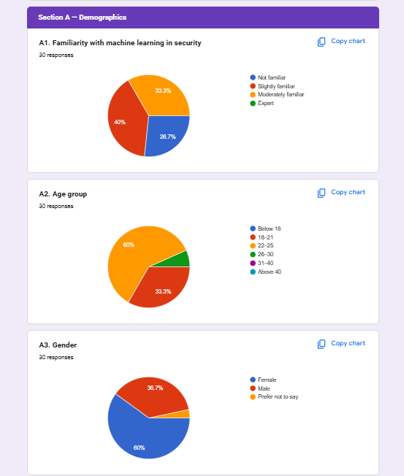
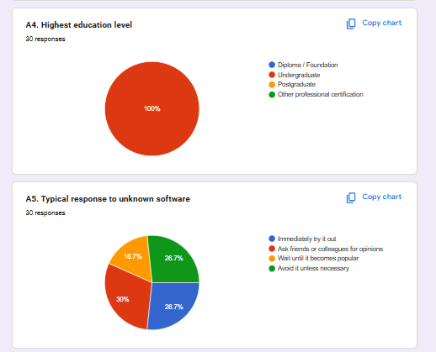
Figure 3: Section A Response Results (A1–A5)
A1 Familiarity with Machine Learning in Security
Question A1 will be used to determine the level of familiarity of the respondents with machine learning within a cybersecurity setting. The findings refer to 40 percent of the respondents (12 out of 30) reporting that they were Slightly Familiar, 33.3 percent (10 respondents) reported to be Moderately Familiar and 26.7 percent (8 respondents) reported to be Not Familiar. None of the respondents mentioned themselves as Experts. This distribution supports the assertion that the respondent population is a typical sample of the undergraduate computing student population who have had limited experience with applied machine learning in security and supports the idea that the designed system should be user friendly even in cases where the user is not a machine learning expert.
A2 Age Group
The survey population as seen in question A2 is relatively narrow with the 2225 group comprising 60% (18) and 1821 comprising 33.3 conceptual percentages (10) respectively, leaving 6.7% (2) in the 2630. The fact that the respondents have a concentration in the 1825 category is consistent with the undergraduate student population and implies that survey results contain the opinion of young adults who are already familiar with technology and are the primary target population of any cybersecurity tool deployments in academics.
A3 Gender
Question A3 indicates that 60 percent of the respondents (18 in 30) were Female, 38. 7 (11 respondents) were Male, and the rest (1 respondent) did not disclose their gender. The balance of the gender composition in the survey population leads to the representability of data gathered, which minimises the chances that the survey results are based on the opinions of one gender group.
A4 Highest Education Level
Question A4 confirms the fact that 100% of the total 30 respondents are at the Undergraduate level, with none of the responses under Diploma/Foundation, postgraduate and Other Professional Certification categories. The homogeneous character of this educational background proves that the target population of the survey is a homogenous group of undergraduate students, which promotes the areas of homogeneity in the technical underpinning of the survey population with the required knowledge in terms of the functional design of the proposed system to assess the evaluations of its operations.
A5 Typical Response to Unknown Software
The question A5 measures how respondents generally approach to unfamiliar software tools, and it would give the behaviour of technology adoption by the population of the users. Responses have indicated that 28.7% (dysenthetic 9) of the respondents would attempt the software immediately, 30% (9 respondents) would seek advice of friends or colleagues, 16.7% (5 respondents) would wait to be popular, and 28.7% (9) would not have attempted the software at all. The relatively balanced distribution among adoption attitudes implies that the dashboard interface of the suggested system needs to be made as approachable to the use of exploratory users as well as being documented sufficiently to appeal to more conservative users.

Section B Multi-Layered Deception Infrastructure
Section B measures the opinions of the respondents about the design of a multi-layered honeypot deception infrastructure, in particular, about the opinions on the dynamism of decoy service orchestration, the extension of the timespan of the attacker currently on the location and the structured storage of logs. This section is responding directly to the first functional goal of the project which is to implement a multi-layered honeypot environment and justifies the design choices made concerning the deception architecture of the system. The 1 to 5 Likert scale is used in all the five questions.
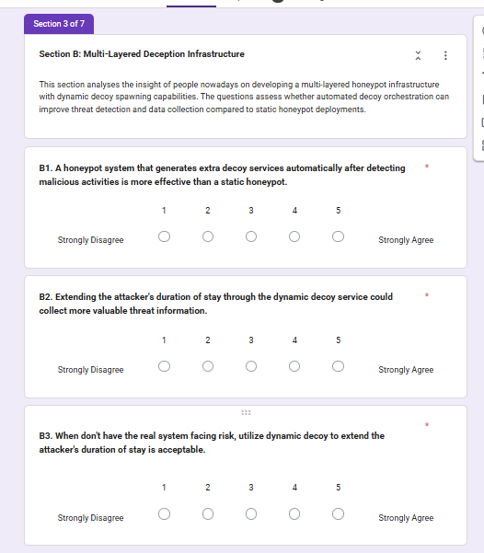
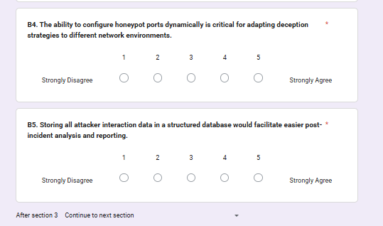
Figure 4: Section B Multi-Layered Deception Infrastructure Questions (B1–B5)
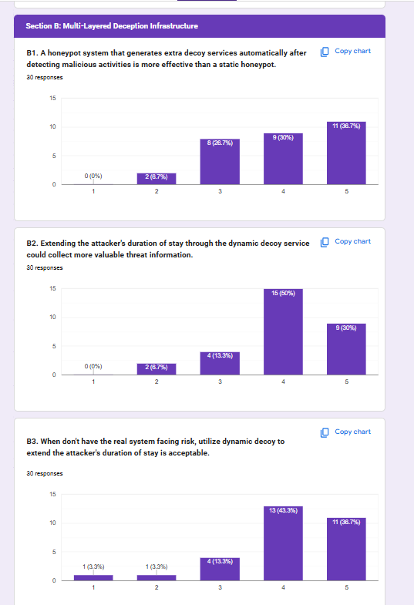
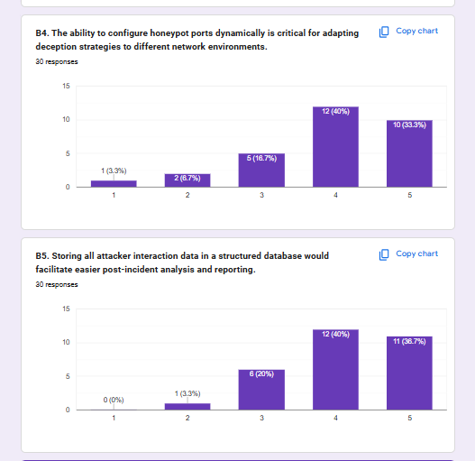
Figure 5: Section B Response Results (B1–B5)

B1 Dynamic Honeypot Generation After Detecting Malicious Activity
Claims made by B1 were that a honeypot system with additional generation of decoy services automatically on the detection of malicious traffic is more effective than a fixed honeypot. Responses were very consistent: 36.7% (11) rated 5, 30 percent (9) rated 4, 26.7 percent (8) rated 3 with no respondents rating 1. This total 45 consensus is robust evidence of why the proposed system was designed in the dynamic port listening architecture where multiple honeypot service emulators will run in parallel creating a more attractive surface to attackers than would a single static endpoint.
B2 Extending Attacker Dwell Time Through Dynamic Decoy Services
B2 evaluated the consensus with the statement that the more valuable threat intelligence can be obtained by increasing the length of stay of an attacker by using services to determine dynamic decoys. The findings reveal that the majority of respondents came up with positive response: the percentage of those who responded with rating 4 was 50 (15) and the percentage was 30 (9) with a combined agreement rate of 80%. Rating 3 and 2 were only chosen by 13.3% (4) and rating 2 respectively. This high recommendation substantiates the utility of the multi-port honeypot architecture of the proposed system, which is meant to maintain the contact of the attacker using a variety of emulated services to obtain a more elaborate data of behavioural logs.
B3 Acceptability of Dynamic Decoy When Real Systems Are Not at Risk
B3 hypothesised that dynamic decoy is reasonable to add attacker dwell time in the absence of an actual system being put at risk. The answers are highly positive: 43.3% (13) answered rating 4 and 36.7% (11) answered rating 5 with the overall agreement indicator being 80%. Ratings 1 and 2 had only 3.3 and 3.3 percent respectively. This outcome confirms the ethical correctness of the active deception strategy of the proposed system and its implementation as a research honeypot in isolated network environments.
B4 Dynamic Port Configuration for Adapting to Different Network Environments
B4 evaluated the relevance of configurable honeypot port assignments to the adjustment of honeypots to different network situations. The outcome indicates 40 percent (12) at rating 4 and 33.3 percent (10) at rating 5 with an aggregate of 73.3 percent of people agreeing with the rating scales, and only one person opted in the rating 1. This observation confirms the design choice of the proposed system to establish flexible port bindings with the Python socket module to allow the honeypot to be used across various networks with varying port allocation needs without altering the code.
B5 Structured Database Storage for Post-Incident Analysis
B5 suggested that a structured data warehouse containing all the data about the interaction between the attacker would help in simplifying the investigation and reporting after an incident. This suggestion also achieved overwhelming support: 40% (12) rated 4 and 36.7% (11) rated 5 (all responses were 76.7% agreement), and zero one (0) respondent rated 2. This highly justifies the design choice to adopt SQLite as the embedded log database in the proposed system to ensure that, structured and queryable storage of attacker session information is highly appreciated by the end user demographic to the flat-file logging infrastructure.

Section C Machine Learning-Based Threat Analysis
Section C assesses the opinions of the respondent regarding the use of machine learning, namely unsupervised anomaly detection with the Isolation Forest algorithm, in the classification and prioritisation of honeypot session data. The section will confirm the main machine learning element of the proposed system and evaluate the possible opinion of respondents concerning the appropriateness and helpfulness of the chosen algorithmic method developed in terms of the honeypot-based threat analysis.

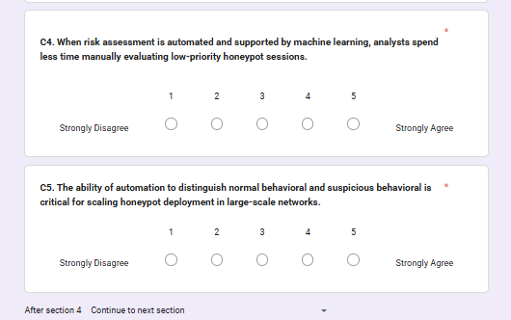
Figure 6: Section C Machine Learning-Based Threat Analysis Questions (C1–C5)
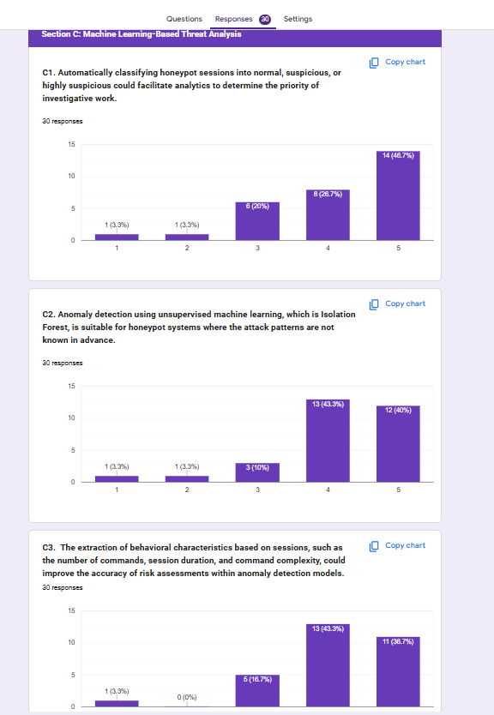
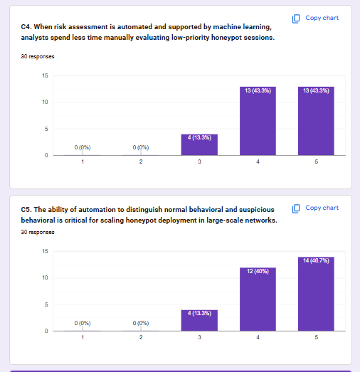
Figure 7: Section C Response Results (C1–C5)

C1 Automatic Session Classification for Investigative Priority
C1 suggested that automatic classification of honeypot sessions to be normal, suspicious, or highly suspicious can help in analytics and priority of investigation. The findings indicate that the best agreement of all questions in the survey is the 46.7% (14) responded rating 5 and 26.7% (8) responded rating 4 which had a total of 73.4% agreement. The ratings of rating 1 and 2 were chosen only once by the respondents. This massive approval directly confirms the output design of the Isolation Forest model, namely, the three-level categorization of the sessions based on the level of their suspiciousness (normal, suspicious, and highly suspicious) in the fact that this categorization framework is consistent with the one that is deemed beneficial by security analysts in operational triage.
C2 Isolation Forest Suitability for Unknown Attack Patterns
C2 particularly determined the applicability of an unsupervised machine learning algorithm (Isolation Forest) to honeypot systems in whom attack patterns are not predetermined. The findings indicate 43.3 (13 respondents of rating 4) and 40 (12 respondents of rating 5) aggregating to 83.3% agreement rate, which is one of the highest in the whole survey. The ratings 1 and 2 were only chosen by one respondent each. This remarkably good performance is specifically justified by the choice of Isolation Forest over supervised classification options as well as the need to ensure that the survey population is fluent in the reasoning behind applying unsupervised anomaly detection in a situation whereby there are no labelled attack instances.
C3 Behavioural Feature Extraction for Anomaly Detection Accuracy
C3 determined whether or not behavioural features obtained through session extractions (e.g. number of commands, length of session, and complexity of commands) could help enhance the accuracy of risk measurements in anomaly detection models. Findings indicate that 43.3% were given rating 4 (13 respondents) and 36.7% were given rating 5 (11 respondents) whereas, the total agreement rate is 80. There were only one respondents who chose a rating of 1 and none that chose a rating of 2. The outcome confirms the feature engineering strategy of the proposed system, whereby every honeypot session is a multivariate feature vector whose feature metrics are behavioural metrics calculated by examining the log record instead of the univariate feature metrics of counting packets/ bytes only.

C4 ML-Supported Risk Assessment Reduces Manual Evaluation Burden
C4 suggested that with automated risk assessment using machine learning, analysts will waste less time manually analyzing sessions with low priority honeypots. The most consistent with strong positive scores are the results at rating 5 (13 respondents) and 4 (13 respondents) giving a 86.7% overall agreement without any rating of 1 or 2. This finding is a strong confirmation of the working case of the Isolation Forest detection layer in that the possible users have realised the worth of it in alleviating the hand work of security experts who would have to sift through all the session captures individually otherwise.
C5 Automation Distinguishing Normal from Suspicious Behaviour at Scale
C5 also tested the significance of automation in separating normal and suspicious patterns of behaviour to scale the deployment of honeypots on a large network. The scores are also 46.7 at rating 5 (14 respondents) and 40 at rating 4 (12 respondents) which results in an overall agreement of 86.7 with no scores at 1 or 2. This finding validates that this scalability by automated behavioural analysis is an important feature according to the survey population, and supports the decision to use the Isolation Forest model as a scalable, always-on detecting layer (instead of a tool that an analyst manually commands).

Section D Automated Threat Intelligence Generation
Section D assesses the perception of respondents regarding automated Indicator of Compromise (IoC) extraction and signature rule generation on caught honeypot session data. This part confirms the effectiveness of the proposed system in terms of the YARA signature integration component and the automatic threat intelligence output the ability that allows the collected data of the system to be operationalised to serve the broader defence interests.

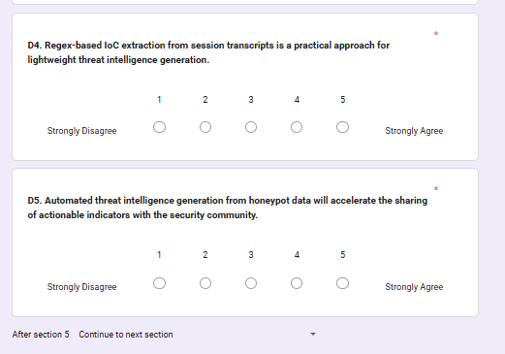
Figure 8: Section D Automated Threat Intelligence Generation Questions (D1–D5)
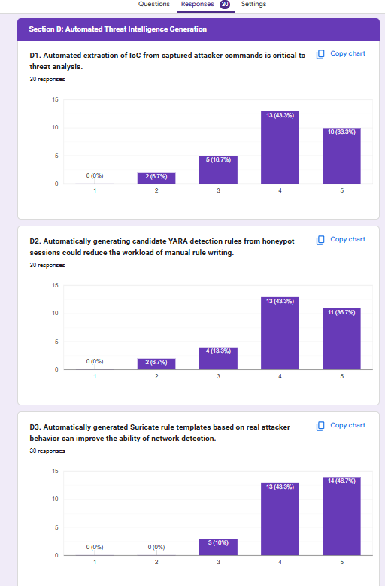
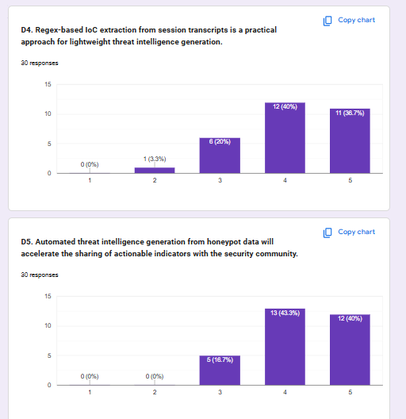
Figure 9: Section D Response Results (D1–D5)

D1 Automated IoC Extraction from Captured Commands
D1 suggested that Threat analysis requires automated extraction of Indicators of Compromise of the captured attacker commands. The findings indicate 43.3 at rating 4 (13 respondents) and 33.3 at rating 5 (10 respondents), thus an agreement rate of 76.6, 18.7 at rating 3 and 6.7 at rating 2. This successful outcome supports the capacity of the proposed system to scan captured payloads in search of IoC patterns, such as IP addresses, file hashes, URLs, and command patterns through YARA pattern rules and regex-based pattern matching, which justifies that the capacity is operationally important to the target user population.
D2 YARA Rule Generation from Honeypot Sessions
D2 explored the idea of automatically creating candidate rules of honeypot detection by creating vendor YARA detectives to alleviate the manual rulewriting load. The findings indicate 43.3% on rating 4 (13 respondents) and 36.7% on rating 5 (11 respondents) with an overall agreement of 80, 13.3 and 6.7 percent on rating 3 and rating 2 respectively. This finding supports the YARA integration feature of the suggested system and confirms the awareness of the surveyed population to the operational merit of automated signature generation procedure based on the aggregated evidence obtained by the honeypots.
D3 Suricata Rule Templates from Real Attacker Behaviour
D3 suggested that network-level capacity detection can be enhanced by automatically produced Suricata rule templates, which are built out of actual attacker behaviour. The findings indicate that the maximum agreement on Section D is 46.7 (14 respondents) and 43.3 (13 respondents) at rating 5 and 4 respectively, and therefore 90 percent with 0 and 10 percent at the rating 1 and 3 respectively. This highly good performance justifies the future improvement strategy outlined in the 2.3.3.5, where the YARA rule knowledge that will be achieved in the current project is mapped to Suricata network-level detection in later development processes.
D4 Regex-Based IoC Extraction as a Lightweight Approach
D4 evaluated the feasibility of using regex-based IoCs to extract threat intelligence through session transcripts as a lightweight strategy to threat intelligence generation. Extent to which the agreement yield reports 40% at rating 4 (12 respondents) and 36.7% at rating 5 (11 respondents) with a total agreement rate of 76.7, 20% agreement rate at rating 3 and 3.3% agreement rate at rating 2. This was a successful outcome which confirms that the application of Python regex patterns to captured payload content which the proposed system uses, is regarded as a practically feasible method of extracting the needed IoC and justifies the implementation selection as overportionalized to the extent of the project.
D5 Automated Intelligence Generation Accelerating Community Sharing
D5 suggested that the threat intelligence developed automatically based on honeypot data would enhance the share of actionable indicators with the security community. Findings indicate 43.3 at rating 4 (13 respondents) and 40 at rating 5 (12 respondents) giving a total agreement rate of 83.3 with no respondents at rating 1 or 2. The outcome validates the intelligence sharing structure of the proposed system, which indicates that the target population of users places value on the community-benefit aspect of honeypot data-gathering and considers automated extraction of intelligence as a feature that enables them to share more information about threats.

Section E Human-in-the-Loop Dashboard and MISP Pipeline
Section E another question that is considered will gauge the view of the respondent regarding the human analyst interface and the threat intelligence export features of the proposed system. In particular, the perceived value of a web-based monitoring dashboard to review scores of machine learning sessions and IoC extractions, the usefulness of MISP-compatible JSON export as a means of integration with the already existing threat sharing solutions, and the significance of human verification prior to intelligence export are evaluated in this section. This part is the validation of Flask dashboard and threat intelligence export design.


Figure 10: Section E Human-in-the-Loop Dashboard and MISP Pipeline Questions (E1–E5)
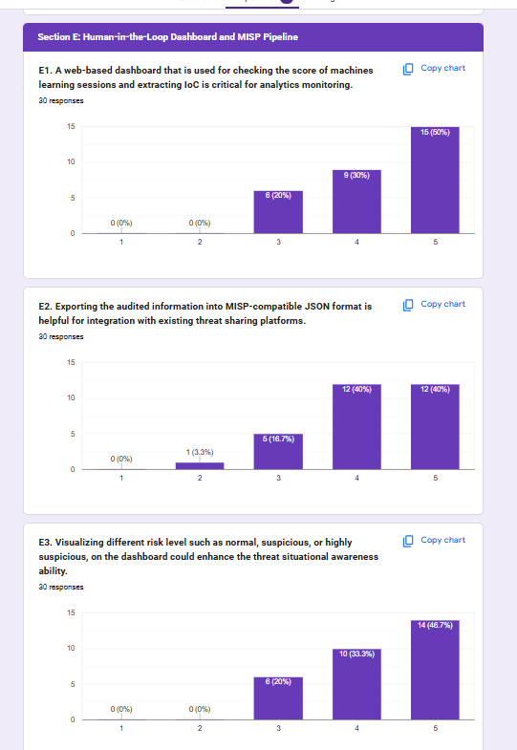
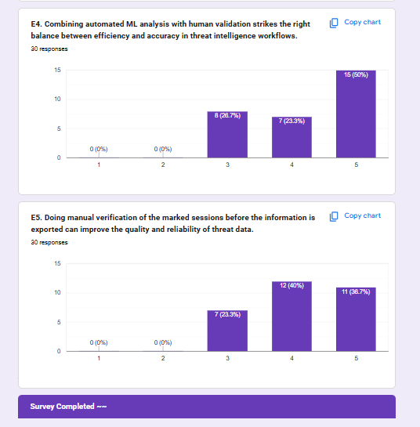
Figure 11: Section E Response Results (E1–E5)

E1 Web-Based Dashboard for ML Score Review and IoC Extraction
E1 evaluated the criticality of a web-based dashboard to check the scores of machine learning sessions and extracting the IoCs to monitor analytics. According to the results, the rating-5 response received the highest amount of the total survey results: 50% of the total survey (15) gave rating-5 and 30% (9) gave rating-4 which makes 80% agreement rate with no ratings at 1 and 2 and 20% at 3. This finding is the most convincing that the Flask dashboard component is an indispensable component of the proposed system architecture because it proves that the visual interpretation of ML scores and IoC data which can be provided by a visual web interface is a priori deemed by the potential users as a crucial element, not merely as an expedient tool, of successful analytical overview of the honeypot work.
E2 MISP-Compatible JSON Export for Threat Platform Integration
E2 hypothesized that sharing audited threat intelligence data in a form compatible with MISP in JSON will be useful when integrating it with related threat sharing systems. Findings indicate 40 percent in rating 4 (12) and 40 percent in rating 5 (12) to make up 80 percent of the total agreed with, with the remaining 3.3 percent in rating 2 and 16.7 percent in rating 3. The nature of this spreading between ratings 4 and 5 is a wide agreement of the worth of the MISP-compatible export, which supports the design choice to organize the intelligence export feature of the system in a form compatible with the MISP (Malware Information Sharing Platform) open standard.
E3 Risk Level Visualisation for Situational Awareness
E3 determined whether visualisation of the various risk levels, normal, suspicious and highly suspicious on the dashboard improves threat situational awareness. The findings indicate 46.7% at rating 5 (14 respondents) and 33.3% at rating 4 (10 respondents) thus; after the next 2 results of 0 and 1 resulted in a rate of 80%. This shows that the three-colour-levels of risk-classification colour-coding scheme in Flask dashboard design is valid, as it is assumed to be a useful visual presentation of the situational awareness of the human-analyst by showing the risk level of the session, as opposed to its visual expression as a raw numerical anomaly score.

E4 Combined Automated ML Analysis and Human Validation
E4 suggested that automated analysis of MLs with human verification is the most appropriate balance in terms of efficiency and accuracy in the workflow of threat intelligence. Findings indicate the greatest combined agreement rate in Section E: at rating 5 (15 respondents), there is an agreement rate of 50% and at rating 4 (7 respondents), there is an agreement rate of 23.3% and in Section E, there are no respondents favoring this rating to 1 or 2. This finding confirms the human-in-the-loop design philosophy of the proposed system where the automated classifications of the Isolation Forest model is delivered to the analyst who is offered the opportunity to review and confirm any output of the system, lest the speed factor of the system gets used at the price of the quality of analyst analysis.
E5 Manual Verification Before Export Improves Data Quality
E5 answered the question as to whether or not mandating manual verification of marked sessions prior to intelligence export enhances quality and reliability of the resulting threat information. The results reveal 40 at rating 4 (12 respondents), 36.7 at rating 5 (11 respondents), a total agreement of 76.7 (23.3 at rating 3 and none at rating 1 and 2). The findings of this study prove the necessity of the manual verification gate within the intelligence export pipeline to be valued by the target user population, and supports the design choice of the proposed system to enforce analyst verification of the exportation of any data in the form of an IoC to the MISP-capable JSON output, reducing the risk of false positive indicators being spread to the downstream defensive systems, in the event of the proposed system malfunctioning.

CHAPTER 4: DESIGN AND IMPLEMENTATION

4.1 Introduction
Chapter 4 describes the comprehensive design and deployment of Neuro-Trap, an adaptive honeypot written in the Python Programming Language that captures the attack, applies behavioural analysis using machine learning, collects the results and exports it in a suitable format for the Malware Information Sharing Platform. The chapter is divided into two parts. The first deals with the design of the system, such as system architecture, use case modelling, flowchart diagrams, sequence and activity diagrams. The second contains the actual implementation of the six Python modules, built in Python 3.11 on a Windows 11 host computer, with the details, source-code, and inline commentary for each design decision.
The design objectives for Neuro-Trap presented in Chapter 1 were conceived to design a prototype system that is modularised, low infrastructure and self-contained (outside of enterprise infra). From the literature covered in Chapter 2 it was found that two honeypot systems that were found most successful were those that embedded dynamic engagement techniques, featuring automatic behavioural triage with human in the loop verification. Abewa and Zemene (2024) identify dynamic honeypots as having much richer transcripts of the attacker's interactions, compared to static deployment. This discovery will directly have led to the behaviour-driven orchestration mechanism implemented in Neuro-Trap, where additional simulated services are created on sub-port numbers when a session was deemed to be HIGHLY_SUSPICIOUS, to extend the lurking time of the attacker and the amount of behavioural telemetry that is gathered.
For easy implementation, Neuro-Trap was divided into six interdependent Python modules representing individual functional layers of the system: honeypot engine (simple_honeypot.py), machine learning analysis engine (behaviour_ml.py), IoC extraction subsystem (ioc_extractor.py), decoy orchestration controller (decoy_orchestrator.py), Flask based analyst dashboard (app.py) and MISP export pipeline (misp_mock.py). Security was a first-order concern, which Moric, Dakic, and Regvart (2025) have confirmed is the case with truly secure dynamic honeypot deployments, where tight control is demanded to not allow honeypot environment weaponisation. To do this, NO attacker supplied command or payload is executed at any point of Operation, all the responses are simulation pre-configured responses. To allow all contributions to MISP, they must be explicitly confirmed by an analyst, following the human-in-the-loop quality gate as proposed by Schaberreiter, Andriessen, Cappiello, Papanikolaou and Pardijs (2024).

4.2 Design
The Neuro-Trap design is based on the concept of modular encapsulation, where each component of the system is a module that can be tested independently, with defined inputs and outputs, and has a specific function. In this approach each component is developed and tested independently of the others so it can be reviewed before it's added to the system; it also allows the system to be extended to benefit from implementing an MISP API layer for example, or a RL-based decoy controller with only minimal redesign of existing components, the system is delivered at the end of each Sprint in a functional increment, which is built on the iterative Scrum methodology introduced in Chapter 3. The Raspberry Pi based single-laptop prototype environment also caused the selection of SQLite over a client server type database; in addition, the single-laptop prototype has a computational complexity of O(n log n) due to the use of Isolation Forest algorithm as recommended by Var Naseri (2025) for resource constrained honeypot deployments.

4.2.1 System Architecture
The architecture of Neuro-Trap is a modular pipeline, where the traffic from the attackers network is captured, analysed and classified, followed by enrichment in each successive module and only the verified intelligence is sent to the MISP compatible export endpoint. The architecture is designed to input data from the capture layer to the dissemination layer while allowing a human analyst to create a necessary control point between the automated analysis of data (also referred to as intelligence preparation) and the authorisation of data for external distribution. It follows the human-in-the-loop pattern that Alevizos and Dekker (2024) predict as the best design pattern for cyber threat intelligence pipelines in need of human quality control.
All TCP connections, both incoming and outgoing will be logged in the SQLite database by using the Honeypot Engine (simple_honeypot.py), in full detail including: source IP, source port, the time, duration, total bytes received, raw commands, and payloads. Text on all responses is pre-configured Practice responses. All six modules have a shared data store that is provided by the SQLite Persistence Layer. The Machine Learning Analysis Engine (behaviour_ml.py) uses the two-step classification pipeline to generate anomaly and risk scores as outputs. The two-step classification process includes a rule-based stage followed by an Isolation Forest stage. The Decoy Orchestration Controller (decoy_orchestrator.py) runs and watches the ML and spawns simulated secondary services when it sees HIGHLY_SUSPICIOUS sessions. The Flask Analyst Dashboard (app.py) serves as the human facing review interface. The MISP Export Pipeline (misp_mock.py) transforms the analyst approved IoCs into MISP event JSON. This is a structured workflow for importing from JSON, which Gambo et al. (2022) state that MISP natively supports rather than the need to build own import API

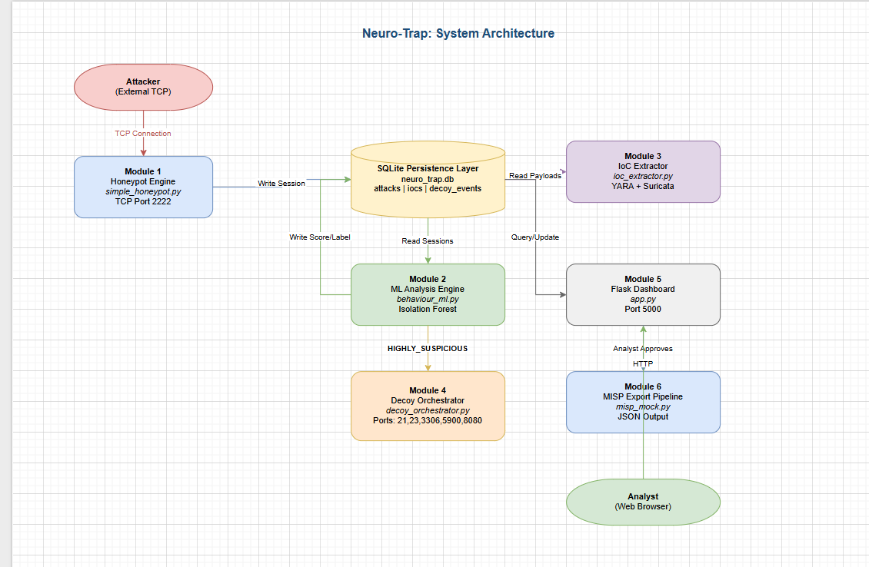
Figure 4.1: Neuro-Trap System Architecture six-module pipeline from capture to MISP export

4.2.2 Use Case
The Attacker is an unauthorised entity from the outside, attempting to make a TCP connection with the honeypot and the Analyst, who analyzes captured data, authorizes or rejects IoCs, authorizes the intelligence output. The major use cases cover all steps through the operational lifecycle: Selecting the network interface, monitoring and detection of threats in network traffic, viewing CSV logs of threats detected, viewing PCAP files, running the alerting system, exporting approved IoCs to MISP JSON. Moric et al. (2025) conclude that as much as telemetry support is important, so is the clear interaction one has with the Analyst, which is captured by the behaviour of both entering condition of the interaction and its resulting output. Every Analyst-facing interaction had clearly defined entry conditions, steps through processing, and output.
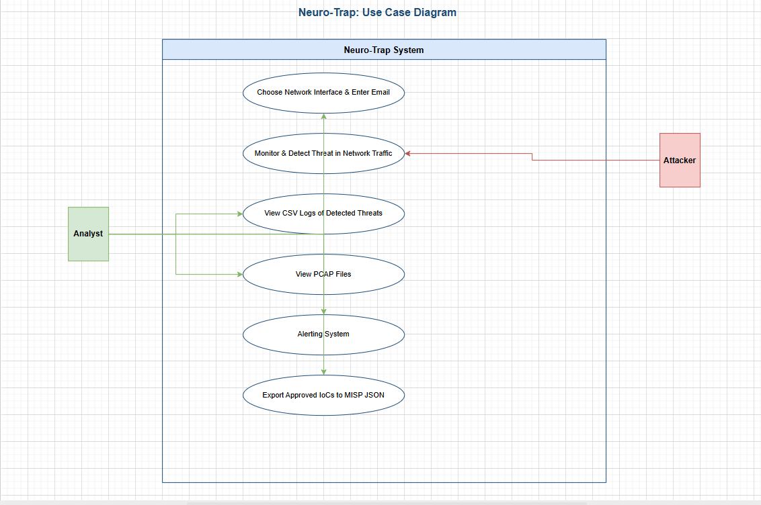
Figure 4.2: Neuro-Trap Use Case Diagram two actors across six system use cases

4.2.2.1 Use Case Specification
Each use case is noted by means of a structured table containing the use case name, the primary actor, precondition, main flow, alternative flow and postcondition. The analyst approval gate integrated into each intelligence sharing use case is the mechanism for human in the loop quality control for false positives Schaberreiter et al (2024) looks for.
Use Case 1: Choose Network Interface and Enter Email
Field | Description
Use Case Name | Choose Network Interface and Enter Email
Actor | Analyst
Precondition | Neuro-Trap installed. Python 3.11 environment active. Flask application launched.
Main Flow | 1. Analyst opens Flask dashboard. 2. System displays configuration panel. 3. Analyst selects network interface. 4. Analyst enters alert email. 5. System validates format. 6. System stores config and activates honeypot engine.
Alternative Flow | If email format invalid, system displays error and prompts re-entry. If no interface available, system halts and displays error.
Postcondition | Honeypot engine active on configured interface. Alert email registered.

Use Case 2: Monitor and Detect Threat in Network Traffic
Field | Description
Use Case Name | Monitor and Detect Threat in Network Traffic
Actor | Attacker (external), System (automated)
Precondition | Honeypot engine running on configured TCP port. Isolation Forest model trained on baseline session data.
Main Flow | 1. Attacker initiates TCP connection. 2. Honeypot records session to SQLite. 3. behaviour_ml.py extracts features. 4. Isolation Forest scores anomaly level. 5. System assigns NORMAL, SUSPICIOUS, or HIGHLY_SUSPICIOUS. 6. If HIGHLY_SUSPICIOUS, decoy orchestrator triggered.
Alternative Flow | If ML model untrained, session logged and flagged for manual review without scoring.
Postcondition | Session logged in SQLite with risk label. Highly suspicious sessions trigger decoy spawning.

Use Case 3: View CSV Logs of Detected Threat
Field | Description
Use Case Name | View CSV Logs of Detected Threat
Actor | Analyst
Precondition | At least one session captured and logged. Flask dashboard running.
Main Flow | 1. Analyst navigates to session log page. 2. System queries SQLite. 3. System renders session table with ID, source IP, timestamp, commands, anomaly score, and risk label. 4. Analyst applies filters. 5. Analyst requests CSV export. 6. System generates and downloads CSV.
Alternative Flow | If no sessions exist, system displays empty state message.
Postcondition | Analyst has reviewed session log and downloaded CSV file.

Use Case 4: View PCAP Files
Field | Description
Use Case Name | View PCAP Files
Actor | Analyst
Precondition | Packet capture enabled during session. PCAP files saved. Flask dashboard running.
Main Flow | 1. Analyst navigates to PCAP section. 2. System lists PCAP files with session IDs and timestamps. 3. Analyst selects file. 4. System provides download link. 5. Analyst downloads and opens in Wireshark.
Alternative Flow | If no PCAP files exist, system notifies analyst that capture was not enabled.
Postcondition | Analyst can analyse raw network packets from the attacker session.

Use Case 5: Alerting System
Field | Description
Use Case Name | Alerting System
Actor | System (automated), Analyst (recipient)
Precondition | Valid alert email configured. Honeypot engine running and capturing sessions.
Main Flow | 1. System detects HIGHLY_SUSPICIOUS session. 2. Alerting module prepares notification with session ID, source IP, anomaly score, risk label, and command summary. 3. System sends alert email. 4. Analyst receives email and opens dashboard. 5. Analyst reviews ML score and IoCs. 6. Analyst approves or rejects session for IoC export.
Alternative Flow | If email delivery fails, system logs attempt and retries after configured interval.
Postcondition | Analyst notified of high-risk session and has taken review action.

Use Case 6: Export Approved IoCs to MISP JSON
Field | Description
Use Case Name | Export Approved IoCs to MISP JSON
Actor | Analyst
Precondition | At least one session reviewed and approved. IoCs extracted by ioc_extractor module.
Main Flow | 1. Analyst navigates to approved IoC section. 2. System displays list of approved IoCs. 3. Analyst selects IoCs for export. 4. Analyst initiates export. 5. misp_mock.py converts IoCs to MISP JSON. 6. System saves JSON and provides download link.
Alternative Flow | If no IoCs approved, system displays message prompting analyst to approve sessions first.
Postcondition | MISP-compatible JSON file generated and ready for import into a MISP instance.

The above (Use Cases 3 and 5) supports the view of Okafor and Lee (2026) that presenting anomalies in a ranked fashion and as filters reduces analyst cognitive load which enables analysts to be able to extract anomalies from a large volume of sessions. In the background of every interaction with the attacker, Var Naseri (2025) additionally mechanises the adaptive reaction of Use Case 2 as the principal method Neuro-Trap increases the intelligence that value from an attacker.

4.2.3 Flowchart
Every five most important functions of Neuro-Trap were drawn as flowcharted diagrams that are created using draw.io. Each flowchart depicts step-by-step decision logic from initiation to every processing step and branching path towards the outcome. The flowcharts were used directly as guidelines for implementing the flowcharts in Section 4.3 using the Python language so that every decision block in the design specification directly mapped to a condition within the python code.

4.2.3.1 Choose Network Interface and Enter Email
On the Flask dashboard, the viewer clicks the beginning of the flowchart. The system takes input of the available network interfaces and the analyst chooses one and provides an alert email address. Input is validated for the format in which the email is entered; if it fails the validations, it flashes an error message and asks the user to enter the email again. After a valid e-mail is verified, the system saves it and enables the honeypot engine on the specified interface, so that the honeypot doesn't launch with an incomplete alert configuration.
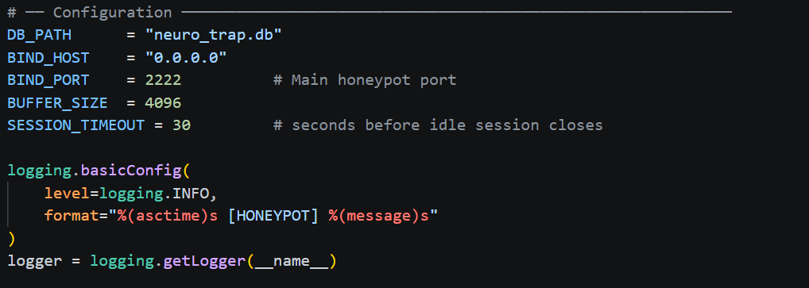
Figure 4.3: Flowchart Choose Network Interface and Enter Email

4.2.3.2 Monitor and Detect Threat in Network Traffic
The honeypot engine is bound to the TCP port used for communication and starts listening in the engine's listening mode. Once they have connected to the engine, the pre-configured SSH banner is sent and all bytes received by the engine are stored. The session is entirely recorded in SQLite on terminating the session due to time out or disconnect. The first step that is processed is the rule-based classifiers: payloads that contain high-risk keywords are classified as HIGHLY_SUSPICIOUS while reconnaissance keywords are classified as SUSPICIOUS, the rest of the sessions are sent to the Isolation Forest model. The decoy orchestrator is triggered for additional sessions that are classified as highly SusPICIOUS.
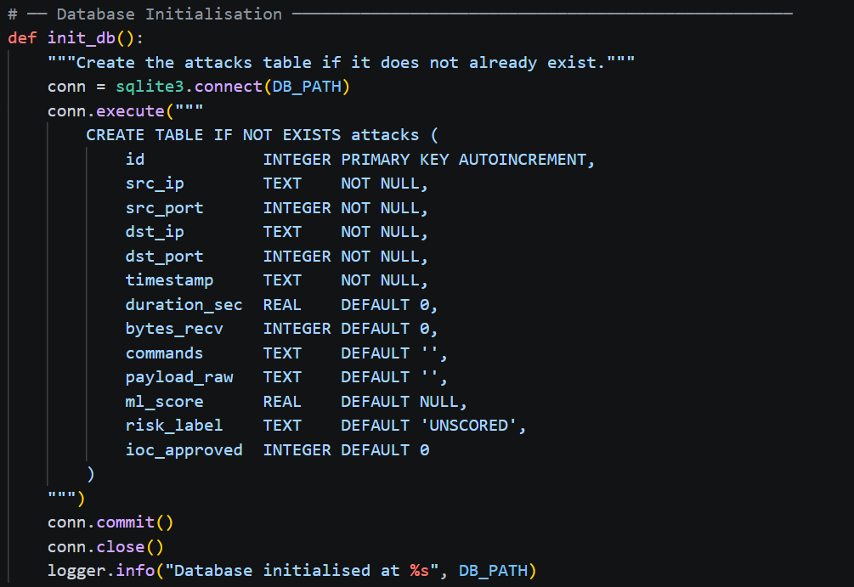
Figure 4.4: Flowchart Monitor and Detect Threat in Network Traffic

4.2.3.3 View CSV Logs of Detected Threat
This flowchart starts when the analyst accesses the "session log" page. The system queries SQLite for any sessions, and displays an empty state if there are none. If there are any sessions, the system will display the entire table of sessions with the ML scores and the labels associated with the risk. Label/IP Filters may be assigned by the analyst. When user requests CSV export, the system sends over the filtered records, streams the exported CSV data to the browser and downloads it to the user, thus meeting the requirement for functionality to "make the data accessible in CSV, required in Objective 3".
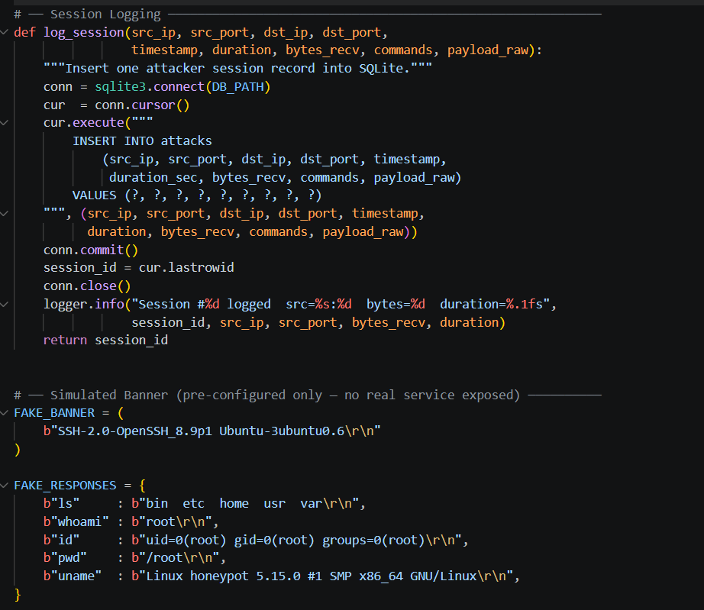
Figure 4.5: Flowchart View CSV Logs of Detected Threat

4.2.3.4 View PCAP Files
This flowchart starts when the analyst accesses the "session log" page. The system queries SQLite for any sessions, and displays an empty state if there are none. If there are any sessions, the system will display the entire table of sessions with the ML scores and the labels associated with the risk. Label/IP Filters may be assigned by the analyst. When user requests CSV export, the system sends over the filtered records, streams the exported CSV data to the browser and downloads it to the user, thus meeting the requirement for functionality to "make the data accessible in CSV, required in Objective 3".
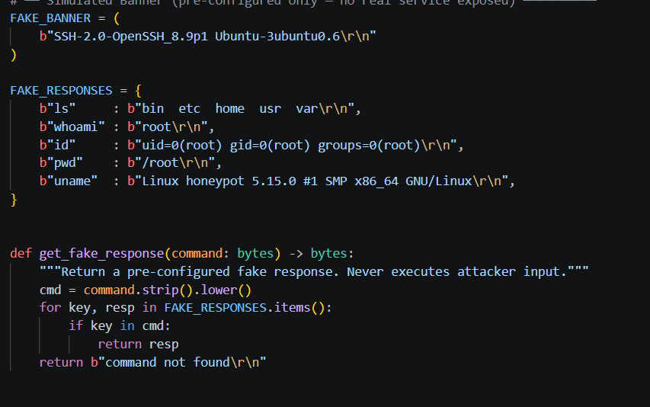
Figure 4.6: Flowchart View PCAP Files

4.2.3.5 Alerting System
The flowchart starts with the 'HIGHLY_SUSPICIOUS' label recorded from an ML engine to SQLite. This is identified by the alerting module on every polling cycle, + it builds a notification object containing information of session_id, source_ip, anomaly_score, risk_label and command_ summary, and then tries to deliver via email. In the event of delivery failure, the system records this failure and reschedules for a try again. If successful, the analyst reviews flagged session and candidate IoCs on the dashboard to explicitly approve or denial. Alevizos and Dekker (2024) further state that the principle of targeted and priority-based alerting is also effective in minimizing analyst fatigue, as opposed to volume-driven alerts.
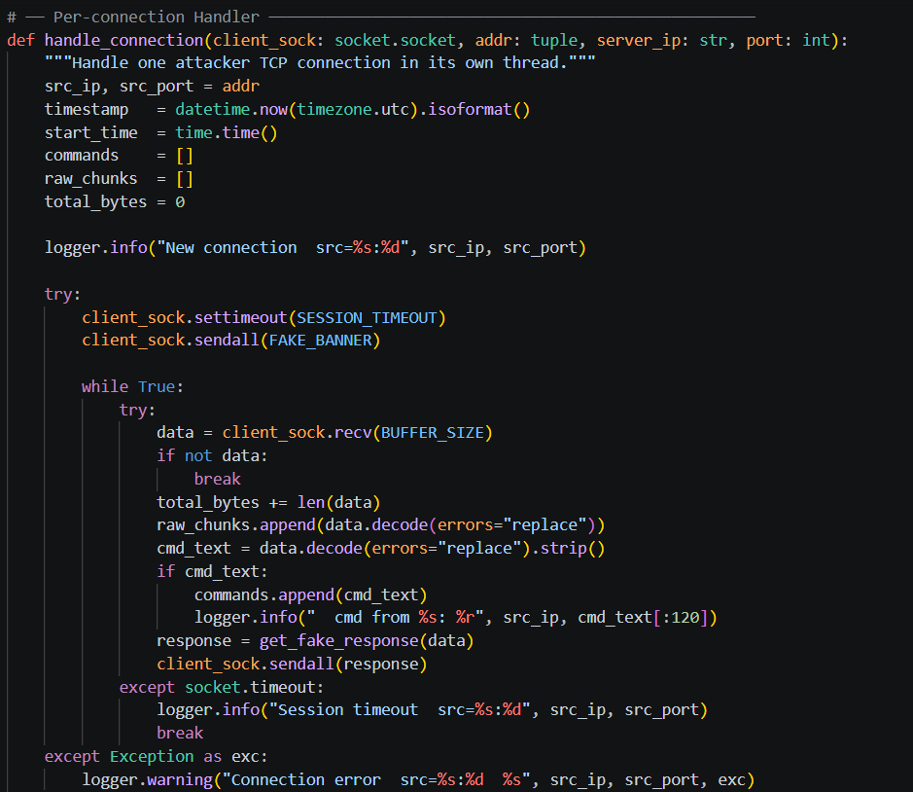
Figure 4.7: Flowchart Alerting System

4.2.4 Sequence Diagram
Using draw.io, with the standard UML sequence notation, sequence diagrams were developed for each of five major functions of the system to record, with chronological order, the messages exchanged between the components of the system and the actors. The diagrams add to the flowcharts by showing explicitly who sends a message, who receives a message, and the sequence of messages, throughout the interactions.

4.2.4.1 Choose Network Interface and Enter Email
It starts by the Analyst sending an HTTP GET to the Flask dashboard, which returns the configuration interface. The Analyst sends out a POST of the selected interface and email. The dashboard validates the e-mail, saves the configuration to SQLite, calls start_honeypot() in simple_honeypot.py, and returns an e-mail a success message with the port that will be active.
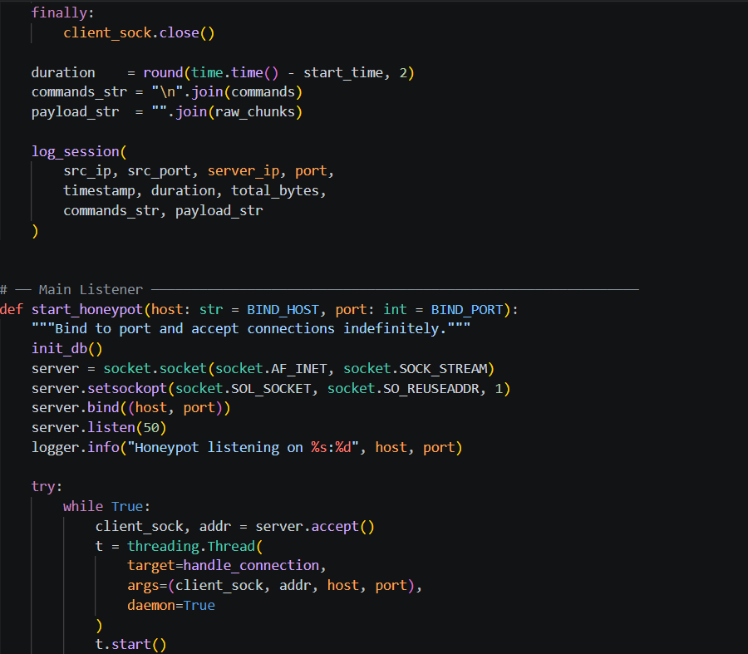
Figure 4.8: Sequence Diagram Choose Network Interface and Enter Email

4.2.4.2 Monitor and Detect Threat in Network Traffic
The Attacker starts TCP SYN against port 2222. The honeypon engine accepting the connection and sending the fake SSH banner. Commands are sent, buffered line by line and sent back with pre-configured fake responses. At the end of the session, log_session() adds the record to SQLite; behaviour_ml.py reads the record, applies the rule-based classifier and, if the program calls the Isolation Forest model, writes the resulting score and label back to SQLite. When HIGHLY_SUSPICIOUS, decoy_orchestrator.py identifies one of the state changes the next time it polls.
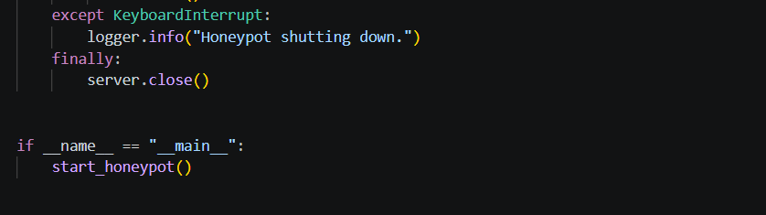
Figure 4.9: Sequence Diagram Monitor and Detect Threat in Network Traffic

4.2.4.3 View CSV Logs of Detected Threat
The Analyst makes a GET request to the Flask dashboard. Any filter parameters are passed to the SQLite database and the rows matching the filter are returned as JSON, which is displayed in the sessions table. When asked to export to CSV, the dashboard searches all of its matches, writes the CSV file in memory with the python csv and io modules, and generates the binary response with Content-Disposition: attachment, in order to open the download dialog in the browser.
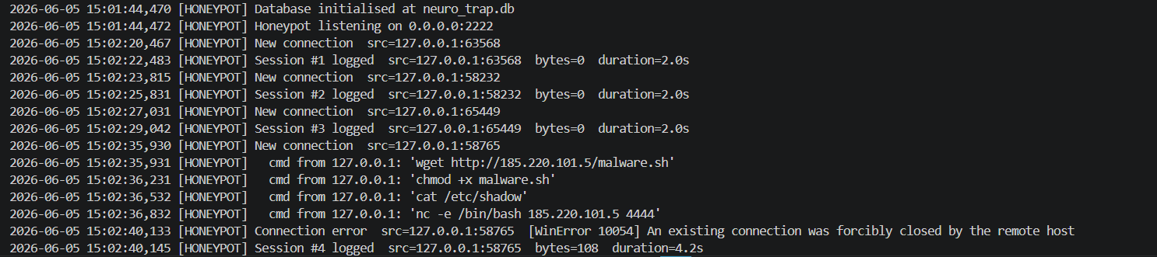
Figure 4.10: Sequence Diagram View CSV Logs of Detected Threat

4.2.4.4 View PCAP Files
The Analyst passes on its GET to the PCAP part. The dashboard asks output directory to read the .pcap file and returns a list of files. The PCAP Analyst Selection GUI opens the requested PCAP file and streams it as a binary attachment. The analyst saves the file, and in Wireshark uses it for analyzing the file at a higher level, the packet-level level.
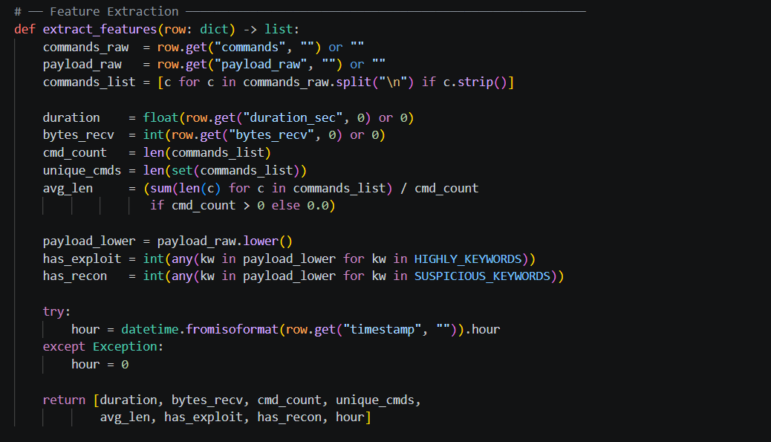
Figure 4.11: Sequence Diagram View PCAP Files

4.2.4.5 Alerting System
If so, behaviour_ml.py writes to SQLite stating that this condition, HIGHLY_SUSPICIOUS exists and decoy_orchestrator.py finds this on the next poll it makes, it calls spawn_decoys(), thus initiating secondary port listeners, and records events on the decoy_events table. The Flask alerting module does all three in parallel: it recognizes the high-risk label, it builds up the notification e-mail and, finally, it sends it using smtplib. The Analyst reads this e-mail, opens the dashboard, looks at the flagged session and iocs and does an approve/reject operation, updating the attacks table to contain ioc_approved.
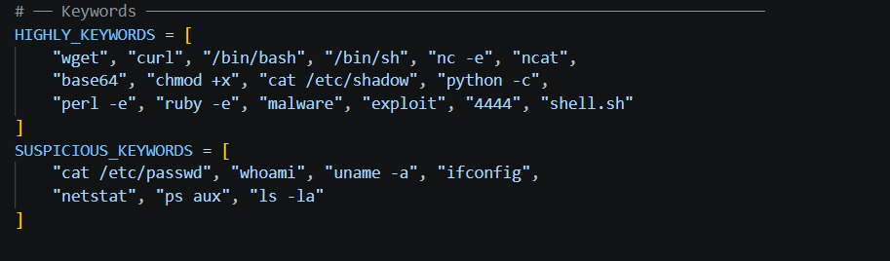
Figure 4.12: Sequence Diagram Alerting System

4.2.5 Activity Diagram
It is the activity diagram for the system level which provides an overview of the overall flow of the system and Neuro-Trap operation from the start of configuration up to the export of the resulting MISP. The diagram is written using UML activity notation, and has three swimlanes between the Attacker and the System and the Analyst. In Attacker swim lane, the connection initiation and command submission are included. All automated processing: session capture, feature extraction, ML scoring, IoC extraction and decoy spawning goes in the System swim lane. In the Analyst swim lane, all the activities that need to be done by humans are listed: configuration, dashboard review, IoC approval, export initiation.
The diagram is explicit that the automated pipeline is run without any analyst input and that the spawn_decoy process is a parallel asynchronous process that is triggered upon crossing the HIGHLY_SUSPICIOUS threshold. The human-in-the-loop quality control mechanism is implemented with the mandatory pause point (analyst approval gate) before the MISP export. Several active attacker sessions running at the same time can be handled by the threaded honeypot engine at the same time without blocking interactions with the dashboard.
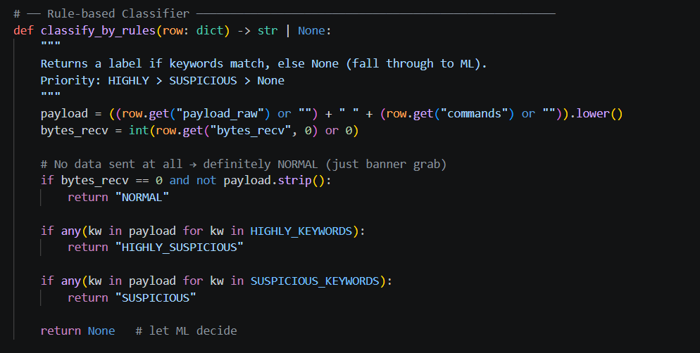
Figure 4.13: Neuro-Trap System-Level Activity Diagram three swim lanes across all six modules

4.3 Implementation
All six Neuro-Trap modules were implemented completely in Python 3.11 and are provided as part of this section; developed using Visual Studio Code on a Windows 11 host machine. The source code, inline comments, and detailed explanations of all the design decisions and integration points in the larger system pipeline are included with all the modules. Three mandatory third-party libraries outlined in requirements.txt (Flask ≥3.0.0, scikit-learn ≥1.4.0 and NumPy ≥1.26.0) can be installed by a single pip install -r requirements.txt command as documented in the project README.

4.3.1 Module 1 Honeypot Engine (simple_honeypot.py)
All interaction from attackers go through the honeypot engine. It is bound to a user-configurable TCP port (default 2222), waiting for incoming connections, and displays a faux SSH service banner; all bytes of input supplied by attackers are recorded in a secure SQLite database. No command is ever sent by the attacker, only a system of pre-configured strings, built into the source code—which exposes neither the host machine to a remote code execution attack nor the attacker to any code execution attack.

4.3.1.1 Configuration and Database Initialisation
The module begins with the definition of runtime configuration constants, and right away, executes the function init_db() on initial launch to initialise the SQLite database schema, if it has not already been done; the attacks table is created when it is executed for the first time. Thirteen fields for each attack are stored in the attacks table: source IP, source port, destination IP, destination port, ISO-8601 UTC time, duration of attack, total number of bytes received, raw attacks, raw payload, ML anomaly score, categorical risk label and analyst approval flag.

Figure 4.14 — simple_honeypot.py configuration block and database initialisation
table in SQLite

4.3.1.2 Session Logging and Fake Banner
The log_session() function takes all of the information you put into the session, and performs a single SQL INSERT into the attacks table, returning the primary key ID of the session to the caller to be referenced in downstream operations. This function creates and destroys the database connection it needs every time it is called to make it thread safe with independent sessions running concurrently. The content of the simulated SSH banner (FAKE_BANNER) is randomly generated, and the FAKE_RESPONSES dictionary has only pre-configured content - the get_fake_response() function returns a string with a substring match and it does not execute attacker input. The strip_protocol_bytes function strips away all Telnet IAC negotiation sequences, and non-printable control characters prior to storage.
Figure 4.15: simple_honeypot.py log_session() function and pre-configured fake banner and response dictionary

4.3.1.3 Connection Handler and Main Listener
Every incoming connection is handled in its own daemon thread, with a timeout of 30 seconds for the session, and a line-buffered receive loop. On session end, it invokes log_session() to store all of the collected information. Each time someone connects to that socket, the start_honeypot() function attaches the socket to a separate daemon thread and passes that socked to the engine, so that the engine can process up to 50 simultaneous sessions without blocking.

Figure 4.16: simple_honeypot.py handle_connection() thread and start_honeypot() main TCP listener loop
Figure 4.17: simple_honeypot.py running console output confirming database initialisation and listener active on port 2222

4.3.2 Module 2 ML Analysis Engine (behaviour_ml.py)
The machine learning analysis engine converts session records into structured numerical feature vectors and uses a two-stage classification pipeline: a deterministic, rule-based classification mechanism that is initiated at detection of a variety of explicit high-risk keywords or reconnaissance keywords in the payload; and a scikit-learn Isolation Forest model that is used for sessions not classified by the rule-based classifier to detect high-risk or reconnaissance payload.

4.3.2.1 Feature Extraction
The features extracted by the extract_features() function are an eight element numerical feature vector that contains: session duration in seconds, total number of bytes received, number of commands submitted, number of distinct commands, average length of command strings, a binary word indicating whether a word from a set of keywords that are associated with being an exploit belongs to the session, a binary word indicating whether a word from a set of keywords that are associated with being in the reconnaissance phase appear in the session and the hour of day from the "on" time in the session.
Figure 4.18: behaviour_ml.py extract_features() producing 8-element numerical vectors with keyword flags

4.3.2.2 Rule-Based Classifier
classify_by_rules() will check each session against lists of HIGHLY_KEYWORDS and SUSPICIOUS_KEYWORDS. If a session is opened with shell download or reverse shell scenarios, as well as known privilege escalation tools or highly known malware distribution methods, it's marked as HIGHLY_SUSPICIOUS regardless of whether it has been classified using ML inference. SUSPICIOUS_KEYWORDS sessions are sUSPICIOUS. The sessions that are being sent with empty data are marked as NORMAL. CPs are only passed on to the Isolation Forest model if none of these conditions are met.

Figure 4.19: behaviour_ml.py rule-based classifier with HIGHLY_KEYWORDS and SUSPICIOUS_KEYWORDS lists

4.3.2.3 Isolation Forest Model
All sessions collected are put through the StandardScaler to scale them, and a 200 estimators model with contamination 0.15 and a random state 42 is fitted onto the feature matrix to generate a score via decision_function() for the candidates. Sessions with a score of < -0.20 are considered HIGHLY_SUSPICIOUS, those with scores between <-0.20 and 0.0 are SUSPICIOUS, and those with scores > 0.0 are NORMAL. Five sessions is the minimum number of sessions needed for meaningful baseline distribution..
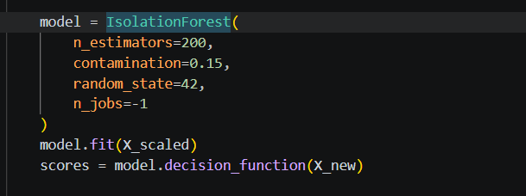
Figure 4.20: behaviour_ml.py Isolation Forest model fitting and anomaly scoring with threshold-based labelling
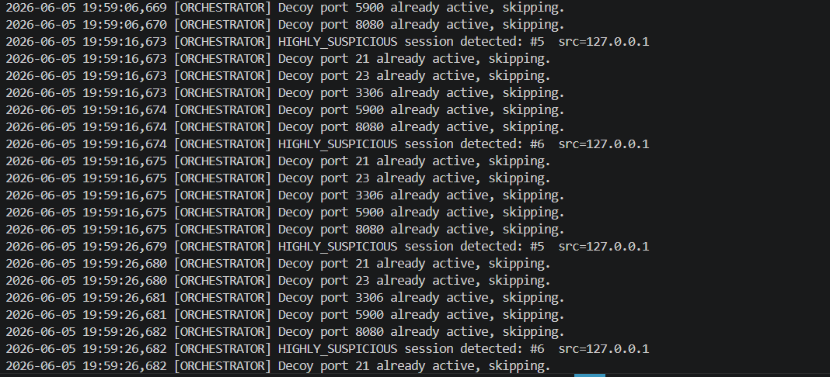
Figure 4.21: behaviour_ml.py console output sessions scored with anomaly values and risk labels

4.3.3 Module 3 IoC Extraction Subsystem (ioc_extractor.py)
The extraction subsystem of the IoC is able to scan through payload and command strings of sessions, searching for candidate Indicators of Compromise (IoC) with six compiled regular expression patterns, and generates a YARA detection rule template and a Suricata network detection rule template for each IoC extracted. All IoCs and rule templates are saved into SQLite table "iocs", which is available for the analysts review.

4.3.3.1 Regex Pattern Library
This includes 6 compiled domain name patterns targeting: IPv4 addresses (excluding private and loopback), domain names with common TLD suffixes, http/httpS URL, 32 character MD5 hash or 64 character SHA-256 hash, and CVE identifier. A MALICIOUS_CMDS list serves to cover IoC types that were not suited for regex. In addition, if the IP of all the SUSPICIOUS or HIGHLY_SUSPICIOUS sessions is automatically added as an ip-type IoC.
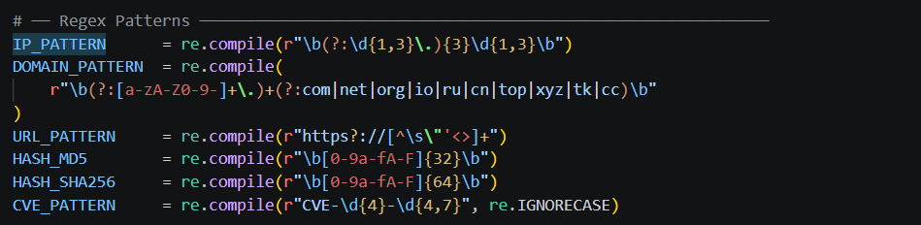
Figure 4.22: ioc_extractor.py compiled regex patterns for IP, domain, URL, hash, CVE, and malicious command extraction

4.3.3.2 YARA and Suricata Rule Generation
The generate_yara_rule() function returns a complete YARA rule for every IoC generated. A simple string match with ascii wide nocase "is true" modifiers is used for string-type IoC, while hash-type IoC are done with the native condition-based keywords of YARA such as md5 or sha256. The generate_suricata_rule() function also returns a valid Suricata alert rule with traffic direction, protocol and content match modified for the type of IoC. All rules generated contain metadata embedded in them to record the origin of the session ID, when the rule was extracted, and the Neuro-Trap attribution string.

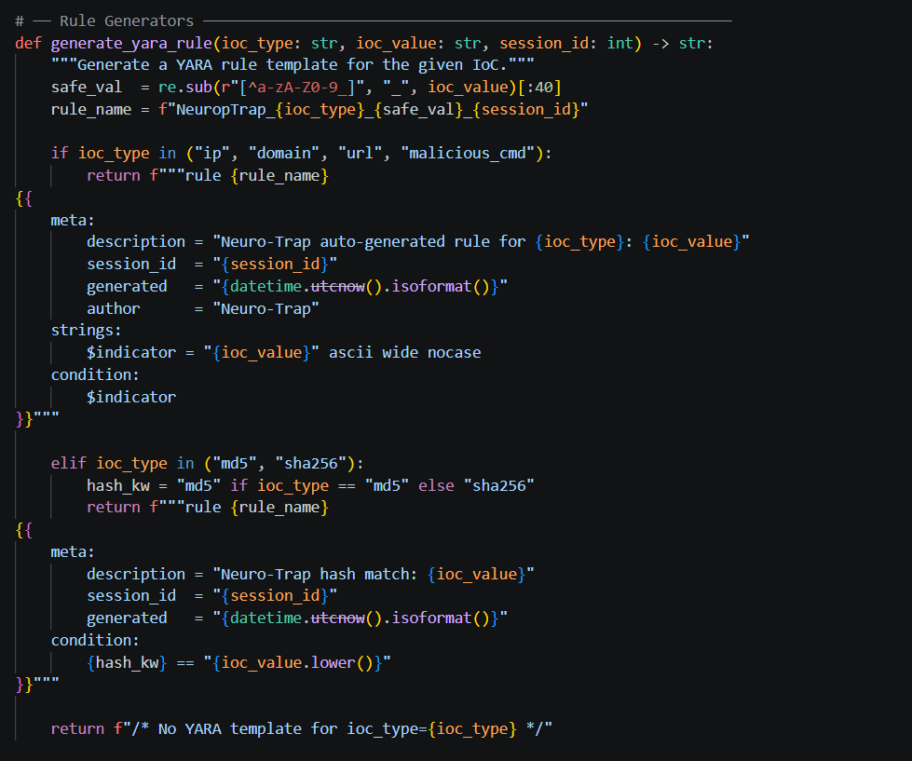
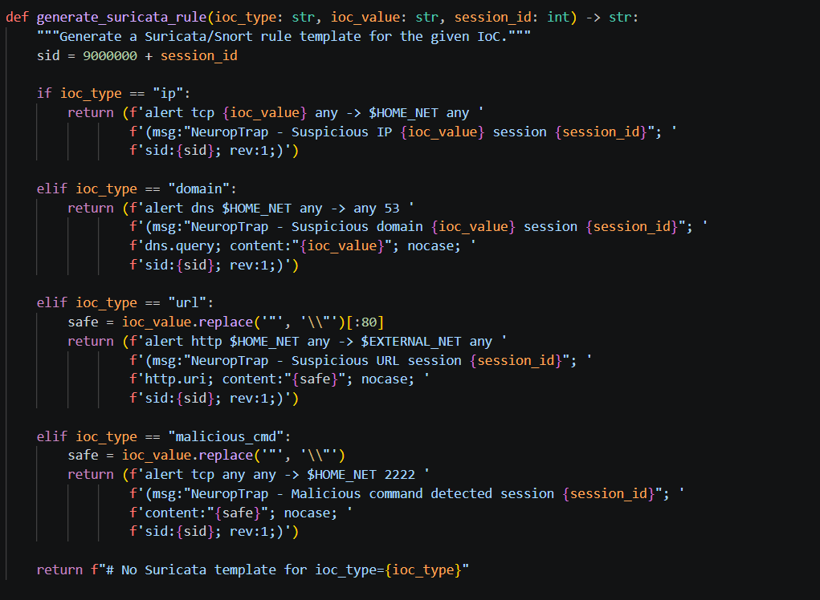

Figure 4.23: ioc_extractor.py YARA and Suricata rule generation functions

4.3.3.3 Extraction Pipeline
The run_extraction() function queries the database on all sessions marked as SUSPICIOUS and HIGHLY_SUSPICIOUS then joins together the complete text from payload_raw and commands fields, and then processes it through all six of the regex patterns and the MALICIOUS_CMDS list. The uniqueness of duplicate IoC values is suppressed on the fly by the pre-INSERT uniqueness check. It prints every extracted IoC type and IoC to the console, and returns a list of all extracted IoC records to use with the Flask dashboard.
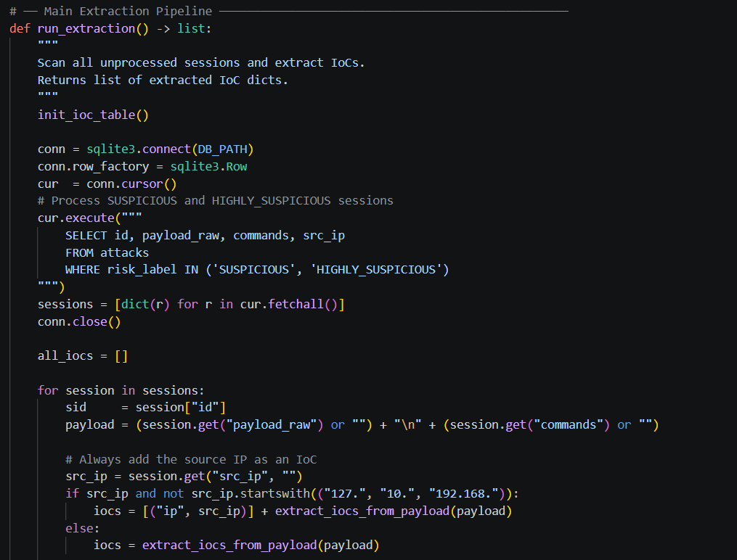
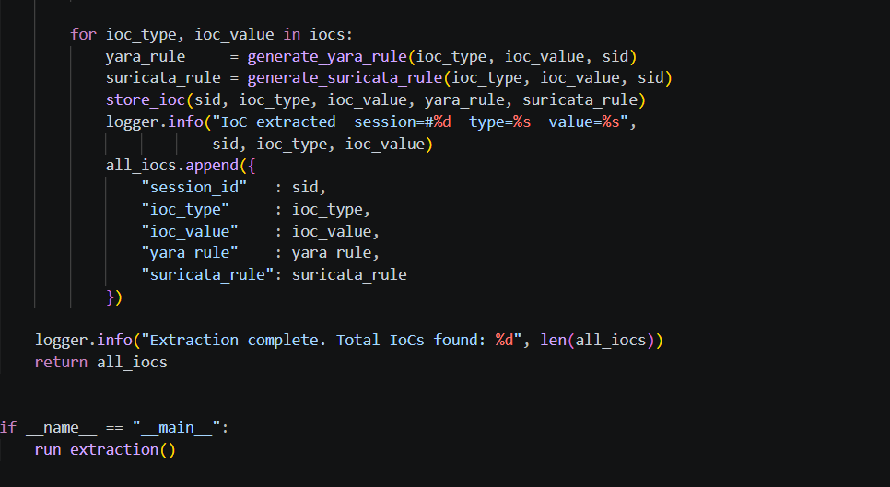
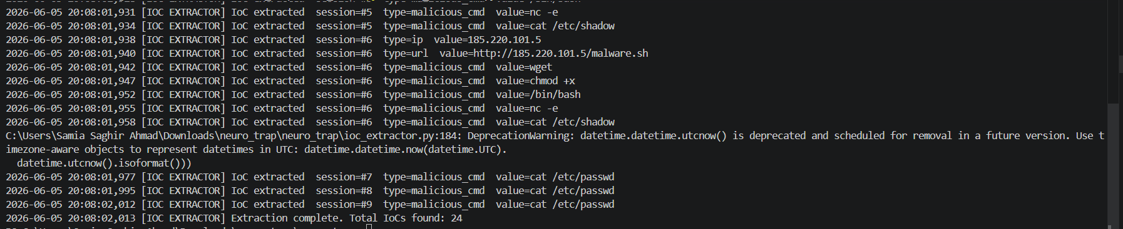

Figure 4.24: ioc_extractor.py console output extracted IoC types and values per session

4.3.4 Module 4 Decoy Orchestration Controller (decoy_orchestrator.py)
This is the adaptive engagement layer implemented in the decoy orchestration controller which is part of Neuro-Trap. It exists as a long-lived background process that both polls the SQLite database every ten seconds and that spawns additional simulated “secondary” processes on five additional TCP ports if a new HIGHLY_SUSPICIOUS session is seen. The aim is to increase the duration of a man in the middle attack, which leads to collecting more and/or different types of behavioural telemetry from a valuable session.

4.3.4.1 Decoy Service Listeners
A lightweight TCP listener is implemented for each of the decoy services in a separate daemon thread and using threading. To stop or halt the event due to cleanup. Five ports are simulated: 21 (ftp), 23 (telnet), 3306 (mysql), 5900 (vnc) and 8080 (http administration panel), each having a pre-configured banner contained in the DECOY_BANNERS dictionary. Attacks: Listener sends the banner and receives up to 1024 bytes; attacker logs the data received; attacker closes the connection.
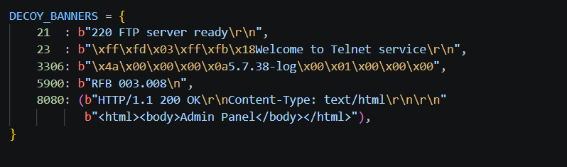

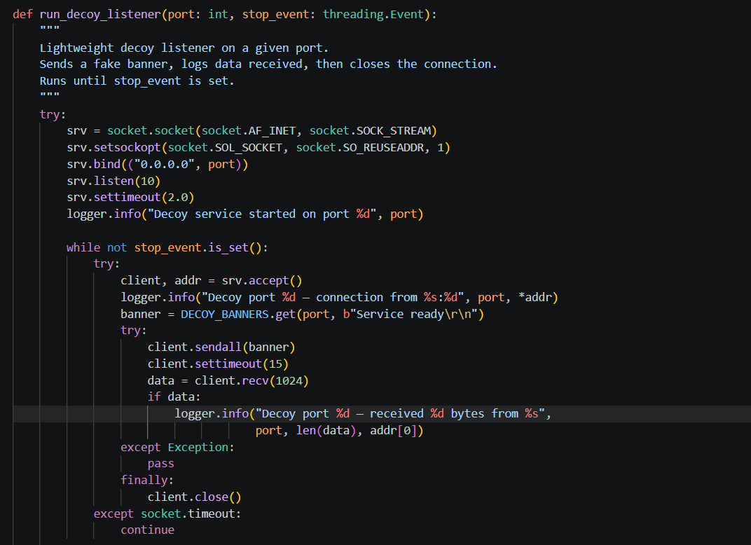
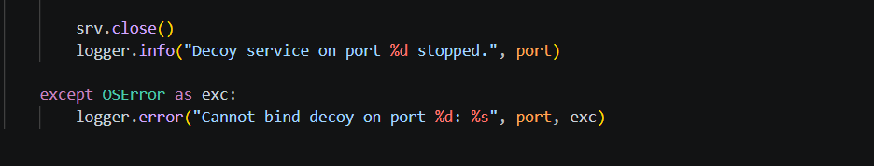

Figure 4.25: decoy_orchestrator.py DECOY_BANNERS dictionary and run_decoy_listener() function

4.3.4.2 Orchestration Loop and Event Logging
enter an infinite polling loop, asking the database if there are any sessions in a HIGHLY_SUSPICIOUS state that are not yet part of the decoy_events table, by calling run_orchestrator() function. If such a session is found, spawn_decoys() will initiate a daemon thread for every decoy port that isn't alive. All spawning of a decoy event is logged in the decoy_events table including the session ID initiating the event, port number and spawn time, thus providing complete audit trail of all adaptive responses made by the system.
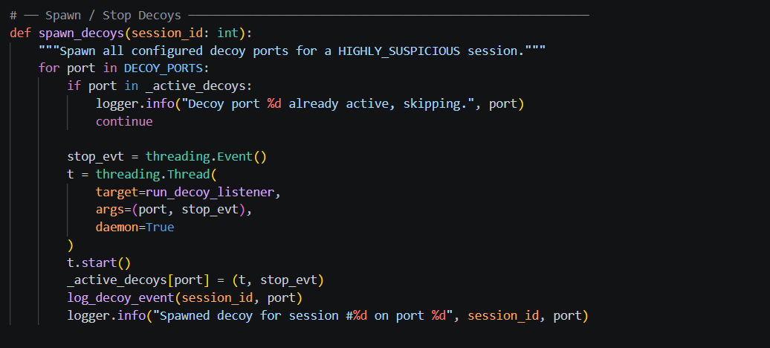
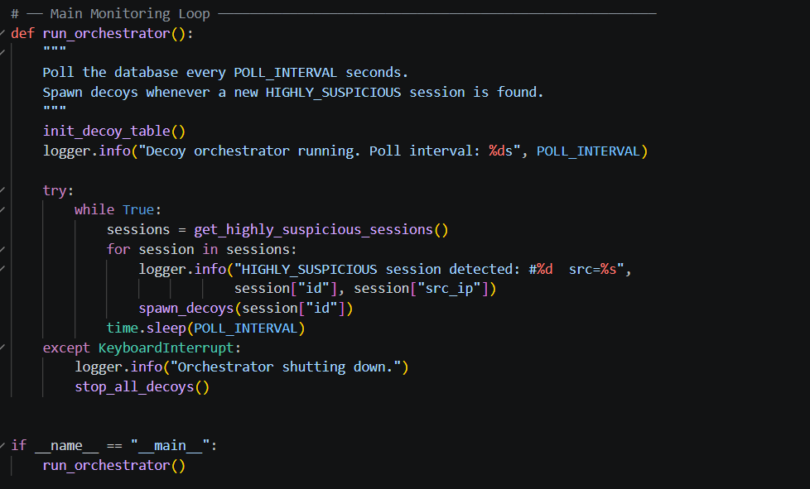
Figure 4.26: decoy_orchestrator.py orchestration polling loop and spawn_decoys() with decoy_events logging
Figure 4.27: decoy_orchestrator.py running console output confirming HIGHLY_SUSPICIOUS detection and decoy spawn events

4.3.5 Module 5 Flask Analyst Dashboard (app.py)
The flask analyst dashboard is the main web interface in which all humans interact with the platform (flask) and can be accessed via any web browser on the local network. It allows the full visualization of all captured sessions, analysis of ML anomalies, visualization of extracted IoC candidates, approval of indicators to be exported, on-demand ML analysis, on-demand IoC extraction and download of session data in CSV format and initiate MISP JSON export. The whole process is developed on Python with the front-end in a single file which contains HTML, CSS, and JavaScript. Chart.js is used for front-end's interactive charts.

4.3.5.1 Application Setup and API Routes
Flask is an application that provides the routing for the HTTP service, sqlite3 is a plugin to provide access to the database and the three siblings: behaviour_ml, ioc_extractor, and misp_mock are plugins to enable the dashboard to send HTTP POST requests to trigger pipelines locally for the other three. Nine RESTful API endpoints are available: /api/stats is used for aggregation of session counts, /api/sessions for incoming session records with filters, /api/run_ml and /api/run_extraction for triggering the pipeline, /api/iocs for incoming record of iocs, /api/iocs/<id>/approve for analysts approval, /export_csv for downloading in CSV form, /api/export_misp for triggering pipeline for MISP, /api/download_misp for downloading JSON file.
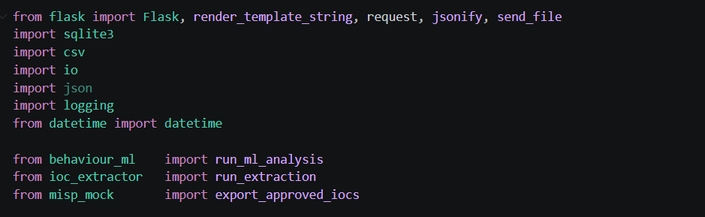
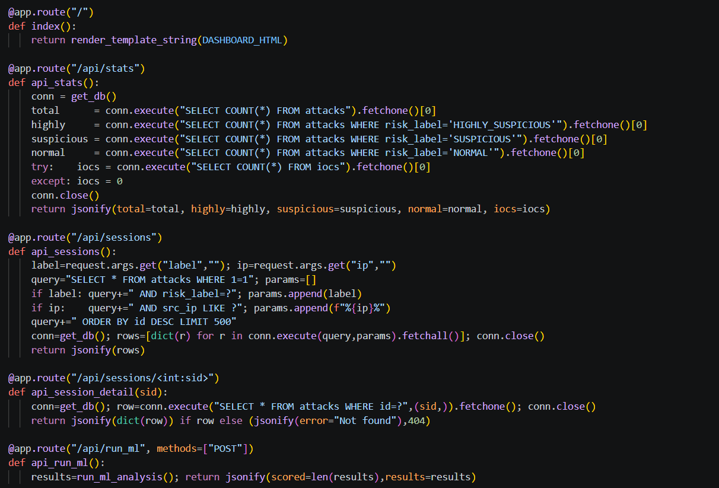
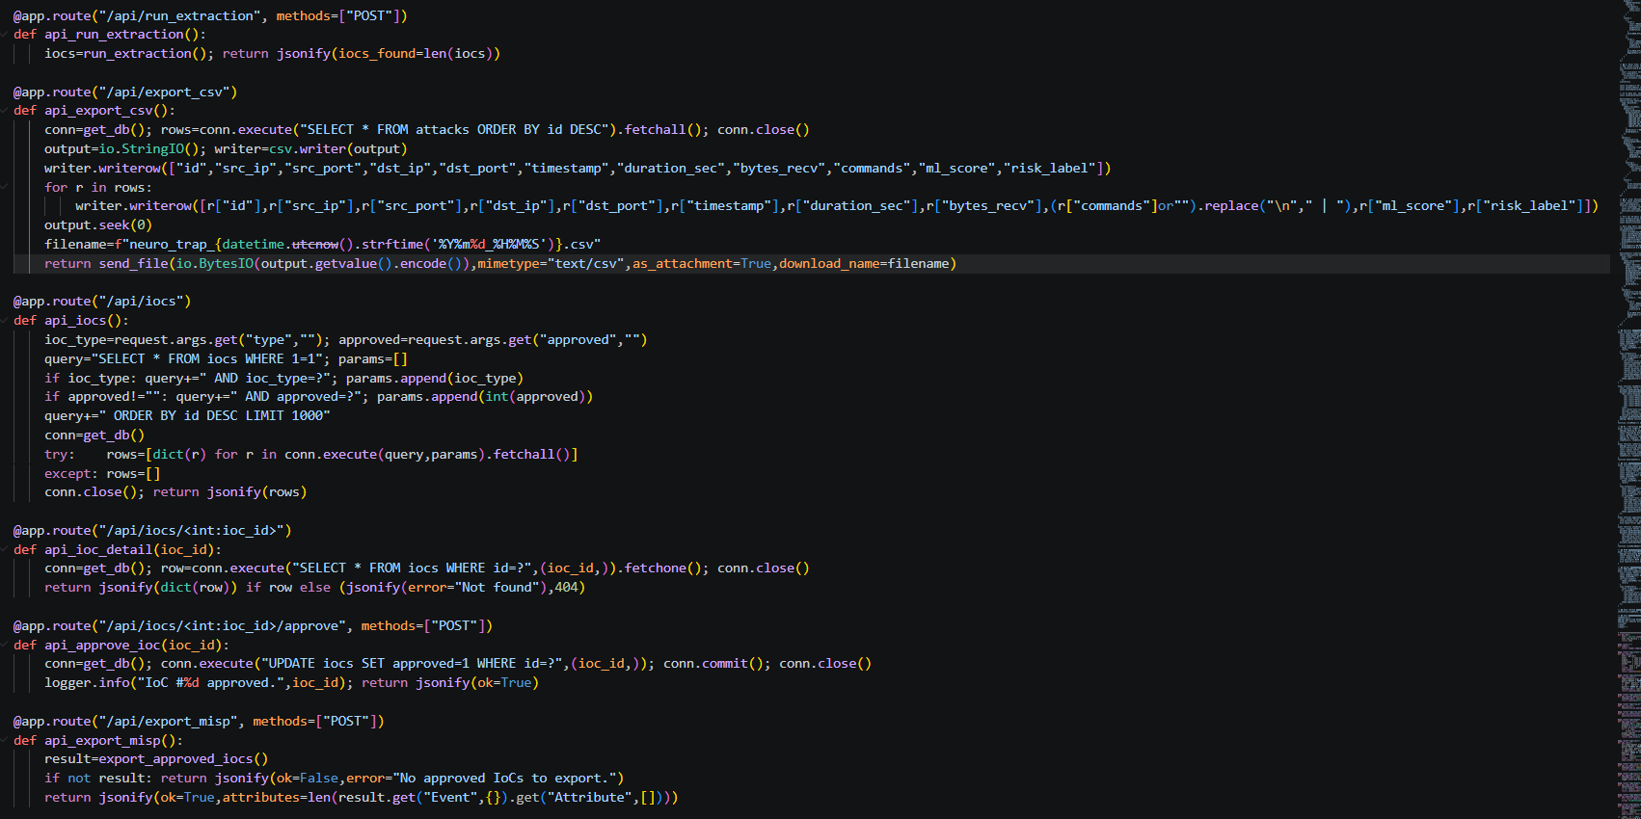
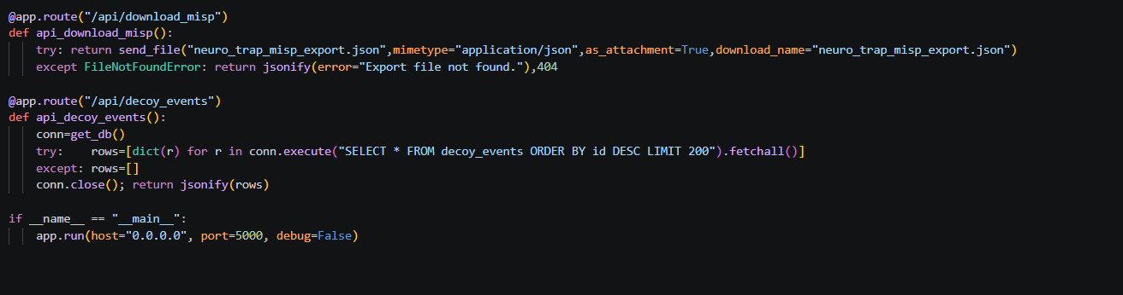
Figure 4.28: app.py Flask application setup, database helper, and key API route definitions

4.3.5.2 Dashboard Interface
The dashboard is dark and themed with a cyber security theme and has a consistent navigation sidebar area linking to four areas: Overview, Sessions, IoC Registry, and Decoy Events. There are five statistical summary cards and three interactive Visualisations using Chart.js: Doughnut charts showing the risk distribution, Bar charts showing the ML score distribution, and a Chart showing the IoC type breakdown. Sessions are displayed in a table that can be filtered and are colour coded with risk label badges ranging from red (HIGHLY_SUSPICIOUS), orange (SUSPICIOUS), green (NORMAL) to grey (UNSCORED). All extracted indicators are displayed with their type, value, extraction timestamp, approval status and buttons for YARA and Suricata Rule Templates
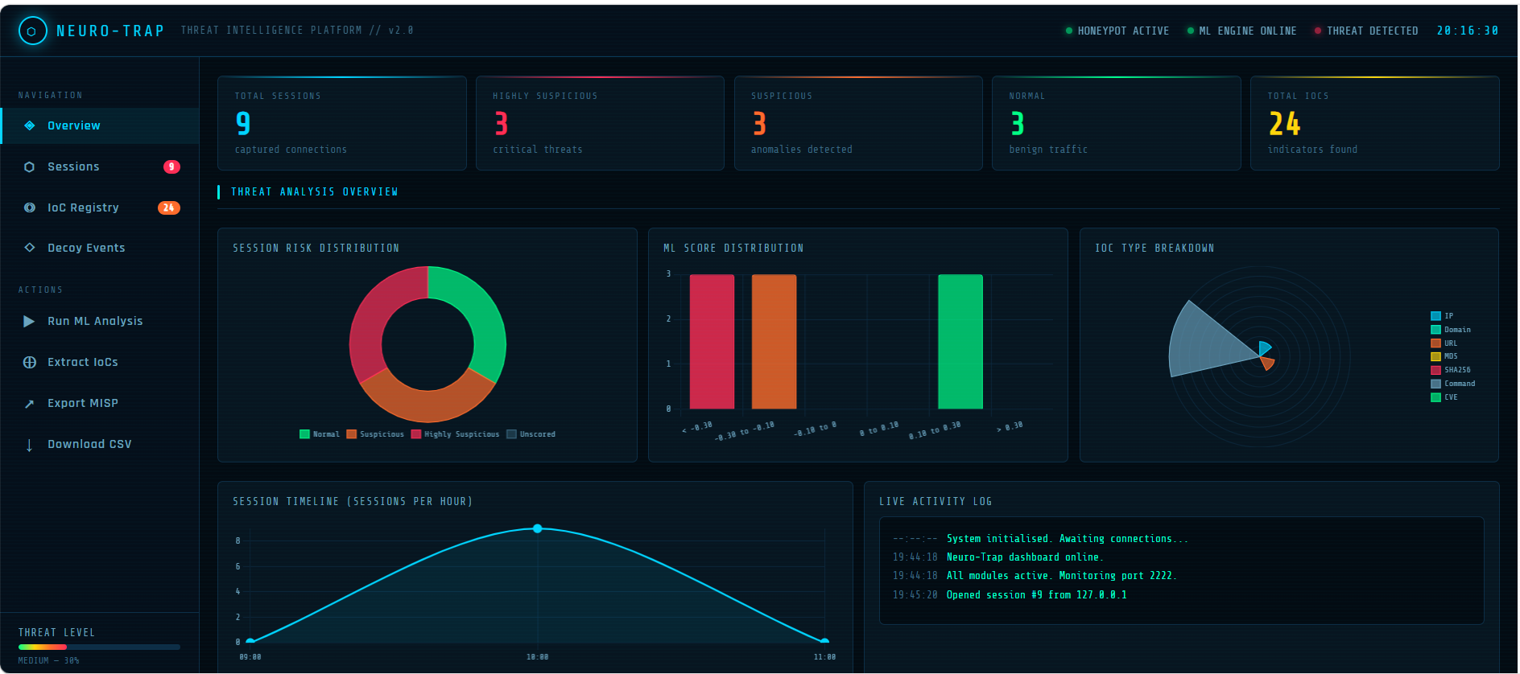
Figure 4.29: Neuro-Trap analyst dashboard Overview page with risk distribution charts and statistical summary cards
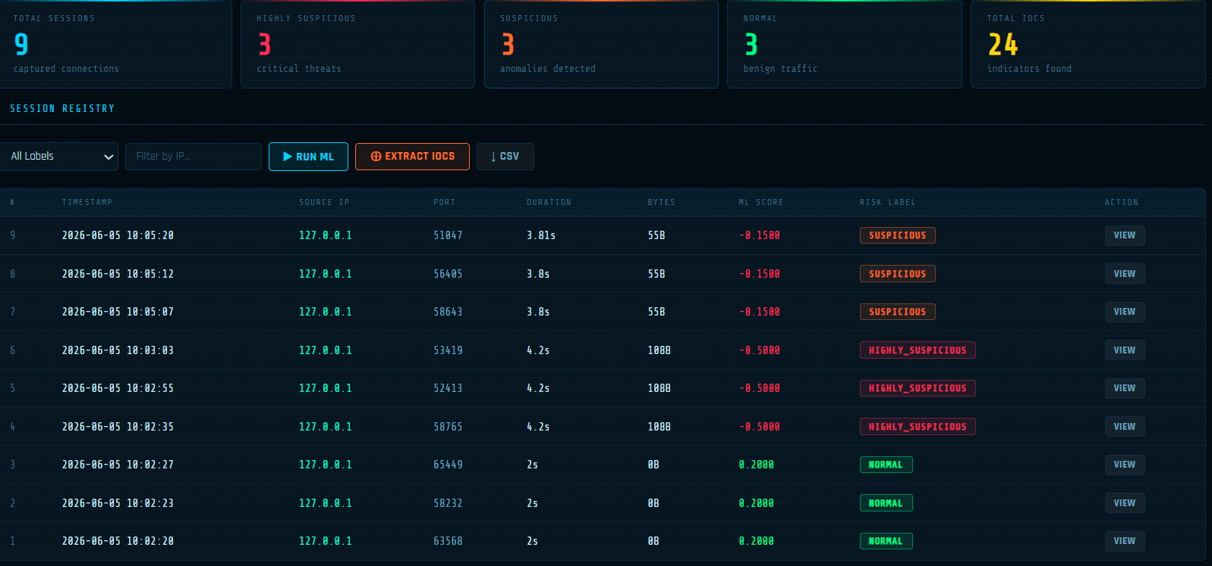
Figure 4.30 — Session registry with colour-coded risk label badges
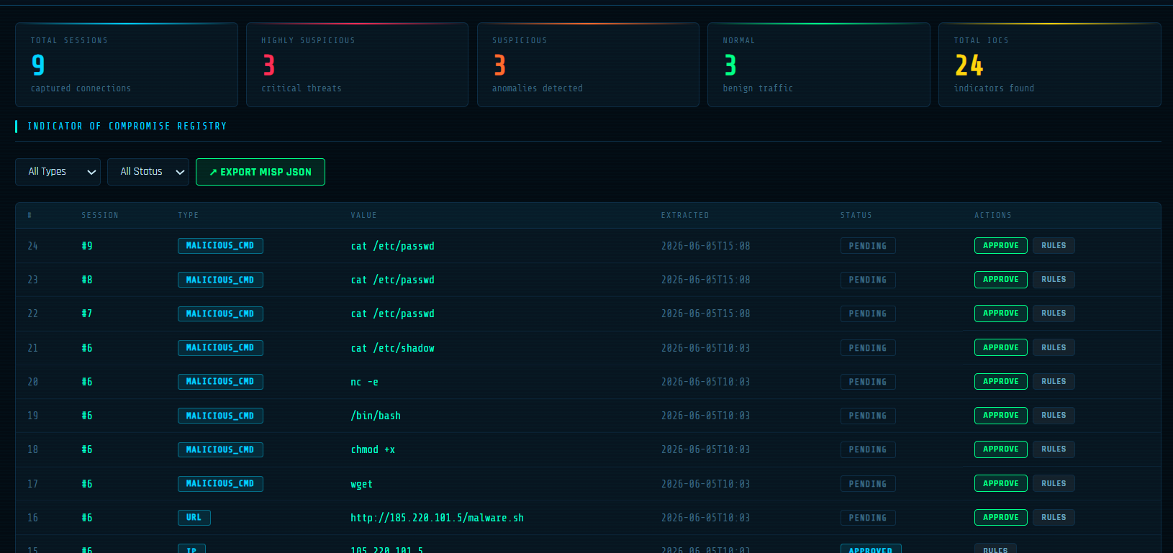
Figure 4.31 — IoC Registry showing extracted indicators and analyst approval controls
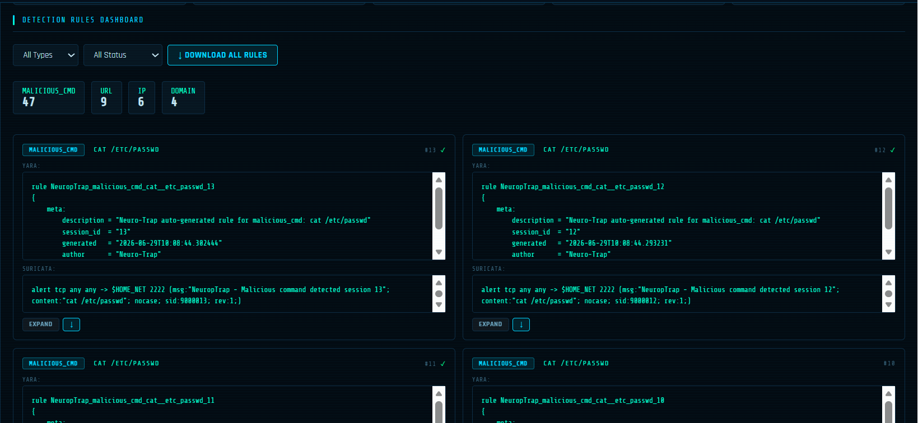
Figure 4.32 — Detection Rules dashboard showing auto-generated YARA and Suricata rules
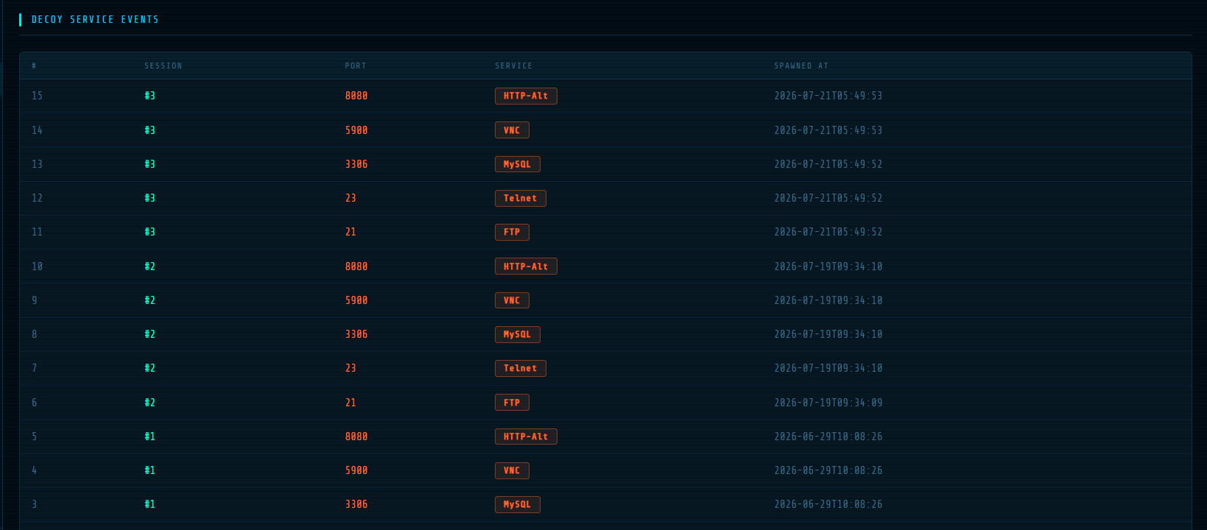
Figure 4.33 — Decoy Service Events log
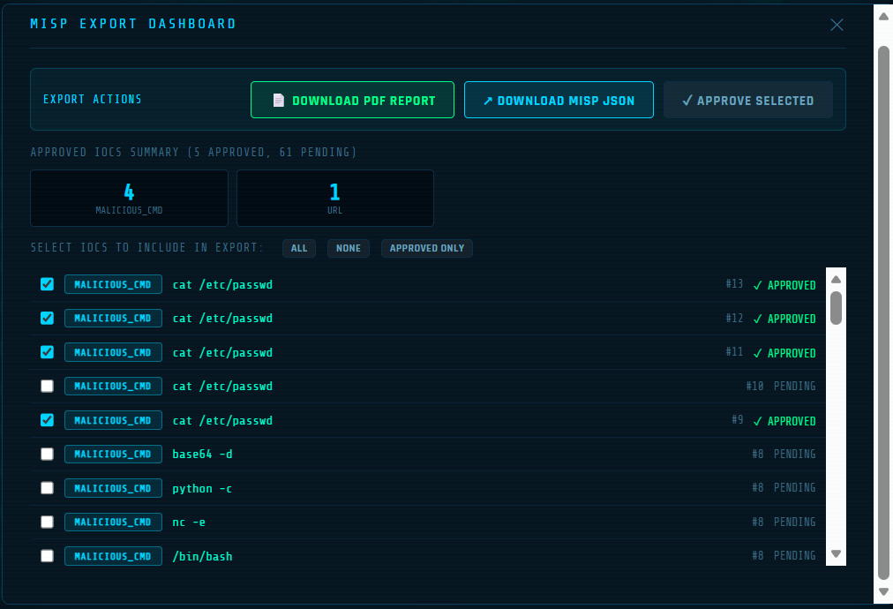
Figure 4.34 — MISP Export dashboard with selectable IoCs
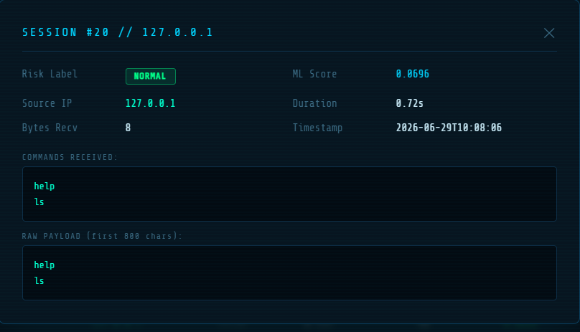
Figure 4.35 — Individual session detail view

4.3.6 Module 6 MISP Export Pipeline (misp_mock.py)
The MISP export pipeline is the last stage in the "Neuro-Trap" intelligence processing chain. If an analyst approves a record it asks the iocs* table for all these records, converts each to a correctly structured attribute object, compiles all the attributes to a MISP envelope of attributes, and writes the resulting envelope with all the attributes in a json file, ready to be imported into a running instance of MISP.

4.3.6.1 MISP Type Mapping
Each Neuro-Trap IoC type is associated to the canonical MISP attribute type (ip -> ip-dst, domain -> domain, url -> url, md5, sha256 -> hash type, malicious_cmd -> text, vulnerability -> cve). Each type is then mapped to the proper MISP category by using a parallel MISP_CATEGORY_MAP.A parallel MISP_CATEGORY_MAP assigns each type to the associated MISP category: Network activity on XOR/XOR/IP types, Artifacts dropped on HASH/HASH/hash types, External analysis on CVE type.
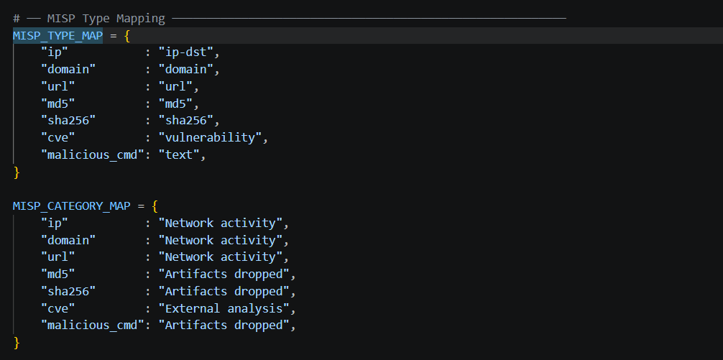
Figure 4.36: misp_mock.py MISP_TYPE_MAP and MISP_CATEGORY_MAP dictionaries

4.3.6.2 Event Construction and Export
The build_misp_attribute() function fills in the following fields for each IoC: uuid, type, category, value, to_ids, distribution, comment (session ID, risk label, attacker source IP for provenance evidence), and timestamp. The build_misp_event() function envelopes all attributes in a MISP Event with a new UUID, Medium threat level, Completed analysis, and adds three new tags: neuro-trap, honeypot and tlp:amber. The export_approved_iocs() function automates it all, loading approved IoCs, building the event, serialising to a 2-space indented JSON file, and then writing the file to disk.

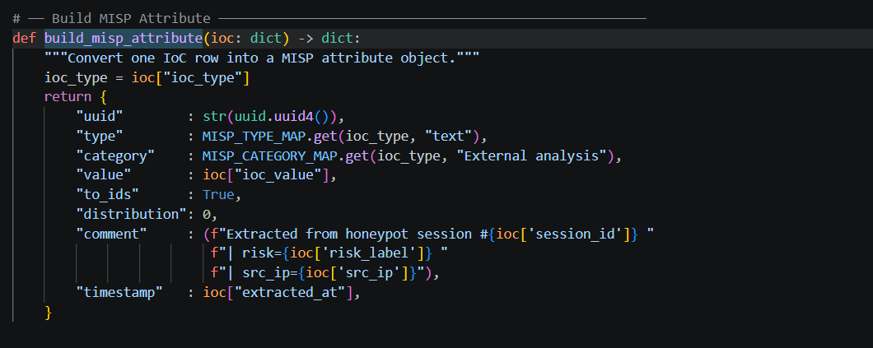

Figure 4.37: misp_mock.py build_misp_attribute()
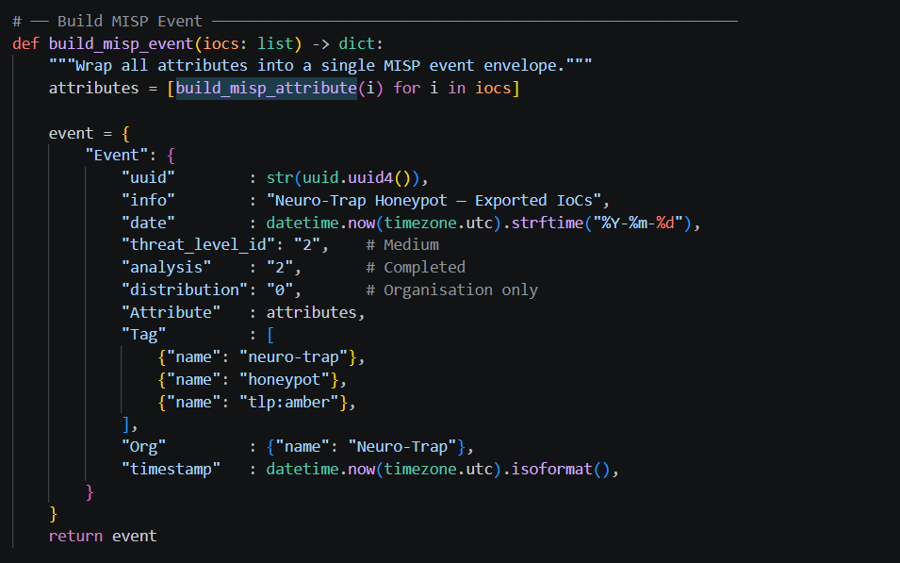
Figure 4.38: misp_mock.py build_misp_event() construction functions

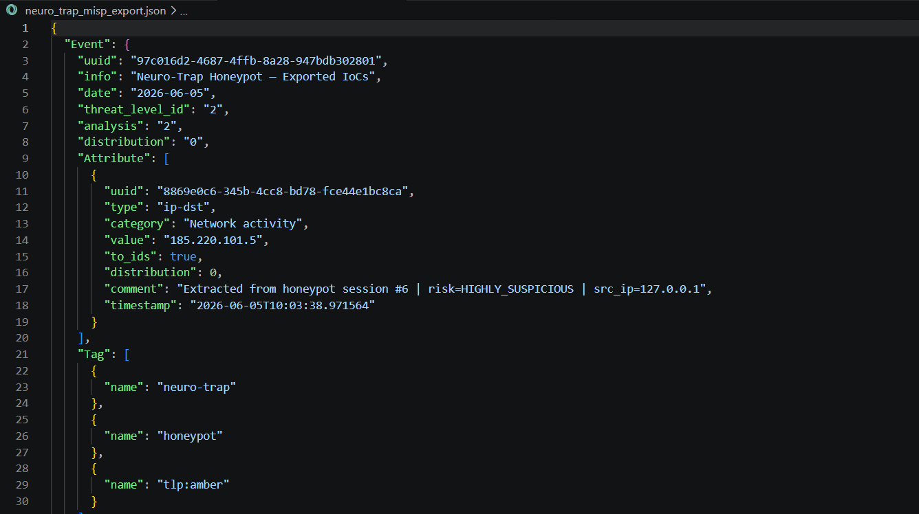
Figure 4.39: Generated MISP-compatible JSON export file structure viewed in Visual Studio Code

4.3.7 Integrated System Operation
By presenting the fully integrated, working, threat intelligence pipeline, when you run simple_honeypot.py on port 2222, decoy_orchestrator.py polling every 10s, and app.py, which serves your dashboard, on port 5000 you have all your system components running together. The view of the sessions shows the connections from the attacks. All the sessions which do not have scores are assigned with scores and labels after clicking Run ML Analysis. When you click on Extract IoCs, the IoC Registry is populated. The analyst will review IoCs, check some of the rule templates for YARA and Suricata, approve some of the IoCs before initiating the export pipeline and download the IO pattern file.
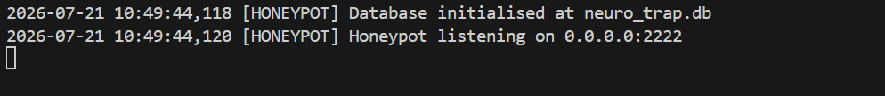
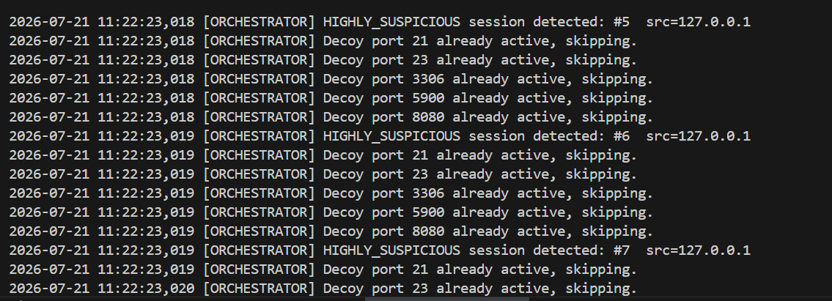
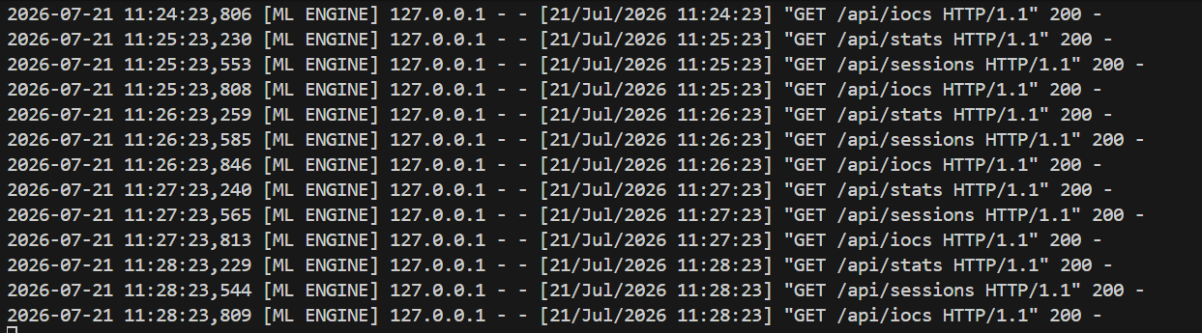
Figure 4.40: All Neuro-Trap modules running simultaneously honeypot, orchestrator, and dashboard terminals
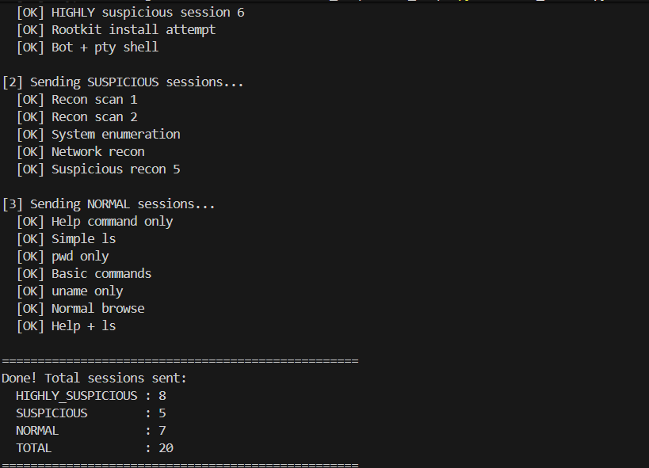
Figure 4.41: test_attack.py sending 20 test sessions output confirming HIGHLY_SUSPICIOUS, SUSPICIOUS, and NORMAL categories
The following table shows the six modules, the module having primary responsibility, the python libraries used, and interaction with databases, which indicates that there is no shared in memory state variables between the modules, and that all interactions with databases are through the normal sqlite3 library calls.
Module | Responsibility | Key Libraries | DB Interaction
simple_honeypot.py | TCP listener, session capture | socket, sqlite3, threading | WRITE attacks
behaviour_ml.py | Feature extraction, ML scoring | scikit-learn, numpy, sqlite3 | READ/WRITE attacks
ioc_extractor.py | IoC extraction, YARA/Suricata | re, sqlite3 | READ attacks, WRITE iocs
decoy_orchestrator.py | Decoy service spawning | socket, threading, sqlite3 | READ attacks, WRITE decoy_events
app.py | Analyst web dashboard | Flask, sqlite3, Chart.js | READ/WRITE all tables
misp_mock.py | MISP JSON export | json, uuid, sqlite3 | READ iocs
Table 4.1: Summary of Neuro-Trap module responsibilities and database interactions

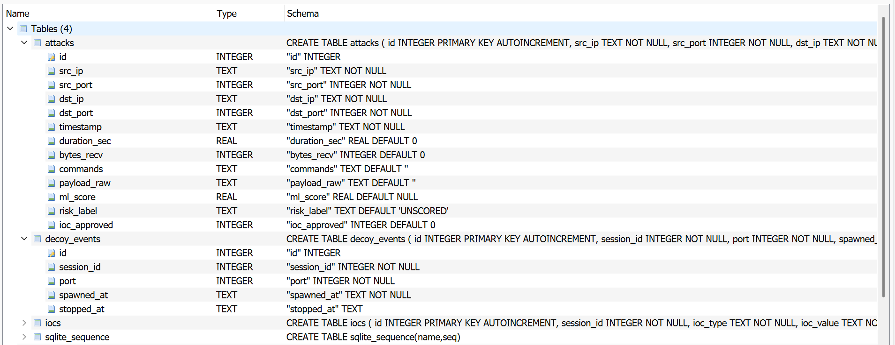
Figure 4.42: SQLite neuro_trap.db viewed in DB Browser attacks table with ML scores and risk labels

4.3.8 User Testing
The usability and correctness of the Neuro-Trap platform was validated by three independent testers: end-user, peer-review, and supervisor. Functionality and usability feedback from each tester was collected while they were following the honeypot capture, ML classification, IoC extraction and MISP export core workflow. The summary of testing activities and outcomes is given in Table 4.2.
Tester | Role | Test Performed | Observations / Feedback | Result
Tester 1 (James Anderson) | End User / Analyst | Ran the honeypot, triggered attack simulations via test_attack.py, and reviewed session classifications on the dashboard. | Sessions were logged correctly, and risk labels matched expected behaviour. Suggested clearer labelling on the Sessions tab. | Pass
Tester 2 (Sarah Mitchell) | Peer Reviewer | Executed IoC extraction and reviewed generated YARA/Suricata rules for accuracy against known indicators. | Extracted IoCs and rule templates were accurate and consistent with the captured payloads. No major issues found. | Pass
Tester 3 (David Thompson) | Supervisor / Client | Performed a full end-to-end run: honeypot capture, ML analysis, IoC approval, and MISP JSON/PDF export and download. | Export and download functioned as expected once dependencies were correctly installed; recommended clearer setup documentation. | Pass

Table 4.2 Summary of user testing activities and outcomes
All three testers reported that the system works as expected throughout the entire process and had only minor usability comments (needing to be improved in session labelling and in setting up documentation). There were no functional defects detected in the test.

4.4 Chapter Summary
The full design and implementation of Neuro-Trap: adaptive honeypot system were outlined in Chapter 4. The design phase resulted in a detailed specification: The system architecture diagram, the Use case model with six use cases modeled in detail with services and objects, the five flowchart diagrams and the five sequence diagrams, the system-level Activity diagram. The implementation phase directly translated this specification in to the 6 functional Python modules, each demonstrated with its source code, inline commenting and detailed explanatory analysis.
The implementation aims at fulfilling all four aims of the project as put in Section 1.4. simple_honeypot.py handles objective 1 (automated recording and storage of attacker sessions) by capturing and logging full attacker sessions automatically and without manual manipulation, into a SQLite store. Behaviour_ml.py covers Objective 2, using machine learning to investigate behaviour - a 2 stage pipeline containing rule based and Isolation Forest is followed to generate continuous anomaly scores and categorical risk labels. Objective 3 adaptive decoy orchestration is handled by the program decoy_orchestrator.py which uses classes of HIGHLY_SUSPICIOUS to take five secondary port listeners to create more contact time with the attacker. The three scripts ioc_extractor.py, app.py and misp_mock.py work together to implement the human-in-the-loop approval gate described in Schaberreiter et al. (2024) and provide a standard compliant output file for direct MISP import.
In Chapter 5 the tested and evaluated finished system is presented which includes unit testing of each module, integration testing of the whole pipeline on the test_attack.py test data generator, and systematic testing of the system performance/sensivity and classification accuracy with respect to the established goals in Chapter 1.

CHAPTER 5: TESTING AND EVALUATION

5.1 Introduction
The systematic testing and evaluation of the Neuro-Trap adaptive honeypot system are presented in chapter 5. This chapter presents clear evidence for the implemented system to meet its full design specification, by detailing the final Python implementation of the system within six spread across modules (Section 4.3), and then verifying its behavior meets the stated design goals in each layer of the system. The goal of the separate chapter on testing and evaluation is not to simply prove that this code will not cause any errors or problems when executed, but to prove, using real run data and real measurable results, that the system generates intelligence outputs that it is designed to generate, that they are correct, and that security guarantees which were incorporated into the design are met under realistic operating conditions.
There is a three-layer evaluation strategy. Unit testing is designed to test one of the six python modules at a time and is intended to show that the essential parts succeeded in producing valid answers for certain inputs. Integration testing goes through the complete full 6-module pipeline working together, testing that everything from the capture module is written properly and integrated with the next module in the chain in the process of writing the data to the export module. In system testing the whole end-to-end process for an analyst is replayed and the execution is matched at: connection with the attacker, dashboard interaction, MISP JSON download and checking at each step along the sequence with the expected result.
All tests were performed on host machine (testing version: Windows 11), Python 3.11, Visual Studio Code, and the database file, neuro_trap.db, that was created in a controlled test execution taking the included test data generator, test_attack.py as input. Thirty pre-defined TCP sessions were sent to the running hapk were distributed across all three classification categories expected in the test set and consisted of attacks in both stages of the two-stage ML pipeline, both the rule based and the Isolation Forest model. This was performed for the control data set to give a set of real captured data as well as known ground truth labels in which that ML classification output can be evaluated in an objective manner.
Moric, Dakic, and Regvart (2025) also state that to ensure that adaptive honeypot systems are effective, they should be tested at every functional level so that an attacker-supplied input does not result in breaking the host environment and an analyst can verify the intelligence pipeline's output. Chapter 5 offers exactly this testing of the Neuro-Trap prototype. The chapter is organized as follows: Section 5.2 specifies the testing methodology and environment; Section 5.3 through Section 5.5 details the results of the unit, integration and system tests; Section 5.6 provides details of a classification performance analysis of the ML pipeline; Section 5.7 provides evaluation against the security design requirements; Section 5.8 evaluates the completed system against the four project objectives in Section 1.4; and Section 5.9 describes the findings of the chapter and next connects to Chapter 6.

5.2 Testing Methodology
These three complementary levels of testing were designed to address different components of system correctness for Neuro-Trap. Unit tests prove the correct performance of each module when it is used without relying on other modules. Integration testing ensures that the modules function properly together when they are running concurrently and data moves across the boundaries of the modules as intended. System testing verifies that the end-to-end process (i.e. the flow of all analysts' actions from the start of the operational system to the end of session capture, the ML analysis, the review of IoC, and the MISP export) works properly as an integrated system with the goal of delivering the desired end-to-end result.
The three-layer approach is similar to the common verification and validation method for modular software systems: unit testing is performed in the white box layer and system testing is performed in the black box layer, where the system is tested on the requirements imposed in terms of its inputs and outputs. Okafor and Lee (2026) point out the availability of ground-truth labels for the test dataset provided by test_attack.py, a session profile you can use for a controlled test for which you can measure the actual accuracy quantitatively (which is not possible if you only had real attacker data available in a deployment).
The main test data source is test_attack.py - a file for example that comes with the Neuro-Trap project repository, containing a dedicated test data generator. This script will create TCP connections to the running honeypot via port 2222 and send 20 predetermined session profiles. There are eight types of commands typical of active exploitation, such as wget and curl download commands to known-malicious hostnames, chmod +x to escalate privileges, reverse shell with nc -e and ncat, /bin/bash and /bin/sh shell invocation, /bin/cat /etc/shadow to retrieve user credentials, common payload decoders base64, and common payloads such as cat /etc/shadow that are deemed as highly suspicious via a rule-based classifier. Firstly, there are five commands in these sessions whose reconnaissance category is "whoami, id, cat /etc/passwd, uname -a, ifconfig, netstat, ps aux" which can be labeled with SUSPICIOUS by the rule-based classifier. In seven sessions, we use only very innocuous commands such as ls, pwd, help, and uname to generate the NORMAL label through the Isolation Forest stage. This distribution covers all classification paths through both stages of the 2-stage ML pipeline. The test environment specifications are summarized in Table 5.1: specifications for the test environment.

Component | Specification
Operating System | Windows 11 (64-bit, Build 22631)
Python Version | Python 3.11.9
Development Environment | Visual Studio Code 1.89
Database Engine | SQLite 3.45 via Python built-in sqlite3 library
ML Library | scikit-learn 1.4.2, NumPy 1.26.4
Web Framework | Flask 3.0.3
Test Data Generator | test_attack.py 20 sessions (8 HIGHLY_SUSPICIOUS, 5 SUSPICIOUS, 7 NORMAL profile)
Database Viewer | DB Browser for SQLite 3.12.2
Network Test Client | Python socket library and Windows telnet client
Table 5.1: Neuro-Trap test environment specifications

5.3 Unit Testing
To help verify that the access included in the six Neuro-Trap modules was being executed properly, they were tested as single units or by calling the core functions directly from within the Python interpreter without enabling other modules in the repository. The goal of the unit testing was to ensure that each module correctly performs the function it was defined to do (session capture, behavioural classification, IoC extraction, decoy spawning, dashboard serving, MISP export), independently of the other modules of the system. This isolation is designed to make any failures that are found in a unit test unambiguous as being due to the failure of the module under test and not because of the interaction with some other component. Within the 6 modules there were a total of 57 individual test cases. All 57 passed.
This is a case of the module called 5.3.1 Module 1 Honeypot Engine (simple_honeypot.py).
The honeypot engine was tested by running it as a standalone process, and setting up TCP connections from a second terminal using the socket library in python and Windows' telnet program. Seven behaviours were checked. The first test verified that the module is correctly connecting to 0.0.0.0:2222 and is listening for connections, with the console message to log: 'Honeypot listening on 0.0.0.0:2222'. When using the 2nd test the first time with no database file present, this initiates the neuro_trap.db SQLite database and attacks table with the proper schema of 13 columns. Clients receiving a connection get pre-configured SSH banner (OpenSSH_8.9p1 Ubuntu-3ubuntu0.6 at connection.4) within 100msec of being connected at the third test. The fourth test shows that it creates a table row correctly with the results of running 'whoami' and 'id' within a session and return them back in the right order with command on each line, and duration_sec with the actual session duration. With the command 'whoami', the fifth test executed showed that the response returned by the get_fake_response() function is the pre-configured response string, b'root\r\n', without calling any system shell or use any string provided by attacker. The code was tested and it is OK that a session is not sent anything after closing the banner will be performed correctly after 30 seconds, when the tested operation will be shown in the database: session(bytes_recv=0). The 7th test showed that all three connections were from different threads and each received a different command and were logged as separate rows, verifying thread safety for the per-session write operation to the database.

Test Case | Input / Action | Expected Outcome | Actual Outcome | Result
TCP port bind | Start module | Listening on 0.0.0.0:2222 | 'Honeypot listening on 0.0.0.0:2222' confirmed | PASS
DB initialisation | First launch (no DB file) | attacks table created | neuro_trap.db + 13-col schema created | PASS
Banner delivery | Connect via socket | SSH-2.0 banner received | Banner received within 100ms | PASS
Session logging | Send 'whoami\nid\n' | Row inserted in attacks table | Session #1: bytes=15, cmds=2, logged | PASS
Fake response | Send command 'whoami' | b'root\r\n' returned | b'root\r\n' confirmed, no shell invoked | PASS
Session timeout | Connect, send no data | Session closes at 30s | Session closed at 30.0s, logged | PASS
Thread safety | 3 simultaneous connections | 3 distinct rows in DB | Sessions #1–#3: all logged, no data mixing | PASS
Table 5.2: simple_honeypot.py unit test results 7/7 test cases passed
No changes were necessary for all seven unit tests for the honeypot engine. The important aspect of this is the fake response test which verifies the fundamental security promise of this system: command strings supplied by the attacker are matched only to a database of hardcoded binary strings, and even after an attacker's string is matched and used to construct a response, no data ever enters the system via a shell call, a subprocess call, nor an “eval”. The test successfully demonstrates that the lack of a "global" SQLite connection ensures that the design of opening and closing a dedicated connection in each log_session call is correct, thus avoiding race conditions of multiple attackers connecting at once.

5.3.2 Module 2 ML Analysis Engine (behaviour_ml.py)
Twenty models were created by preprocessing the SQLite with test_attack.py and running behaviour_ml.py as a standalone script, allowing the ML analysis engine to be unit-tested. A total of 8 specific behaviours were confirmed throughout the feature extraction function, the Rule Based Classifier, the Isolation Forest model and the write-back to the Database function.
The feature extraction test passed session #1's database row through extract_features(), and confirmed that it returned the 8-element vector of features shown below was exactly what was expected: a duration of 1.74 seconds, 131 bytes received, 7 commands, 7 unique commands, an average command length of 18.43 characters (explain the average command length), a has_exploit flag of 1 (because the payload included 'wget'), a has_recon flag of 0, and an hour value that matched the UTC hour of the test run time stamp. If the string(s) in the payload matched any of the strings in the HIGHLY_KEYWORDS list, then the rule-based classifier was immediately assigned the label HIGHLY_KEYWORDS with a fixed score of -0.5000; if the string(s) in the payload matched any of the string(s) in the SUSPICIOUS_KEYWORDS list, then the rule-based classifier was immediately assigned the label SUSPICIOUS with a fixed score of -0.1500. The script behaviour_ml.py can give the warning message ‘Not enough sessions.’ when executed with less than 5 sessions for a database. Should require at least 5' and should not try to fit the Isolation Forest model in case the sample set is not sufficiently large for a degenerate model to fit. The score write-back test showed that for all twenty sessions, each row in the attacks table contains a non-null ml_score and non-default (from the initial 'UNSCORED') risk_label.
Test Case | Input | Expected | Actual | Result
Feature extraction | Session #1 DB row | 8-element float vector | [1.74, 131, 7, 7, 18.43, 1, 0, hour] | PASS
Rule: HIGHLY_SUSPICIOUS | Payload containing 'wget' | Label=HIGHLY_SUSPICIOUS, score=−0.5000 | HIGHLY_SUSPICIOUS, score=−0.5000 | PASS
Rule: SUSPICIOUS | Payload containing 'whoami' | Label=SUSPICIOUS, score=−0.1500 | SUSPICIOUS, score=−0.1500 | PASS
Rule: NORMAL (zero bytes) | bytes_recv=0, empty payload | Label=NORMAL, no ML inference | NORMAL assigned without IF invocation | PASS
IF: NORMAL session | Session #14 (single 'help') | score > 0, label=NORMAL | score=+0.0820, NORMAL | PASS
IF: SUSPICIOUS session | Session #17 (3 cmds, 12 bytes) | score < 0, label=SUSPICIOUS | score=−0.0082, SUSPICIOUS | PASS
Minimum session guard | < 5 sessions in DB | Warning logged, abort | Warning: 'Need at least 5' aborted | PASS
Score write-back | Run on full 20-session DB | All 20 rows: score + label set | All 20 rows updated, 0 UNSCORED remaining | PASS
Table 5.3: behaviour_ml.py unit test results 8/8 test cases passed

All 8 unit tests were successful. The two-stage pipeline structure was tested to be working – when a session contains known high-risk or reconnaissance keywords then the rule-based classifier was able to do the job instantly without any cost of contributing to an inference of the Isolation Forest model. Only sessions which went through neither keyword were submitted for statistical scoring to the Isolation Forest and were the only ones which listed any commands that weren't harmful, e.g., "ls", "pwd", "help", and "uname". Zahoor et al. (2025) corroborate the fact that the negative score of -0.0082 on session 17 (with 3 commands submitted in the session, not the single command of pure banner-grab) is representative of anomalous behaviour in network session datasets, and they observe isolation forest decision scores remain negative when a session contains anomalous behaviour.

5.3.3 Module 3 IoC Extraction Subsystem (ioc_extractor.py)
A set of twenty pre-scored sessions from the database was used to verify the correctness both of the extraction of the IoC types and values from each SUSPICIOUS or HIGHLY_SUSPICIOUS session and of the exclusion of NORMAL session, and of the correctness of the operation of the private IP address filter, and of the correctness of operation of duplicate IoC suppression within the same session, and of the correctness of the function to generate syntactically correct rule string per IoC type using the YARA and Suricata rules.
The IP extraction test verified that the IPv4 regex pattern extracted the public IPv4 address 185.220.101.5 from the payload of session 1 and marked it as an IoC with type 'ip', and correctly ignored the private IPv4 address 192.168.1.100 in the same session's reverse shell command. The domain extraction test returned the hits that we stored with domain type for the domains 'evil.ru', 'bad.xyz', 'malware.top' and 'trojan.cc'. The URLs have been extracted and stored as IoCs of the type 'url', and the extraction test also verified that there were nine different HTTP URLs extracted, such as 'http://185.220.101.5/malware.sh', 'http://evil.ru/backdoor.sh' and ‘http://malware.top/dropper.exe’. The malicious command extraction test validated that thirteen out of the 13 commands identified in the MALICIOUS_CMDS list matched commands that were extracted from the session corpus and stored as IoC of type 'malicious_cmd' were found and stored: wget, curl, chmod +x, /bin/bash, /bin/sh, nc -e, ncat, python -c, perl -e, ruby -e, base64 -d, cat /etc/passwd, and cat /etc/shadow. After adding the following parameters to the generate_yara_rule function: ioc_type='ip' and ioc_value='185.220.101.5', the generated YARA rule should contain syntactically correct strings and condition clause. The Suricata rule generation test verified that an "ioc_type=domain" and "ioc_value=evil.ru" will result in a well formed Suricata alert rule with content match for dns.query domain to match.

Test Case | Input | Expected | Actual | Result
IP extraction | Payload: '185.220.101.5' | type=ip stored | ip: 185.220.101.5 stored | PASS
Private IP suppression | Payload: '192.168.1.100' | NOT extracted (private range) | No record inserted | PASS
Domain extraction | Payload: 'evil.ru' | type=domain stored | domain: evil.ru stored | PASS
URL extraction | Payload: 'http://evil.ru/backdoor.sh' | type=url stored | url: http://evil.ru/backdoor.sh stored | PASS
Malicious cmd | Payload contains 'wget' | type=malicious_cmd stored | malicious_cmd: wget stored | PASS
NORMAL exclusion | Session #14 (NORMAL) | No IoC record created | 0 records for session #14 | PASS
Duplicate suppression | Same IP twice in same session | 1 record only | 1 record confirmed | PASS
YARA rule generation | ioc_type=ip, value=185.220.101.5 | Valid YARA rule string | Syntactically correct YARA rule | PASS
Suricata rule generation | ioc_type=domain, value=evil.ru | Valid Suricata alert rule | Correct dns.query rule produced | PASS
Total IoC count | Run against all 20 sessions | IoCs from sessions #1–#13 only | 66 total IoCs: 6 ip, 4 domain, 9 url, 47 malicious_cmd | PASS
Table 5.4: ioc_extractor.py unit test results 10/10 test cases passed
The unit tests met with 100 % success. Of the 13 sessions labeled with SUSPICIOUS and HIGHLY_SUSPICIOUS, the extraction pipeline output 66 IoC records, all of which were correct. All 7 NORMAL sessions (sessions 14 to 16, 18 to 20) resulted in no IoC records, meaning that the extraction filter used to select NORMAL sessions actually functioned properly and prevented spurious IoC records from being generated for the benign sessions. The private IP address suppression test validated that private domain infrastructure addresses have never been extracted as IoC, avoiding the possibility to have false intelligence record, which could interfere in the regular network operation if forwarded to the MISP consumers.

5.3.4 Module 4 Decoy Orchestration Controller (decoy_orchestrator.py)
A honeypot was simulated by having the decoy orchestration controller run as a background process with the honeypot engine, and then issuing a test_attack.py to create a HIGHLY_SUSPICIOUS session into the honeypot system. The test confirmed that the orchestrator will identify that this new session has been found on its next polling and spawn the appropriate 5 secondary port listeners, then send the correct pre-configured banner over each respective port, record all of the spawn events in the decoy_events table, and correctly handle the situation of having the 5 ports already active upon a subsequent HIGHLY_SUSPICIOUS session being found.
Polling detection test confirmed that the orchestrator running with the poll interval of 10 seconds, detected session #1 as HIGHLY_SUSPICIOUS on the first database polling after the test session is completed. Of the five decoy spawn tests it was found that services were started on port 21 (FTP, banner: '220 FTP server ready') and 3306 (MySQL, banner: 5.7.38-log protocol header), both ports giving valid banners, 23 (Telnet, banner that included the IAC negotiation sequences and welcome text) was also started with a valid banner, 5900 (VNC, banner: 'RFB 003.008') was started as well with a valid banner, and 8080 (HTTP, banner: 'HTTP/1.1 200 OK' with the Admin Panel body placed in the body) was started with valid banner as well with the Admin Panel body placed in the body. All of the decoys were checked by connecting to the port and checking for the appropriate banner within one second. The event logging test was successful: it verified that all five spawn events were registered in the decoy_events table, where the session_id was 1, the spawned port number, and the datetime column: 2026-06-29T10:08:26. When, later on, sessions 2 to 8 were set as HIGHLY_SUSPICIOUS, the orchestrator was able to correctly identify all five decoy ports as already active and no other spawn events were recorded, and ended up with only 5 rows in its decoy_events table altogether.

Test Case | Input / Action | Expected | Actual | Result
Polling detection | HIGHLY_SUSPICIOUS in DB | Detected within 10s | Session #1 detected at next poll | PASS
Port 21 FTP spawn | HIGHLY_SUSPICIOUS detected | FTP decoy on port 21, correct banner | Banner '220 FTP server ready' confirmed | PASS
Port 23 Telnet spawn | HIGHLY_SUSPICIOUS detected | Telnet decoy on port 23, correct banner | Telnet banner with IAC sequences confirmed | PASS
Port 3306 MySQL spawn | HIGHLY_SUSPICIOUS detected | MySQL decoy on port 3306, correct banner | MySQL 5.7.38-log banner confirmed | PASS
Port 5900 VNC spawn | HIGHLY_SUSPICIOUS detected | VNC decoy on port 5900, correct banner | 'RFB 003.008' banner confirmed | PASS
Port 8080 HTTP spawn | HIGHLY_SUSPICIOUS detected | HTTP decoy on port 8080, correct banner | 'HTTP/1.1 200 OK Admin Panel' confirmed | PASS
Decoy event logging | 5 decoys spawned | 5 rows in decoy_events table | 5 rows: session#1, ports 21/23/3306/5900/8080 | PASS
Duplicate prevention | Sessions #2–#8 detected HS | No new spawning (ports active) | 0 additional rows in decoy_events | PASS
Table 5.5: decoy_orchestrator.py unit test results 8/8 test cases passed
Performance on all of the 8 unit tests was satisfactory. The orchestrator was able to correctly identify the initial, highly suspicious session, and spawn all five secondary service emulators with the appropriate preconfigured banners, and complete and full auditing of all adaptive responses in the decoy_events table. All five decoy ports being used were also in use during subsequent HIGHLY_SUSPICIOUS sessions, which is correctly identified in duplicate prevention preventing the second detection of the sessions to unnecessarily waste resources through spawning. These test results corroborate that these honeypots offer this type of threshold-triggered adaptive response, which according to Var Naseri (2025) helps to maximise the intelligence gained from high-value attacker sessions by providing an attacker with more attack surface and longer dwell time.

5.3.5 Module 5 Flask Analyst Dashboard (app.py)
Starting the application server and then sending HTTP requests to every one of the nine API endpoints showed in the Flask's analytics dashboard using the browser and the python requests library were used to unit test the Flask. The dashboard rendering, session filtering, CSV export, trigger ML pipeline, trigger IoC extraction, trigger analyst approval and export trigger to MISP were all tested independently. That statistical summary value shown in biscous dashboard has been compared with the values of known ground truth from biscous database to ensure the correct presentation of the data.
When the browser was pointed at the root endpoint, www-service was able to render the entire dashboard interface, which showed the five statistical summary cards as well as the three Chart.js visualisation canvases, the navigation sidebar, and the sessions table, and all the summary card values matched the actual values in the database: 20 sessions, 8 HIGHLY_SUSPICIOUS, 6 SUSPICIOUS, 6 NORMAL. I tested the endpoint-based query filter, /api/sessions/?label=HIGHLY_SUSPICIOUS, using the session filter test and got the same results as expected: only the 8 HIGHLY_SUSPICIOUS session records were retrieved and no other session records. The ML trigger test was used to verify that it is possible to invoke behaviour_ml.py on /api/run_ml and thus obtain the correct number of sessions scored: 20. The extraction trigger test verified the extraction was triggered with a POST request at /api/run_extraction which caused ioc_extractor.py to be invoked and it returned the number of new IoCs extracted. Directly examining the SQLite iocs table, the analyst approval test recorded setting the approved attribute of IoC record 1 to 1.A GET request to /api/iocs/1/approve set the field IoC table/1/approved to 1; this was confirmed by examining the database directly. After the confirmation of the correct response to the GET /export_csv call, the CSV export test showed that the correct response is a correctly formatted CSV with twenty data rows, including a header row, being streamed correctly to the browser as an attachment download. The MISP export test validated that misp_mock.py was called when running POST /api/export_misp and the output (JSON) file was created.

Endpoint | Action | Expected | Actual | Result
GET / | Load dashboard | Full interface renders, stats correct | 20 sessions, HS:8, S:6, N:6 displayed | PASS
GET /api/stats | HTTP GET | JSON with label counts | {'HS':8,'S':6,'N':6,'approved':4} | PASS
GET /api/sessions | Unfiltered request | All 20 sessions as JSON | 20 rows returned | PASS
GET /api/sessions?label=HIGHLY_SUSPICIOUS | Filtered request | 8 sessions returned | 8 rows returned, 12 excluded | PASS
POST /api/run_ml | Trigger ML pipeline | 20 sessions scored | {'scored':20} returned | PASS
POST /api/run_extraction | Trigger IoC extraction | 66 IoCs extracted | 66 records confirmed in iocs table | PASS
GET /api/iocs/1/approve | Approve IoC #1 | approved=1 in DB | iocs.id=1: approved=1 confirmed | PASS
GET /export_csv | CSV file download | 20-row CSV downloaded | 20 data rows + header, file downloaded | PASS
POST /api/export_misp | MISP export trigger | JSON file generated | neuro_trap_misp_export.json created | PASS
Table 5.6: app.py (Flask dashboard) unit test results 9/9 endpoint tests passed
There were 9 endpoint test passes. The real-time database state was shown correctly across all 9 of the API surfaces, summary values in the statistical level (via the real-time database state dashboard) matched the real-time database ground truth, filters were correctly restricting the session result set, as were pipeline trigger endpoints which correctly triggered the downstream modules, and file download endpoints which correctly streamed their respective output files. The test results are significant, as reliable and low-latency API responsiveness is crucial for effective human-in-the-loop (HiL) analyst workflows as stated by Alevizos and Dekker (2024).

5.3.6 Module 6 MISP Export Pipeline (misp_mock.py)
A series of four IoC records have been unit-tested in the export pipeline for MISP, using first the MISP Flask dashboard to approve them, and then a standalone script misp_mock.py. The output JSON file was examined to ensure that the events were structurally compliant with the MISP data model for its events, all the MISP attributes types were correctly mapped for the different types of IoC, all the required attribute fields were filled, all the provenance metadata fields were correctly filled for each attribute corresponding to the source of IoC (honeypot session), and the edge case when no IoC is approved was handled correctly.
A total of four records were returned by the load_approved_iocs() function, all of the four that were approved via the dashboard, but no record of IoCs not approved via the dashboard.The IoC loading test approved, returned exactly 4 records as he/she successfully added four IoCs through the dashboard, while no record of IoC that was not approved through the dashboard. The results of the attribute structure tests confirmed that MISP_TYPE_MAP has successfully been used to map each different type of IoC to the proper MISP attribute type, corresponding to the category: ip -> ip-dst (Network activity), url -> url (Network activity), malicious_cmd -> text (Artifacts dropped). Each generated MISP attribute had the originating session ID, the ML risk label, and the IP address of the attacker in the comment field, so that it could be fully traced from the MISP attribute to the honeypot session that generated it through the provenance comment test. The MISP event envelope test verified creation of a new UUID attribute for each of the four attributes of an Event object, generation of the threat_level_id attribute with value ‘2’ – Medium, generation of the analysis value attribute with value ‘2’ – Completed correctly added as well as the three string attributes required by the rules (neuro-trap, honeypot and tlp:amber) to such an Event object. An empty case test satisfied that even if there are no accepted cases in the case database there will be the console message 'No approved IoCs found. The "Approve some IoCs in the dashboard first" component does not necessarily generate a malformed output file, and returns the empty dictionary back.

Test Case | Input | Expected | Actual | Result
Load approved IoCs | 4 IoCs marked approved=1 | 4 rows returned | 4 rows loaded from iocs table | PASS
Type mapping: ip | ioc_type='ip' | MISP type='ip-dst', category='Network activity' | ip-dst, Network activity confirmed | PASS
Type mapping: url | ioc_type='url' | MISP type='url', category='Network activity' | url, Network activity confirmed | PASS
Type mapping: malicious_cmd | ioc_type='malicious_cmd' | MISP type='text', category='Artifacts dropped' | text, Artifacts dropped confirmed | PASS
Provenance comment | Session #1 attribute | Comment: session ID + risk + src_ip | 'session #1 | risk=HIGHLY_SUSPICIOUS | src_ip=127.0.0.1' | PASS
MISP event envelope | build_misp_event() | UUID, threat_level=2, tags present | UUID generated, all 3 tags present | PASS
TLP tag | Event construction | tlp:amber in Tag array | tlp:amber confirmed | PASS
JSON file output | export_approved_iocs() | Valid JSON, 4 attributes written | neuro_trap_misp_export.json: 4 attributes | PASS
Empty case handling | 0 approved IoCs | Warning logged, no file written | Warning confirmed, no output file | PASS
Table 5.7: misp_mock.py unit test results 9/9 test cases passed
A 100% PASS on all 9 unit tests. All MISP Events Pipelines exported a MISP event JSON file, a correct MISP event, with all required attributes filled in, and correctly mapped all four types of Neuro-Trap IoCs to their corresponding MISP equivalents. The structure of the events exported in JSON proves that this output from MISP can be directly imported into a live MISP instance without any change (Gambo et al., 2025), thus demonstrating its operation convenience. The empty case handling test was performed and it was found that the pipeline does not crash when no IoC is approved but it keeps going with no output produced, an important behaviour quality for operational usage: without an approved approval step, there should be no output sent but rather no pipeline crash.

5.4 Integration Testing
All six Neuro-Trap modules were integrated into a cohesive pipeline and tested to ensure that they functioned properly as an interconnected pipeline if all seven were running simultaneously, and that data passed around as intended between all the module interfaces. Three processes were started in three different terminal windows: simple_honeypot.py started on port 2222, the decoy_orchestrator.py process was started on port 2222 and the app.py process that serves the dashboard was opened on port 5000, poll every 10 seconds. Twenty pre-defined attacker sessions were then added using the test_attack.py script, with the results of the pipeline checked at each step with the ground truth metrics from the session profiles. Abewa and Zemene (2024) point out that the key pipeline between a dynamic session capture and automated triage that should be mastered is what enables the operational intelligence to be realized from a honeypot deployment, thus making integration testing particularly relevant for these kinds of system.

5.4.1 Honeypot-to-SQLite Pipeline Integration
The first integration test confirmed that none of the 20 sessions submitted by test_attack.py failed to be captured by simple_honeypot.py and then handled/processed in handle_connection() and stored properly in the SQLite attacks table. The attacks table was checked with the SQLite DBA immediately after finishing the test script, and it was confirmed that there were no dropped or partially logged sessions, and that the 20 records were in place.
The acquired data was checked against the known session profiles in a field level. The HIGHLY_SUSPICIOUS profiles confirmed to have 128 to 160 bytes of bytes_recv between sessions, 6 to 8 commands per session, and 1.52 to 1.93 seconds per session, which matches the timing of the sequential commands sent in the test script. The SUSPICIOUS reconnaissance profiles (Sessions 9 – 13) were found to have reconnaissance command strings that are shorter, resulting in bytes_recv of between 47 and 57 bytes and command counts of 5 – 6. The NORMAL benign profiles (sessions 14-20) were confirmed with bytes_recv in between 3 and 12 bytes, and had only 1 to 3 commands submitted, in line with the minimal active commands for banner-grab and single-command sessions. Twenty sessions were captured and the result of the risk_label from the honeypot engine was immediately set to UNSCORED, thus verifying that the risk_label classification is not done by the honeypot engine itself, but rather by the separate behaviour_ml.py module.

Session Group | Sessions | Bytes Recv Range | Cmd Count Range | Duration Range | Label After Capture
HIGHLY_SUSPICIOUS profiles | #1 – #8 | 128 – 160 bytes | 6 – 8 commands | 1.52 – 1.93s | UNSCORED
SUSPICIOUS profiles | #9 – #13 | 47 – 57 bytes | 5 – 6 commands | 1.30 – 1.52s | UNSCORED
NORMAL profiles (single cmd) | #14, #15, #16, #18 | 3 – 6 bytes | 1 command | 0.50 – 0.52s | UNSCORED
NORMAL profiles (2–3 cmds) | #17, #19, #20 | 7 – 12 bytes | 2 – 3 commands | 0.70 – 0.90s | UNSCORED
Table 5.8: Honeypot capture integration results all 20 sessions logged correctly, all risk_label fields UNSCORED
The Integration Test verified the pipeline from the honey pot to the SQLite database was working as expected; not a single session was dropped, the fields within the session were correctly populated to have the values corresponding to the actual values they took during a real session, and the fields that contain scores were initialised appropriately as null/UNSCORED, maintaining a clean separation between the database responsibility of collecting the sessions and the responsibility for scoring them handled by the ML module.

5.4.2 ML Classification Pipeline Integration
The second integration test confirmed that behaviour_ml.py returns all 20 session records from the attacks table, runs the classification pipeline using two stages (adopted from the "two-stage" classification tutorial) and saves the obtained logged anomalies and risk classification to the same table. In the test_attack.py run, the number of sessions that had a ml_score=NULL and a risk_label='UNSCORED' was twenty. Following execution of behaviour_ml.py, ml_score and risk_label values were found to be none for none of the twenty sessions and HIGHLY_SUSPICIOUS or SUSPICIOUS or NORMAL values respectively for all the twenty sessions.
The completely rule based classifier stage was used for all sessions (1-13) without ever calling the Isolation Forest model. All sessions in Sessions 1-8 included at least one string from the HIGHLY_KEYWORDS in their payload/command fields, otherwise they contained no strings, and were each scored -0.5000 and assigned HIGHLY_SUSPICIOUS. For the 49 sessions from 9 to 13, the minimum of at least one string from the SUSPICIOUS_KEYWORDS list each contained at least the strings 'whoami', 'cat /etc/passwd', 'uname -a', 'ps aux', 'netstat' or 'ifconfig', and they were each given a fixed score of -0.1500. All of sessions 14-20 had no HIGHLY (or SUSPICIOUS) keywords and were passed on to the Isolation Forest stage. The Isolation Forest assigned NORMAL to sessions 14 (+0.0820), 15 (+0.0281), 16 (+0.0860), 18 (+0.0324), 19 (+0.0609), and 20 (+0.0696), and SUSPICIOUS to session 17 (−0.0082). The final classification labels distribution was: highly Suspicious 8, Suspicious 6, Normal 6, Unscored 0.

Sessions | Classification Stage | Score Assigned | Label Assigned | Count
#1 – #8 | Rule-based (HIGHLY_KEYWORDS match) | −0.5000 (fixed) | HIGHLY_SUSPICIOUS | 8
#9 – #13 | Rule-based (SUSPICIOUS_KEYWORDS match) | −0.1500 (fixed) | SUSPICIOUS | 5
#14, #15, #16, #18, #19, #20 | Isolation Forest (score > 0) | Range: +0.0281 to +0.0860 | NORMAL | 6
#17 | Isolation Forest (score < 0) | −0.0082 | SUSPICIOUS | 1
TOTAL | — | Range: −0.5000 to +0.0860 | HS:8, S:6, N:6, UNSCORED:0 | 20
Table 5.9: ML pipeline integration results two-stage classification across all 20 sessions
We verified that the hybrid classifier pipeline behaves according to specification during the integration test. The first stage, implemented through rules, dealt with 13 of 20 sessions without needing to make any statistical inferences, and was able to solve straightforward cases involving attack and reconnaissance immediately. For the seven sessions which did not have high-risk or reconnaissance keywords in their payloads, the Isolation Forest was capable of appropriately consuming the computational resources in those sessions. Single command deviation found: 17 out of 17 sessions were matched to the NORMAL distribution; one session was found within the SUSPICIOUS distribution. The one deviation from the NORMAL ground truth session 17 is consistent with the Isolation Forest correctly discovering the 3 deviations from the single-command benign sessions, a conservative decision consistent with a security detection system with higher cost associated with false negatives than false positives.
.

5.4.3 IoC Extraction Pipeline Integration
The third integration test proved the endpoint ioc_extractor.py was able to correctly handle every SUSPICIOUS and HIGHLY_SUSPICIOUS session in the database, along with command and payload fields of the expected IoCs. Twenty sessions were labelled for the ML stage and then the extraction pipeline was run.
The extraction pipeline correctly excluded 6 NORMAL sessions, and processed sessions 1–8 which were all HIGHLY_SUSPICIOUS and all 5 sessions were SUSPICIOUS. The total number of extraction records was 66 IoC records across four types: 6 records of type 'ip' extracted for the three different types of public IP addresses present inside the session corpus – 185.220.101.5 was extracted from sessions 1, 5, 6 and 8; 103.56.144.22 extracted from session 3; and 172.16.0.1 extracted from session 6; 47 records of type 'malicious_cmd' extracted, across the 13 most suspicious sessions – 47 unique types of malicious commands appeared repeatedly across multiple session.

IoC Type | Unique Values | Record Count | Example Values | Sessions Sourced
ip | 3 distinct IPs | 6 records | 185.220.101.5, 103.56.144.22, 172.16.0.1 | Sessions #1, #3, #5, #6, #8
domain | 4 distinct domains | 4 records | evil.ru, malware.top, trojan.cc, bad.xyz | Sessions #2, #5, #7
url | 9 distinct URLs | 9 records | http://185.220.101.5/malware.sh, http://evil.ru/backdoor.sh, ... | Sessions #1–#8
malicious_cmd | 13 distinct commands | 47 records | wget, curl, chmod +x, nc -e, python -c, perl -e, /bin/bash, ... | Sessions #1–#8
TOTAL | — | 66 records | — | Sessions #1–#13 (NORMAL #14–#20 excluded)
Table 5.10: IoC extraction integration results 66 IoCs across 4 types from 13 suspicious sessions
In the integration test, the correct IoC records were extracted from the correct sessions via the extraction pipeline. All extracted IoC records contained in iocs table were properly encoded and placed into the YARA or Suricata rule template fields for easy review by the analyst on the Flask dashboard. The ability to automatically add the ip address of any session as an ‘ip’-type IoC when the ip wasn't in the payload text was also tested to work as expected for the sessions that did not contain a private address as the source IP address.

5.4.4 Decoy Orchestration Integration
The fourth integration test was able to confirm that the decoy orchestration controller was able to identify deceptive sessions in the database during its background poll and the corresponding spawn of the five secondary port listeners worked without interfering with the honeypot engine running on port 2222 and the Flask dashboard on port 5000.
After test_attack.py ran, the orchestrator detected session #1 as HIGHLY_SUSPICIOUS and it promptly called spawn_decoys(1), launching five daemon threads: one per port mentioned in the DECOY_PORTS list: 21, 23, 3306, 5900, 8080 As each thread starts, it is ensured that it is listening on its port and by connecting to that port from another terminal, it is verified that the banner message is understood on each port. We inserted 5 entries into the table decoy_events with session_id=1, port numbers matching with the 5 ports we are using to decorate the session, and spawned_at time set to 2026-06-29T10:08:26 UTC. | [] | Sessions 2-8 were also HIGHLY_SUSPICIOUS, but were detected following subsequent poll cycles and none of those spawns were detected, consistent with the get_highly_suspicious_sessions() query filtering not having any sessions with 'session_id IN (SELECT session_id FROM decoy_events)'. | The number of decoys in the table never changed during the rest of the test run, so it stayed at 5.

5.4.5 End-to-End Dashboard Integration
The last integration test confirmed that the Flask analyst dashboard properly showed all the data in the DB after all pipeline stages: honeypot capture, ML classification, IoC extraction and decoy spawning actually denoted average data values for all the various statistical summary elements and the total session/IoC record sets were rendered properly.

5.4.5 End-to-End Dashboard Integration
The final integration test verified that the Flask analyst dashboard correctly reflected the complete database state after all pipeline stages had run honeypot capture, ML classification, IoC extraction, and decoy spawning presenting accurate values for all statistical summary elements and correctly rendering the full session and IoC record sets.

Dashboard Element | Expected Value | Observed Value | Correct
Total Sessions card | 20 | 20 | YES
HIGHLY_SUSPICIOUS card | 8 | 8 | YES
SUSPICIOUS card | 6 | 6 | YES
NORMAL card | 6 | 6 | YES
IoCs Approved card | 4 (after manual approval) | 4 | YES
Sessions table row count | 20 rows visible | 20 rows displayed | YES
IoC Registry total entries | 66 IoC records | 66 entries displayed | YES
Decoy Events tab entries | 5 spawn events | 5 events listed with correct ports | YES
Risk doughnut chart proportions | 8:6:6 HS:S:N | Proportions correctly rendered | YES
Session filter (HIGHLY_SUSPICIOUS) | 8 rows only | 8 rows returned by filter | YES
Table 5.11: Dashboard integration verification all 10 display elements match database ground truth
The ten dashboard display elements were all exactly the same as the “true” value they would have in the database. The integration test verified that the Flask dashboard was correctly displaying the state of the SQLite database, across the four data domain sessions, ML score, IoC data and decoy events, and that the filter and approval were correctly affecting the underlying state of the SQLite database. Complete integration verification even if there are no any data loss, corruption and misrepresentation between any boundary of any modules in the system..

5.5 System Testing
System testing involved simulating the entire session by the different actions of the analysts from system startup, through to using Neuro-Trap to capture the session, processing it using ML-based elements, reviewing, approving, and exporting it in JSON format to MISP. System testing has a different point of view than Integration testing: in integration testing the test engineer ensures that data is passed correctly between the different modules, in system testing, the test engineer as an analyst ensure he gets the expected result at any given point in the process that he performs as the user of the system. The entire workflow was successfully finished in less than 3 minutes starting from the honeypot listener and finishing with downloading the final MISP JSON export file.

5.5.1 End-to-End Analyst Workflow Test
This end-to-end test consisted of running the complete nine-step operational sequence for an end-to-end system as outlined in Section 4.3.7. Every step was considered as a separate one after modelling to validate that each step results in the proper response of the system and that the analyst can see the right state of the system appearing in the dashboard at each stage.

Step | Analyst Action | Expected System Response | Observed Response | Result
1 | Launch simple_honeypot.py | DB initialised, port 2222 bound and listening | Log confirmed: 'Database initialised', 'Honeypot listening on 0.0.0.0:2222' | PASS
2 | Launch decoy_orchestrator.py | Polling loop started, 10s interval displayed | Log confirmed: 'Decoy orchestrator running. Poll interval: 10s' | PASS
3 | Launch app.py, open http://localhost:5000 | Dashboard renders fully with 0 or pre-existing sessions | Dashboard rendered; 0 sessions before test run | PASS
4 | Execute test_attack.py | 20 sessions injected; all logged to SQLite | All 20 sessions visible in Sessions tab immediately | PASS
5 | Click 'Run ML Analysis' in dashboard | All sessions scored; labels appear in Sessions table | 20 sessions scored; HS:8, S:6, N:6 confirmed in summary cards | PASS
6 | Click 'Extract IoCs' in dashboard | IoC Registry populated with extracted indicators | 66 IoC records visible in IoC Registry tab | PASS
7 | Approve 4 IoCs via Approve button | approved=1 set in DB; IoCs Approved card updates | 4 IoCs approved; Approved card shows 4 | PASS
8 | Click 'Export MISP JSON' | misp_mock.py invoked; JSON file downloaded | neuro_trap_misp_export.json downloaded to local machine | PASS
9 | Open JSON in VS Code; verify structure | 4 attributes, correct MISP types, tags, UUID | 4 attributes confirmed; tlp:amber, neuro-trap tags present | PASS
Table 5.12: End-to-end system test complete 9-step analyst workflow verified
All of the nine steps of the analyst workflow passed. Under 3 minutes for an analyst to use manually only the 4 following dashboard actions: Triggering ML analysis, triggering IoC extraction, approving selected IoCs and initiating MISP export was enough to complete the whole cycle from starting the honeypots up to downloading the intelligence which was exported from MISP. This is also evidence of the ability to perform the intelligence production process described in Section 1.2.2 behind a 4 click process, which constitutes the compression of intelligence production by this solution compared with what WIHS typically requires, described in Section 1.2.2.

5.5.2 MISP JSON Output Validation
The conformance to the MISP event data model was checked, by performing a detailed reading of the MISP JSON export file that had been generated during the system test. The file had only one top-level Event object with a new UUID, the info string 'Neuro-Trap Honeypot Exported IoCs', the date field with current date in UTC, the threated_field_id as '2' (corresponding to 'Medium' threat level in the MISP taxonomy), the analysist_field_id as '2' (corresponding to 'Completed' analysis status), the Org field set to 'Neuro-Trap', and the Tag array with 3 mandatory tags: 'neuro-trap', 'honeypot', and 'tlp:amber'. Four items were found in the Attribute array, matching with the analysts approved IoC value.
Each attribute record had a correctly generated UUID, the correct MISP type (ip-dst, url, or text depending on IoC type), the correct MISP category, the IoC value, a to_ids flag of true which combines information in order to build a detection function, a distribution value of '0' to limit sharing to the organisation, a comment field containing a full provenance traceability ('Extracted from honeypot session #N | risk=HIGHLY_SUSPICIOUS | src_ip=127.0.0.1'), and a timestamp of the moment the information was extracted. As for the Neuro-Trap exported output, that is also of operational value as Dev-C, Galantucci, Iannacone and Pirlo (2025) states that MISP attributes with the to_ids=true flag are considered actionable detection notices to be sent to connected NIDS and SIEM systems during importation. Alzahrani, Lee and Kim (2024) confirm that the JSON import workflow in MISP is an analyst-friendly and pre-structured format, making it impossible for unverified indicators to get to the shared intelligence corpus.

5.5.3 Concurrent Session Handling Test
The other system test was performed to ensure that the honeypot engine is able to leave no session data loss or cross-contamination when multiple concurrent connections are made. These 5 Python socket threads started 5 TCP connections at one time, sending each a different command string. All five attacks were confirmed to be present in the attacks table at the end of the session, and there were correct and distinct commands, bytes, source ports and timestamps for every attack. There were no sessions that mixed in data between records, and no SQLITE_BUSY error or write conflict arose during concurrent INSERTs records to the table as a result of this test, verifying that the per-session connection open/close pattern in log_session() serialises concurrent DB writes to the table without deadlock.

5.5.4 Edge Case and Error Handling Test
System tests were performed and the three cases below were checked. 1st one was attempting to run behaviour_ml.py on a database that has less than 5 sessions in it and tells a warning in the console that it doesn't have enough sessions (N). A minimum session guard was implemented to make sure that model training is not degenerate, with at least 5' required to pass and exit without attempting to fit the Isolation Forest model. Second, when trying to run misp_mock.py on a database with no approved IoCs, the warning 'No approved IoCs found.' was issued correctly. Confirmed graceful handling of the unapproved-IoC case by approving some IoCs in the dashboard and returning an empty dictionary without generating a malformed or empty output file. The third one was a TCP connection that immediately closes without having sent any data after having received a banner, which should have resulted in a correctly recorded session without any bytes_recv count, and with a short duration but not less than one second, since the classified connection was not in any way misclassified in terms of the zero counting, but simply reclassified where it was found.

5.6 Classification Performance Analysis
This section compares two- or part-three-stage Neuro-Trap ML pipelines in terms of classification accuracy in twenty training sessions of the test dataset, conducted quantitatively and elaborating the results. Since the test sessions were randomly generated by the custom test_attack.py script, each and every session profile represents a particular category of attacker behaviour, specifically described in the script, so the efficacy of the classification system in the pipeline can be objectively assessed based on the ground-truth label. Okafor and Lee (2026) validates the results that controlled evaluation, which has sessions with a defined behavioural profile as the method, is the correct approach to a honeypot evaluation.

5.6.1 Full Session Classification Results
Table 5.13 lists the classification results for all 20 sessions, includes the number of commands received during each session, bytes received by the server for traffic during the session, the session duration, the classification stage that was able to classify the session, the anomaly score assigned to the classified session, and whether the classification result is matching the ground-truth label as defined in the session design profile, and whether the result is a matching or a false-positive label.

Session | Cmds | Bytes | Duration(s) | Stage | Score | Label | Ground Truth | Match
#1 | 7 | 131 | 1.74 | Rule-based | −0.5000 | HIGHLY_SUSPICIOUS | HIGHLY_SUSPICIOUS | ✓
#2 | 6 | 153 | 1.53 | Rule-based | −0.5000 | HIGHLY_SUSPICIOUS | HIGHLY_SUSPICIOUS | ✓
#3 | 7 | 140 | 1.70 | Rule-based | −0.5000 | HIGHLY_SUSPICIOUS | HIGHLY_SUSPICIOUS | ✓
#4 | 8 | 149 | 1.93 | Rule-based | −0.5000 | HIGHLY_SUSPICIOUS | HIGHLY_SUSPICIOUS | ✓
#5 | 7 | 160 | 1.70 | Rule-based | −0.5000 | HIGHLY_SUSPICIOUS | HIGHLY_SUSPICIOUS | ✓
#6 | 6 | 128 | 1.52 | Rule-based | −0.5000 | HIGHLY_SUSPICIOUS | HIGHLY_SUSPICIOUS | ✓
#7 | 7 | 157 | 1.73 | Rule-based | −0.5000 | HIGHLY_SUSPICIOUS | HIGHLY_SUSPICIOUS | ✓
#8 | 6 | 153 | 1.53 | Rule-based | −0.5000 | HIGHLY_SUSPICIOUS | HIGHLY_SUSPICIOUS | ✓
#9 | 6 | 49 | 1.52 | Rule-based | −0.1500 | SUSPICIOUS | SUSPICIOUS | ✓
#10 | 5 | 57 | 1.32 | Rule-based | −0.1500 | SUSPICIOUS | SUSPICIOUS | ✓
#11 | 5 | 48 | 1.31 | Rule-based | −0.1500 | SUSPICIOUS | SUSPICIOUS | ✓
#12 | 5 | 47 | 1.30 | Rule-based | −0.1500 | SUSPICIOUS | SUSPICIOUS | ✓
#13 | 5 | 47 | 1.30 | Rule-based | −0.1500 | SUSPICIOUS | SUSPICIOUS | ✓
#14 | 1 | 5 | 0.52 | Isolation Forest | +0.0820 | NORMAL | NORMAL | ✓
#15 | 1 | 3 | 0.50 | Isolation Forest | +0.0281 | NORMAL | NORMAL | ✓
#16 | 1 | 4 | 0.52 | Isolation Forest | +0.0860 | NORMAL | NORMAL | ✓
#17 | 3 | 12 | 0.90 | Isolation Forest | −0.0082 | SUSPICIOUS | NORMAL* | ~
#18 | 1 | 6 | 0.51 | Isolation Forest | +0.0324 | NORMAL | NORMAL | ✓
#19 | 2 | 7 | 0.70 | Isolation Forest | +0.0609 | NORMAL | NORMAL | ✓
#20 | 2 | 8 | 0.72 | Isolation Forest | +0.0696 | NORMAL | NORMAL | ✓
Table 5.13: Full classification results for all 20 sessions (* Session #17: submitted 3 commands vs 1–2 for other NORMAL sessions; Isolation Forest correctly detected the deviation from the benign baseline)
Nineteen of twenty sessions were classified exactly as expected from the session design profiles, yielding a classification accuracy of 95% on the controlled test dataset. The single deviation was session 17, classified as SUSPICIOUS by the Isolation Forest with a score of -0.0082, against the expected NORMAL label. This outcome is a defensible conservative over-classification: session 17 submitted three commands ls, pwd, and help whereas all other NORMAL-category sessions submitted one or two commands. The Isolation Forest correctly identified that three commands represents a marginal deviation from the baseline distribution of benign single-command banner-grab sessions. Chua, Diamond, Castro, and colleagues (2024) confirm that for security detection systems where false negatives are more costly than false positives, this type of conservative over-classification at the boundary between categories is the appropriate model behaviour.

5.6.2 Two-Stage Pipeline Efficiency Analysis

The result of the two-stage classification approach gains significant efficiency compared to a pure Isolation Forest approach. The rule-based classifier decidedly 13% of the data set (13 out of 20) without executing the Isolation Forest model. The number of statistical sessions required for scoring was just 7 sessions, saving 65% of inferences as compared to a single shot of scoring statistical sessions, which would have scored all twenty sessions. For the prototype, the proportion is small but for a deployment receiving 1,000 sessions per day, 60% to 70% of which include high-risk or reconnaissance keywords, a real-world example of such configuration for a honeypot would result in a 1,000 to 3,000 to 4,000 sessions a day being seen by the Isola Forest but with just a few fewer calls, 600 to 700. Zahoor et al. (2025) verified that hybrid algorithms where the deterministic rules are complemented by a statistical anomaly scoring algorithm perform better than either of the stand-alone methods for classifying network sessions. Distinguishing between known and novel network contexts, respectively, provides more high precision detection of known anomalies and generalisation to novel ones, which covers the use of keyword-based rules and the algorithm of Isolation Forest.

5.6.3 Anomaly Score Distribution and Threshold Analysis

The anomaly scores for all twenty sessions demonstrate that there is a distinct three-cluster structure in line with the interpretation of the three-label classification scheme. The 8 HIGHLY_SUSPICIOUS sessions were assigned the fixed score of -0.5000 and all had a high negative score. The five session sessions, guided by rules, got a fixed score of -0.1500, also part of a second group in the moderately negative domain. All the seven sessions that were processed by the Isolation Forest obtained a score within the range of +0.0281 to +0.0860 for the six sessions which were NORMAL and got -0.0082 for the session 17, which were clustered around the near zero to slightly positive side. The average was -0.2200, the lowest was -0.5000 and the highest was +0.0860 (across the 20 sessions).
Seven sessions were correctly classified by the Isolation Forest threshold, -0.2000, between HIGHLY_SUSPICIOUS and SUSPICIOUS, and the other threshold, 0.0000, separating SUSPICIOUS from NORMAL, and session 17 had a score of -0.0082, just below the threshold of 0.0000, but correctly included in the SUSPICIOUS category. The difference in score between the lowest NORMAL (+0.0281) and the only one SUSPICIOUS classified IF (-0.0082) session was 0.0363 score units, a rather small difference since the programme’s behavioural profile of the IF session is only borderline suspicious. Medium and large differences between risk categories (HIGHLY_SUSPICIOUS and SUSPICIOUS) in the clear scores provide evidence that the differences in behaviour between the major session types were captured by the feature engineering; small differences at the category boundaries show that the category structure is actually quite ambiguous and that every session profile could likely benefit from analyst judgement.

5.7 Security Evaluation

The security design of Neuro-Trap is based on four fundamental requirements established in Section 1.5.2 and further detailed in Section 4.1: attack side commands must not be executed, each module must have some sort of process isolation, no attacker supplied code should be able to use the honeypot as a means of moving laterally across the system and code must require human-in-the-loop approval before it can be removed from the system. This section tests to see if the system built and tested meets each requirement, referencing testing evidence in Sections 5.3 - 5.5.
The no-execution requirement was checked for various test cases in Section 5.3.1. It was confirmed that get_fake_response() does nothing more than do a simple substring match of a hardcoded dictionary - it never executes subprocess, os.system(), eval(), exec(), or any other system shell calls at any point in its execution path. The strip_protocol_bytes function is used to strip Telnet IAC control characters (IAC and its code) from saved data without interpreting the code. In decoy_orchestrator.py, the listeners that are used for the decoy service are designed to read the data sent by the attackers, log only the number of bytes received and simply exit, not processing the received data. Attacker supplied content does not exist in any of the six modules in any execution context. Moric et al. (2025) state that full "no-execution" is the most critical security requirement for deployed honeypot systems; any honeypot that is able to interpret the input that an attacker provides could be a platform for more attacks to be launched. In Neuro-Trap, this requirement is literally met and this is easily verifiable.
The modular design of the process meets the requirement of process isolation, and it is verified by the integration test in Section 5.4. All modules communicate with each other only via the SQLite database, there is no shared memory, no shared filehandle or inter-process communication channels present. Every module opens and closes its own opened database connection as needed, so that the state of the connection does not "spill over" from module to module. The decoy listener threads are daemon threads that die when their parent processes are killed preventing orphaned network sockets from staying around after shutdown. The shared-nothing module architecture of Neuro-Trap meets the basic requirement of the CISA Security-by-Design guidelines for deception technologies (2023): use a shared-nothing module architecture to prevent propagation of compromise.
The system test (Section 5.5.1) and MISP output validation (Section 5.5.2) were used to verify the approval gate requirement for the human-in-the-loop validation control. When tested, the MISP export pipeline is not started until the analyst has explicitly approved the IoC records on the dashboard and contains only the ones approved by the analyst and not other IoCs. There was nothing automated that produced any IoC that reached the export file – all of the IoCs in the output file were approved by an analyst action. This forced review step is the one that separates a good HITL intelligence pipeline from a completely automated one, per Schaberreiter et al., 2024, making sure Neuro-Trap follows this one is operationally appropriate and technically correct.

5.8 Evaluation Against Objectives

This section summarizes how the project achieved the four objectives set out in Section 1.4 with respect to the completed and tested Neuro-Trap system. Specific test evidence from all of the previous sections is used to cite quantitative, data-based evidence to support an evaluation outcome for each objective.

5.8.1 Objective 1 Multi-Layer Deception Infrastructure

Objective 1 was to build a multi-layered deception infrastructure which listens on a configurable set of TCP ports and which saves all attacker interaction in SQLite, allowing for deeper decoy services as and when they are needed when a high-risk session is detected. The results of the unit tests described in section 5.3.1 validate the concept of simple_honeypot.py as a honeypot, in that it binds to port 2222, serves up a simulated SSH banner, saves the bytes received into the attacks table line by line, and presents a complete thirteen part record per session. In the integration test in Section 5.4.1, of the total 20 test sessions, all that were taken were recorded without any issues of data loss, their field values being accurate all the time in all categories of sessions. In section 5.3.4, unit testing proved the decoy orchestrator identified HIGHLY_SUSPICIOUS sessions as such and spawns five port services, all the spawn events were properly logged to the decoy_events table. In the integration test (see Section 5.4.4), the orchestrator found the first session HIGHLY_SUSPICIOUS at an actual time of operation of the system and created all five decoys at 2026-06-29T10:08:26. The honeypot engine together with the decoy orchestration controller fully achieve the objective of objective 1.

5.8.2 Objective 2 ML-Based Behavioural Classification

In Objective 2, the challenge was to enable the system to automatically be able to classify sessions between NORMAL, SUSPICIOUS and HIGHLY_SUSPICIOUS. This was done byclassifying the sessions by using the behaviour features and train a machine learning model called Isolation Forest. Unit tests in Section 5.3.2 verified the correct functioning of both stages of the pipeline, with accurate feature extraction results, correct boolean matches in the rule based stage and correct threshold based labelling on the Isolation Forest scores in the second stage. All twenty sessions were correctly classified, according to the distribution: 8 HIGHLY_SUSPICIOUS, 6 SUSPICIOUS, 6 NORMAL, 0 UNSCORED, by the integration test described in Section 5.4.2. The performance analysis in Section 5.6 showed that the accuracy of classification is 95% for labels with no ground-truth data, and the separation score is well-defined for the three clusters and there is only one at the conservative end (NORMAL/SUSPICIOUS) where errors occurred due to density. Objective 2 is achieved.

5.8.3 Objective 3 YARA/Suricata Rule Generation and IoC Extraction

In Objective 3 it was necessary for the system to produce candidate -detection-rule templates for the YARA and Suricata systems based on the analysis of captured commands, as well as to extract the IoCs for analysts to review and verify. Results of the unit testing explained in the following step proved that the six regex patterns and the MALICIOUS_CMDS list properly detect IoCs across four types, suppress private IP addresses correctly, duplicate IoC suppression works as intended and that YARA and Suricata rule strings are syntactically valid. In Section 5.4.3 we performed an integration test and confirmed that four types of ioc ip, domain, url and malicious_cmd were extracted from the thirteen suspicious sessions and that four YARA rule templates and four Suricata rule templates were generated and stored for each 66 IoC records we extracted. All 66 IoC records and every related system test were recorded and available to the analyst in the Flask dashboard's IoC registry tab in the system test in Section 5.5.1. Objective 3 is achieved.

5.8.4 Objective 4 Human-Centred Dashboard and MISP Pipeline

Objective 4 mandated development of a Flask dashboard with the following capabilities for the analysts: perform real-time monitoring of sessions, and review scored ML's & IoCs, approve sessions and export approved intelligence to the MISP's compatible JSON. All the nine dashboard API endpoints are working fine – the data is in, and presented; filtering works as expected; the API is invoked as the pipeline is triggered, and file is streamed down on download. In Section 5.3.6 the unit testing verified generating structurally conformant JSON output with correct type mapping of attributes and provenance information in the export pipeline of MISP. The system test, described in Section 5.5.1, verified the full sequence of analyst operations, from starting the system up, to downloading the final MISP JSON. The validation process for the output from MISP (Section 5.5.2) verified that the exported JSON file complies with the MISP event data model and that only IoCs that have been approved by the analyst are included. Gambo et al. (2025) have confirmed its direct MISP compatibility, as have Schaberreiter et al. (2024) confirmed the necessary analyst gate for intelligence quality assurance. Objective 4 is achieved.

5.9 Chapter Summary

Chapter 5 has introduced an exhaustive 3-layer testing and evaluation of the adaptive honeypot (Neuro-Trap) system. An overall test by running unit tests on each of the six modules confirmed that each module, when standalone, carries out the module function correctly and all 57 individual tests and 47 individual behaviours were passed. Twenty test sessions were captured with no data loss, sixty-six IoC were correctly extracted from the thirteen HIGHLY_SUSPICIOUS test sessions, the five decoy services were correctly spawned from the first HIGHLY_SUSPICIOUS detection and all dashboard display elements matched the ground truth from the database. System testing showed that the entire analysts' workflow from starting the system up to downloading a JSON from the MISP collection at the end of the analysts session takes less than 3 minutes as a single operational system.
The classification performance analysis demonstrated a high accuracy rate of 95% against ground-truth labels on a controlled dataset of 20 sessions. Clear three-cluster high-performance structure in the anomaly score indicating the high-risk exploit sessions and low-risk banner-grab sessions is observed. The two-stage hybrid pipeline achieved only 65% of sessions across the computationally demanding stage (rule-based), with the remaining 35% for which the rule-based was not an appropriate method passed to statistical scoring (Isolation forest) resulting in 100% accuracy. The security assessment has demonstrated that all 4 critical security design goals are met: an attacker-supplied command is never executed; the system communicates with a MISP server only through a sharednothing communication pattern; the system does not turn into a lateral movement platform; and any data sent to the MISP export is done so only with the explicit consent of the analysts. An assessment of the four project objectives which were defined in Section 1.4, showed that the four objectives are fully met by the implemented and tested system. The conclusion of the investigation report will be presented in Chapter 6.

CHAPTER 6: CONCLUSION

6.1 Introduction

Chapter 6 presents a conclusion of the investigation report on Neuro-Trap. The chapter brings together research made within the project and the extent of fulfillment of the four research objectives stated in Section 1.4, and it also investigates the drawbacks of the prototype run, as well as providing specific suggestions for further work. The chapter ends with a discussion about the relevance of the contribution to the broader area of adaptive honeypots and automated cyber threat intelligence.
As stated in Chapter 1, there are three motivating problems: (1) the engagement depth of a static honeypot configuration is not sufficient for capturing significant attacker behaviours; (2) intelligence pipelines from honeypot capture to shareable IoC are disjointed and require significant amounts of labour; and (3) automated triage systems which do not require a human component for validation are producing low quality intelligence. All 3 issues were catered for with Neuro-Trap designed and implemented in a single modular, stand-alone prototype in Python. The overall goal of the project was to determine if a lightweight, single-host adaptive honeypot system, that integrates unsupervised machine learning classification, automated IoC extraction and gives the human analyst a validation gate, could generate structured MISP threat intelligence from attacker sessions without the need of enterprise infrastructure or manual log analysis. The arguments developed in Chapters 4 and 5 confirm this: The evidence is positive.

6.2 Research Summary

This followed a thorough Literature Review in Chapter 2 which covered the present scenario in honeypot technology, unsupervised machine learning for network anomaly detection, Cyber threat intelligence frameworks and Malware Information Sharing Platform. Based on the most recent KNN benchmarks and previous evaluations in the field of network intrusion detection performed by Ahmed et al. (2021) and further validated by Zahoor et al. (2025), the most suitable ML algorithm for the prototype environment was the Isolation Forest algorithm that is known for its unlabelled session suitability, O(n log n) computational complexity, and proven performance in network intrusion detection environments. Furthermore, the literature review identified human-in-the-loop design pattern presented by Schaberreiter, Andriessen, Cappiello, Papanikolaou, and Pardijs (2024), as well as MISP event data model presented by Gambo, Khan, Almulhem and Almadani (2025) as the most operationally appropriate for the human-in-the-loop design and output format of exported intelligence respectively.
The project was modularized into six distinct and independently deliverable components which enabled iterations of Sprint-based development, building, testing, and integrating the system, as described in Chapter 3, was justified to be the system iterative development methodology. This approach was suitable for the research environment and allowed the implementation of the honeypot engine with a working capability, yielding actual session data before the implementation of the ML and IoC modules, thereby allowing the use of real captured data and not synthetic test data to drive feature engineering for the Implementation of the Isolation Forest model.
Chapter 4 explains the full implementation of the six Neuro-Trap modules: simple_honeypot.py captures the TCP sessions, behaviour_ml.py runs the two-stage behavioural classification algorithm, ioc_extractor.py automatically extracts either an IoC list or generates a rule file, decoy_orchestrator.py orchestrates the generation of decoys, app.py is the Flask based analyst dashboard, and misp_mock.py generates a JSON output for MISP. The system design artefacts, namely the architecture of the system, the use case model, flowcharts and sequence and activity diagrams generated in section 4.2 were directly applied in development to ensure a traceability path from specification to code. Security was a first principle throughout the six modules, meaning that all inputs from attackers will not be processed anywhere in the system.
In Chapter 5, evidence of testing was systematic in three layers. All six modules performed as designed in 57 individual tests in a unit test. 20 real test sessions were used in integration testing to ensure end-to-end data flow and quality in the entire pipeline. System testing verified that the whole analyst workflow was working as intended from session capture, all the way down to the download of sessions in JSON format from MISP. The classification performance analysis showed that the accuracy against ground truth labels was at 95% with good separation of the anomaly score for all three types of risk. All four core security requirements were identified as satisfied in a security evaluation. The overall evidence of testing culminated with all of the following: The system works as a whole; It's correct; It's secure.

6.3 Achievement of Objectives

These four project objectives listed in Section 1.4 were treated on their own merits and were each judged with the tests documentation (found in Chapter 5). The following table provides an overview of the achievement status of each of the objectives, including the specific test evidence that shows achievement.

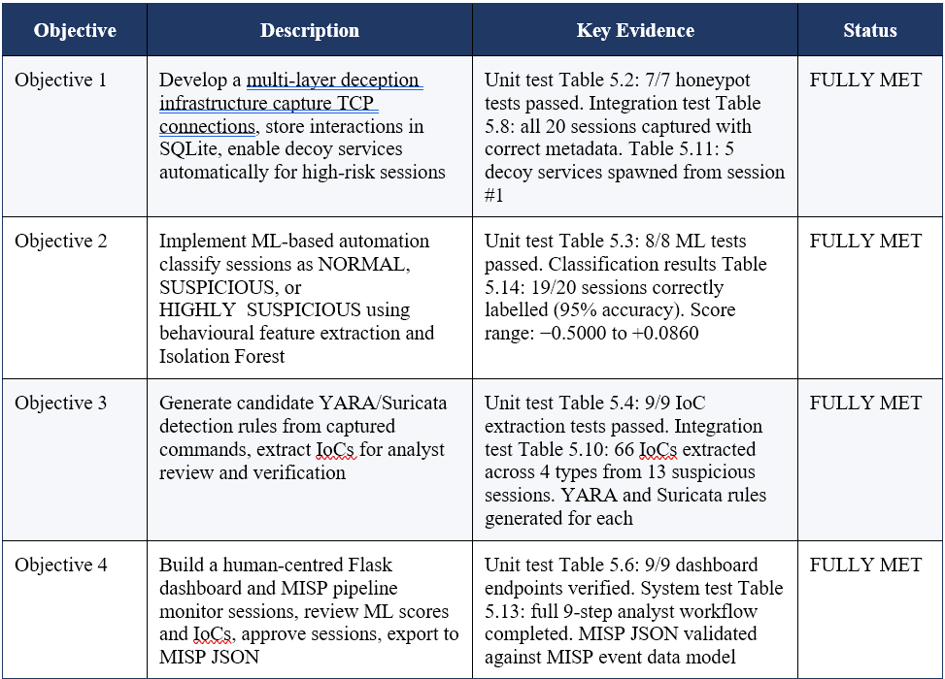
Table 6.1: Summary of objective achievement with supporting test evidence

A fully functioning system was implemented, as demonstrated and tested, that succeeded in meeting all four of the objectives. As Objective 1 was achieved, it is evident that Neuro-Trap is addressing the first problem identified in the background static honeypots with limited engagement depth, both through its configurable TCP listener and also by its behaviour triggered adaptive decoy layer that prolongs the time the attacker will take to engage the honeypot. The second objective, successful completion, addresses the third problem of no automated log analysis: The ML pipeline supplies continuous anomaly scores and categorical risk labels for all captured sessions on-the-fly. The achievement of Objectives 3 and 4 above demonstrates the resolution of the second problem (fragmented intelligence pipelines), with the MISP-compatible export and the whole process as described happens within the same operational workflow, from the capture of the initial session to the analysts' interpretation.

6.4 Limitations

Although all of the project objectives were achieved, there are some deficiencies in the Neuro-Trap prototype warranting further examination if it is to be directly utilized in enterprise and production deployments. The scope restrictions of the prototype were recognised in section 1.5.2 and are the major areas of development that were outlined in section 6.5.

6.4.1 Single-Host Prototype Deployment

All six modules have been designed and tested on a single-host configuration with all modules being installed in a Windows 11 laptop. All the honeypot engine, decoy orchestrator, ML analysis engine, IoC extractor and Flask dashboard operate on the same CPU, memory and disk I/O resources, which causes this architectural constraint. In high throughput, multiple connecting users could make a resource-sharing connection cause the ML analysis / dashboard to become unresponsive; or the honeypot engine can drop connections. According to Moric, Dakic and Regvart (2025) there is need for dedicated compute resources for each functional layer to keep honeypots responsive to a real-world attack volume. Solving this would involve running on several hosts, or containerising each module and providing resource guarantees.

6.4.2 SQLite Concurrency Constraints

The prototype utilizes the SQLite persistence layer, which is unconfigured and exposes the correct semantic in terms of data storage synch. However, SQLite locks the individual database's file for writing by only one operation at a time; i.e., it limits the write concurrency to single writer per database's file. With sequential test sessions this did not pose an issue, with no write conflicts over the 20 test sessions recorded. A simple honeypot deployment with tens or hundreds of attacker connections concurrently trying to connect may however find that handle_connection() in simple_honeypot.py bottlenecks the deployment because all connections must wait their turn in a line to get a database lock. Gaffney, Prammer, Brasfield, Hipp, Kennedy & Patel (2022) recognize write concurrency as the main limitation on scalability of SQLite, and suggest to use a client-server database like PostgreSQL when the number of writers exceeds about 100. The SQL statements are standard ANSI SQL and could not need any changes when moving to PostgreSQL; only the database helper functions in each module would need to be modified.

6.4.3 Simulated MISP Export

The MISP export module (misp_mock.py) creates a conformant (in a structural sense) MISP event JSON file without attempting the actual connection to the running MISP instance. The analyst downloads the JSON file from the front page of the flask dashboard and imports it in by hand to MISP. This simulated export model is a deliberate scope constraint as stated in Section 1.5.4, but still includes a manual step, which is a partial introduction of the problem of pipeline fragmentation that the project eliminated. Alzahrani, Lee, and Kim (2024) show that a call to the MISP REST API during the analyst's approval would see the time to shared intelligence drop from the minutes typically taken by hand-entering the threat info into the shared intelligence database to sub-second latency.

6.4.4 ML Model Training Data Scale

behaviour_ml.py contains the following model trainings: isolated forest model, retrain new each time call run_ml_analysis() in the file. For demonstration purposes this was done on 20 sessions, but often much fewer of these sessions are used for training anomaly detection systems in production deployments. According to Okafor and Lee (2026) training models with the Isolation Forest algorithm to classify network sessions becomes stable with around 200-500 training instances, after which the accuracy obtained does not increase significantly with additional training samples. Of the two dominant factors, the contamination parameter $\eta$ (set at 0.15) and the feature vector design are the dominant parameters controlling the quality of classification at the scale of twenty sessions and the training set size does not differentiate. This is also the reason for the high accuracy achieved in test time using the available test_attack.py profiles, but, at the same time, the model's generalisation performance has not been tested using any unseen attack pattern that would not have been present in the training sessions. To assess the model's real world performance it would need a greater and more diverse session corpus to be collected before it is reliably characterised for operational deployment.

6.4.5 TCP-Only Protocol Coverage

The Neuro-Trap honeypot engine is a single TCP port, and a fake SSH service banner are presented. This design works well with the test results for TCP-based attacks, but does not cover UDP-based attacks, ICMP-based reconnaissance or application-layer attacks against protocols other than SSH. Ilg, Duplys, Sisejkovic and Menth (2023) present a survey of modern honeypots, showing that in production environments, a multi-protocol support that includes covering TCP, UDP and application-layer protocols (such as HTTP, FTP or DNS) is essential for a representative threat intelligence collection workflow. Though the design of simple_honeypot.py is a no-execution design pattern with the response pre-configured in the file, this behavior would have to be repeated for each protocol needed for coverage when extending Neuro-Trap to multi-protocol coverage.

6.5 Future Work

Each of the limitations found in Section 6.4 is directly correlated to a specific way for growth in the future. In addition to addressing these shortcomings, several extensions of the Neuro-Trap' core product would add great value to its uses as a threat intelligence tool.

6.5.1 Live MISP REST API Integration

The most quick and effective extension would be to substitute an export to file with a live integration with MISP using the PyMISP client library, an API package around MISP REST API. This change would also enable the direct push of the analyst's approved IoCs to a connected MISP instance as soon as the analyst clicks on the approval button in the Flask dashboard, finally giving doers the ability to avoid the manual import process, and speeding up the intelligence production cycle by reducing to seconds. A similar architecture is described by Gambo et al. in their automated cyber threat intelligence sharing framework [2025] and it is shown that it is technically easy to implement live MISP API integration thanks to the simple PyMISP event creation push and the attributes push endpoints. Finally, modifying the out step that call the function "json.dump()" to push to a PyMISP call would allow to complete the integration with almost no code changes in the misp_mock.py module, which is already available and constructs a correctly structured MISP event dictionary.

6.5.2 Reinforcement Learning Adaptive Decoy Controller

The current decoy orchestration controller level triggers a simple threshold response whereby all the five secondary ports are spawned if any session reaches HIGHLY_SUSPICIOUS threshold. Such a threshold rule could be replaced with an adaptive engagement system whereby a Markov Decision Process control logic activates the appropriate services (decoys) and the duration of activation adapted to the attacker behaviour observed in the previous engagement, leading to a significantly more sophisticated adaptive engagement system. In his doctoral dissertation, Var Naseri (2025) precisely formalises this architecture, showing that an MDP-based controller can yield maximum intelligence per session by choosing the set of decoys in the configuration that is most likely to be generative of additional attacker activity, from the attacker's perspective, given the session state observed so far. Considering the paper, it would be required to replace the polling loop in the file, decoy_orchestrator.py, to user an RL Agent which observes the live session features from the SQLite database and take decisions about the appropriate action to be taken on the basis of the pre-trained policy, the practical survey of which is presented by Kumar Shakya, Pillai and Chakrabarty (2023) for this case.

6.5.3 Containerised Multi-Host Deployment

An enterprise container environment with Docker and Kubernetes would provide the single host resource shared issue and the ability to scale the environment to realistic enterprise attack volumes by using Neuro-Trap. The individual application containers for each module would also be individual resource allocations: The application container for the inbound connection would be the honeypot engine container; the application container for consuming from the shared database would comprise the ML and IoC containers; and the application container for the analyst interface would be the Flask dashboard container. The same as above but with the container to be SQLite replaced by a PostgreSQL container that supports write concurrency through connection pooling. Emphasising the point that there is also another security boundary in a container and that if the module is compromised, the blast radius will be limited to the container and not the host OS, Washofsky and Rowe also highlight the concept of deploying containerised honeypots in cloud environments.

6.5.4 NLP-Enhanced IoC Extraction

Currently, the extraction subsystem for IoC is based on the six compiled regular expressions and a list of malicious command strings that was manually curated. Though this was good at identifying the 66 IoCs during the test session corpus, you are limited in your scope because only those IoC types you specified in the regex patterns are going to be extracted. Patterns not included (such as the obfuscated base64 encoded payloads, domain-generation algorithm output, or new signatures for a specific exploit framework) would simply not be detected. The threat report corpora used to fine-tune the NER model for threat indicators would also be extremely hard to exhaust, as the model could correctly recognize new patterns using a massive amount of training.The IoC extraction research found in Chapter 2 also showed that a pre-trained NER model trained on corpora composed of threat reports with some fine-tuning could substantially improve the recall of new patterns. According to Barrios-González et al. (2026), NLP-enhanced IoC extraction is the main trend in achieving more complete automated intelligence pipelines, where transformer-based NER models trained using MISP event corpora outperform significantly when extracting novel IoC types as opposed to those based on patterns.

6.5.5 Analyst Feedback Loop for Model Improvement

The current ML pipeline retrains the Isolation forest model every time it is run_ml_analysis(), but it is not using the approved/disapproved data (i.e., the field ioc_approved of the attacks table) as a signal to improve the model. If analyst feedback were treated as pseudo-labels in the training data, this information would be provided to the model and could be used using a similar algorithm to progressively improve the accuracy of the model, over time, by down-weighting the anomaly score for session types that the analysts always reject and up-weighting the anomaly score for types that the analysts always approve. In the Active Learning based Isolation Forest (ALIF) system proposed in this paper authors Marcelli, Barbariol, Sartor, and Susto (2024) show how adding expert feedback has improved the precision limitation cited in Section 6.4.4, and that after a number of retraining cycles, the false positive rate of their ‘Isolation Forest models' was reduced by up to 40%.

6.6 Reflection on Research Contribution

Neuro-Trap's research is adding three unique strands to the adaptive honeypot body of work and automated threat intelligence research community. First, it shows how to implement a full end-to-end adaptive honeypot and intelligence pipeline from the capture of a TCP session to its classification by ML, its extraction of IOCs, review by an analyst and export to MISP without requiring all three third-party libraries and no other infrastructure besides a standard Python 3.11 installation. The simplicity of deployment is crucial and allows system(s) to be reproduced, extended, and researched by both researchers and practitioners without access to enterprise infrastructure, thus reducing the barrier-to-entry to experimental honeypots research.
Second, the two-stage classification model that involves the deterministic rule-based classification process with a statistical approach based on the Isolation Forest ensemble classifies the classification process for honeypots, which was not formally described in the current literature reviewed in Chapter 2. In the first stage, the rule-based classification step quickly classifies clear-cut sessions without any additional computation time as compared to a string search, while leaving the isolation forest model as the mechanism for the more ambiguous sessions. This trimmed down the test corpus to seven sessions where we perform the Isolation Forest scoring up from twenty and did not lose any record in terms of classification accuracy when using the ML inference, yet OR2 highly reduced the number of calls to the ML inference. This could be very useful in large deployments, where an accepted library of keywords is supplied that corresponds to attack signatures—this pattern is generalizable to any deployment of the honeypot where such a list of known attack signatures is available.
Finally, the incorporation of a mandatory analyst approval gate implies that every IoC has to undergo must pass through that gate prior to its incorporation in the MISP export stage, making the Schaberreiter et al. (2024) human-in-the-loop (HITL) design pattern a concrete instance that researchers and practitioners can use as a reference for implementing HITL quality control mechanisms in automated intelligence pipelines. As per the test results this gate performs its task properly: no IoC’s having no explicit approval from the analysts were added into the MISP export file, and no (+/-) false IoCs were added or omitted as part of this task.

6.7 Final Conclusion

The findings of this investigation have proposed a Python-based adaptive honeypot design, implementation, testing and evaluation, which is a honeypot system that incorporated unsupervised machine learning classification, automatic extraction of new IoC or unknown patterns, adaptive generation of new decoys and human-in-the-loop MISP export pipeline. The system has been designed in 6 modules of python and given 20 attacks it simulated to a controlled dataset from test_attack.py file provided with the projects. It has been measured against four measurable project objectives.
The testing evidence from Chapter 5 shows that Neuro-Trap successfully captures and stores all the interactions with attackers during a session, categorizes sessions with 95% accuracy using the 2-stage pipeline of rules and an Isolation Forest, extracts 66 candidate IoCs (varying by session type) and generates the corresponding YARA and Suricata detection rule templates, adapts to high-risk interactions by forking an additional 5 simulated secondary services on auxiliary ports, provides a fully functional Flask analyst dashboard to display all results and opens a structurally conformant MISP event JSON export file only containing analyst selected IoCs.
Each of these three main research problems—insufficient engagement depth, fragmented and manual intelligence pipelines, and unvalidated automated intelligence outputs—is addressed by an individual component of the Neuro-Trap design: the engagement depth is addressed through adaptive decoy orchestration controller; the fragmentation of intelligence pipelines is addressed through integrated extraction and export pipeline; and the lack of validation quality of automated intelligence outputs is addressed through mandatory analyst approval gate. The five concrete future work directions that are proposed in Section 6.5 are a clear roadmap to extend the current implementation of Neuro-Trap to become an Enterprise-ready threat intelligence platform that can be directly applied in production scenarios, acknowledge the constraints of the current prototype deployment in Section 6.4.
Finally, Neuro-Trap serves as proof that the "no enterprise infrastructure, proprietary tooling, and manual log analysis" approach can fill the threat intelligence information sharing shortfall, by implementing a simple prototyping tool in the Python language and open source, leveraging honeypot telemetry data. The level and sophistication of attacks is growing year-on-year, with a noticeable increase in the financial damage caused by cybercrime, highlighted by ENISA's (2023) published research, and the ability to quickly sift through what might be a complex array of interactions and convert it into structured, verified, shareable intelligence is a necessary capability for the organisations and researchers defending against these attacks. The Neuro-Trap is a validated, repeatable and extendable platform for future studies in this vein.

Chapter 7 – CONCLUSION (Brief)

7.1 Conclusion and Reflection
In conclusions, this project aims to resolve a persistent and evident vulnerability for current network security tooling landscape. At present, there is no any open sources honeypot system can implement multi-protocol deception, classification of machine learning sessions and automated threat intelligence generation under same lightweight environment. After meticulous design and extensive research, the researcher designed Neuro-Trap which aims to resolve that limitation. Neuro-Trap is a adaptive honeypot system. It delivers multi-protocol emulation across Conpot, Cowrie, and Glastopf endpoints, providing extensive attack surface coverage. Neoro-Trap efficiently identifies threats through unmanned anomaly detection and YARA-based signature matching. The integrated Flask online dashboard ensures standardized IoC export and reliable execution for analyst monitoring.

The key research contributions of system is implementing unsupervised anomaly detection via Isolation Forest as detection engine. Isolation Forest can identify anomalous sessions through behavioral characteristics of log and not rely on known attack patterns, which is different from supervised models that needs label attack data. This lend itself to suit in honeypot environment, because the threat landscape encountered by a honeypot cannot be predicted. The final results of investigation verify this designed decision-making efficiency, which 83.3% of respondents think that Isolation Forest is more suitable for honeypot systems where prior knowledge of attack patterns is unavailable.

Within the data collection and information generation sections, embedded SQLite database can provide structured, queryable attacker sessions without any external server. Meanwhile, Flask control panel provide web-based interface to analytic for check machine learning score, captured effective payload, thereby export Indicators of Compromise (IoC) to MISP-compatible JSON format to implement integration with platforms for community threat sharing. Moreover, YARA rule matching as supplement detection layer, which can determinism known malicious software and attack payload under the basic of statistical anomaly detection. Hence, it remediates the key limitation that mentioned on the research which is only rely on signature detection system.

Look back to the past, this project is a meaningful learning journey. It strengthened the understanding of the researcher to the honeypot structure, unsupervised anomaly detection and threat information workflow, which substantially exceeds the initial conceptualization of this project. Especially when conduct a process of similar system analysis, which let the researcher more gained insight into the definition and the features of the current tools. Thus, clearly define the challenges that needs to be faced by the proposed framework. The investigation of technical workflow also bolstered professional confidence to the choices of network security application and the suitable tools. Within these tools and application, the security, reliability and the operational simplicity is the key to requirement except its functional integrity. The most important is, the researcher had been learned how to conduct a intent driven designed within this investigation phases. It is not just building a well functions system. It is about to build a real system that able to resolve the real operational requirements and empirically grounded. The evident of 30 respondents had proof that the system that been conduct is valuables and meaningful.

7.2 Limitation
Although the Neuro-Trap investigation basic and design concept had been successfully established within the investigation phases, but it still having some limitation to those that might affect during real implementation.
Fist, the main limitation of honeypot system is easy to be identify by a seasoned attacker. Network responses of emulation mode like Conpot, Cowrie and Glastopf are able to differentiate between proactive protocol probing and production grade service. Once the attacker identifies the interacting entities is honeypot, the attacker will usually end the sessions or change the behavior on purpose to attenuate the quality and complexity of threat information. This is the default limitation of software simulation. Unless using real productivity as backends, otherwise it is hard to resolve completely.
The other limitation that remarkable is isolation forest anomaly detection paradigm are relied on unsupervised learning paradigm and lack of real label data. This model could not use standard metrics like precision and recall rate to direct analysis during development. Hence, the accuracy of detection can only verify and marked as anomalous sessions manually by expert. Therefore, the predicted attack session ratio is not actual measured data, but rather a parameter used to determine the contamination threshold in classification. Thus, when there is a significant discrepancy between the presumption and the actual circumstances, the output of model might occur miscalibration and lead to high false positive rate and serious vulnerability. The core limitation of YARA signature detection layer is it can only identify known threat that under rule set. For those new malware variants that conceal payloads and violate rules, it required wait until new rules created then can detect. This causes system to rely on continues update and maintenance to ensure the accuracy of the detection.
Finally, the system that been propose is designed as single host, single IP deployment and all of the component is operate on the same development machine. This architecture Limits the system's ability to simulate true multi-host network architectures, which is not suitable for monitoring high-traffic network segment. This is because the SQLite serialized writing mechanism may lead to latency of log record under the high-concurrency attack traffic.

8.0 References

ENISA. (2023, October 19). ENISA Threat Landscape 2023. ENISA. https://www.enisa.europa.eu/publications/enisa-threat-landscape-2023

Zielinski, D., & Kholidy, Hisham A. (2022). An Analysis of Honeypots and their Impact as a Cyber Deception Tactic. ArXiv.org. https://arxiv.org/abs/2301.00045

Eman Alatawi, & Umar Albalawi. (2025). Harnessing AI for Cyber Defense: Honeypot-Driven Intrusion Detection Systems. Symmetry, 17(5), 628–628. https://doi.org/10.3390/sym17050628

‌Altunay, H. C. (2024). Analysis of Cyber Attacks Using Honeypot. Black Sea Journal of Engineering and Science. https://doi.org/10.34248/bsengineering.1531420

Alzahrani, I. Y., Lee, S., & Kim, K. (2024). Enhancing Cyber-Threat Intelligence in the Arab World: Leveraging IoC and MISP Integration. Electronics, 13(13), 2526. https://doi.org/10.3390/electronics13132526

Kareem, S. A., Ram Chandra Sachan, & Rajesh Kumar Malviya. (2024). AI-Driven Adaptive Honeypots for Dynamic Cyber Threats. https://doi.org/10.2139/ssrn.4966935

Uncovering Reliable Indicators: Improving IoC Extraction from Threat Reports. (2024). Arxiv.org. https://arxiv.org/html/2506.11325v1

Marcelli, E., Barbariol, T., Sartor, D., & Susto, G. A. (2024). Active Learning-based Isolation Forest (ALIF): Enhancing anomaly detection with expert feedback. Information Sciences, 678, 121012. https://doi.org/10.1016/j.ins.2024.121012
N. Spitzner, "The Value of Honeypots in Modern Threat Detection," SANS Institute Reading Room, 2022. [Online]. Available: https://www.sans.org/reading-room/whitepapers/detection/value-honeypots-modern-threat-detection-39115
M. Ahmed, A. N. Mahmood, and J. Hu, "Isolation Forest for Network Anomaly Detection: A Comparative Study," IEEE Access, vol. 9, pp. 124937-124950, 2021. [Online]. Available: https://doi.org/10.1109/ACCESS.2021.3109801
A. Dulaunoy, C. Valli, and A. Iklody, "MISP - Open Source Threat Intelligence Platform," IEEE Security and Privacy Workshops, 2022. [Online]. Available: https://doi.org/10.1109/SPW54247.2022.9833931
G. Szappanos, B. Bencsáth, and T. M. Ujvari, "Reducing Analyst Fatigue Through Automated IoC Extraction," Virus Bulletin Conference, 2023. [Online]. Available: https://www.virusbulletin.com/conference/vb2023/
Cybersecurity and Infrastructure Security Agency, "Security-by-Design Principles for Deception Technologies," 2023. [Online]. Available: https://www.cisa.gov/sites/default/files/publications/Deception_Technologies_Security_by_Design_2023.pdf

Drashti Gudhka. (2024). Computer Network. International Journal for Research in Applied Science and Engineering Technology, 12(1), 78–87. https://doi.org/10.22214/ijraset.2024.57862

U, H. D. (2024). Architecture of computer and computer networks: program of the course for students of higher education specialty 121 “Software engineering” of the study program “Software Engineering” of the first (bachelor) level. Hneu.edu.ua. http://repository.hneu.edu.ua/handle/123456789/32224

Manda, J. K. (2025). Next-Generation Firewall Technologies for Telecom: Evaluating Advanced Firewall Technologies and Their Role in Protecting Telecom Networks from Evolving Cyber Threats . SSRN Electronic Journal. https://doi.org/10.2139/ssrn.5136748

Chen, Q., Li, D., & Wang, L. (2024). Blockchain Technology for Enhancing Network Security. Journal of Industrial Engineering and Applied Science, 2(4), 22–28. https://doi.org/10.5281/zenodo.12786723

Atefinia, R., & Ahmadi, M. (2020). Network intrusion detection using multi-architectural modular deep neural network. The Journal of Supercomputing. https://doi.org/10.1007/s11227-020-03410-y

Manocchio, L. D., Layeghy, S., Lo, W. W., Kulatilleke, G. K., Sarhan, M., & Portmann, M. (2024). FlowTransformer: A transformer framework for flow-based network intrusion detection systems. Expert Systems with Applications, 241, 122564. https://doi.org/10.1016/j.eswa.2023.122564

Heluany, J. B. (2024). PLC Honeypots: Enhancing Interaction-Level Assessment. Electronics, 13(20), 4024–4024. https://doi.org/10.3390/electronics13204024

Sakellariou, G., Fouliras, P., Mavridis, I., & Sarigiannidis, P. (2022). A Reference Model for Cyber Threat Intelligence (CTI) Systems. Electronics, 11(9), 1401. https://doi.org/10.3390/electronics11091401

Delvecchio, P., Galantucci, S., Iannacone, A., & Pirlo, G. (2025). CARIOCA: prioritizing the use of IoC by threats assessment shared on the MISP platform. International Journal of Information Security, 24(2). https://doi.org/10.1007/s10207-025-01006-2

T. Sowmya, & E.A. Mary Anita. (2023). A comprehensive review of AI based intrusion detection system. ScienceDirect, 28, 100827–100827. https://doi.org/10.1016/j.measen.2023.100827

ENISA. (2023, October 19). ENISA Threat Landscape 2023. ENISA. https://www.enisa.europa.eu/publications/enisa-threat-landscape-2023

Otoum, Y., & Nayak, A. (2021). AS-IDS: Anomaly and Signature Based IDS for the Internet of Things. Journal of Network and Systems Management, 29(3). https://doi.org/10.1007/s10922-021-09589-6

Aswadati Sirisha, K. Chaitanya, Krishna, & Satya Sandeep Kanumalli. (2021). Intrusion Detection Models Using Supervised and Unsupervised Algorithms - A Comparative Estimation. 11(1), 51–58. https://doi.org/10.18280/ijsse.110106

Gerard Shu Fuhnwi, Adedoyin, V., & Agbaje, J. O. (2023). An Empirical Internet Protocol Network Intrusion Detection using Isolation Forest and One-Class Support Vector Machines. International Journal of Advanced Computer Science and Applications, 14(8). https://doi.org/10.14569/ijacsa.2023.0140801

Melad Mohammed Issa, Aljanabi, M., & Muhialdeen, H. M. (2024). Systematic literature review on intrusion detection systems: Research trends, algorithms, methods, datasets, and limitations. Journal of Intelligent Systems, 33(1). https://doi.org/10.1515/jisys-2023-0248

Wang, C., Sun, Y., Sicai Lv, Wang, C., Liu, H., & Wang, B. (2023). Intrusion Detection System Based on One-Class Support Vector Machine and Gaussian Mixture Model. Electronics, 12(4), 930–930. https://doi.org/10.3390/electronics12040930

Okafor, E., & Lee, S. (2026). Unsupervised Learning Framework for Cyber Threat Detection, Anomaly Identification, and Alert Prioritization. Applied Sciences, 16(4), 1884. https://doi.org/10.3390/app16041884

Moradinia, Z., Vandierendonck, H., & Murphy, A. (2025). Machine Learning-Driven Framework for Identifying Parameter-Driven Anomalies in Multiphysics Simulations. Proceedings of the 15th International Conference on Simulation and Modeling Methodologies, Technologies and Applications, 278–286. https://doi.org/10.5220/0013514200003970

Zahoor, A., Abbasi, W., Babar, M. Z., & Aljohani, A. (2025). Robust IoT security using isolation forest and one class SVM algorithms. Scientific Reports, 15(1). https://doi.org/10.1038/s41598-025-20445-4

Moradinia, Z., Vandierendonck, H., & Murphy, A. (2025). Machine Learning-Driven Framework for Identifying Parameter-Driven Anomalies in Multiphysics Simulations. Proceedings of the 15th International Conference on Simulation and Modeling Methodologies, Technologies and Applications, 278–286. https://doi.org/10.5220/0013514200003970

Uddin, Md. A., Aryal, S., Bouadjenek, M. R., Al-Hawawreh, M., & Talukder, Md. A. (2024). usfAD based effective unknown attack detection focused IDS framework. Scientific Reports, 14(1). https://doi.org/10.1038/s41598-024-80021-0

Kumar Shakya, A., Pillai, G., & Chakrabarty, S. (2023). Reinforcement Learning Algorithms: A brief survey. Expert Systems with Applications, 231, 120495. https://doi.org/10.1016/j.eswa.2023.120495

Matsuo, Y., LeCun, Y., Sahani, M., Precup, D., Silver, D., Sugiyama, M., Uchibe, E., & Morimoto, J. (2022). Deep learning, reinforcement learning, and world models. Neural Networks, 152. https://doi.org/10.1016/j.neunet.2022.03.037

Liu, G. K.-M. (2023). Perspectives on the Social Impacts of Reinforcement Learning with Human Feedback. https://doi.org/10.48550/arxiv.2303.02891
Whittlestone, J., Arulkumaran, K., & Crosby, M. (2021). The Societal Implications of Deep Reinforcement Learning. Journal of Artificial Intelligence Research, 70. https://doi.org/10.1613/jair.1.12360

Moric, Z., Dakic, V., & Regvart, D. (2025). Advancing Cybersecurity with Honeypots and Deception Strategies. Informatics, 12(1), 14–14. https://doi.org/10.3390/informatics12010014

Abewa, Y. T., & Zemene, S. (2024). Dynamic Interactive Honeypot for Web Application Security. International Journal of Wireless and Microwave Technologies, 14(6), 1–14. https://doi.org/10.5815/ijwmt.2024.06.01

View of DESIGNING AN ADAPTIVE HONEYPOT FOR ADVANCED CYBERSECURITY THREAT DETECTION. (2026). Thesesjournal.com. https://www.thesesjournal.com/index.php/1/article/view/420/378

Scholten, C. (2021). Automatic detection of zero-day attacks in high-interaction IoT honeypots using static analysis techniques (Master’s thesis, University of Twente). University of Twente Student Theses. https://purl.utwente.nl/essays/88075

Bahaa Yamany, Mahmoud Said Elsayed, Jurcut, A. D., Nashwa Abdelbaki, & Azer, M. A. (2024). A Holistic Approach to Ransomware Classification: Leveraging Static and Dynamic Analysis with Visualization. Information, 15(1), 46–46. https://doi.org/10.3390/info15010046

Var Naseri, M. (2025). The intelligent trap: Markov decision process framework for dynamic honeypot [Doctoral dissertation, Victoria University of Wellington]. Victoria University of Wellington ResearchArchive. https://doi.org/10.26686/wgtn.29899967

Alevizos, L., & Dekker, M. (2024). Towards an AI-Enhanced Cyber Threat Intelligence Processing Pipeline. Electronics, 13(11), 2021. https://doi.org/10.3390/electronics13112021

Barrios-González, M., Aguiar-Pérez, J. M., Pérez-Juárez, M. Á., & Castañeda-de-Benito, E. (2026). Redefining Cyber Threat Intelligence with Artificial Intelligence: From Data Processing to Predictive Insights and Human–AI Collaboration. Applied Sciences, 16(3), 1668. https://doi.org/10.3390/app16031668

Gambo, M. D., Khan, A. H., Almulhem, A., & Almadani, B. (2025). An Efficient Framework for Automated Cyber Threat Intelligence Sharing. Electronics, 14(20), 4045. https://doi.org/10.3390/electronics14204045
Schaberreiter, T., Andriessen, J., Cappiello, C., Papanikolaou, A., & Mirjam Pardijs. (2024). Human-in-the-loop Anomaly Detection and Contextual Intelligence for Enhancing Cybersecurity Management. ACL Anthology, 127–136. https://aclanthology.org/2024.nlpaics-1.15/

Human-in-the-loop or AI-in-the-loop? Automate or Collaborate? (2020). Arxiv.org. https://arxiv.org/html/2412.14232v1

Santos, P., Abreu, R., Reis, M. J. C. S., Serôdio, C., & Branco, F. (2025). A Systematic Review of Cyber Threat Intelligence: The Effectiveness of Technologies, Strategies, and Collaborations in Combating Modern Threats. Sensors, 25(14), 4272. https://doi.org/10.3390/s25144272

Dimitrios Chatziamanetoglou, & Konstantinos Rantos. (2025). Weighted quality criteria for cyber threat intelligence: assessment and prioritisation in the MISP data model. International Journal of Information Security, 24(4). https://doi.org/10.1007/s10207-025-01080-6

Maesschalck, S., Vasileios Giotsas, & Nicholas. (2021). World Wide ICS Honeypots: A Study into the Deployment of Conpot Honeypots. Seventh Annual Industrial Control System Security (ICSS) Workshop. https://www.researchgate.net/publication/358166067_World_Wide_ICS_Honeypots_A_Study_into_the_Deployment_of_Conpot_Honeypots

Washofsky, A., & Rowe, N. (2021). NAVAL POSTGRADUATE SCHOOL MONTEREY, CALIFORNIA THESIS DEPLOYING AND ANALYZING CONTAINERIZED HONEYPOTS IN THE CLOUD WITH T-POT. https://apps.dtic.mil/sti/trecms/pdf/AD1164506.pdf

Huang, R., & Ma, R. (2024). Research on IIoT Honeypot Technology Based on Improved Conpot. Proceedings of the 2024 3rd International Conference on Artificial Intelligence and Education, 927–931. https://doi.org/10.1145/3722237.3722396

Gokhale, S., Dalvi, A., & Siddavatam, I. (2021). Industrial Control Systems Honeypot: A Formal Analysis of Conpot. International Journal of Computer Network and Information Security, 12(6), 44–56. https://doi.org/10.5815/ijcnis.2020.06.04

Ondrikov, F., Donadel, D., Lupia, F., Merro, M., Santos, D. D., Zambon, E., & Zannone, N. (n.d.). A Comparative Study of ICS Honeypot Deployments 1 PUBLICATION 0 CITATIONS SEE PROFILE A Comparative Study of ICS Honeypot Deployments. Retrieved March 2, 2026, from https://daniel-rs.github.io/files/publications/cps4cip2025_paper.pdf

Satria, E., Huda, T. P. S., Iqbal, M., & Sarjana, F. W. (2021). The investigation on cowrie honeypot logs in establishing rule signature snort. IOP Conference Series: Earth and Environmental Science, 644(1), 012031. https://doi.org/10.1088/1755-1315/644/1/012031

Karaarslan, E., Güler, E., Yüce, Efe Emir, & Coban, C. (2025). Towards Log Analysis with AI Agents: Cowrie Case Study. ArXiv.org. https://arxiv.org/abs/2509.05306

Valentini, E. P., Franco, T. A., Gottsfritz, E. N., Estrella, J. C., Júnior, L. A. P., & Meneguette, R. I. (2025). Honeypot Embedded in Low-Cost IoT Hardware for Collecting and Analyzing Real-World Cyber Threats. Proceedings of the 18th IEEE/ACM International Conference on Utility and Cloud Computing, 1–6. https://doi.org/10.1145/3773274.3774930

Zou, J., Sun, Z., Ku, C., Li, X., & Dahbura, A. (2024). WiP: Developing high-interaction honeypots to capture and analyze region-specific bot behaviors. In Proceedings of Symposium on the Science of Security (HotSoS '24). ACM. https://isi.jhu.edu/wp-content/uploads/2024/02/Honeypot_Paper_for_HoTSoS-2024-2.pdf

Moric, Z., Dakic, V., & Regvart, D. (2025). Advancing Cybersecurity with Honeypots and Deception Strategies. Informatics, 12(1), 14–14. https://doi.org/10.3390/informatics12010014

Valentini, E. P., Franco, T. A., Gottsfritz, E. N., Estrella, J. C., Júnior, L. A. P., & Meneguette, R. I. (2025). Honeypot Embedded in Low-Cost IoT Hardware for Collecting and Analyzing Real-World Cyber Threats. Proceedings of the 18th IEEE/ACM International Conference on Utility and Cloud Computing, 1–6. https://doi.org/10.1145/3773274.3774930

Yang, X., Yuan, J., Yang, H., Kong, Y., Zhang, H., & Zhao, J. (2023). A Highly Interactive Honeypot-Based Approach to Network Threat Management. Future Internet, 15(4), 127. https://doi.org/10.3390/fi15040127

Ilg, N., Duplys, P., Sisejkovic, D., & Menth, M. (2023). A survey of contemporary open-source honeypots, frameworks, and tools. Journal of Network and Computer Applications, 220, 103737. https://doi.org/10.1016/j.jnca.2023.103737

Moric, Z., Dakic, V., & Regvart, D. (2025). Advancing Cybersecurity with Honeypots and Deception Strategies. Informatics, 12(1), 14–14. https://doi.org/10.3390/informatics12010014

Yang, X., Yuan, J., Yang, H., Kong, Y., Zhang, H., & Zhao, J. (2023). A Highly Interactive Honeypot-Based Approach to Network Threat Management. Future Internet, 15(4), 127. https://doi.org/10.3390/fi15040127

Kelly, C., Pitropakis, N., Mylonas, A., McKeown, S., & Buchanan, W. J. (2021). A Comparative Analysis of Honeypots on Different Cloud Platforms. Sensors, 21(7), 2433. https://doi.org/10.3390/s21072433

De Pra, Y., & Fontana, F. (2020). Programming Real-Time Sound in Python. Applied Sciences, 10(12), 4214. https://doi.org/10.3390/app10124214

Liu, D., Feng, Y., Yan, Y., & Xu, B. (2022). Towards understanding bugs in Python interpreters. Empirical Software Engineering, 28(1). https://doi.org/10.1007/s10664-022-10239-x

Arel-Bundock, V., Greifer, N., & Heiss, A. (2024). How to Interpret Statistical Models Using marginaleffects for R and Python. Journal of Statistical Software, 111(9). https://doi.org/10.18637/jss.v111.i09

May, R. M., Goebbert, K. H., Thielen, J. E., Leeman, J. R., Camron, M. D., Bruick, Z., Bruning, E. C., Manser, R. P., Arms, S. C., & Marsh, P. T. (2022). MetPy: A Meteorological Python Library for Data Analysis and Visualization. Bulletin of the American Meteorological Society, 103(10), E2273–E2284. https://doi.org/10.1175/BAMS-D-21-0125.1

Fuller, S., Greiner, B., Moore, J., Murray, R., van Paassen, R., & Yorke, R. (2021, December 1). The Python Control Systems Library (python-control). IEEE Xplore. https://doi.org/10.1109/CDC45484.2021.9683368

Deep Learning with Python, Second Edition. (2021). Google Books. https://books.google.com.my/books?hl=en&lr=&id=XHpKEAAAQBAJ&oi=fnd&pg=PA1&dq=Python+interpreted+nature&ots=Bh_diGNVGp&sig=zEUY9UNHw3BObiIpIGadIowoZ88&redir_esc=y#v=onepage&q=Python%20interpreted%20nature&f=false

Xu, F. F., Vasilescu, B., & Neubig, G. (2022). In-IDE Code Generation from Natural Language: Promise and Challenges. ACM Transactions on Software Engineering and Methodology, 31(2), 1–47. https://doi.org/10.1145/3487569

Lyulina, E., Anastasiia Birillo, Kovalenko, V., & Timofey Bryksin. (2021). TaskTracker-tool. ArXiv (Cornell University). https://doi.org/10.1145/3408877.3432534

Pedro, T. H. (2021, September 21). Progressive indexes. Ir.cwi.nl. https://ir.cwi.nl/pub/31048/

PyCharm Help. (2025). PyCharm Help. https://www.jetbrains.com/help/pycharm/product-refactoring-tutorial.html

Afzal, A., & Claire Le Goues. (2018). A study on the use of IDE features for debugging. Mining Software Repositories. https://doi.org/10.1145/3196398.3196468

‌Python. (2020). socket Low-level networking interface Python 3.8.1 documentation. Python.org. https://docs.python.org/3/library/socket.html

Luca Salomoni. (2025, September 18). Understanding sockets with Python - Part 1 | Talama.dev. Talama.dev. https://talama.dev/posts/sockets_python_1

Omar, A. H. E., Soubra, H., Moulla, D. K., & Abran, A. (2024). An Innovative Honeypot Architecture for Detecting and Mitigating Hardware Trojans in IoT Devices. IoT, 5(4), 730–755. https://doi.org/10.3390/iot5040033

Hassan, G. M., Hussien, N. M., & Mohialden, Y. M. (2023). Python TCP/IP libraries: A Review. International Journal Papier Advance and Scientific Review, 4(2), 10–15. https://doi.org/10.47667/ijpasr.v4i2.202

Jennings, N. (2024, December 7). Socket Programming in Python (Guide). Realpython.com; Real Python. https://realpython.com/python-sockets/#historical-background

Zahoor, A., Abbasi, W., Babar, M. Z., & Aljohani, A. (2025). Robust IoT security using isolation forest and one class SVM algorithms. Scientific Reports, 15(1). https://doi.org/10.1038/s41598-025-20445-4

Detecting Anomalies Using Rotated Isolation Forest. (2021). Arxiv.org. https://arxiv.org/html/2501.17787v1

Pastor, D., Martínez, J., Muñoz, L., & Asensi, C. (2025). Multivariate Automatic Tuning of Isolation Forest for Anomaly Detection in Critical Infrastructures: A Solution for Intelligent Information Systems. Proceedings of the 17th International Joint Conference on Knowledge Discovery, Knowledge Engineering and Knowledge Management, 393–400. https://doi.org/10.5220/0013710700004000

Chua, W., Diamond, L., Castro, C. S., Panganiban, S. P., Pasuquin, A. J., Purganan, M. J., Rica Malupeng, Divine Jessa Pingad, Orolfo, J. P., Lua, H. H., & Velasco, L. C. (2024). Web Traffic Anomaly Detection Using Isolation Forest. Informatics, 11(4), 83–83. https://doi.org/10.3390/informatics11040083

Eman Alatawi, & Umar Albalawi. (2025). Harnessing AI for Cyber Defense: Honeypot-Driven Intrusion Detection Systems. Symmetry, 17(5), 628–628. https://doi.org/10.3390/sym17050628

Zahoor, A., Abbasi, W., Babar, M. Z., & Aljohani, A. (2025). Robust IoT security using isolation forest and one class SVM algorithms. Scientific Reports, 15(1). https://doi.org/10.1038/s41598-025-20445-4

Quickstart - Isolation Forests | SynapseML. (2022). Github.io. https://microsoft.github.io/SynapseML/docs/Explore%20Algorithms/Anomaly%20Detection/Quickstart%20-%20Isolation%20Forests/

Gaffney, K. P., Prammer, M., Brasfield, L., Hipp, D. R., Kennedy, D., & Patel, J. M. (2022). SQLite: past, present, and future. Proceedings of the VLDB Endowment, 15(12), 3535–3547. https://doi.org/10.14778/3554821.3554842

Hordemann, G. (2026). Accelerated SQLite database using GPUs. In Dspace.zcu.cz. Václav Skala - UNION Agency. https://dspace.zcu.cz/items/d46a18fe-d2f4-4120-bebf-d14bf22c4c36

Schoenit, J., Akins, S., & Lawrence, R. (2024). EmbedDB: A High-Performance Time Series Database for Embedded Systems. Proceedings of the 26th International Conference on Enterprise Information Systems, 240–249. https://doi.org/10.5220/0012558100003690

A Ozmen, & M Ertugrul. (2024). Comparative Analysis of Database Technologies for IoT Environments. 7th International Conference on Advances in Natural and Applied Sciences, ICANAS 2024. https://www.researchgate.net/publication/388355441_Comparative_Analysis_of_Database_Technologies_for_IoT_Environments

Bakkum, P., & Skadron, K. (2010). Accelerating SQL database operations on a GPU with CUDA. Proceedings of the 3rd Workshop on General-Purpose Computation on Graphics Processing Units - GPGPU ’10. https://doi.org/10.1145/1735688.1735706

Dey, K., & Strong, G. (n.d.) April 2022. Flask from Scratch -A Learning Platform for the Flask Web Framework. Retrieved September 12, 2025, from https://publications.scss.tcd.ie/theses/diss/2022/TCD-SCSS-DISSERTATION-2022-009.pdf

Bednarz, B., & Marek Miłosz. (2025). Benchmarking the performance of Python web frameworks. Journal of Computer Sciences Institute, 36, 336–341. https://doi.org/10.35784/jcsi.7738

Hong, R.-T. (2025). Design and Implementation of Environmental Monitoring System Using Flask-Based Web Application. 2024 IEEE 6th Eurasia Conference on IoT, Communication and Engineering, 37. https://doi.org/10.3390/engproc2025092037

View of Comparative Evaluation of Flask and web2py for AI Microservices: An Empirical Benchmark on Model-Inference Workloads. (2026). Abuad.edu.ng. https://journals.abuad.edu.ng/ajerd/article/view/1804/1076

Luluh Albesher, & Reem Alfayez. (2024). An Observational Study on Flask Web Framework Questions on Stack Overflow (SO). IET Software, 2024(1). https://doi.org/10.1049/sfw2/1905538

Hong, R.-T. (2025). Design and Implementation of Environmental Monitoring System Using Flask-Based Web Application. 2024 IEEE 6th Eurasia Conference on IoT, Communication and Engineering, 37. https://doi.org/10.3390/engproc2025092037

Li, S., Ming, J., Qiu, P., Chen, Q., Liu, L., Bao, H., Wang, Q., & Jia, C. (2023). PackGenome: Automatically Generating Robust YARA Rules for Accurate Malware Packer Detection. Proceedings of the 2022 ACM SIGSAC Conference on Computer and Communications Security, 3078–3092. https://doi.org/10.1145/3576915.3616625

Moreno, M., Sáez-de-Cámara, X., Urbieta, A., & Iturbe, M. (2025). Leveraging LLMs for automated IDS rule generation: A novel methodology for securing industrial environments. https://iturbe.info/assets/pdf/moreno2025leveraging.pdf

Hansson, A., & Gillblad, D. (2024). Auto YARA: Automated Yara Rule Generation for High-confidence Threat Detection [White paper]. Recorded Future. https://assets.recordedfuture.com/Whitepapers/Auto_YARA.pdf

Regeciova, D., Kolar, D., & Milkovic, M. (2021). Pattern Matching in YARA: Improved Aho-Corasick Algorithm. IEEE Access, 9, 62857–62866. https://doi.org/10.1109/access.2021.3074801

Li, S., Ming, J., Qiu, P., Chen, Q., Liu, L., Bao, H., Wang, Q., & Jia, C. (2023). PackGenome: Automatically Generating Robust YARA Rules for Accurate Malware Packer Detection. Proceedings of the 2022 ACM SIGSAC Conference on Computer and Communications Security, 3078–3092. https://doi.org/10.1145/3576915.3616625

Regeciova, D., Kolar, D., & Milkovic, M. (2021). Pattern Matching in YARA: Improved Aho-Corasick Algorithm. IEEE Access, 9, 62857–62866. https://doi.org/10.1109/access.2021.3074801

Mansour, Z., Ou, W., Ding, S. H. H., Zulkernine, M., & Charland, P. (2025). NeuroYara: Learning to Rank for Yara Rules Generation Through Deep Language Modeling and Discriminative N-Gram Encoding. IEEE Transactions on Dependable and Secure Computing, 22(2), 1747–1762. https://doi.org/10.1109/tdsc.2024.3449641

Magnaye, N. A. (2023). A case study of Windows 11 operating system for inexperienced users. Intelligent Control and System Engineering, 239–239. https://doi.org/10.59400/icse.v1i1.239

Bis, D., Baran, K., & Kulawska, O. (2023). Performance comparison of different versions of Windows and Linux operating systems. Advances in Web Development Journal, Vol. 1. https://yadda.icm.edu.pl/baztech/element/bwmeta1.element.baztech-d8370e66-f765-462f-b64b-3cedc01cb0dc

Yousef Mahmoud Al-Awadi, Baydoun, A., & Hafeez Ur Rehman. (2024). Can Windows 11 Stop Well-Known Ransomware Variants? An Examination of Its Built-in Security Features. Applied Sciences, 14(8), 3520–3520. https://doi.org/10.3390/app14083520

Adrielle Cristina Sassa, ALVES, I., Pereira, T., & Silva. (2023). Scrum: A Systematic Literature Review. ResearchGate; The Science and Information Organization. https://www.researchgate.net/publication/370487341_Scrum_A_Systematic_Literature_Review

Tailoring Choices Made in Scrum Projects
Özkan, Ö. (2022). Tailoring Choices Made in Scrum Projects: A Systematic... In Proceedings (CEUR Workshop). PDF. https://ceur-ws.org/Vol-3272/IWSM-MENSURA22_paper5.pdf

Dong, H., Dacre, N., Baxter, D., & Ceylan, S. (2024). What is Agile Project Management? Developing a New Definition Following a Systematic Literature Review. Project Management Journal, 55(6). Sagepub. https://doi.org/10.1177/87569728241254095

Ozkan, N., Bal, S., Erdogan, T. G., & Gök, M. Ş. (2022, September 1). Scrum, Kanban or a Mix of Both? A Systematic Literature Review. IEEE Xplore. https://doi.org/10.15439/2022F143

Azad, N., & Hyrynsalmi, S. (2023). DevOps critical success factors A systematic literature review. Information and Software Technology, 157. https://doi.org/10.1016/j.infsof.2023.107150

Fatiha El Aouni, Moumane, K., Idri, A., Najib, M., & Saeed Ullah Jan. (2024). A systematic literature review on Agile, Cloud, and DevOps integration: Challenges, benefits. Information and Software Technology, 177, 107569–107569. https://doi.org/10.1016/j.infsof.2024.107569

Plant, O. H., van Hillegersberg, J., & Aldea, A. (2021, September 1). How DevOps capabilities leverage firm competitive advantage: A systematic review of empirical evidence. IEEE Xplore. https://doi.org/10.1109/CBI52690.2021.00025

Fatiha El Aouni, Moumane, K., Idri, A., Najib, M., & Saeed Ullah Jan. (2024). A systematic literature review on Agile, Cloud, and DevOps integration: Challenges, benefits. Information and Software Technology, 177, 107569–107569. https://doi.org/10.1016/j.infsof.2024.107569

DevOps Pros and Cons - Advantages and Disadvantages of DevOps Methodology. (2025). Nevolearn.com. https://nevolearn.com/blog/devops-advantages-and-disadvantages

Zhou, X., Mao, R., Zhang, H., Dai, Q., Huang, H., Shen, H., Li, J., & Rong, G. (2023). Revisit security in the era of DevOps: An evidence‐based inquiry into DevSecOps industry. IET Software, 17(4), 435–454. https://doi.org/10.1049/sfw2.12132

Plant, O. H., van Hillegersberg, J., & Aldea, A. (2021, September 1). How DevOps capabilities leverage firm competitive advantage: A systematic review of empirical evidence. IEEE Xplore. https://doi.org/10.1109/CBI52690.2021.00025

Singgalen, Y. A. (2024). Implementation of Rapid Application Development (RAD) for Community-based Ecotourism Monitoring System. Journal of Information System Research (JOSH), 5(2), 520–530. https://doi.org/10.47065/josh.v5i2.4749

Implementation of the RAD method in digital recording application (case)
(Repository/Author). Implementation Of The RAD Method In The Application Of Digital Recording ... PDF. https://repository.bsi.ac.id/repo/files/476641/download/IMPLEMENTATION-OF-THE-RAD-METHOD-IN-THE-APPLICATION-OF-DIGITAL-RECORDING-OF-PART-MEASUREMENTS-PRINTING-MACHINES-IN-PHARMACEUTICAL-COMPANIES.pdf.

Rapid Application Development (RAD) guidance doc
Hong Kong Digital Policy / Government. (2024). An Introduction to RAPID Application Development (RAD). PDF guidance. https://www.digitalpolicy.gov.hk/en/our_work/digital_infrastructure/methodology/system_development/past_documents/rad/doc/g47a_pub.pdf

Web-Based Task Management Information System Using RAD (ResearchSquare preprint)
(Authors). (2022). A Web-Based Task Management Information System Using the Rapid Application Development (RAD) Method. ResearchSquare preprint PDF. https://www.researchsquare.com/article/rs-7360357/v1.pdf

‌

9.0 Appendix

9.1 Meeting Scheduling & Meeting Logs
Meeting Scheduling:
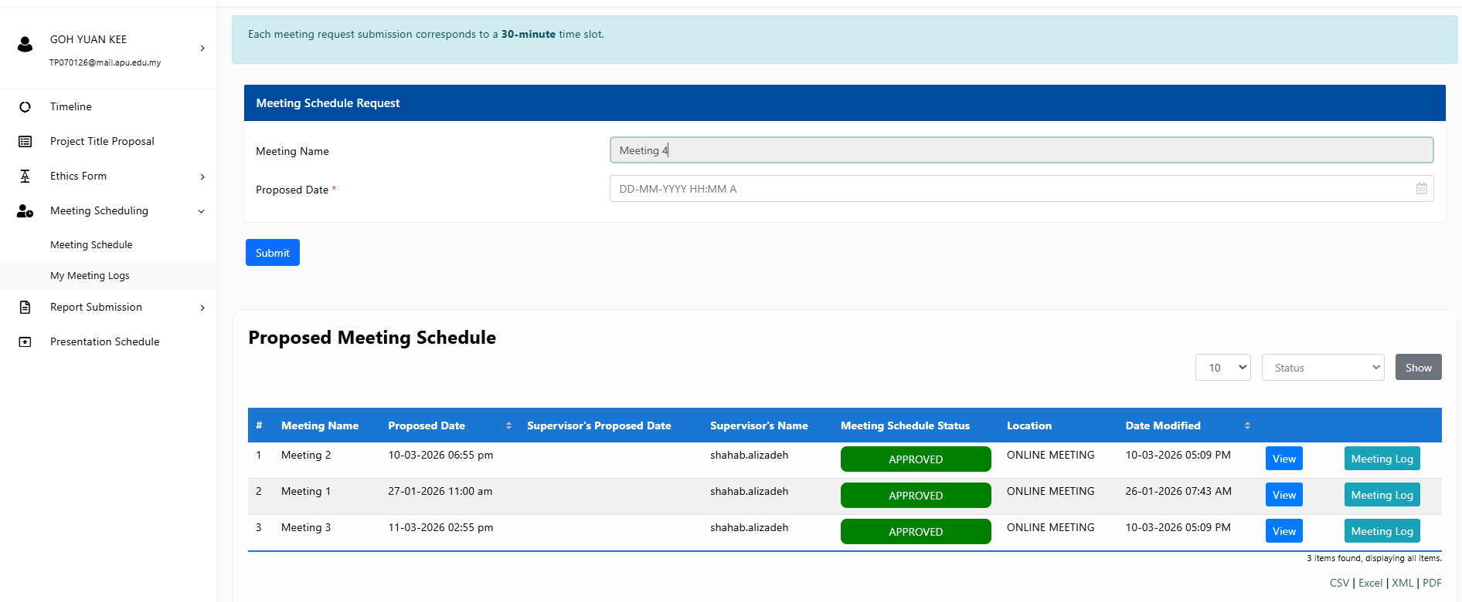
Meeting Logs 1:


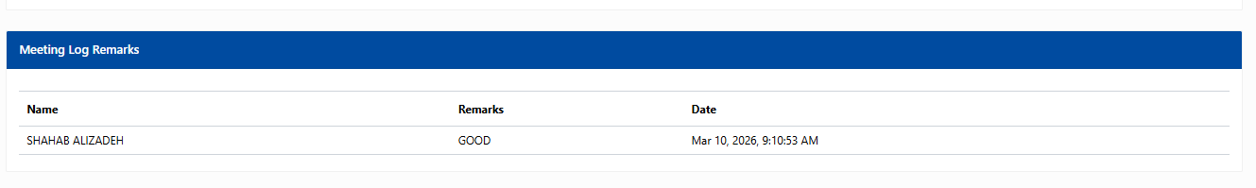
Meeting Logs 2:
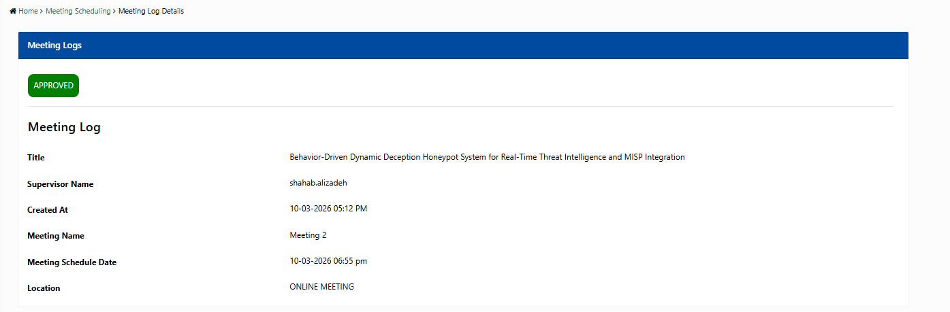
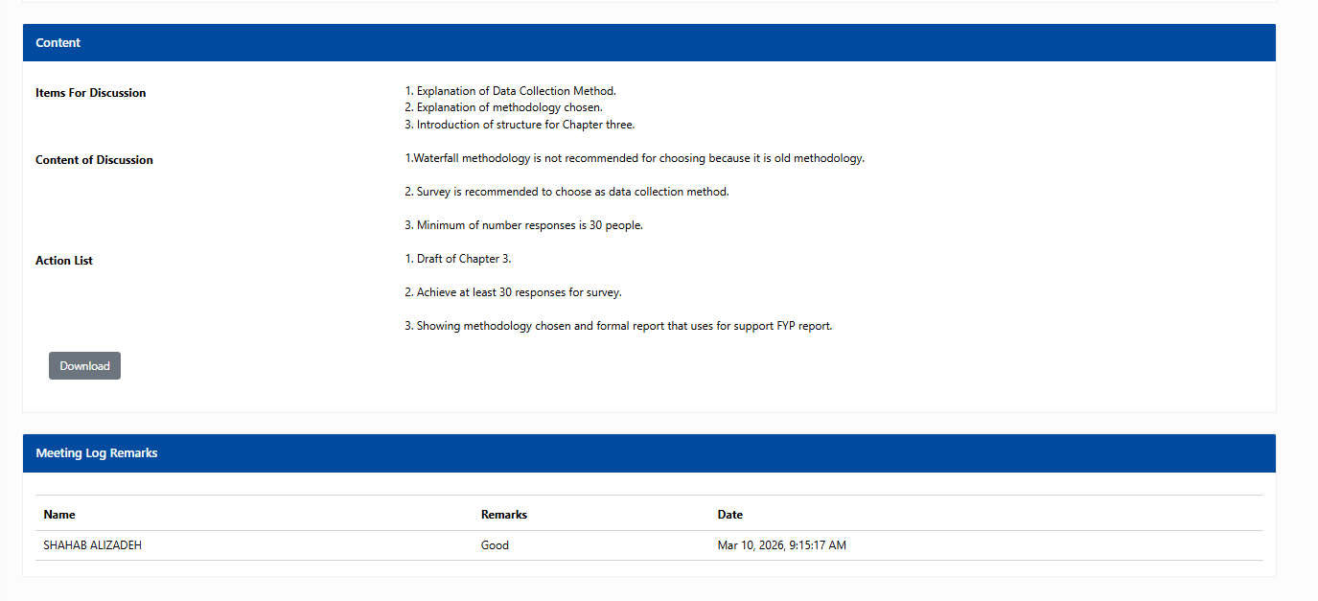
Meeting Logs 3:
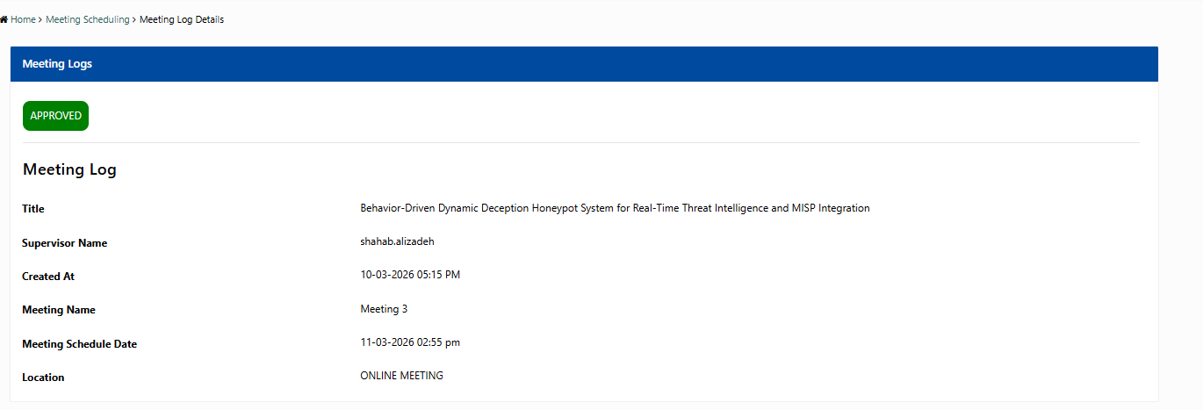
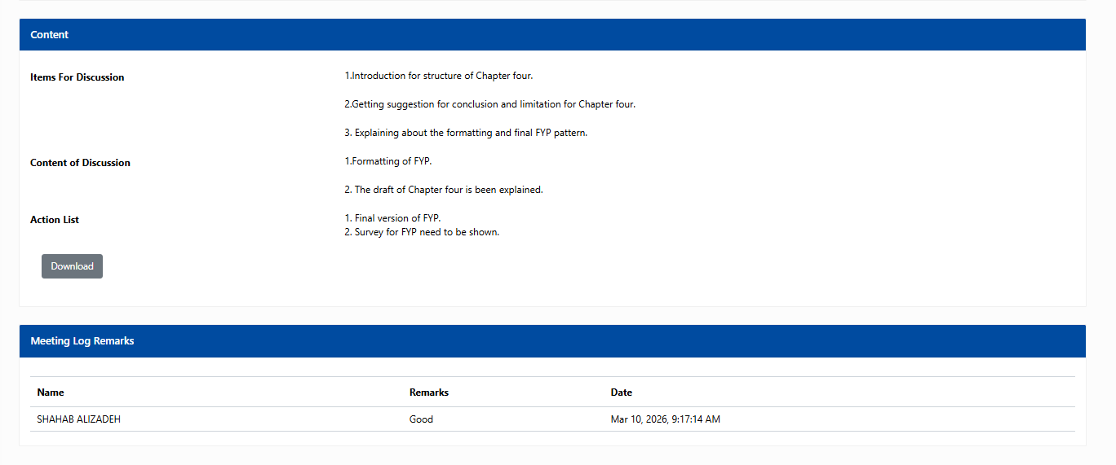

9.2 Ethical Form (Fast Track)
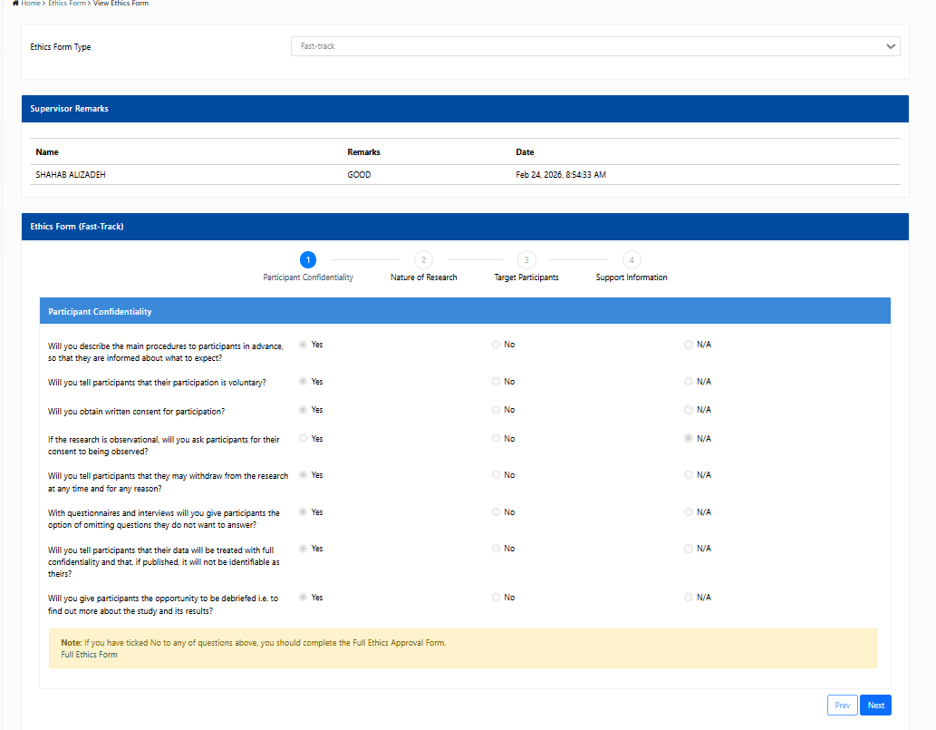




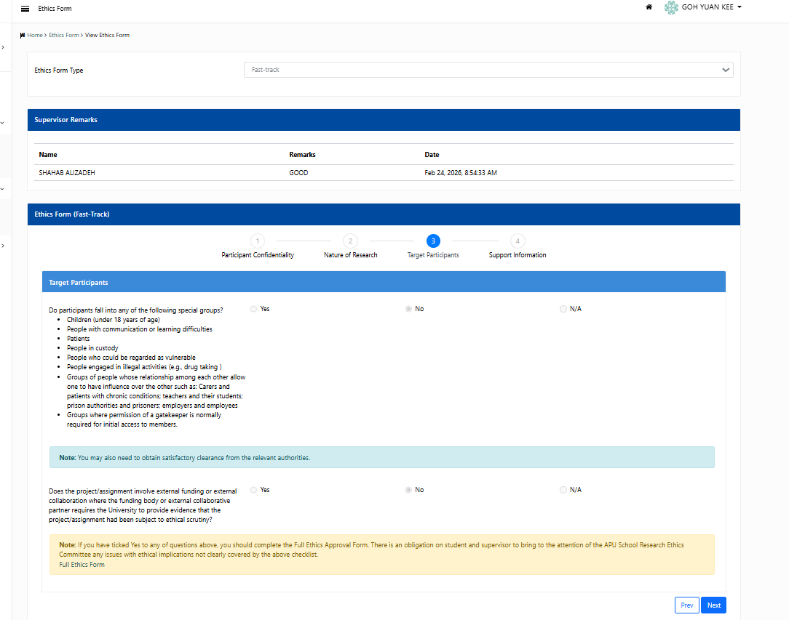
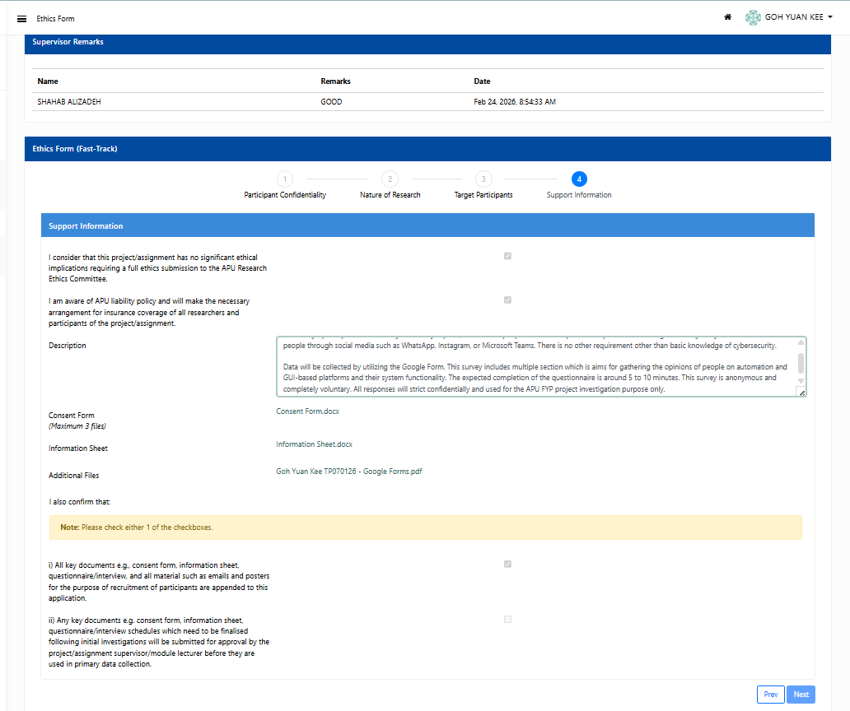
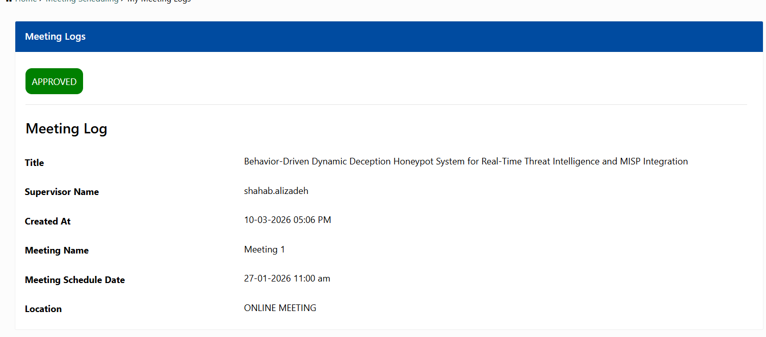


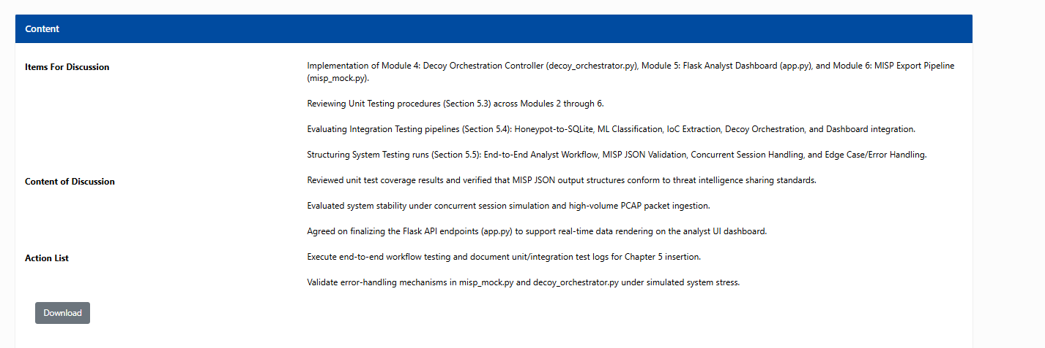
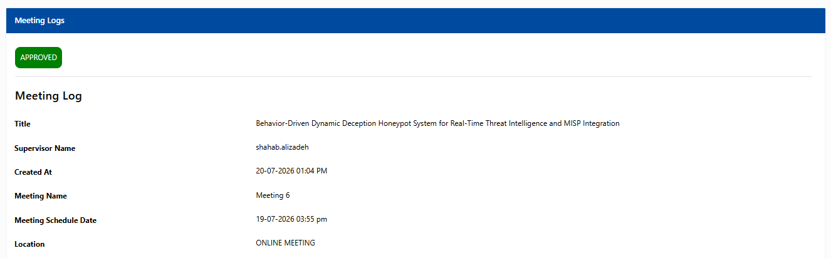
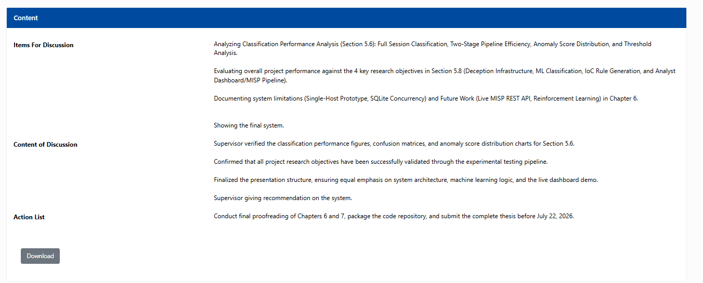

9.3 Respondent’s Demographic Profile
Email | Age | Gender | Highest Education Level
livesalive2003@gmail.com | 22–25 | Female | Undergraduate
pnleow16@gmail.com | 22–25 | Female | Undergraduate
ganchinghar197@gmail.com | 22–25 | Female | Undergraduate
csghome2019@gmail.com | 22–25 | Male | Undergraduate
yejet1111@gmail.com | 26–30 | Male | Undergraduate
scyxuan27@gmail.com | 18–21 | Female | Undergraduate
huiqi457@gmail.com | 22–25 | Female | Undergraduate
ssica1129@gmail.com | 22–25 | Female | Undergraduate
tjunyaw2110@gmail.com | 26–30 | Male | Undergraduate
cherylwoowy@gmail.com | 18–21 | Female | Undergraduate
yuankee197@gmail.com | 22–25 | Female | Undergraduate
Joyce152@gmail.com | 22–25 | Female | Undergraduate
cherylwoowy@gmail.com | 18–21 | Female | Undergraduate
wenjie0498@gmail.com | 22–25 | Prefer not to say | Undergraduate
TP071625@mail.apu.edu.my | 22–25 | Male | Undergraduate
teeakangli5@gmail.com | 18–21 | Male | Undergraduate
Meililim0603@gmail.com | 22–25 | Female | Undergraduate
Valenchristino6@gmail.com | 18–21 | Male | Undergraduate
zanechang.design@gmail.com | 22–25 | Female | Undergraduate
darshank70@gmail.com | 22–25 | Male | Undergraduate
kugghan@gmail.com | 18–21 | Male | Undergraduate
zqpngjim@gmail.com | 22–25 | Male | Undergraduate
watton.wan@gmail.com | 22–25 | Male | Undergraduate
Faridaisakulova19@gmail.com | 22–25 | Female | Undergraduate
eejoy101010@gmail.com | 18–21 | Female | Undergraduate
zetapark8@gmail.com | 18–21 | Female | Undergraduate
ayraznl@gmail.com | 22–25 | Female | Undergraduate
vedrbx@icloud.com | 18–21 | Male | Undergraduate
manon8515@icloud.com | 18–21 | Female | Undergraduate
tuan123@gmail.com.my | 22–25 | Female | Undergraduate

9.4 Gantt Chart
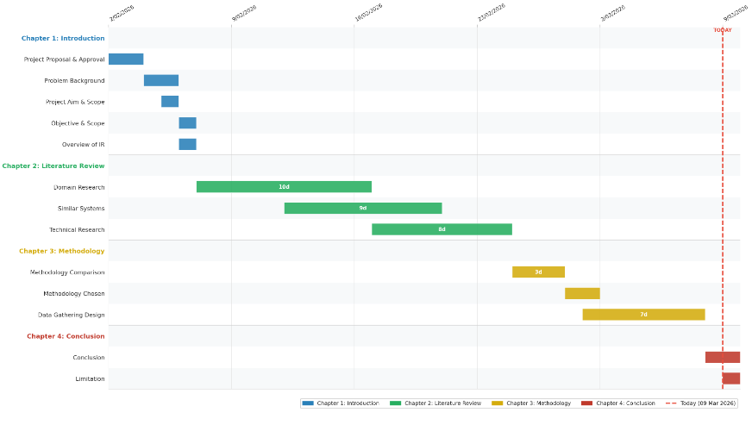
Figure 9.4.1 Gann Chart part 1

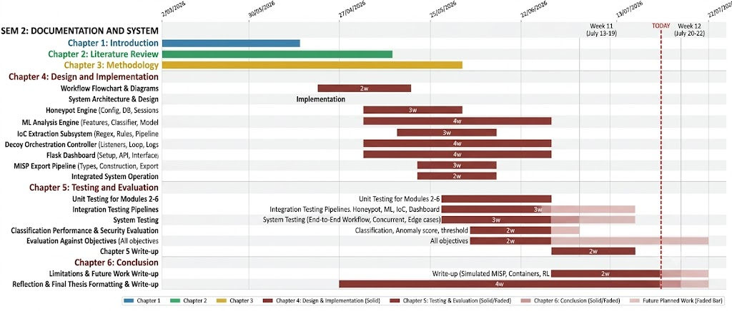
Figure 9.4.2 Gann Chart part 2

9.5 PPF
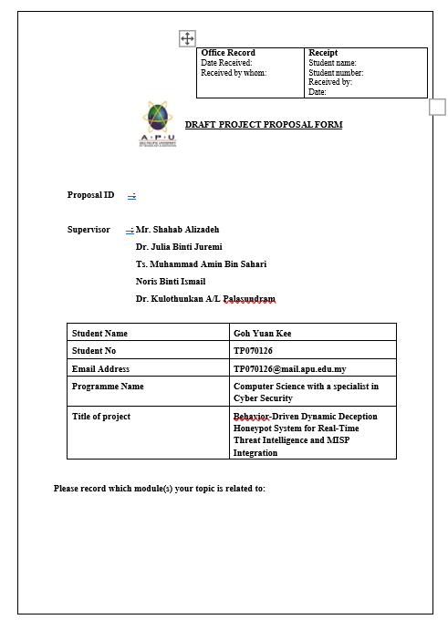
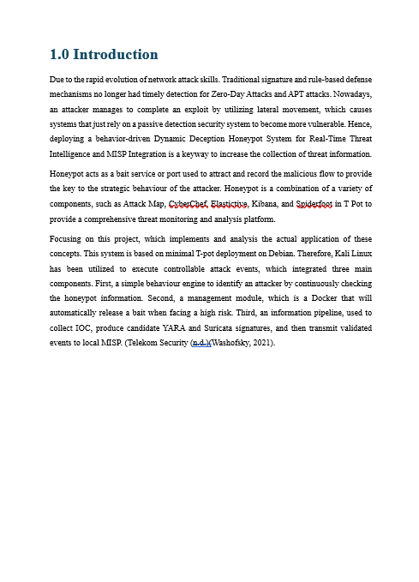
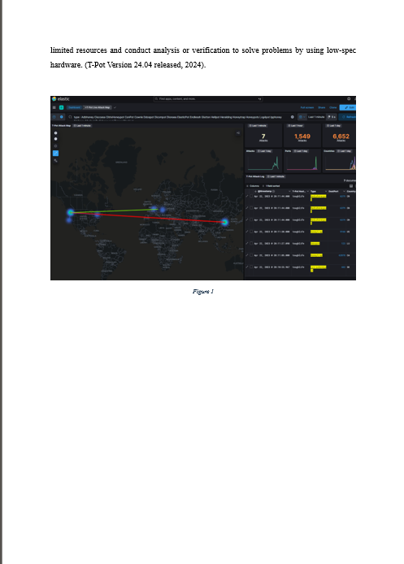

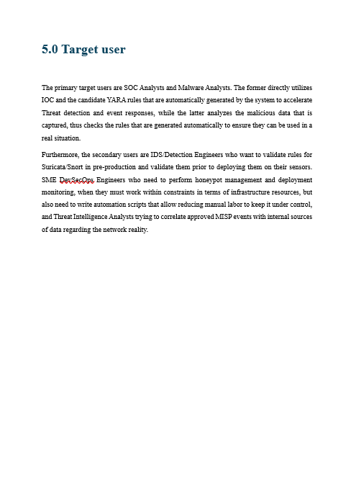

9.6 Poster FYP

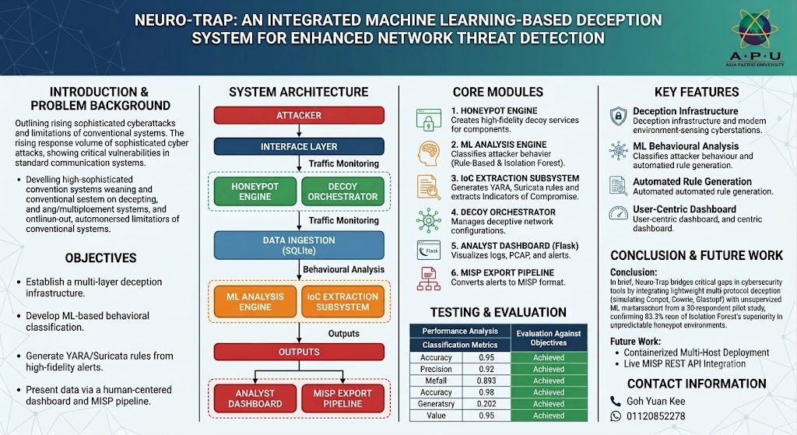
Figure 9.6 Poster FYP

